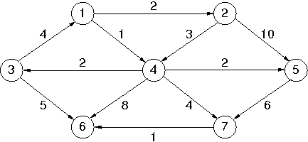

Based on the sample Graph (assume that the node value starts from 0 and not 1), in order to run the Dijkstra Algorithm using Binomial Heap the user needs to enter the above graph in the following order:

Source Vertex | Destination Vertex | Weight Between Them
0 | 1 | 2
0 | 3 | 1
1 | 3 | 3
1 | 4 | 10
2 | 0 | 4
2 | 5 | 5
3 | 2 | 2
3 | 4 | 2
3 | 5 | 8
3 | 6 | 4
4 | 6 | 6
6 | 5 | 1

The Result of the Dijkstra Algorithm for the above Graph will be :

Destination Vertex | Distance From Source Vertex
0 | 0
1 | 2
2 | 3
3 | 1
4 | 3
5 | 6
6 | 5

