Linear Regression Analysis

Pramod Nipunajith

2022-11-07

# Install Packages

The following packages are used to evaluate the fitted model for the given data set.

library(MASS)  
library(tidyverse)

## ── Attaching core tidyverse packages ──────────────────────── tidyverse 2.0.0 ──  
## ✔ dplyr 1.1.2 ✔ readr 2.1.4  
## ✔ forcats 1.0.0 ✔ stringr 1.5.0  
## ✔ ggplot2 3.4.2 ✔ tibble 3.2.1  
## ✔ lubridate 1.9.2 ✔ tidyr 1.3.0  
## ✔ purrr 1.0.1   
## ── Conflicts ────────────────────────────────────────── tidyverse_conflicts() ──  
## ✖ dplyr::filter() masks stats::filter()  
## ✖ dplyr::lag() masks stats::lag()  
## ✖ dplyr::select() masks MASS::select()  
## ℹ Use the conflicted package (<http://conflicted.r-lib.org/>) to force all conflicts to become errors

library(gridExtra)

##   
## Attaching package: 'gridExtra'  
##   
## The following object is masked from 'package:dplyr':  
##   
## combine

library(corrplot)

## corrplot 0.92 loaded

library(performance)  
library(tinytex)  
library(sp)

## The legacy packages maptools, rgdal, and rgeos, underpinning the sp package,  
## which was just loaded, will retire in October 2023.  
## Please refer to R-spatial evolution reports for details, especially  
## https://r-spatial.org/r/2023/05/15/evolution4.html.  
## It may be desirable to make the sf package available;  
## package maintainers should consider adding sf to Suggests:.  
## The sp package is now running under evolution status 2  
## (status 2 uses the sf package in place of rgdal)

# Import the data set

insurance_claims <- read.csv("../data/insurance_claims.csv")  
attach(insurance_claims)  
head(insurance_claims)

## age sex bmi children is_smoker working_env tot_claims  
## 1 19 female 27.900 0 yes factory 16884.924  
## 2 18 male 33.770 1 no office 1725.552  
## 3 28 male 33.000 3 no office 4449.462  
## 4 33 male 22.705 0 no factory 21984.471  
## 5 32 male 28.880 0 no office 3866.855  
## 6 31 female 25.740 0 no office 3756.622

summary(insurance_claims)

## age sex bmi children   
## Min. :18.00 Length:1338 Min. :15.96 Min. :0.000   
## 1st Qu.:27.00 Class :character 1st Qu.:26.30 1st Qu.:0.000   
## Median :39.00 Mode :character Median :30.40 Median :1.000   
## Mean :39.21 Mean :30.66 Mean :1.095   
## 3rd Qu.:51.00 3rd Qu.:34.69 3rd Qu.:2.000   
## Max. :64.00 Max. :53.13 Max. :5.000   
## is_smoker working_env tot_claims   
## Length:1338 Length:1338 Min. : 1122   
## Class :character Class :character 1st Qu.: 4740   
## Mode :character Mode :character Median : 9382   
## Mean :13270   
## 3rd Qu.:16640   
## Max. :63770

str(insurance_claims)

## 'data.frame': 1338 obs. of 7 variables:  
## $ age : int 19 18 28 33 32 31 46 37 37 60 ...  
## $ sex : chr "female" "male" "male" "male" ...  
## $ bmi : num 27.9 33.8 33 22.7 28.9 ...  
## $ children : int 0 1 3 0 0 0 1 3 2 0 ...  
## $ is_smoker : chr "yes" "no" "no" "no" ...  
## $ working_env: chr "factory" "office" "office" "factory" ...  
## $ tot_claims : num 16885 1726 4449 21984 3867 ...

Note that, there are three categorical variables in the given data set. Such as, ‘sex’ , ‘is_smoker’ and ‘working_env’

# Exploratory Analysis

Under the exploratory analysis, We have to look at the relationship between categorical variables and numerical variables. Also, want to look at the relationship between each and every variables with the response variable.

#### 1. Total amount of claims made by the policyholder

p1 <- insurance_claims %>%   
 ggplot(aes(x = tot_claims)) +  
 geom_histogram(col = "black", fill = "yellow") +  
 labs(x = "Total amount of Claims",   
 title = "Histogram for Total amount of Claims") +  
 theme_bw()  
  
p2 <- insurance_claims %>%   
 ggplot(aes(x = log(tot_claims))) +  
 geom_histogram(col = "black", fill = "green") +  
 labs(x = "log(Total amount of Claims)",  
 title = "Histogram for Log transformed\nTotal amount of Claims") +  
 theme_bw()  
  
grid.arrange(p1,p2, ncol = 2)

## `stat_bin()` using `bins = 30`. Pick better value with `binwidth`.  
## `stat_bin()` using `bins = 30`. Pick better value with `binwidth`.

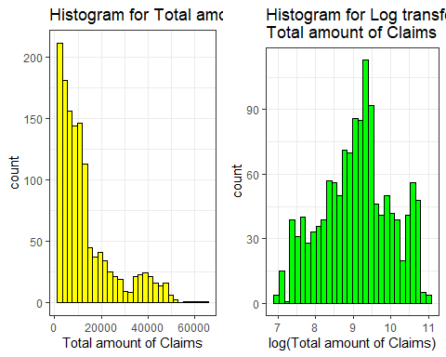

p01 <- insurance_claims %>%   
 ggplot(aes(y = tot_claims)) +  
 geom_boxplot(col = "blue", fill = "skyblue") +  
 labs(x = "Total amount of Claims",   
 title = "Boxplot for Total amount of Claims") +  
 theme_bw()  
  
p02 <- insurance_claims %>%   
 ggplot(aes(y = log(tot_claims))) +  
 geom_boxplot(col = "black", fill = "red") +  
 labs(x = "log(Total amount of Claims)",  
 title = "Boxplot for Log transformed\nTotal amount of Claims") +  
 theme_bw()  
  
grid.arrange(p01,p02, ncol = 2)

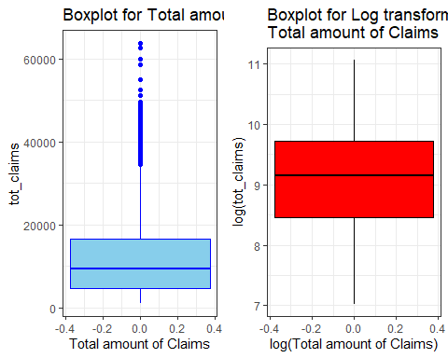

‘tot_claims’ variable is not normally distributed. Then I applied log transformation to the variable and it seems that, transformed variable is fairly normally distributed. So, we used log transformed variable for further analysis.

#### 2. Relationship between Age and Total amount of claims

p3 <- insurance_claims %>%   
 ggplot(aes(x = age,y = log(tot_claims))) +  
 geom_point(col = "black") +  
 labs(x = "Age",y = "log(Total amount of Claims)",  
 title = "Age vs Log transformed\nTotal amount of Claims") +  
 theme_bw()  
  
p4 <- insurance_claims %>%   
 ggplot(aes(y = age)) +  
 geom_boxplot(col = "blue", fill = "skyblue") +  
 labs(x = "Age",  
 title = "Boxplot for Age") +  
 theme_bw()  
  
grid.arrange(p3,p4, ncol = 2)

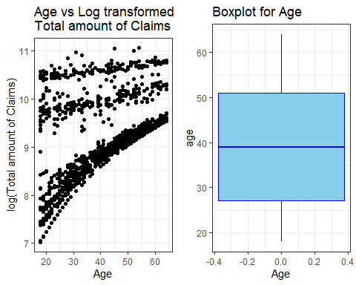

There is a a moderately positive relationship between Age and log transformed variable. Age variable does not contain any outliers.

#### 3. Relationship between BMI and Total amount of claims

p5 <- insurance_claims %>%   
 ggplot(aes(x = bmi,y = log(tot_claims))) +  
 geom_point(col = "blue") +  
 labs(x = "BMI",y = "log(Total amount of Claims)",  
 title = "BMI vs Log transformed\nTotal amount of Claims") +  
 theme_bw()  
  
p6 <- insurance_claims %>%   
 ggplot(aes(y = bmi)) +  
 geom_boxplot(col = "blue", fill = "skyblue") +  
 labs(x = "BMI",  
 title = "Boxplot for BMI") +  
 theme_bw()  
  
grid.arrange(p5,p6, ncol = 2)

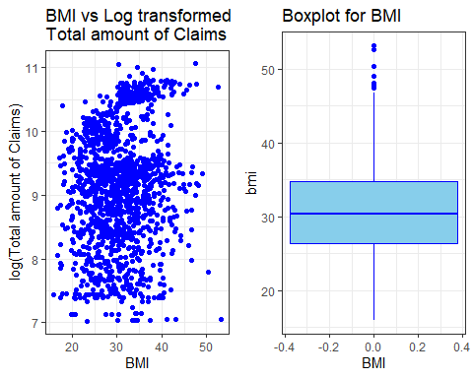

It seems that there exists a very poor relationship between ‘bmi’ and log transformed variable. There are some outlires in ``bmi`` variable.

#### 4. Relationship between Number of Dependents and Total amount of claims

p7 <- insurance_claims %>%   
 ggplot(aes(x = children,y = log(tot_claims))) +  
 geom_point(col = "green") +  
 labs(x = "Number of Dependents",y = "log(Total amount of Claims)",  
 title = "Number of Dependents vs Log\ntransformed Total amount of Claims") +  
 theme_bw()  
  
p8 <- insurance_claims %>%   
 ggplot(aes(y = children)) +  
 geom_boxplot(col = "blue", fill = "skyblue") +  
 labs(x = "Number of Dependents",  
 title = "Boxplot for Number of Dependents") +  
 theme_bw()  
  
grid.arrange(p7,p8, ncol = 2)

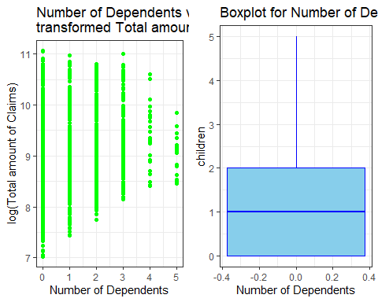

There is a poor relationship with ‘children’ and log transformed variable. But we can not detect any outlires in this variable.

#### 5. Total amount of claims across Gender

p9 <- insurance_claims %>%   
 ggplot(aes(x = sex, y = tot_claims)) +  
 geom_boxplot(fill = "skyblue") +  
 labs(x = "Gender",y = "Total amount of Claims",   
 title = "Total amount of claims across\nGender") +  
 theme_bw()  
  
p10 <- insurance_claims %>%   
 ggplot(aes(x = sex,y = log(tot_claims))) +  
 geom_boxplot(fill = "skyblue") +  
 labs(x = "Gender",y = "log(Total amount of Claims)",  
 title = "log(Total amount of claims) across\nGender") +  
 theme_bw()  
  
grid.arrange(p9,p10, ncol = 2)

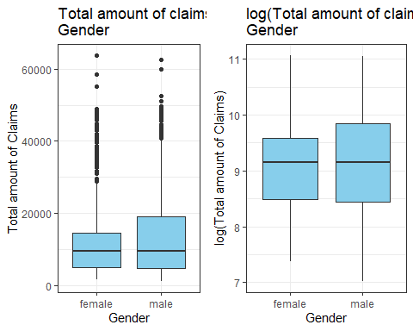

We can see that there are outlires in the right side boxplot. But after applied the log transformation, we can not detect any outlires. Further, both distributions are fairly normally distributed because of both medians are approximately equal.

#### 6. Total amount of claims across Smoking status

p11 <- insurance_claims %>%   
 ggplot(aes(x = is_smoker, y = tot_claims)) +  
 geom_boxplot(fill = "skyblue") +  
 labs(x = "Smoking status",y = "Total amount of Claims",   
 title = "Total amount of claims across\nSmoking status") +  
 theme_bw()  
  
p12 <- insurance_claims %>%   
 ggplot(aes(x = is_smoker,y = log(tot_claims))) +  
 geom_boxplot(fill = "skyblue") +  
 labs(x = "Smoking status",y = "log(Total amount of Claims)",  
 title = "log(Total amount of claims) across\nSmoking status") +  
 theme_bw()  
  
grid.arrange(p11,p12, ncol = 2)

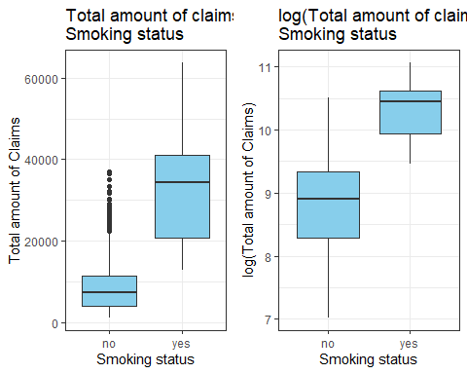

We can see that there are outlires in the right side boxplot. But after transformed, we can not detect any outliers and both distributions are fairly normally distributed. In ‘yes’ category has significantly higher median than ‘no’ category. So, it seems that ‘is_smoker’ variable has an effect on ‘tot_claims’ variable.

#### 7. Total amount of claims across working environment

p13 <- insurance_claims %>%   
 ggplot(aes(x = working_env, y = tot_claims)) +  
 geom_boxplot(fill = "skyblue") +  
 labs(x = " Working environment",y = "Total amount of Claims",   
 title = "Total amount of claims across\nWorking environment") +  
 theme_bw()  
  
p14 <- insurance_claims %>%   
 ggplot(aes(x = working_env,y = log(tot_claims))) +  
 geom_boxplot(fill = "skyblue") +  
 labs(x = "Working environment",y = "log(Total amount of Claims)",  
 title = "log(Total amount of claims) across\nWorking environment") +  
 theme_bw()  
  
grid.arrange(p13,p14, ncol = 2)

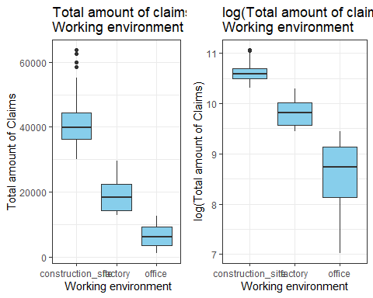

We can see that there are outlires in the right side boxplots. In ‘construction_site’ category has significantly higher median than other categories. So, it seems ‘working_env’ variable has an effect on ‘tot_claims’ variable.

#### Correlation between Age, BMI and Number of Dependents

corrplot(cor(insurance_claims[,c("age","bmi","children")]),method = 'square')

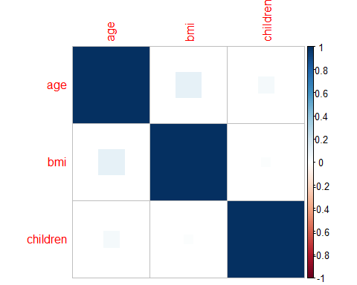

There is a very poor correlation between ‘bmi and ’age’. Also, there is no relationship between other pairs in the plot.

# Handle the categorical variables

Here, we have to covert all the categorical variables as numeric.

insurance_claims$sex <- as.numeric(factor(insurance_claims$sex , labels = c("male" , "female")))

insurance_claims$is_smoker <- as.numeric(factor(insurance_claims$is_smoker , labels = c("yes" , "no")))

insurance_claims$working_env <- as.numeric(factor(insurance_claims$working_env , labels = c("factory" , "office" , "construction_site")))

str(insurance_claims)

## 'data.frame': 1338 obs. of 7 variables:  
## $ age : int 19 18 28 33 32 31 46 37 37 60 ...  
## $ sex : num 1 2 2 2 2 1 1 1 2 1 ...  
## $ bmi : num 27.9 33.8 33 22.7 28.9 ...  
## $ children : int 0 1 3 0 0 0 1 3 2 0 ...  
## $ is_smoker : num 2 1 1 1 1 1 1 1 1 1 ...  
## $ working_env: num 2 3 3 2 3 3 3 3 3 2 ...  
## $ tot_claims : num 16885 1726 4449 21984 3867 ...

head(insurance_claims)

## age sex bmi children is_smoker working_env tot_claims  
## 1 19 1 27.900 0 2 2 16884.924  
## 2 18 2 33.770 1 1 3 1725.552  
## 3 28 2 33.000 3 1 3 4449.462  
## 4 33 2 22.705 0 1 2 21984.471  
## 5 32 2 28.880 0 1 3 3866.855  
## 6 31 1 25.740 0 1 3 3756.622

# Model Fitting

For the purpose of model fitting, I have used the forward selection method based on Adjusted R-squared values to select the significance variables.

### Iteration 01

summary(lm(tot_claims ~ age, data = insurance_claims))$adj.r.squared

## [1] 0.08872432

summary(lm(tot_claims ~ bmi, data = insurance_claims))$adj.r.squared

## [1] 0.03862008

summary(lm(tot_claims ~ sex, data = insurance_claims))$adj.r.squared

## [1] 0.002536334

summary(lm(tot_claims ~ children, data = insurance_claims))$adj.r.squared

## [1] 0.003878717

summary(lm(tot_claims ~ is_smoker, data = insurance_claims))$adj.r.squared

## [1] 0.6194802

summary(lm(tot_claims ~ working_env, data = insurance_claims))$adj.r.squared

## [1] 0.8614734

Since ‘working_env’ variable has the largest adjusted R-squared value as 0.8614734, that variable is included to the model

### Iteration 02

summary(lm(tot_claims ~ working_env + age, data = insurance_claims))$adj.r.squared

## [1] 0.886051

summary(lm(tot_claims ~ working_env + sex, data = insurance_claims))$adj.r.squared

## [1] 0.8614025

summary(lm(tot_claims ~ working_env + bmi, data = insurance_claims))$adj.r.squared

## [1] 0.865276

summary(lm(tot_claims ~ working_env + children, data = insurance_claims))$adj.r.squared

## [1] 0.8643907

summary(lm(tot_claims ~ working_env + is_smoker, data = insurance_claims))$adj.r.squared

## [1] 0.8679371

Here ‘age’ variable has the highest adjusted R-squared value as 0.886051. Therefore, ‘age’ is added to the model.

### Iteration 03

summary(lm(tot_claims ~ working_env + age + sex, data = insurance_claims))$adj.r.squared

## [1] 0.8859661

summary(lm(tot_claims ~ working_env + age + bmi, data = insurance_claims))$adj.r.squared

## [1] 0.888348

summary(lm(tot_claims ~ working_env + age + children, data = insurance_claims))$adj.r.squared

## [1] 0.8883291

summary(lm(tot_claims ~ working_env + age + is_smoker, data = insurance_claims))$adj.r.squared

## [1] 0.9013036

Note that, ‘is_smoker’ variable has largest adjusted R-squared value as 0.9013036. So, this variable is also added to the model.

### Iteration 04

summary(lm(tot_claims ~ working_env + age + is_smoker + sex, data = insurance_claims))$adj.r.squared

## [1] 0.9012491

summary(lm(tot_claims ~ working_env + age + is_smoker + bmi, data = insurance_claims))$adj.r.squared

## [1] 0.9063182

summary(lm(tot_claims ~ working_env + age + is_smoker + children, data = insurance_claims))$adj.r.squared

## [1] 0.903542

Since ‘bmi’ variable has largest adjusted R-squared as 0.9063182. ‘bmi’ variable is included to the model.

### Iteration 05

summary(lm(tot_claims ~ working_env + age + is_smoker + bmi + sex, data = insurance_claims))$adj.r.squared

## [1] 0.9063071

summary(lm(tot_claims ~ working_env + age + is_smoker + bmi + children, data = insurance_claims))$adj.r.squared

## [1] 0.9085069

Here ‘children’ variable has highest adjusted R-squared value as 0.9085069. So, this variable is also in the model.

### Iteration 06

summary(lm(tot_claims ~ working_env + age + is_smoker + bmi + children + sex, data = insurance_claims))$adj.r.squared

## [1] 0.9085106

Note that, when the ‘sex’ variable is added to the model there is no any significance change in adjusted R-squared value. Based on that reason, we cannot include the ‘sex’ variable for the above fitted model.

#### Plot all the iteration

plot(c(1,2,3,4,5,6),c(0.8614734,0.886051,0.9013036,0.9063182,0.9085069, 0.9085106),  
xlab = "Number of variables in the model", ylab ="Adjusted R-squared", type="o")

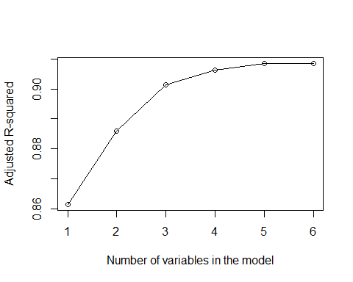

According to the above plot, we have to include the following variables in order to obtain the best fitted model.

* age
* bmi
* children
* is_smoker
* working_env

# Full model

Obtained the full model by including all the variables as follows.

full_model <- lm(tot_claims ~ . , data = insurance_claims)  
drop1(full_model, test = "F")

## Single term deletions  
##   
## Model:  
## tot_claims ~ age + sex + bmi + children + is_smoker + working_env  
## Df Sum of Sq RSS AIC F value Pr(>F)   
## <none> 1.7858e+10 21966   
## age 1 6.1495e+09 2.4008e+10 22360 458.3293 < 2.2e-16 ***  
## sex 1 1.4141e+07 1.7872e+10 21965 1.0539 0.3048   
## bmi 1 9.9272e+08 1.8851e+10 22037 73.9888 < 2.2e-16 ***  
## children 1 4.4385e+08 1.8302e+10 21997 33.0808 1.095e-08 ***  
## is_smoker 1 3.5266e+09 2.1385e+10 22205 262.8435 < 2.2e-16 ***  
## working_env 1 3.1215e+10 4.9073e+10 23317 2326.4839 < 2.2e-16 ***  
## ---  
## Signif. codes: 0 '***' 0.001 '**' 0.01 '*' 0.05 '.' 0.1 ' ' 1

summary(full_model)

##   
## Call:  
## lm(formula = tot_claims ~ ., data = insurance_claims)  
##   
## Residuals:  
## Min 1Q Median 3Q Max   
## -11247.0 -1187.3 184.6 1669.3 24756.6   
##   
## Coefficients:  
## Estimate Std. Error t value Pr(>|t|)   
## (Intercept) 24886.835 1435.366 17.338 < 2e-16 ***  
## age 159.817 7.465 21.409 < 2e-16 ***  
## sex -206.535 201.182 -1.027 0.305   
## bmi 145.770 16.947 8.602 < 2e-16 ***  
## children 478.491 83.193 5.752 1.1e-08 ***  
## is_smoker 6958.673 429.218 16.212 < 2e-16 ***  
## working_env -12172.133 252.358 -48.234 < 2e-16 ***  
## ---  
## Signif. codes: 0 '***' 0.001 '**' 0.01 '*' 0.05 '.' 0.1 ' ' 1  
##   
## Residual standard error: 3663 on 1331 degrees of freedom  
## Multiple R-squared: 0.9089, Adjusted R-squared: 0.9085   
## F-statistic: 2214 on 6 and 1331 DF, p-value: < 2.2e-16

According to the above results, we have to exclude the ‘sex’ variable as it is not significant to the fitted model. Further, it has high p value of 0.305 (>0.05) than the other variables.

# Reduced model

Obtained the reduced model by dropping ‘sex’ variable from the full_model.

red_model <- lm(tot_claims ~ age + bmi + children + is_smoker + working_env , data = insurance_claims)  
summary(red_model)

##   
## Call:  
## lm(formula = tot_claims ~ age + bmi + children + is_smoker +   
## working_env, data = insurance_claims)  
##   
## Residuals:  
## Min 1Q Median 3Q Max   
## -11334.8 -1162.1 182.1 1684.2 24667.6   
##   
## Coefficients:  
## Estimate Std. Error t value Pr(>|t|)   
## (Intercept) 24608.441 1409.546 17.458 < 2e-16 ***  
## age 160.017 7.463 21.442 < 2e-16 ***  
## bmi 144.977 16.929 8.564 < 2e-16 ***  
## children 477.031 83.182 5.735 1.21e-08 ***  
## is_smoker 6942.301 428.930 16.185 < 2e-16 ***  
## working_env -12170.053 252.355 -48.226 < 2e-16 ***  
## ---  
## Signif. codes: 0 '***' 0.001 '**' 0.01 '*' 0.05 '.' 0.1 ' ' 1  
##   
## Residual standard error: 3663 on 1332 degrees of freedom  
## Multiple R-squared: 0.9088, Adjusted R-squared: 0.9085   
## F-statistic: 2656 on 5 and 1332 DF, p-value: < 2.2e-16

# Validation of the model

Here, I have used Partial F Test to check the adequacy of the reduced model.

* **null hypothesis** : Reduced model is adequate
* vs
* **alternative** : Reduced model is not adequate

anova(full_model,red_model)

## Analysis of Variance Table  
##   
## Model 1: tot_claims ~ age + sex + bmi + children + is_smoker + working_env  
## Model 2: tot_claims ~ age + bmi + children + is_smoker + working_env  
## Res.Df RSS Df Sum of Sq F Pr(>F)  
## 1 1331 1.7858e+10   
## 2 1332 1.7872e+10 -1 -14140693 1.0539 0.3048

By looking at the ANOVA table, we can detect that the p-value (0.3048) is greater than 0.05 at 5% significance level. That means we don’t have enough evidence to reject null hypothesis at 5% significance level. Moreover, we can conclude that the reduced model is adequate.

# Residual analysis

check_model(red_model, check = c("linearity","homogeneity","qq","outliers"))

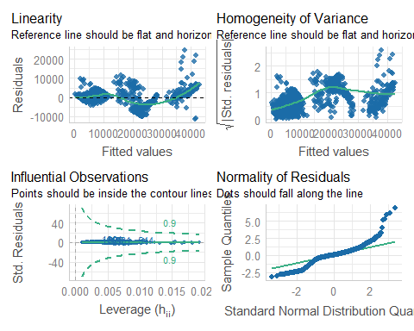

check_normality(red_model)

## Warning: Non-normality of residuals detected (p < .001).

check_heteroskedasticity(red_model)

## Warning: Heteroscedasticity (non-constant error variance) detected (p < .001).

check_outliers(red_model)

## OK: No outliers detected.  
## - Based on the following method and threshold: cook (0.9).  
## - For variable: (Whole model)

check_autocorrelation(red_model)

## OK: Residuals appear to be independent and not autocorrelated (p = 0.946).

By looking at the above plot and results that we obtained, we can detect that the normality of residuals and heteroskedasticity is violated. So, we have to use the transformation method to correct those violation.

# Box-cox transformation

box_trans <- boxcox(red_model)

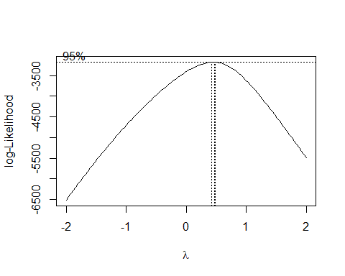

(lambda <- box_trans$x[which.max(box_trans$y)])

## [1] 0.4646465

fit_model <- lm(((tot_claims^lambda-1)/lambda) ~ working_env + is_smoker + bmi + children + age, data = insurance_claims)  
  
summary(fit_model)

##   
## Call:  
## lm(formula = ((tot_claims^lambda - 1)/lambda) ~ working_env +   
## is_smoker + bmi + children + age, data = insurance_claims)  
##   
## Residuals:  
## Min 1Q Median 3Q Max   
## -71.549 -10.617 -0.124 10.492 90.610   
##   
## Coefficients:  
## Estimate Std. Error t value Pr(>|t|)   
## (Intercept) 193.97208 7.75948 24.998 < 2e-16 ***  
## working_env -63.40573 1.38920 -45.642 < 2e-16 ***  
## is_smoker 40.89734 2.36124 17.320 < 2e-16 ***  
## bmi 0.37064 0.09320 3.977 7.36e-05 ***  
## children 4.84877 0.45792 10.589 < 2e-16 ***  
## age 1.54199 0.04108 37.535 < 2e-16 ***  
## ---  
## Signif. codes: 0 '***' 0.001 '**' 0.01 '*' 0.05 '.' 0.1 ' ' 1  
##   
## Residual standard error: 20.16 on 1332 degrees of freedom  
## Multiple R-squared: 0.9132, Adjusted R-squared: 0.9129   
## F-statistic: 2802 on 5 and 1332 DF, p-value: < 2.2e-16

## Check the model assumption

check_model(fit_model, check = c("qq", "linearity", "homogeneity", "outliers"))

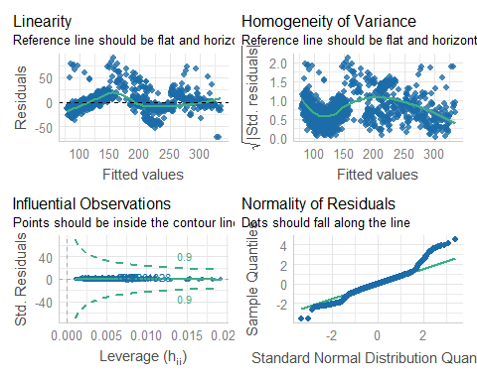

check_normality(fit_model)

## Warning: Non-normality of residuals detected (p < .001).

check_heteroskedasticity(fit_model)

## Warning: Heteroscedasticity (non-constant error variance) detected (p < .001).

check_outliers(fit_model)

## OK: No outliers detected.  
## - Based on the following method and threshold: cook (0.9).  
## - For variable: (Whole model)

check_autocorrelation(fit_model)

## OK: Residuals appear to be independent and not autocorrelated (p = 0.264).

In order to correct the non constant error of variance, we can use log transformation.

# Log transformation

log_model <- lm(log(tot_claims) ~ age + bmi + children + is_smoker + working_env, data = insurance_claims )  
summary(log_model)

##   
## Call:  
## lm(formula = log(tot_claims) ~ age + bmi + children + is_smoker +   
## working_env, data = insurance_claims)  
##   
## Residuals:  
## Min 1Q Median 3Q Max   
## -1.1242 -0.2302 0.0434 0.1943 1.4307   
##   
## Coefficients:  
## Estimate Std. Error t value Pr(>|t|)   
## (Intercept) 8.9522671 0.1349223 66.351 <2e-16 ***  
## age 0.0291044 0.0007143 40.744 <2e-16 ***  
## bmi 0.0003439 0.0016205 0.212 0.832   
## children 0.1014024 0.0079623 12.735 <2e-16 ***  
## is_smoker 0.5641608 0.0410574 13.741 <2e-16 ***  
## working_env -0.7063503 0.0241555 -29.242 <2e-16 ***  
## ---  
## Signif. codes: 0 '***' 0.001 '**' 0.01 '*' 0.05 '.' 0.1 ' ' 1  
##   
## Residual standard error: 0.3506 on 1332 degrees of freedom  
## Multiple R-squared: 0.8551, Adjusted R-squared: 0.8546   
## F-statistic: 1573 on 5 and 1332 DF, p-value: < 2.2e-16

## Check the model assumption

check_model(log_model, check = c("qq", "linearity", "homogeneity", "outliers"))

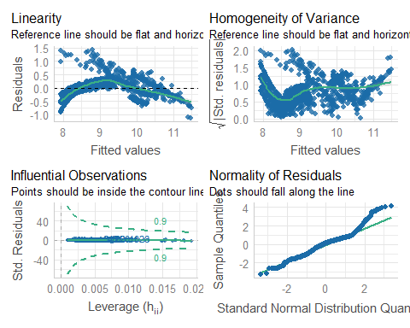

check_normality(log_model)

## Warning: Non-normality of residuals detected (p < .001).

check_heteroskedasticity(log_model)

## OK: Error variance appears to be homoscedastic (p = 0.232).

check_outliers(log_model)

## OK: No outliers detected.  
## - Based on the following method and threshold: cook (0.9).  
## - For variable: (Whole model)

check_autocorrelation(log_model)

## OK: Residuals appear to be independent and not autocorrelated (p = 0.450).

Still normality assumption is violated.

# Multicolinearity

library(caTools)  
library(car)

## Loading required package: carData

##   
## Attaching package: 'car'

## The following object is masked from 'package:dplyr':  
##   
## recode

## The following object is masked from 'package:purrr':  
##   
## some

library(quantmod)

## Loading required package: xts

## Loading required package: zoo

##   
## Attaching package: 'zoo'

## The following objects are masked from 'package:base':  
##   
## as.Date, as.Date.numeric

##   
## ######################### Warning from 'xts' package ##########################  
## # #  
## # The dplyr lag() function breaks how base R's lag() function is supposed to #  
## # work, which breaks lag(my_xts). Calls to lag(my_xts) that you type or #  
## # source() into this session won't work correctly. #  
## # #  
## # Use stats::lag() to make sure you're not using dplyr::lag(), or you can add #  
## # conflictRules('dplyr', exclude = 'lag') to your .Rprofile to stop #  
## # dplyr from breaking base R's lag() function. #  
## # #  
## # Code in packages is not affected. It's protected by R's namespace mechanism #  
## # Set `options(xts.warn_dplyr_breaks_lag = FALSE)` to suppress this warning. #  
## # #  
## ###############################################################################

##   
## Attaching package: 'xts'

## The following objects are masked from 'package:dplyr':  
##   
## first, last

## Loading required package: TTR

## Registered S3 method overwritten by 'quantmod':  
## method from  
## as.zoo.data.frame zoo

library(xts)  
library(zoo)

vif_values <- vif(red_model)  
barplot(vif_values, main = "VIF values", horiz = TRUE, col = "green")  
abline(v = 4, lwd = 3, lty = 2)

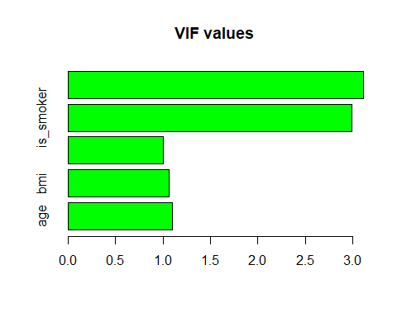

insurance_claims %>% dplyr::select(age, bmi, is_smoker) %>% pairs()

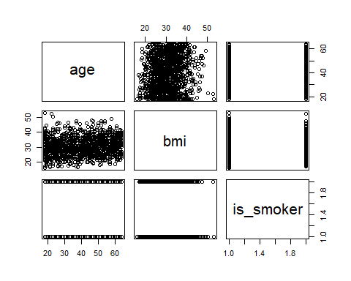

According to the above plot, we can conclude that the variables are uncorrelated. Therefore, the multicolinearity does not effect when predict the annual claims.

# Discussion

In the best fitted model, each and every exploratory variables should be uncorrelated. If we detect the multicolinearity of the fitted model, It would be directly effected when predict the response variable. So, in this multiple linear regression analysis, we didn’t detect the multicolinearity.

When checking the assumption, normality assumption was violated even use the log and boxcox transformation.

dim(insurance_claims)

## [1] 1338 7

This data set contains 1338 observations. By Central Limit Therom for sufficiently large sample we can conclude that the residual will approximately normal.

# Conclusion

coef_log_model <- coef(log_model)  
coef_log_model

## (Intercept) age bmi children is_smoker   
## 8.9522670887 0.0291043745 0.0003438572 0.1014024291 0.5641607659   
## working_env   
## -0.7063503004

plot(log_model) + geom_abline(intercept = coef_log_model[1], slope = coef_log_model[2], color = "red")

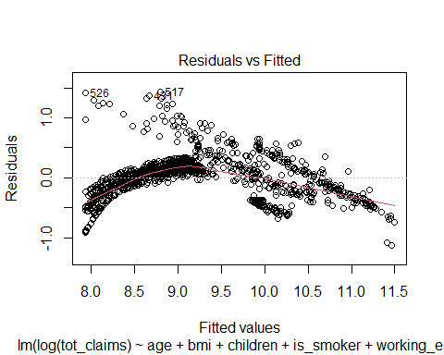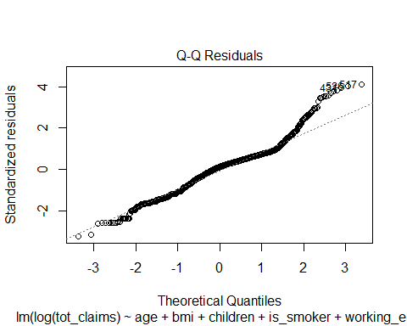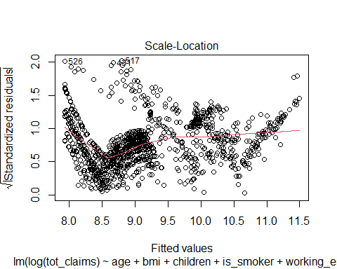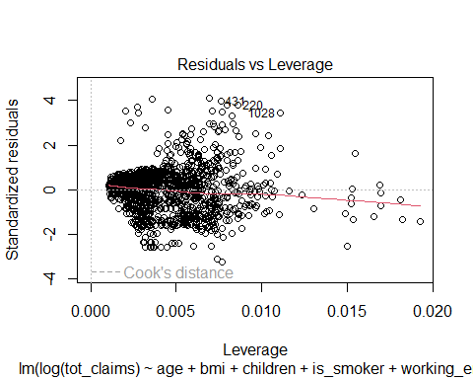

## NULL

#### Best fitted model

log(tot_claims) = 8.95226 + (0.0291)age + (0.00034)bmi + (0.1014)children + (0.56416)is_smoker