fish_consuption

S/17/436

2023-06-17

### Required Packages

library(tidyverse)

## ── Attaching core tidyverse packages ──────────────────────── tidyverse 2.0.0 ──  
## ✔ dplyr 1.1.2 ✔ readr 2.1.4  
## ✔ forcats 1.0.0 ✔ stringr 1.5.0  
## ✔ ggplot2 3.4.2 ✔ tibble 3.2.1  
## ✔ lubridate 1.9.2 ✔ tidyr 1.3.0  
## ✔ purrr 1.0.1   
## ── Conflicts ────────────────────────────────────────── tidyverse_conflicts() ──  
## ✖ dplyr::filter() masks stats::filter()  
## ✖ dplyr::lag() masks stats::lag()  
## ℹ Use the conflicted package (<http://conflicted.r-lib.org/>) to force all conflicts to become errors

library(tinytex)  
library(janitor)

##   
## Attaching package: 'janitor'  
##   
## The following objects are masked from 'package:stats':  
##   
## chisq.test, fisher.test

### Import the data set

fish_consumption <- read.csv("../data/data.csv")  
head(fish_consumption)

## X1..Grama.Niladhari.Division X2..Gender X3..Age.of.the.child..Years.  
## 1 rambewa female 10  
## 2 pandukabhayapura male 5  
## 3 rambewa male 8  
## 4 diviya udabendawewa male 5  
## 5 sadamalgama male 4  
## 6 sadamalgama female 7  
## X4..Weight.of.the.child..kg..  
## 1 28  
## 2 21.4  
## 3 35  
## 4 18  
## 5 6.5  
## 6 21  
## X5..How.would.you.rate.your.child.s.Overall.Academic.performances.....  
## 1 Very Good  
## 2 Fair  
## 3 Excellent  
## 4 Good  
## 5 Good  
## 6 Fair  
## X6..Number.of.people.who.live.in.your.household  
## 1 5  
## 2 4  
## 3 4  
## 4 7  
## 5 7  
## 6 5  
## X7..What.animal.protein.sources.do.you.give.your.child.the.most.  
## 1 Meat (Chicken,Beef, Pork, etc.), Fish, Eggs, Dairy Products  
## 2 Meat (Chicken,Beef, Pork, etc.), Eggs  
## 3 Meat (Chicken,Beef, Pork, etc.), Fish, Eggs, Dairy Products  
## 4 Dairy Products  
## 5 Dairy Products  
## 6 Meat (Chicken,Beef, Pork, etc.), Fish, Eggs, Dairy Products  
## X8..Is.seafood.available.frequently.in.your.area.  
## 1 No  
## 2 Yes  
## 3 No  
## 4 Maybe  
## 5 Yes  
## 6 Maybe  
## X9..Does.your.child.eat.freshwater.fish.  
## 1 Yes  
## 2 Yes  
## 3 Yes  
## 4 No  
## 5 Yes  
## 6 Yes  
## X9...A..If.Yes..mention.the.most.preferred.freshwater.fish.type.of.the.child.  
## 1 Tilapia  
## 2 Not mentioned  
## 3 Loolla  
## 4 Not mentioned  
## 5 Tilapia   
## 6 Tilapia   
## X9...B..If.no..what.is.the.reason.  
## 1   
## 2   
## 3   
## 4 Dislike of the taste or texture  
## 5   
## 6   
## X9...C..If.your.child.hesitates.to.eat.freshwater.fish..what.are.the.methods.you.used.to.encourage.improve.their.consumption.usually.  
## 1 Cook in different ways to make it more appealing (Fish cutlets, Fish patties, Fish biriyani, Fish sandwiches)  
## 2   
## 3 Cook in different ways to make it more appealing (Fish cutlets, Fish patties, Fish biriyani, Fish sandwiches)  
## 4 Serve with their favorite foods  
## 5 Cook in different ways to make it more appealing (Fish cutlets, Fish patties, Fish biriyani, Fish sandwiches)  
## 6   
## X10..Why.does.your.child.prefer.freshwater.fish.  
## 1 Awareness of nutritional quality  
## 2 As a food habit  
## 3 Milder taste  
## 4   
## 5 As a food habit  
## 6 Milder taste, As a food habit  
## X11..What.is.the.reason.for.including.freshwater.fish.in.your.child.s.diet.  
## 1 Nutritional benefits, Health benefits, Freshness, Readily available  
## 2 Nutritional benefits, Taste  
## 3 Nutritional benefits  
## 4   
## 5 Nutritional benefits  
## 6 Nutritional benefits, Health benefits  
## X12..Has.the.amount.of.freshwater.fish.your.family..consumed.changed.over.the.last.3.years.  
## 1 No change  
## 2 Decreased  
## 3 No change  
## 4 Not mentioned  
## 5 Decreased  
## 6 Decreased  
## X13..If.changed..what.is.the.reason.  
## 1   
## 2 High consumption of other animal sources  
## 3   
## 4   
## 5 Expensive   
## 6 Inflation   
## X14..Have.you.ever.received.any.guidance.or.recommendation.from.a.healthcare.professional.regarding.freshwater.fish.consumption.of.your.child.  
## 1 No  
## 2 No  
## 3 No  
## 4 Not mentioned  
## 5 No  
## 6 No  
## X15..Have.you.ever.limited.your.child.s.freshwater.fish.consumption.due.to.any.reason.  
## 1 No  
## 2 No  
## 3 No  
## 4   
## 5 Maybe  
## 6 No  
## X16..If.Yes..what.is.the.reason.  
## 1   
## 2   
## 3   
## 4   
## 5 Due to some health conditions of the children  
## 6   
## X17...Freshwater.fish.is.a.healthy.source.of.animal.protein.and.provide.other.important.nutrients.for.children..  
## 1 Strongly agree  
## 2 Agree  
## 3 Agree  
## 4   
## 5 Agree  
## 6 Agree  
## X18..How.often.does.your.child.eat.freshwater.fish.  
## 1 Twice a week  
## 2 Every few months  
## 3 3-4 times a week  
## 4   
## 5 Once a week  
## 6 Twice a week  
## X19..When.the.child.eats.freshwater.fish..what.is.the.average.amount.per.day.  
## 1 Two meals  
## 2 Two meals  
## 3 Two meals  
## 4   
## 5 One meal  
## 6 Two meals  
## X20..How.many.pieces.the.child.eats.per.meal.  
## 1 2  
## 2 2  
## 3 2  
## 4   
## 5 2  
## 6 2  
## X21.What.is.your.child.s.favorite.way.of.preparing.freshwater.fish.  
## 1 Fried fish  
## 2 Curry (With coconut milk), Fried fish  
## 3 Curry (With coconut milk)  
## 4   
## 5 Fish cutlet, Patties, Sandwiches  
## 6 Curry (With coconut milk), Fried fish, Fish cutlet/patties/sandwiches  
## X22.What.type.of.freshwater.fish.usually.purchase.in.your.household.and.how.much.per.month...Tilapia.  
## 1 Less than 2 kg  
## 2 Less than 2 kg  
## 3 Less than 2 kg  
## 4   
## 5 More than 6 kg  
## 6 Less than 2 kg  
## X22.What.type.of.freshwater.fish.usually.purchase.in.your.household.and.how.much.per.month...Korali.  
## 1   
## 2   
## 3 No purchasing  
## 4   
## 5   
## 6 Less than 2 kg  
## X22.What.type.of.freshwater.fish.usually.purchase.in.your.household.and.how.much.per.month...Hunga.  
## 1   
## 2   
## 3 No purchasing  
## 4   
## 5   
## 6   
## X22.What.type.of.freshwater.fish.usually.purchase.in.your.household.and.how.much.per.month...Loolla.  
## 1   
## 2   
## 3 Less than 2 kg  
## 4   
## 5   
## 6 Less than 2 kg  
## X22.What.type.of.freshwater.fish.usually.purchase.in.your.household.and.how.much.per.month...Pethiya.  
## 1   
## 2   
## 3 No purchasing  
## 4   
## 5   
## 6   
## X22.What.type.of.freshwater.fish.usually.purchase.in.your.household.and.how.much.per.month...Aandha.  
## 1   
## 2   
## 3 No purchasing  
## 4   
## 5   
## 6   
## X22.What.type.of.freshwater.fish.usually.purchase.in.your.household.and.how.much.per.month...Kawayya.  
## 1   
## 2   
## 3 No purchasing  
## 4   
## 5   
## 6   
## X22.What.type.of.freshwater.fish.usually.purchase.in.your.household.and.how.much.per.month...Ankutta.  
## 1   
## 2   
## 3 No purchasing  
## 4   
## 5   
## 6   
## X22.What.type.of.freshwater.fish.usually.purchase.in.your.household.and.how.much.per.month...Magura.  
## 1   
## 2   
## 3 No purchasing  
## 4   
## 5   
## 6   
## X22.What.type.of.freshwater.fish.usually.purchase.in.your.household.and.how.much.per.month...Karadu.issa.  
## 1   
## 2   
## 3 No purchasing  
## 4   
## 5   
## 6   
## X22.What.type.of.freshwater.fish.usually.purchase.in.your.household.and.how.much.per.month...Carp.Spp..  
## 1   
## 2   
## 3 No purchasing  
## 4   
## 5   
## 6   
## X22.What.type.of.freshwater.fish.usually.purchase.in.your.household.and.how.much.per.month...Other.  
## 1   
## 2   
## 3 No purchasing  
## 4   
## 5   
## 6   
## X22...b..If.you.consume.fish.other.than.the.above.mentioned.species..please.mention.it.here.  
## 1   
## 2   
## 3   
## 4   
## 5   
## 6   
## X23.What.are.the.most.frequently.purchasing.processed.freshwater.fish.products.in.your.household.per.month...Dried.fish.  
## 1 Less than 0.5 kg  
## 2   
## 3 0.5 - 1 kg  
## 4   
## 5 More than 2 kg  
## 6 Less than 0.5 kg  
## X23.What.are.the.most.frequently.purchasing.processed.freshwater.fish.products.in.your.household.per.month...Smoked.fish.  
## 1 Less than 0.5 kg  
## 2   
## 3 0.5 - 1 kg  
## 4   
## 5   
## 6 Less than 0.5 kg  
## X23.What.are.the.most.frequently.purchasing.processed.freshwater.fish.products.in.your.household.per.month...Other.  
## 1   
## 2   
## 3   
## 4   
## 5   
## 6   
## X23...b..If.you.consume.fish.product.other.than.the.above.mentioned.processed.product..please.mention.it.here.  
## 1   
## 2   
## 3   
## 4   
## 5   
## 6   
## X24..What.are.the.barriers.to.increasing.freshwater.fish.consumption.  
## 1 Expensive  
## 2 Fewer places to purchase, Expensive, Fish yield is low,   
## 3 Expensive  
## 4   
## 5 Expensive  
## 6 Expensive  
## X25..Where.do.you.usually.get.the.fish.from.  
## 1 Fish stall, Fair  
## 2 Fish stall  
## 3 Fish stall  
## 4   
## 5 Delivery vehicles  
## 6 Fish stall, Directly from fishermen  
## X26..Have.you.noticed.any.allergies.symptoms.of.your.child.after.eating.Freshwater.fish.  
## 1 No  
## 2 No  
## 3 No  
## 4   
## 5 No  
## 6 No  
## X27..If.Yes..please.mention.the.fish.species.s  
## 1   
## 2   
## 3   
## 4   
## 5   
## 6   
## X28..If.Yes..which.symptoms.have.you.observed...You.can.select.more.than.one.option.  
## 1   
## 2   
## 3   
## 4   
## 5   
## 6

### Rename the data set

fish_consumption<- clean_names(dat = fish_consumption, case = "snake")   
glimpse(fish_consumption)

## Rows: 384  
## Columns: 46  
## $ x1_grama_niladhari_division <chr> …  
## $ x2_gender <chr> …  
## $ x3_age_of_the_child_years <dbl> …  
## $ x4_weight_of_the_child_kg <chr> …  
## $ x5_how_would_you_rate_your_child_s_overall_academic_performances <chr> …  
## $ x6_number_of_people_who_live_in_your_household <chr> …  
## $ x7_what_animal_protein_sources_do_you_give_your_child_the_most <chr> …  
## $ x8_is_seafood_available_frequently_in_your_area <chr> …  
## $ x9_does_your_child_eat_freshwater_fish <chr> …  
## $ x9_a_if_yes_mention_the_most_preferred_freshwater_fish_type_of_the_child <chr> …  
## $ x9_b_if_no_what_is_the_reason <chr> …  
## $ x9_c_if_your_child_hesitates_to_eat_freshwater_fish_what_are_the_methods_you_used_to_encourage_improve_their_consumption_usually <chr> …  
## $ x10_why_does_your_child_prefer_freshwater_fish <chr> …  
## $ x11_what_is_the_reason_for_including_freshwater_fish_in_your_child_s_diet <chr> …  
## $ x12_has_the_amount_of_freshwater_fish_your_family_consumed_changed_over_the_last_3_years <chr> …  
## $ x13_if_changed_what_is_the_reason <chr> …  
## $ x14_have_you_ever_received_any_guidance_or_recommendation_from_a_healthcare_professional_regarding_freshwater_fish_consumption_of_your_child <chr> …  
## $ x15_have_you_ever_limited_your_child_s_freshwater_fish_consumption_due_to_any_reason <chr> …  
## $ x16_if_yes_what_is_the_reason <chr> …  
## $ x17_freshwater_fish_is_a_healthy_source_of_animal_protein_and_provide_other_important_nutrients_for_children <chr> …  
## $ x18_how_often_does_your_child_eat_freshwater_fish <chr> …  
## $ x19_when_the_child_eats_freshwater_fish_what_is_the_average_amount_per_day <chr> …  
## $ x20_how_many_pieces_the_child_eats_per_meal <chr> …  
## $ x21_what_is_your_child_s_favorite_way_of_preparing_freshwater_fish <chr> …  
## $ x22_what_type_of_freshwater_fish_usually_purchase_in_your_household_and_how_much_per_month_tilapia <chr> …  
## $ x22_what_type_of_freshwater_fish_usually_purchase_in_your_household_and_how_much_per_month_korali <chr> …  
## $ x22_what_type_of_freshwater_fish_usually_purchase_in_your_household_and_how_much_per_month_hunga <chr> …  
## $ x22_what_type_of_freshwater_fish_usually_purchase_in_your_household_and_how_much_per_month_loolla <chr> …  
## $ x22_what_type_of_freshwater_fish_usually_purchase_in_your_household_and_how_much_per_month_pethiya <chr> …  
## $ x22_what_type_of_freshwater_fish_usually_purchase_in_your_household_and_how_much_per_month_aandha <chr> …  
## $ x22_what_type_of_freshwater_fish_usually_purchase_in_your_household_and_how_much_per_month_kawayya <chr> …  
## $ x22_what_type_of_freshwater_fish_usually_purchase_in_your_household_and_how_much_per_month_ankutta <chr> …  
## $ x22_what_type_of_freshwater_fish_usually_purchase_in_your_household_and_how_much_per_month_magura <chr> …  
## $ x22_what_type_of_freshwater_fish_usually_purchase_in_your_household_and_how_much_per_month_karadu_issa <chr> …  
## $ x22_what_type_of_freshwater_fish_usually_purchase_in_your_household_and_how_much_per_month_carp_spp <chr> …  
## $ x22_what_type_of_freshwater_fish_usually_purchase_in_your_household_and_how_much_per_month_other <chr> …  
## $ x22_b_if_you_consume_fish_other_than_the_above_mentioned_species_please_mention_it_here <chr> …  
## $ x23_what_are_the_most_frequently_purchasing_processed_freshwater_fish_products_in_your_household_per_month_dried_fish <chr> …  
## $ x23_what_are_the_most_frequently_purchasing_processed_freshwater_fish_products_in_your_household_per_month_smoked_fish <chr> …  
## $ x23_what_are_the_most_frequently_purchasing_processed_freshwater_fish_products_in_your_household_per_month_other <chr> …  
## $ x23_b_if_you_consume_fish_product_other_than_the_above_mentioned_processed_product_please_mention_it_here <chr> …  
## $ x24_what_are_the_barriers_to_increasing_freshwater_fish_consumption <chr> …  
## $ x25_where_do_you_usually_get_the_fish_from <chr> …  
## $ x26_have_you_noticed_any_allergies_symptoms_of_your_child_after_eating_freshwater_fish <chr> …  
## $ x27_if_yes_please_mention_the_fish_species_s <chr> …  
## $ x28_if_yes_which_symptoms_have_you_observed_you_can_select_more_than_one_option <chr> …

names(fish_consumption)

## [1] "x1_grama_niladhari_division"   
## [2] "x2_gender"   
## [3] "x3_age_of_the_child_years"   
## [4] "x4_weight_of_the_child_kg"   
## [5] "x5_how_would_you_rate_your_child_s_overall_academic_performances"   
## [6] "x6_number_of_people_who_live_in_your_household"   
## [7] "x7_what_animal_protein_sources_do_you_give_your_child_the_most"   
## [8] "x8_is_seafood_available_frequently_in_your_area"   
## [9] "x9_does_your_child_eat_freshwater_fish"   
## [10] "x9_a_if_yes_mention_the_most_preferred_freshwater_fish_type_of_the_child"   
## [11] "x9_b_if_no_what_is_the_reason"   
## [12] "x9_c_if_your_child_hesitates_to_eat_freshwater_fish_what_are_the_methods_you_used_to_encourage_improve_their_consumption_usually"   
## [13] "x10_why_does_your_child_prefer_freshwater_fish"   
## [14] "x11_what_is_the_reason_for_including_freshwater_fish_in_your_child_s_diet"   
## [15] "x12_has_the_amount_of_freshwater_fish_your_family_consumed_changed_over_the_last_3_years"   
## [16] "x13_if_changed_what_is_the_reason"   
## [17] "x14_have_you_ever_received_any_guidance_or_recommendation_from_a_healthcare_professional_regarding_freshwater_fish_consumption_of_your_child"  
## [18] "x15_have_you_ever_limited_your_child_s_freshwater_fish_consumption_due_to_any_reason"   
## [19] "x16_if_yes_what_is_the_reason"   
## [20] "x17_freshwater_fish_is_a_healthy_source_of_animal_protein_and_provide_other_important_nutrients_for_children"   
## [21] "x18_how_often_does_your_child_eat_freshwater_fish"   
## [22] "x19_when_the_child_eats_freshwater_fish_what_is_the_average_amount_per_day"   
## [23] "x20_how_many_pieces_the_child_eats_per_meal"   
## [24] "x21_what_is_your_child_s_favorite_way_of_preparing_freshwater_fish"   
## [25] "x22_what_type_of_freshwater_fish_usually_purchase_in_your_household_and_how_much_per_month_tilapia"   
## [26] "x22_what_type_of_freshwater_fish_usually_purchase_in_your_household_and_how_much_per_month_korali"   
## [27] "x22_what_type_of_freshwater_fish_usually_purchase_in_your_household_and_how_much_per_month_hunga"   
## [28] "x22_what_type_of_freshwater_fish_usually_purchase_in_your_household_and_how_much_per_month_loolla"   
## [29] "x22_what_type_of_freshwater_fish_usually_purchase_in_your_household_and_how_much_per_month_pethiya"   
## [30] "x22_what_type_of_freshwater_fish_usually_purchase_in_your_household_and_how_much_per_month_aandha"   
## [31] "x22_what_type_of_freshwater_fish_usually_purchase_in_your_household_and_how_much_per_month_kawayya"   
## [32] "x22_what_type_of_freshwater_fish_usually_purchase_in_your_household_and_how_much_per_month_ankutta"   
## [33] "x22_what_type_of_freshwater_fish_usually_purchase_in_your_household_and_how_much_per_month_magura"   
## [34] "x22_what_type_of_freshwater_fish_usually_purchase_in_your_household_and_how_much_per_month_karadu_issa"   
## [35] "x22_what_type_of_freshwater_fish_usually_purchase_in_your_household_and_how_much_per_month_carp_spp"   
## [36] "x22_what_type_of_freshwater_fish_usually_purchase_in_your_household_and_how_much_per_month_other"   
## [37] "x22_b_if_you_consume_fish_other_than_the_above_mentioned_species_please_mention_it_here"   
## [38] "x23_what_are_the_most_frequently_purchasing_processed_freshwater_fish_products_in_your_household_per_month_dried_fish"   
## [39] "x23_what_are_the_most_frequently_purchasing_processed_freshwater_fish_products_in_your_household_per_month_smoked_fish"   
## [40] "x23_what_are_the_most_frequently_purchasing_processed_freshwater_fish_products_in_your_household_per_month_other"   
## [41] "x23_b_if_you_consume_fish_product_other_than_the_above_mentioned_processed_product_please_mention_it_here"   
## [42] "x24_what_are_the_barriers_to_increasing_freshwater_fish_consumption"   
## [43] "x25_where_do_you_usually_get_the_fish_from"   
## [44] "x26_have_you_noticed_any_allergies_symptoms_of_your_child_after_eating_freshwater_fish"   
## [45] "x27_if_yes_please_mention_the_fish_species_s"   
## [46] "x28_if_yes_which_symptoms_have_you_observed_you_can_select_more_than_one_option"

fish_consumption <- fish_consumption %>%  
rename(Division = x1_grama_niladhari_division,  
 Gender = x2_gender,  
 Age = x3_age_of_the_child_years,  
 Weight = x4_weight_of_the_child_kg,  
 Academic_performance = x5_how_would_you_rate_your_child_s_overall_academic_performances,  
 number_of_family_members = x6_number_of_people_who_live_in_your_household,  
 animal_protein = x7_what_animal_protein_sources_do_you_give_your_child_the_most,  
 seafood_availability = x8_is_seafood_available_frequently_in_your_area,  
 eat_freshwater_fish = x9_does_your_child_eat_freshwater_fish,  
 fish_type = x9_a_if_yes_mention_the_most_preferred_freshwater_fish_type_of_the_child,  
 reason = x9_b_if_no_what_is_the_reason,  
 improve_consumption = x9_c_if_your_child_hesitates_to_eat_freshwater_fish_what_are_the_methods_you_used_to_encourage_improve_their_consumption_usually,  
 reason_to_prefer = x10_why_does_your_child_prefer_freshwater_fish,  
 reason_to_include = x11_what_is_the_reason_for_including_freshwater_fish_in_your_child_s_diet,  
 consumption_changing = x12_has_the_amount_of_freshwater_fish_your_family_consumed_changed_over_the_last_3_years,  
 reason_to_change = x13_if_changed_what_is_the_reason,  
 healthcare_guidance = x14_have_you_ever_received_any_guidance_or_recommendation_from_a_healthcare_professional_regarding_freshwater_fish_consumption_of_your_child,  
 limit_the_consumption = x15_have_you_ever_limited_your_child_s_freshwater_fish_consumption_due_to_any_reason,  
 reason_to_limit_change = x16_if_yes_what_is_the_reason,  
 freshwater_fish_nut = x17_freshwater_fish_is_a_healthy_source_of_animal_protein_and_provide_other_important_nutrients_for_children,  
 time_range = x18_how_often_does_your_child_eat_freshwater_fish,  
 avg_amount = x19_when_the_child_eats_freshwater_fish_what_is_the_average_amount_per_day,  
 num_of_pieces = x20_how_many_pieces_the_child_eats_per_meal,  
 preparing_way = x21_what_is_your_child_s_favorite_way_of_preparing_freshwater_fish,  
 amount_permonth_Tilapia = x22_what_type_of_freshwater_fish_usually_purchase_in_your_household_and_how_much_per_month_tilapia,  
 amount_permonth_Korali = x22_what_type_of_freshwater_fish_usually_purchase_in_your_household_and_how_much_per_month_korali,  
 amount_permonth_Hunga = x22_what_type_of_freshwater_fish_usually_purchase_in_your_household_and_how_much_per_month_hunga,  
 amount_permonth_Loolla = x22_what_type_of_freshwater_fish_usually_purchase_in_your_household_and_how_much_per_month_loolla,  
 amount_permonth_Pethiya = x22_what_type_of_freshwater_fish_usually_purchase_in_your_household_and_how_much_per_month_pethiya,  
 amount_permonth_Aandha = x22_what_type_of_freshwater_fish_usually_purchase_in_your_household_and_how_much_per_month_aandha,  
 amount_permonth_Kawayya = x22_what_type_of_freshwater_fish_usually_purchase_in_your_household_and_how_much_per_month_kawayya,  
 amount_permonth_Ankutta = x22_what_type_of_freshwater_fish_usually_purchase_in_your_household_and_how_much_per_month_ankutta,  
 amount_permonth_Magura = x22_what_type_of_freshwater_fish_usually_purchase_in_your_household_and_how_much_per_month_magura,  
 amount_permonth_Kanradu.issa = x22_what_type_of_freshwater_fish_usually_purchase_in_your_household_and_how_much_per_month_karadu_issa,  
 amount_permonth_Crap.spp = x22_what_type_of_freshwater_fish_usually_purchase_in_your_household_and_how_much_per_month_carp_spp,  
 amount_permonth_Other = x22_what_type_of_freshwater_fish_usually_purchase_in_your_household_and_how_much_per_month_other,  
 other_species = x22_b_if_you_consume_fish_other_than_the_above_mentioned_species_please_mention_it_here,  
 processed_dried_fish = x23_what_are_the_most_frequently_purchasing_processed_freshwater_fish_products_in_your_household_per_month_dried_fish,  
 processed_smoked_fish = x23_what_are_the_most_frequently_purchasing_processed_freshwater_fish_products_in_your_household_per_month_smoked_fish,  
 processed_other = x23_what_are_the_most_frequently_purchasing_processed_freshwater_fish_products_in_your_household_per_month_other,  
 other_fish_product = x23_b_if_you_consume_fish_product_other_than_the_above_mentioned_processed_product_please_mention_it_here,  
 increasing_barriers = x24_what_are_the_barriers_to_increasing_freshwater_fish_consumption,  
 buying_place = x25_where_do_you_usually_get_the_fish_from,  
 allergies = x26_have_you_noticed_any_allergies_symptoms_of_your_child_after_eating_freshwater_fish,  
 allergy_species = x27_if_yes_please_mention_the_fish_species_s,  
 symptoms = x28_if_yes_which_symptoms_have_you_observed_you_can_select_more_than_one_option)  
   
  
glimpse(fish_consumption)

## Rows: 384  
## Columns: 46  
## $ Division <chr> "rambewa", "pandukabhayapura", "rambewa",…  
## $ Gender <chr> "female", "male", "male", "male", "male",…  
## $ Age <dbl> 10, 5, 8, 5, 4, 7, 10, 5, 9, 8, 7, 8, 8, …  
## $ Weight <chr> "28", "21.4", "35", "18", "6.5", "21", "2…  
## $ Academic_performance <chr> "Very Good", "Fair", "Excellent", "Good",…  
## $ number_of_family_members <chr> "5", "4", "4", "7", "7", "5", "5", "4", "…  
## $ animal_protein <chr> "Meat (Chicken,Beef, Pork, etc.), Fish, E…  
## $ seafood_availability <chr> "No", "Yes", "No", "Maybe", "Yes", "Maybe…  
## $ eat_freshwater_fish <chr> "Yes", "Yes", "Yes", "No", "Yes", "Yes", …  
## $ fish_type <chr> "Tilapia", "Not mentioned", "Loolla", "No…  
## $ reason <chr> "", "", "", "Dislike of the taste or text…  
## $ improve_consumption <chr> "Cook in different ways to make it more a…  
## $ reason_to_prefer <chr> "Awareness of nutritional quality", "As a…  
## $ reason_to_include <chr> "Nutritional benefits, Health benefits, F…  
## $ consumption_changing <chr> "No change", "Decreased", "No change", "N…  
## $ reason_to_change <chr> "", "High consumption of other animal sou…  
## $ healthcare_guidance <chr> "No", "No", "No", "Not mentioned", "No", …  
## $ limit_the_consumption <chr> "No", "No", "No", "", "Maybe", "No", "No"…  
## $ reason_to_limit_change <chr> "", "", "", "", "Due to some health condi…  
## $ freshwater_fish_nut <chr> "Strongly agree", "Agree", "Agree", "", "…  
## $ time_range <chr> "Twice a week", "Every few months", "3-4 …  
## $ avg_amount <chr> "Two meals", "Two meals", "Two meals", ""…  
## $ num_of_pieces <chr> "2", "2", "2", "", "2", "2", "2", "1", ""…  
## $ preparing_way <chr> "Fried fish", "Curry (With coconut milk),…  
## $ amount_permonth_Tilapia <chr> "Less than 2 kg", "Less than 2 kg", "Less…  
## $ amount_permonth_Korali <chr> "", "", "No purchasing", "", "", "Less th…  
## $ amount_permonth_Hunga <chr> "", "", "No purchasing", "", "", "", "No …  
## $ amount_permonth_Loolla <chr> "", "", "Less than 2 kg", "", "", "Less t…  
## $ amount_permonth_Pethiya <chr> "", "", "No purchasing", "", "", "", "No …  
## $ amount_permonth_Aandha <chr> "", "", "No purchasing", "", "", "", "No …  
## $ amount_permonth_Kawayya <chr> "", "", "No purchasing", "", "", "", "No …  
## $ amount_permonth_Ankutta <chr> "", "", "No purchasing", "", "", "", "No …  
## $ amount_permonth_Magura <chr> "", "", "No purchasing", "", "", "", "No …  
## $ amount_permonth_Kanradu.issa <chr> "", "", "No purchasing", "", "", "", "2 -…  
## $ amount_permonth_Crap.spp <chr> "", "", "No purchasing", "", "", "", "Les…  
## $ amount_permonth_Other <chr> "", "", "No purchasing", "", "", "", "No …  
## $ other_species <chr> "", "", "", "", "", "", "", "", "", "", "…  
## $ processed_dried_fish <chr> "Less than 0.5 kg", "", "0.5 - 1 kg", "",…  
## $ processed_smoked_fish <chr> "Less than 0.5 kg", "", "0.5 - 1 kg", "",…  
## $ processed_other <chr> "", "", "", "", "", "", "No purchasing", …  
## $ other_fish_product <chr> "", "", "", "", "", "", "Tilapia ", "", "…  
## $ increasing_barriers <chr> "Expensive", "Fewer places to purchase, E…  
## $ buying_place <chr> "Fish stall, Fair", "Fish stall", "Fish s…  
## $ allergies <chr> "No", "No", "No", "", "No", "No", "No", "…  
## $ allergy_species <chr> "", "", "", "", "", "", "", "", "", "", "…  
## $ symptoms <chr> "", "", "", "", "", "", "", "", "", "", "…

### View data set after the rename

view(fish_consumption)  
head(fish_consumption)

## Division Gender Age Weight Academic_performance  
## 1 rambewa female 10 28 Very Good  
## 2 pandukabhayapura male 5 21.4 Fair  
## 3 rambewa male 8 35 Excellent  
## 4 diviya udabendawewa male 5 18 Good  
## 5 sadamalgama male 4 6.5 Good  
## 6 sadamalgama female 7 21 Fair  
## number_of_family_members  
## 1 5  
## 2 4  
## 3 4  
## 4 7  
## 5 7  
## 6 5  
## animal_protein  
## 1 Meat (Chicken,Beef, Pork, etc.), Fish, Eggs, Dairy Products  
## 2 Meat (Chicken,Beef, Pork, etc.), Eggs  
## 3 Meat (Chicken,Beef, Pork, etc.), Fish, Eggs, Dairy Products  
## 4 Dairy Products  
## 5 Dairy Products  
## 6 Meat (Chicken,Beef, Pork, etc.), Fish, Eggs, Dairy Products  
## seafood_availability eat_freshwater_fish fish_type  
## 1 No Yes Tilapia  
## 2 Yes Yes Not mentioned  
## 3 No Yes Loolla  
## 4 Maybe No Not mentioned  
## 5 Yes Yes Tilapia   
## 6 Maybe Yes Tilapia   
## reason  
## 1   
## 2   
## 3   
## 4 Dislike of the taste or texture  
## 5   
## 6   
## improve_consumption  
## 1 Cook in different ways to make it more appealing (Fish cutlets, Fish patties, Fish biriyani, Fish sandwiches)  
## 2   
## 3 Cook in different ways to make it more appealing (Fish cutlets, Fish patties, Fish biriyani, Fish sandwiches)  
## 4 Serve with their favorite foods  
## 5 Cook in different ways to make it more appealing (Fish cutlets, Fish patties, Fish biriyani, Fish sandwiches)  
## 6   
## reason_to_prefer  
## 1 Awareness of nutritional quality  
## 2 As a food habit  
## 3 Milder taste  
## 4   
## 5 As a food habit  
## 6 Milder taste, As a food habit  
## reason_to_include  
## 1 Nutritional benefits, Health benefits, Freshness, Readily available  
## 2 Nutritional benefits, Taste  
## 3 Nutritional benefits  
## 4   
## 5 Nutritional benefits  
## 6 Nutritional benefits, Health benefits  
## consumption_changing reason_to_change  
## 1 No change   
## 2 Decreased High consumption of other animal sources  
## 3 No change   
## 4 Not mentioned   
## 5 Decreased Expensive   
## 6 Decreased Inflation   
## healthcare_guidance limit_the_consumption  
## 1 No No  
## 2 No No  
## 3 No No  
## 4 Not mentioned   
## 5 No Maybe  
## 6 No No  
## reason_to_limit_change freshwater_fish_nut  
## 1 Strongly agree  
## 2 Agree  
## 3 Agree  
## 4   
## 5 Due to some health conditions of the children Agree  
## 6 Agree  
## time_range avg_amount num_of_pieces  
## 1 Twice a week Two meals 2  
## 2 Every few months Two meals 2  
## 3 3-4 times a week Two meals 2  
## 4   
## 5 Once a week One meal 2  
## 6 Twice a week Two meals 2  
## preparing_way  
## 1 Fried fish  
## 2 Curry (With coconut milk), Fried fish  
## 3 Curry (With coconut milk)  
## 4   
## 5 Fish cutlet, Patties, Sandwiches  
## 6 Curry (With coconut milk), Fried fish, Fish cutlet/patties/sandwiches  
## amount_permonth_Tilapia amount_permonth_Korali amount_permonth_Hunga  
## 1 Less than 2 kg   
## 2 Less than 2 kg   
## 3 Less than 2 kg No purchasing No purchasing  
## 4   
## 5 More than 6 kg   
## 6 Less than 2 kg Less than 2 kg   
## amount_permonth_Loolla amount_permonth_Pethiya amount_permonth_Aandha  
## 1   
## 2   
## 3 Less than 2 kg No purchasing No purchasing  
## 4   
## 5   
## 6 Less than 2 kg   
## amount_permonth_Kawayya amount_permonth_Ankutta amount_permonth_Magura  
## 1   
## 2   
## 3 No purchasing No purchasing No purchasing  
## 4   
## 5   
## 6   
## amount_permonth_Kanradu.issa amount_permonth_Crap.spp amount_permonth_Other  
## 1   
## 2   
## 3 No purchasing No purchasing No purchasing  
## 4   
## 5   
## 6   
## other_species processed_dried_fish processed_smoked_fish processed_other  
## 1 Less than 0.5 kg Less than 0.5 kg   
## 2   
## 3 0.5 - 1 kg 0.5 - 1 kg   
## 4   
## 5 More than 2 kg   
## 6 Less than 0.5 kg Less than 0.5 kg   
## other_fish_product increasing_barriers  
## 1 Expensive  
## 2 Fewer places to purchase, Expensive, Fish yield is low,   
## 3 Expensive  
## 4   
## 5 Expensive  
## 6 Expensive  
## buying_place allergies allergy_species symptoms  
## 1 Fish stall, Fair No   
## 2 Fish stall No   
## 3 Fish stall No   
## 4   
## 5 Delivery vehicles No   
## 6 Fish stall, Directly from fishermen No

attach(fish_consumption)

### Number of observations

dim(fish_consumption)

## [1] 384 46

#This data set contains 384 obseravtions and 46 columns.

colSums(is.na(fish_consumption))

## Division Gender   
## 0 0   
## Age Weight   
## 0 0   
## Academic_performance number_of_family_members   
## 0 0   
## animal_protein seafood_availability   
## 0 0   
## eat_freshwater_fish fish_type   
## 0 0   
## reason improve_consumption   
## 0 0   
## reason_to_prefer reason_to_include   
## 0 0   
## consumption_changing reason_to_change   
## 0 0   
## healthcare_guidance limit_the_consumption   
## 0 0   
## reason_to_limit_change freshwater_fish_nut   
## 0 0   
## time_range avg_amount   
## 0 0   
## num_of_pieces preparing_way   
## 0 0   
## amount_permonth_Tilapia amount_permonth_Korali   
## 0 0   
## amount_permonth_Hunga amount_permonth_Loolla   
## 0 0   
## amount_permonth_Pethiya amount_permonth_Aandha   
## 0 0   
## amount_permonth_Kawayya amount_permonth_Ankutta   
## 0 0   
## amount_permonth_Magura amount_permonth_Kanradu.issa   
## 0 0   
## amount_permonth_Crap.spp amount_permonth_Other   
## 0 0   
## other_species processed_dried_fish   
## 0 0   
## processed_smoked_fish processed_other   
## 0 0   
## other_fish_product increasing_barriers   
## 0 0   
## buying_place allergies   
## 0 0   
## allergy_species symptoms   
## 0 0

#Looking good! there are no any NA values in the data set.

### Summary of the data

summary(fish_consumption)

## Division Gender Age Weight   
## Length:384 Length:384 Min. : 3.000 Length:384   
## Class :character Class :character 1st Qu.: 5.000 Class :character   
## Mode :character Mode :character Median : 7.000 Mode :character   
## Mean : 6.753   
## 3rd Qu.: 9.000   
## Max. :10.000   
## Academic_performance number_of_family_members animal_protein   
## Length:384 Length:384 Length:384   
## Class :character Class :character Class :character   
## Mode :character Mode :character Mode :character   
##   
##   
##   
## seafood_availability eat_freshwater_fish fish_type reason   
## Length:384 Length:384 Length:384 Length:384   
## Class :character Class :character Class :character Class :character   
## Mode :character Mode :character Mode :character Mode :character   
##   
##   
##   
## improve_consumption reason_to_prefer reason_to_include consumption_changing  
## Length:384 Length:384 Length:384 Length:384   
## Class :character Class :character Class :character Class :character   
## Mode :character Mode :character Mode :character Mode :character   
##   
##   
##   
## reason_to_change healthcare_guidance limit_the_consumption  
## Length:384 Length:384 Length:384   
## Class :character Class :character Class :character   
## Mode :character Mode :character Mode :character   
##   
##   
##   
## reason_to_limit_change freshwater_fish_nut time_range   
## Length:384 Length:384 Length:384   
## Class :character Class :character Class :character   
## Mode :character Mode :character Mode :character   
##   
##   
##   
## avg_amount num_of_pieces preparing_way   
## Length:384 Length:384 Length:384   
## Class :character Class :character Class :character   
## Mode :character Mode :character Mode :character   
##   
##   
##   
## amount_permonth_Tilapia amount_permonth_Korali amount_permonth_Hunga  
## Length:384 Length:384 Length:384   
## Class :character Class :character Class :character   
## Mode :character Mode :character Mode :character   
##   
##   
##   
## amount_permonth_Loolla amount_permonth_Pethiya amount_permonth_Aandha  
## Length:384 Length:384 Length:384   
## Class :character Class :character Class :character   
## Mode :character Mode :character Mode :character   
##   
##   
##   
## amount_permonth_Kawayya amount_permonth_Ankutta amount_permonth_Magura  
## Length:384 Length:384 Length:384   
## Class :character Class :character Class :character   
## Mode :character Mode :character Mode :character   
##   
##   
##   
## amount_permonth_Kanradu.issa amount_permonth_Crap.spp amount_permonth_Other  
## Length:384 Length:384 Length:384   
## Class :character Class :character Class :character   
## Mode :character Mode :character Mode :character   
##   
##   
##   
## other_species processed_dried_fish processed_smoked_fish  
## Length:384 Length:384 Length:384   
## Class :character Class :character Class :character   
## Mode :character Mode :character Mode :character   
##   
##   
##   
## processed_other other_fish_product increasing_barriers buying_place   
## Length:384 Length:384 Length:384 Length:384   
## Class :character Class :character Class :character Class :character   
## Mode :character Mode :character Mode :character Mode :character   
##   
##   
##   
## allergies allergy_species symptoms   
## Length:384 Length:384 Length:384   
## Class :character Class :character Class :character   
## Mode :character Mode :character Mode :character   
##   
##   
##

### Number of children in relevant divisions

fish_consumption %>%  
ggplot(mapping = aes(x = Division)) +  
geom_bar() +  
ylab("number of children") +  
xlab("grama niladhari division") +  
coord_flip()

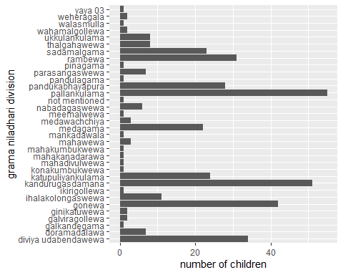

#Majority of the children who come up with this survey in Pallankulama.

### Comparison between Male and Female students

fish_consumption %>%  
ggplot(mapping = aes(x = Gender)) +  
geom_bar() +  
scale_x_discrete("Gender", labels = c("Male","Female")) +  
  
ylab("number of children") +  
theme_classic()

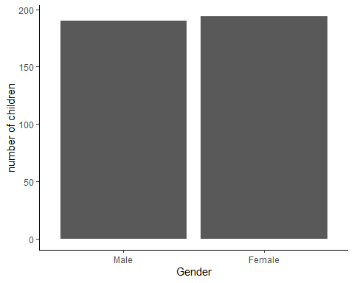

#Female students are highly responsed to this survey compare it with to male students.

### Academic Performance of both Male and Female students

fish_consumption %>%  
ggplot(mapping = aes(x = Gender))+  
geom_bar(aes(fill = Academic_performance), position = "dodge") +  
scale_x_discrete("Gender", labels = c("Male","Female") ) +  
labs(x = "Gender", y = "count",fill='Accademic_performance') +  
theme_bw()

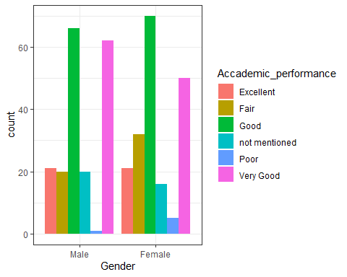

#Academic performance of both female and male students are looking good. But academic performance of male students are little bit lower than to the female students.

### Sea food availability of the divisions

fish_consumption %>%  
ggplot(mapping = aes(x = seafood_availability))+  
geom_bar(aes(fill = Division), position = "dodge") +  
scale_x_discrete("seafood_availability", labels = c("Yes","No","Maybe","Not mentioned") ) +  
labs(x = "seafood_availability", y = "count",fill='Division') +  
theme_bw()

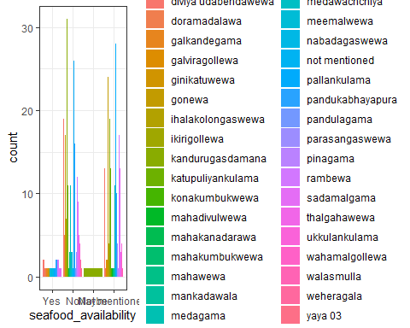

### Fish type according to the division

#Omit the data who didn't mentioned the fish type that contains in their divisions  
fish_consumption_1 <- filter(fish_consumption, fish_type != "Not mentioned")  
 select(fish_consumption_1, Division, fish_type)

## Division fish_type  
## 1 rambewa Tilapia  
## 2 rambewa Loolla  
## 3 sadamalgama Tilapia   
## 4 sadamalgama Tilapia   
## 5 gonewa Tilapia   
## 6 sadamalgama Tilapia   
## 7 gonewa Thilapiya  
## 8 gonewa Thilapiya  
## 9 gonewa THILAPIYA  
## 10 gonewa Thilapiya  
## 11 gonewa Thilapiya  
## 12 gonewa All  
## 13 pallankulama Korali, Loolla, Hunga  
## 14 walasmulla Korali  
## 15 rambewa Tilapia   
## 16 gonewa Talapath  
## 17 rambewa Thilapi  
## 18 pallankulama Loolla  
## 19 pallankulama Tilapia   
## 20 pallankulama Loolla, Korali  
## 21 pallankulama Korali  
## 22 diviya udabendawewa Tilapia   
## 23 diviya udabendawewa Loolla   
## 24 diviya udabendawewa Tilapia   
## 25 diviya udabendawewa Tilapia   
## 26 diviya udabendawewa Tilapia   
## 27 diviya udabendawewa Theppili   
## 28 diviya udabendawewa All  
## 29 diviya udabendawewa All  
## 30 diviya udabendawewa Loolla   
## 31 diviya udabendawewa Tilapia   
## 32 diviya udabendawewa Chicken  
## 33 diviya udabendawewa Loolla   
## 34 diviya udabendawewa Theppili   
## 35 diviya udabendawewa Theppili   
## 36 diviya udabendawewa Tilapia   
## 37 diviya udabendawewa Tilapia   
## 38 thalgahawewa Theppili   
## 39 pallankulama Tilapia   
## 40 rambewa Tilapia   
## 41 pallankulama Theppili   
## 42 pallankulama Kawayya  
## 43 pallankulama Tilapia   
## 44 diviya udabendawewa Loolla,Tilapia   
## 45 thalgahawewa Theppili   
## 46 pallankulama Hunga  
## 47 medawachchiya Loolla   
## 48 medawachchiya Loolla   
## 49 rambewa Tilapia   
## 50 pallankulama Loolla   
## 51 pallankulama Tilapia   
## 52 pallankulama Tilapia   
## 53 pallankulama Theppili   
## 54 diviya udabendawewa Theppili   
## 55 diviya udabendawewa Theppili   
## 56 diviya udabendawewa Tilapia   
## 57 thalgahawewa Loolla   
## 58 diviya udabendawewa Tilapia   
## 59 diviya udabendawewa Theppili   
## 60 diviya udabendawewa Tilapia   
## 61 thalgahawewa Tilapia   
## 62 diviya udabendawewa Loolla , Theppili   
## 63 diviya udabendawewa Tilapia   
## 64 gonewa Loolla   
## 65 gonewa Tilapia   
## 66 gonewa Tilapia   
## 67 gonewa Tilapia   
## 68 gonewa Tilapia   
## 69 diviya udabendawewa Tilapia   
## 70 pallankulama Tilapia   
## 71 gonewa Theppili   
## 72 gonewa Theppili   
## 73 gonewa Tilapia   
## 74 gonewa Tilapia   
## 75 gonewa Tilapia   
## 76 gonewa Tilapia   
## 77 gonewa Korali  
## 78 gonewa Tilapia   
## 79 thalgahawewa Theppili   
## 80 gonewa Tilapia   
## 81 gonewa Loolla   
## 82 gonewa Tilapia   
## 83 medagama Tilapia   
## 84 kandurugasdamana Tilapia   
## 85 medagama Tilapia   
## 86 medagama Tilapia   
## 87 medagama Loolla   
## 88 medagama Loolla and Theppili   
## 89 kandurugasdamana Loolla   
## 90 medagama Tilapia   
## 91 sadamalgama Theppili   
## 92 medagama Tilapia, Loolla, Pethiya   
## 93 medagama Tilapia   
## 94 kandurugasdamana Tilapia   
## 95 medagama Lellu  
## 96 parasangaswewa Theppili   
## 97 kandurugasdamana Tilapia, Loolla   
## 98 medagama Theppili   
## 99 medagama Korali  
## 100 medagama Tilapia, Loolla   
## 101 kandurugasdamana Tilapia  
## 102 medagama Loolla  
## 103 medagama Korali   
## 104 kandurugasdamana Tilapia  
## 105 katupuliyankulama Eggs  
## 106 katupuliyankulama Theppili   
## 107 doramadalawa Theppili   
## 108 sadamalgama Theppili  
## 109 pandukabhayapura Loolla,Theppili   
## 110 doramadalawa Tilapia  
## 111 sadamalgama Loolla   
## 112 ukkulankulama Theppili,Loolla   
## 113 rambewa Loolla   
## 114 pandukabhayapura Not specified spp.  
## 115 rambewa Theppili   
## 116 doramadalawa Theppili  
## 117 sadamalgama Loolla   
## 118 doramadalawa Tilapia   
## 119 yaya 03 Theppili   
## 120 pallankulama Loolla   
## 121 pandukabhayapura Tilapia   
## 122 katupuliyankulama Theppili   
## 123 kandurugasdamana Tilapia  
## 124 pallankulama Theppili  
## 125 pandukabhayapura Tilapia   
## 126 mahadivulwewa Tilapia   
## 127 not mentioned Korali  
## 128 doramadalawa Tilapia   
## 129 katupuliyankulama Theppili   
## 130 doramadalawa Theppili   
## 131 kandurugasdamana Theppili   
## 132 kandurugasdamana Tilapia   
## 133 katupuliyankulama Theppili   
## 134 parasangaswewa Tilapia   
## 135 katupuliyankulama Theppili   
## 136 katupuliyankulama Tilapia   
## 137 parasangaswewa Korali   
## 138 pandukabhayapura Kawayya  
## 139 kandurugasdamana Tilapia   
## 140 pandukabhayapura Loolla   
## 141 pandukabhayapura Theppili   
## 142 kandurugasdamana Tilapia   
## 143 kandurugasdamana Tilapia   
## 144 pandukabhayapura Loolla   
## 145 pandukabhayapura Loolla   
## 146 kandurugasdamana Theppili   
## 147 kandurugasdamana Theppili   
## 148 kandurugasdamana Tilapia   
## 149 pandukabhayapura Theppili   
## 150 kandurugasdamana Loolla   
## 151 pandukabhayapura Loolla   
## 152 kandurugasdamana Tilapia   
## 153 kandurugasdamana Tilapia   
## 154 kandurugasdamana Tilapia   
## 155 mahawewa Loolla   
## 156 kandurugasdamana Tilapia   
## 157 kandurugasdamana Theppili   
## 158 kandurugasdamana Tilapia   
## 159 pandukabhayapura Tilapia   
## 160 kandurugasdamana Tilapia   
## 161 sadamalgama Theppili   
## 162 wahamalgollewa Loolla   
## 163 parasangaswewa Theppili   
## 164 katupuliyankulama Theppili   
## 165 katupuliyankulama Theppili   
## 166 sadamalgama Tilapia   
## 167 sadamalgama Theppili   
## 168 pallankulama Theppili   
## 169 doramadalawa Tilapia   
## 170 pallankulama Theppili   
## 171 katupuliyankulama Korali   
## 172 parasangaswewa Loolla   
## 173 ihalakolongaswewa Korali   
## 174 katupuliyankulama Korali   
## 175 sadamalgama Kawayya   
## 176 sadamalgama Loolla   
## 177 weheragala Loolla   
## 178 rambewa Loolla   
## 179 pallankulama Korali   
## 180 pallankulama Theppili   
## 181 rambewa Loolla   
## 182 pallankulama Tilapia   
## 183 pallankulama Korali   
## 184 pallankulama Korali   
## 185 medawachchiya Loolla   
## 186 pallankulama Loolla   
## 187 ihalakolongaswewa Tilapia   
## 188 ihalakolongaswewa Tilapia   
## 189 ihalakolongaswewa Tilapia   
## 190 ihalakolongaswewa Theppili   
## 191 wahamalgollewa Theppili   
## 192 galviragollewa Loolla   
## 193 galviragollewa Tilapia   
## 194 ihalakolongaswewa Tilapia   
## 195 ihalakolongaswewa Kawayya   
## 196 pallankulama Theppili   
## 197 gonewa Tilapia   
## 198 mahakanadarawa Tilapia   
## 199 pallankulama Theppili   
## 200 ukkulankulama Korali   
## 201 rambewa Tilapia   
## 202 nabadagaswewa Tilapia & Theppili   
## 203 ikirigollewa Korali   
## 204 rambewa Theppili   
## 205 rambewa Tilapia   
## 206 rambewa Tilapia   
## 207 pallankulama Tilapia   
## 208 nabadagaswewa All  
## 209 nabadagaswewa Tilapia   
## 210 gonewa Tilapia   
## 211 nabadagaswewa Loolla   
## 212 sadamalgama Theppili   
## 213 galkandegama Theppili,Loolla,Tilapia   
## 214 meemalwewa All  
## 215 rambewa Loolla   
## 216 pallankulama Theppili   
## 217 sadamalgama Tilapia   
## 218 nabadagaswewa Korali   
## 219 ukkulankulama Tilapia   
## 220 pallankulama Korali   
## 221 diviya udabendawewa Tilapia   
## 222 pallankulama Korali   
## 223 ukkulankulama Kawayya   
## 224 weheragala Hunga

table_1 <- table(fish_type, Division)  
table_1

## Division  
## fish_type diviya udabendawewa doramadalawa galkandegama  
## All 2 0 0  
## Chicken 1 0 0  
## Eggs 0 0 0  
## Hunga 0 0 0  
## Hunga 0 0 0  
## Kawayya 0 0 0  
## Kawayya 0 0 0  
## Korali 0 0 0  
## Korali 0 0 0  
## Korali, Loolla, Hunga 0 0 0  
## Lellu 0 0 0  
## Loolla 0 0 0  
## Loolla 3 0 0  
## Loolla , Theppili 1 0 0  
## Loolla and Theppili 0 0 0  
## Loolla, Korali 0 0 0  
## Loolla,Theppili 0 0 0  
## Loolla,Tilapia 1 0 0  
## Not mentioned 7 0 0  
## Not specified spp. 0 0 0  
## Talapath 0 0 0  
## Theppili 0 1 0  
## Theppili 6 2 0  
## Theppili,Loolla 0 0 0  
## Theppili,Loolla,Tilapia 0 0 1  
## Thilapi 0 0 0  
## Thilapiya 0 0 0  
## THILAPIYA 0 0 0  
## Tilapia 0 1 0  
## Tilapia 13 3 0  
## Tilapia & Theppili 0 0 0  
## Tilapia, Loolla 0 0 0  
## Tilapia, Loolla, Pethiya 0 0 0  
## Division  
## fish_type galviragollewa ginikatuwewa gonewa  
## All 0 0 1  
## Chicken 0 0 0  
## Eggs 0 0 0  
## Hunga 0 0 0  
## Hunga 0 0 0  
## Kawayya 0 0 0  
## Kawayya 0 0 0  
## Korali 0 0 1  
## Korali 0 0 0  
## Korali, Loolla, Hunga 0 0 0  
## Lellu 0 0 0  
## Loolla 0 0 0  
## Loolla 1 0 2  
## Loolla , Theppili 0 0 0  
## Loolla and Theppili 0 0 0  
## Loolla, Korali 0 0 0  
## Loolla,Theppili 0 0 0  
## Loolla,Tilapia 0 0 0  
## Not mentioned 0 2 16  
## Not specified spp. 0 0 0  
## Talapath 0 0 1  
## Theppili 0 0 0  
## Theppili 0 0 2  
## Theppili,Loolla 0 0 0  
## Theppili,Loolla,Tilapia 0 0 0  
## Thilapi 0 0 0  
## Thilapiya 0 0 4  
## THILAPIYA 0 0 1  
## Tilapia 0 0 0  
## Tilapia 1 0 14  
## Tilapia & Theppili 0 0 0  
## Tilapia, Loolla 0 0 0  
## Tilapia, Loolla, Pethiya 0 0 0  
## Division  
## fish_type ihalakolongaswewa ikirigollewa kandurugasdamana  
## All 0 0 0  
## Chicken 0 0 0  
## Eggs 0 0 0  
## Hunga 0 0 0  
## Hunga 0 0 0  
## Kawayya 0 0 0  
## Kawayya 1 0 0  
## Korali 0 0 0  
## Korali 1 1 0  
## Korali, Loolla, Hunga 0 0 0  
## Lellu 0 0 0  
## Loolla 0 0 0  
## Loolla 0 0 2  
## Loolla , Theppili 0 0 0  
## Loolla and Theppili 0 0 0  
## Loolla, Korali 0 0 0  
## Loolla,Theppili 0 0 0  
## Loolla,Tilapia 0 0 0  
## Not mentioned 4 0 28  
## Not specified spp. 0 0 0  
## Talapath 0 0 0  
## Theppili 0 0 0  
## Theppili 1 0 4  
## Theppili,Loolla 0 0 0  
## Theppili,Loolla,Tilapia 0 0 0  
## Thilapi 0 0 0  
## Thilapiya 0 0 0  
## THILAPIYA 0 0 0  
## Tilapia 0 0 3  
## Tilapia 4 0 13  
## Tilapia & Theppili 0 0 0  
## Tilapia, Loolla 0 0 1  
## Tilapia, Loolla, Pethiya 0 0 0  
## Division  
## fish_type katupuliyankulama konakumbukwewa mahadivulwewa  
## All 0 0 0  
## Chicken 0 0 0  
## Eggs 1 0 0  
## Hunga 0 0 0  
## Hunga 0 0 0  
## Kawayya 0 0 0  
## Kawayya 0 0 0  
## Korali 0 0 0  
## Korali 2 0 0  
## Korali, Loolla, Hunga 0 0 0  
## Lellu 0 0 0  
## Loolla 0 0 0  
## Loolla 0 0 0  
## Loolla , Theppili 0 0 0  
## Loolla and Theppili 0 0 0  
## Loolla, Korali 0 0 0  
## Loolla,Theppili 0 0 0  
## Loolla,Tilapia 0 0 0  
## Not mentioned 13 1 0  
## Not specified spp. 0 0 0  
## Talapath 0 0 0  
## Theppili 0 0 0  
## Theppili 7 0 0  
## Theppili,Loolla 0 0 0  
## Theppili,Loolla,Tilapia 0 0 0  
## Thilapi 0 0 0  
## Thilapiya 0 0 0  
## THILAPIYA 0 0 0  
## Tilapia 0 0 0  
## Tilapia 1 0 1  
## Tilapia & Theppili 0 0 0  
## Tilapia, Loolla 0 0 0  
## Tilapia, Loolla, Pethiya 0 0 0  
## Division  
## fish_type mahakanadarawa mahakumbukwewa mahawewa mankadawala  
## All 0 0 0 0  
## Chicken 0 0 0 0  
## Eggs 0 0 0 0  
## Hunga 0 0 0 0  
## Hunga 0 0 0 0  
## Kawayya 0 0 0 0  
## Kawayya 0 0 0 0  
## Korali 0 0 0 0  
## Korali 0 0 0 0  
## Korali, Loolla, Hunga 0 0 0 0  
## Lellu 0 0 0 0  
## Loolla 0 0 0 0  
## Loolla 0 0 1 0  
## Loolla , Theppili 0 0 0 0  
## Loolla and Theppili 0 0 0 0  
## Loolla, Korali 0 0 0 0  
## Loolla,Theppili 0 0 0 0  
## Loolla,Tilapia 0 0 0 0  
## Not mentioned 0 1 2 1  
## Not specified spp. 0 0 0 0  
## Talapath 0 0 0 0  
## Theppili 0 0 0 0  
## Theppili 0 0 0 0  
## Theppili,Loolla 0 0 0 0  
## Theppili,Loolla,Tilapia 0 0 0 0  
## Thilapi 0 0 0 0  
## Thilapiya 0 0 0 0  
## THILAPIYA 0 0 0 0  
## Tilapia 0 0 0 0  
## Tilapia 1 0 0 0  
## Tilapia & Theppili 0 0 0 0  
## Tilapia, Loolla 0 0 0 0  
## Tilapia, Loolla, Pethiya 0 0 0 0  
## Division  
## fish_type medagama medawachchiya meemalwewa nabadagaswewa  
## All 0 0 1 1  
## Chicken 0 0 0 0  
## Eggs 0 0 0 0  
## Hunga 0 0 0 0  
## Hunga 0 0 0 0  
## Kawayya 0 0 0 0  
## Kawayya 0 0 0 0  
## Korali 1 0 0 0  
## Korali 1 0 0 1  
## Korali, Loolla, Hunga 0 0 0 0  
## Lellu 1 0 0 0  
## Loolla 1 0 0 0  
## Loolla 1 3 0 1  
## Loolla , Theppili 0 0 0 0  
## Loolla and Theppili 1 0 0 0  
## Loolla, Korali 0 0 0 0  
## Loolla,Theppili 0 0 0 0  
## Loolla,Tilapia 0 0 0 0  
## Not mentioned 8 0 0 1  
## Not specified spp. 0 0 0 0  
## Talapath 0 0 0 0  
## Theppili 0 0 0 0  
## Theppili 1 0 0 0  
## Theppili,Loolla 0 0 0 0  
## Theppili,Loolla,Tilapia 0 0 0 0  
## Thilapi 0 0 0 0  
## Thilapiya 0 0 0 0  
## THILAPIYA 0 0 0 0  
## Tilapia 0 0 0 0  
## Tilapia 5 0 0 1  
## Tilapia & Theppili 0 0 0 1  
## Tilapia, Loolla 1 0 0 0  
## Tilapia, Loolla, Pethiya 1 0 0 0  
## Division  
## fish_type not mentioned pallankulama pandukabhayapura  
## All 0 0 0  
## Chicken 0 0 0  
## Eggs 0 0 0  
## Hunga 0 1 0  
## Hunga 0 0 0  
## Kawayya 0 1 1  
## Kawayya 0 0 0  
## Korali 1 1 0  
## Korali 0 5 0  
## Korali, Loolla, Hunga 0 1 0  
## Lellu 0 0 0  
## Loolla 0 1 0  
## Loolla 0 3 4  
## Loolla , Theppili 0 0 0  
## Loolla and Theppili 0 0 0  
## Loolla, Korali 0 1 0  
## Loolla,Theppili 0 0 1  
## Loolla,Tilapia 0 0 0  
## Not mentioned 0 24 16  
## Not specified spp. 0 0 1  
## Talapath 0 0 0  
## Theppili 0 1 0  
## Theppili 0 8 2  
## Theppili,Loolla 0 0 0  
## Theppili,Loolla,Tilapia 0 0 0  
## Thilapi 0 0 0  
## Thilapiya 0 0 0  
## THILAPIYA 0 0 0  
## Tilapia 0 0 0  
## Tilapia 0 8 3  
## Tilapia & Theppili 0 0 0  
## Tilapia, Loolla 0 0 0  
## Tilapia, Loolla, Pethiya 0 0 0  
## Division  
## fish_type pandulagama parasangaswewa pinagama rambewa  
## All 0 0 0 0  
## Chicken 0 0 0 0  
## Eggs 0 0 0 0  
## Hunga 0 0 0 0  
## Hunga 0 0 0 0  
## Kawayya 0 0 0 0  
## Kawayya 0 0 0 0  
## Korali 0 0 0 0  
## Korali 0 1 0 0  
## Korali, Loolla, Hunga 0 0 0 0  
## Lellu 0 0 0 0  
## Loolla 0 0 0 1  
## Loolla 0 1 0 4  
## Loolla , Theppili 0 0 0 0  
## Loolla and Theppili 0 0 0 0  
## Loolla, Korali 0 0 0 0  
## Loolla,Theppili 0 0 0 0  
## Loolla,Tilapia 0 0 0 0  
## Not mentioned 1 2 1 16  
## Not specified spp. 0 0 0 0  
## Talapath 0 0 0 0  
## Theppili 0 0 0 0  
## Theppili 0 2 0 2  
## Theppili,Loolla 0 0 0 0  
## Theppili,Loolla,Tilapia 0 0 0 0  
## Thilapi 0 0 0 1  
## Thilapiya 0 0 0 0  
## THILAPIYA 0 0 0 0  
## Tilapia 0 0 0 1  
## Tilapia 0 1 0 6  
## Tilapia & Theppili 0 0 0 0  
## Tilapia, Loolla 0 0 0 0  
## Tilapia, Loolla, Pethiya 0 0 0 0  
## Division  
## fish_type sadamalgama thalgahawewa ukkulankulama  
## All 0 0 0  
## Chicken 0 0 0  
## Eggs 0 0 0  
## Hunga 0 0 0  
## Hunga 0 0 0  
## Kawayya 0 0 0  
## Kawayya 1 0 1  
## Korali 0 0 0  
## Korali 0 0 1  
## Korali, Loolla, Hunga 0 0 0  
## Lellu 0 0 0  
## Loolla 0 0 0  
## Loolla 3 1 0  
## Loolla , Theppili 0 0 0  
## Loolla and Theppili 0 0 0  
## Loolla, Korali 0 0 0  
## Loolla,Theppili 0 0 0  
## Loolla,Tilapia 0 0 0  
## Not mentioned 9 3 4  
## Not specified spp. 0 0 0  
## Talapath 0 0 0  
## Theppili 1 0 0  
## Theppili 4 3 0  
## Theppili,Loolla 0 0 1  
## Theppili,Loolla,Tilapia 0 0 0  
## Thilapi 0 0 0  
## Thilapiya 0 0 0  
## THILAPIYA 0 0 0  
## Tilapia 0 0 0  
## Tilapia 5 1 1  
## Tilapia & Theppili 0 0 0  
## Tilapia, Loolla 0 0 0  
## Tilapia, Loolla, Pethiya 0 0 0  
## Division  
## fish_type wahamalgollewa walasmulla weheragala yaya 03  
## All 0 0 0 0  
## Chicken 0 0 0 0  
## Eggs 0 0 0 0  
## Hunga 0 0 0 0  
## Hunga 0 0 1 0  
## Kawayya 0 0 0 0  
## Kawayya 0 0 0 0  
## Korali 0 1 0 0  
## Korali 0 0 0 0  
## Korali, Loolla, Hunga 0 0 0 0  
## Lellu 0 0 0 0  
## Loolla 0 0 0 0  
## Loolla 1 0 1 0  
## Loolla , Theppili 0 0 0 0  
## Loolla and Theppili 0 0 0 0  
## Loolla, Korali 0 0 0 0  
## Loolla,Theppili 0 0 0 0  
## Loolla,Tilapia 0 0 0 0  
## Not mentioned 0 0 0 0  
## Not specified spp. 0 0 0 0  
## Talapath 0 0 0 0  
## Theppili 0 0 0 0  
## Theppili 1 0 0 1  
## Theppili,Loolla 0 0 0 0  
## Theppili,Loolla,Tilapia 0 0 0 0  
## Thilapi 0 0 0 0  
## Thilapiya 0 0 0 0  
## THILAPIYA 0 0 0 0  
## Tilapia 0 0 0 0  
## Tilapia 0 0 0 0  
## Tilapia & Theppili 0 0 0 0  
## Tilapia, Loolla 0 0 0 0  
## Tilapia, Loolla, Pethiya 0 0 0 0

ggplot(fish_consumption_1, aes(x = fish_type)) +  
 geom_bar() +  
 xlab("fish type") +  
 ylab("Frequency") +  
 ggtitle("Bar Plot for ythe fish_type") + scale_x_discrete(guide = guide_axis(n.dodge=5))

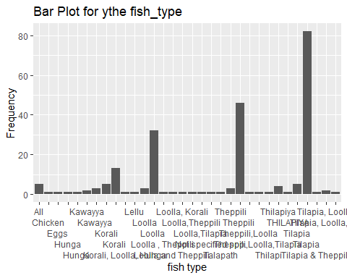

### The relationship between Age and Weight

#eliminate the data who not mentioned their weights  
fish_consumption_2 <- filter(fish_consumption, Weight != "not mentioned")  
 select(fish_consumption_2, Age, Weight)

## Age Weight  
## 1 10.0 28  
## 2 5.0 21.4  
## 3 8.0 35  
## 4 5.0 18  
## 5 4.0 6.5  
## 6 7.0 21  
## 7 10.0 22  
## 8 5.0 13  
## 9 9.0 24  
## 10 8.0 20  
## 11 7.0 18  
## 12 8.0 17  
## 13 8.0 18  
## 14 8.0 14  
## 15 10.0 30  
## 16 4.0 7  
## 17 7.0 24.7  
## 18 3.0 10  
## 19 6.0 18  
## 20 8.0 15  
## 21 5.0 18  
## 22 3.0 10  
## 23 6.0 22  
## 24 6.0 18  
## 25 9.0 16  
## 26 7.0 19  
## 27 9.0 18  
## 28 7.0 16  
## 29 10.0 29  
## 30 9.0 35  
## 31 9.0 19  
## 32 9.0 15  
## 33 9.0 30  
## 34 6.0 17  
## 35 10.0 25  
## 36 7.0 18  
## 37 7.0 16  
## 38 7.0 15  
## 39 7.0 22  
## 40 7.0 17.5  
## 41 7.0 20  
## 42 8.0 32  
## 43 7.0 16.5  
## 44 8.0 15  
## 45 5.0 15  
## 46 10.0 21.6  
## 47 4.0 10.2  
## 48 10.0 22.2  
## 49 5.0 16  
## 50 4.0 14.25  
## 51 7.0 33.5  
## 52 7.0 14  
## 53 9.0 21.1  
## 54 9.0 27  
## 55 5.0 16  
## 56 4.5 13.3  
## 57 4.0 16.3  
## 58 9.0 25  
## 59 9.0 14.7  
## 60 9.0 25  
## 61 9.0 33  
## 62 6.0 14.8  
## 63 3.0 13.2  
## 64 4.0 14.2  
## 65 5.0 14.8  
## 66 5.0 13  
## 67 4.0 12.8  
## 68 5.0 12.6  
## 69 3.5 11  
## 70 4.0 14.9  
## 71 4.0 14.5  
## 72 4.0 11.8  
## 73 4.0 15.5  
## 74 5.0 18.2  
## 75 5.0 14.8  
## 76 4.0 12.9  
## 77 5.0 14.4  
## 78 8.0 24  
## 79 5.0 16  
## 80 9.0 22.9  
## 81 9.0 24  
## 82 6.0 20  
## 83 9.0 43  
## 84 6.0 17  
## 85 8.0 26  
## 86 9.0 17  
## 87 9.0 20  
## 88 10.0 23  
## 89 7.0 21  
## 90 7.0 16  
## 91 6.0 15  
## 92 9.0 23  
## 93 10.0 35  
## 94 8.0 21  
## 95 8.0 20  
## 96 6.0 16  
## 97 8.0 22  
## 98 7.0 14  
## 99 8.0 20  
## 100 6.0 15.3  
## 101 7.0 20  
## 102 9.0 33  
## 103 5.0 16  
## 104 10.0 19.5  
## 105 10.0 19  
## 106 8.0 16  
## 107 10.0 27  
## 108 8.0 20  
## 109 10.0 27  
## 110 6.0 14  
## 111 5.0 15  
## 112 10.0 25  
## 113 9.0 21  
## 114 8.0 21.5  
## 115 8.0 19  
## 116 8.0 23  
## 117 7.0 17  
## 118 8.0 28  
## 119 8.0 20  
## 120 7.0 19  
## 121 7.0 18  
## 122 7.0 17  
## 123 7.0 17  
## 124 7.0 13.5  
## 125 4.0 18.5  
## 126 4.0 12.5  
## 127 5.0 17  
## 128 9.0 18  
## 129 9.0 15  
## 130 9.0 15  
## 131 8.0 21  
## 132 8.0 20  
## 133 5.0 13  
## 134 6.0 15  
## 135 8.0 28  
## 136 8.0 18  
## 137 9.0 20  
## 138 9.0 30  
## 139 8.0 30  
## 140 8.0 18  
## 141 8.0 22  
## 142 8.0 25  
## 143 9.0 21.5  
## 144 8.0 20  
## 145 8.0 15  
## 146 7.0 16  
## 147 7.0 23  
## 148 6.0 24  
## 149 4.0 16  
## 150 5.0 14  
## 151 7.0 13  
## 152 7.0 21  
## 153 7.0 21  
## 154 9.0 32  
## 155 10.0 40  
## 156 10.0 28  
## 157 10.0 30  
## 158 10.0 20  
## 159 9.0 19  
## 160 10.0 22  
## 161 10.0 21  
## 162 8.0 23  
## 163 7.0 20  
## 164 7.0 20  
## 165 9.0 35  
## 166 6.0 12  
## 167 6.0 18  
## 168 9.0 24  
## 169 10.0 31  
## 170 10.0 15  
## 171 9.0 20  
## 172 10.0 22  
## 173 10.0 22  
## 174 4.0 14.6  
## 175 8.0 23  
## 176 4.0 11  
## 177 10.0 21  
## 178 4.0 14.7  
## 179 4.0 12.5  
## 180 5.0 14  
## 181 9.0 21  
## 182 9.0 28  
## 183 9.0 20  
## 184 8.0 20.2  
## 185 9.0 22  
## 186 9.0 22  
## 187 9.0 21  
## 188 10.0 25  
## 189 5.0 15.5  
## 190 5.0 15.3  
## 191 4.0 15.5  
## 192 4.0 14.1  
## 193 5.0 19  
## 194 4.0 16.4  
## 195 3.0 12.7  
## 196 10.0 17  
## 197 3.0 10.3  
## 198 6.0 21  
## 199 6.0 27  
## 200 9.0 23  
## 201 9.0 24  
## 202 9.0 20  
## 203 9.0 18  
## 204 9.0 27  
## 205 8.0 26  
## 206 6.0 15  
## 207 5.0 25  
## 208 6.0 17  
## 209 7.0 21  
## 210 7.0 18  
## 211 7.0 19  
## 212 7.0 17  
## 213 7.0 25  
## 214 7.0 17  
## 215 7.0 15  
## 216 7.0 20  
## 217 7.0 19  
## 218 10.0 22  
## 219 7.0 17  
## 220 6.0 18  
## 221 6.0 17  
## 222 6.0 21  
## 223 5.0 16  
## 224 9.0 25  
## 225 10.0 24  
## 226 10.0 19  
## 227 10.0 20  
## 228 8.0 25  
## 229 5.0 18  
## 230 10.0 24  
## 231 8.0 22  
## 232 8.0 20  
## 233 10.0 25  
## 234 10.0 27  
## 235 9.0 19  
## 236 4.0 16  
## 237 5.0 21  
## 238 10.0 28  
## 239 3.0 7  
## 240 5.0 14.5  
## 241 4.0 15.8  
## 242 4.0 12.6  
## 243 8.0 21  
## 244 9.0 25  
## 245 9.0 28  
## 246 9.0 16  
## 247 6.0 23  
## 248 6.0 16  
## 249 3.0 15  
## 250 5.0 18.1  
## 251 4.0 14.8  
## 252 4.0 14  
## 253 4.0 13  
## 254 4.0 12.8  
## 255 4.0 14.5  
## 256 8.0 24  
## 257 8.0 23  
## 258 8.0 26  
## 259 8.0 20  
## 260 7.0 17  
## 261 7.0 16.5  
## 262 4.0 14  
## 263 5.0 24.5  
## 264 5.0 12.8  
## 265 8.0 23  
## 266 9.0 16  
## 267 6.0 17  
## 268 6.0 16  
## 269 5.0 13.5  
## 270 6.0 18  
## 271 6.0 15  
## 272 6.0 20  
## 273 6.0 21  
## 274 9.0 21  
## 275 7.0 18  
## 276 8.0 19  
## 277 8.0 16  
## 278 7.0 25  
## 279 4.0 14  
## 280 6.0 17  
## 281 8.0 23  
## 282 4.0 14.8  
## 283 7.0 14  
## 284 10.0 21  
## 285 5.0 12  
## 286 6.0 18  
## 287 7.0 13  
## 288 7.0 19  
## 289 4.0 10.5  
## 290 4.0 11.7  
## 291 4.0 12.5  
## 292 5.0 14  
## 293 3.0 13.3  
## 294 4.0 14  
## 295 5.0 15  
## 296 4.0 14  
## 297 3.0 14.2  
## 298 4.0 15.5  
## 299 3.0 11  
## 300 3.0 12.2  
## 301 3.0 11  
## 302 3.0 10.9  
## 303 5.0 14.5  
## 304 5.0 17  
## 305 4.0 11  
## 306 4.0 15  
## 307 5.0 17  
## 308 5.0 14.6  
## 309 3.0 13.9  
## 310 3.0 13.2  
## 311 5.0 16.6  
## 312 4.0 15.9  
## 313 5.0 15  
## 314 5.0 16.3  
## 315 4.0 13.2  
## 316 4.0 14  
## 317 4.0 13.9  
## 318 4.0 15.2  
## 319 4.0 14.1  
## 320 3.0 15.6  
## 321 4.0 13.2  
## 322 4.0 13.5  
## 323 5.0 22  
## 324 4.0 19  
## 325 6.0 25  
## 326 7.0 31  
## 327 8.0 33  
## 328 5.0 20  
## 329 3.0 12  
## 330 7.0 31  
## 331 8.0 25  
## 332 7.0 31  
## 333 8.0 32.5  
## 334 5.0 19  
## 335 4.0 15  
## 336 5.0 13  
## 337 4.0 13  
## 338 5.0 25

#Convert Age and Weight as numeric values  
{fish_consumption_2$Age <- as.numeric(fish_consumption_2$Age)  
fish_consumption_2$Weight <- as.numeric(fish_consumption_2$Weight)}  
   
#Plot Age aganist the Weight   
plot(fish_consumption_2$Age, fish_consumption_2$Weight, xlab = "Age", ylab = "Weight", main = "Age vs. Weight")

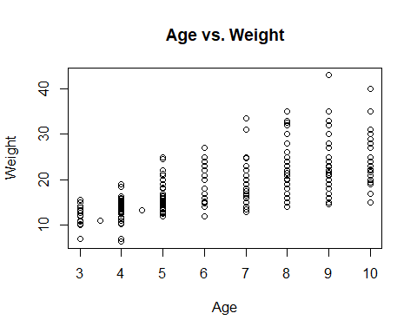

#Calculate the correlation coefficient  
correlation <- cor(fish_consumption_2$Age, fish_consumption_2$Weight)  
correlation

## [1] 0.6656333

#By looking at the plot and correlation coefficient, there is a modarate positive relationship between Age and Weight of the students in this division.

### Eat or not freshwater fish

# Calculate the frequencies of "yes" and "no"  
counts <- table(eat_freshwater_fish)  
  
# Assign colors to each category  
colors <- c("red", "green")  
  
# Create a pie chart with counts and colored segments  
pie(counts, labels = paste(names(counts), "(", counts, ")"),   
 main = "Pie chart for the preference of freshwater fish", col = colors)

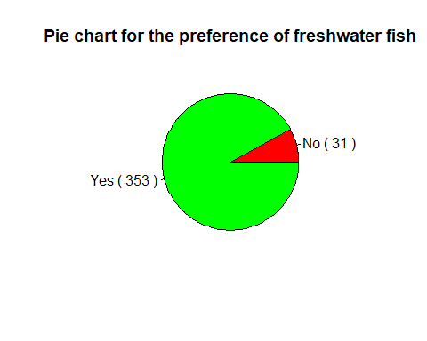

### Sea food availability

# Calculate the frequencies of each state  
availability_counts <- table(seafood_availability)  
  
# Create a stacked bar plot  
barplot(availability_counts, col = rainbow(length(availability_counts)),   
 xlab = "Availabilty", ylab = "Count", main = "Sea food availability of this division")

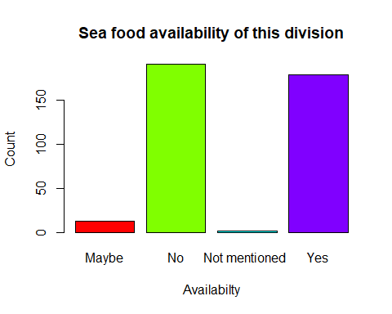

### Sea food buying places

# Calculate the frequencies of each buying place  
buying_place_counts <- table(buying_place)  
  
# Create a bar plot  
barplot(buying_place_counts, col = rainbow(length(buying_place_counts)),   
 xlab = "Buying Place", ylab = "Count", main = "Buying Places of Seafood")

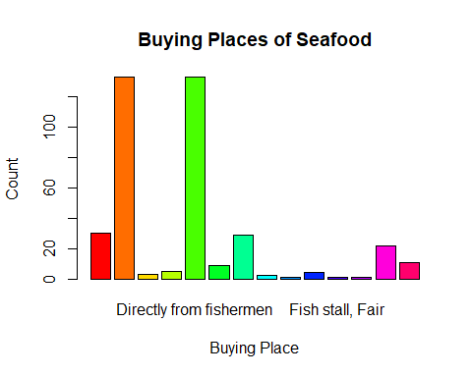

### Allergy distribution

# Calculate the frequencies of each response  
allergy_counts <- table(allergies)  
  
# Create a horizontal bar plot  
barplot(allergy_counts, horiz = FALSE, col = c("green", "red","yellow"),  
 xlab = "Count", ylab = "Allergy Status", main = "Allergy Distribution")

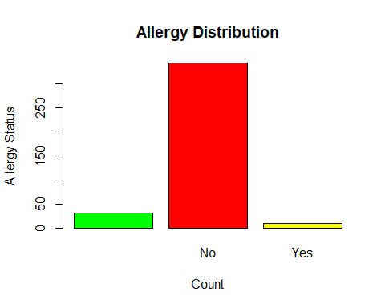

### Identify the Allergy Species

#Omit the data who didn't mentioned the fish type that contains in their divisions  
fish_consumption_3 <- filter(fish_consumption, allergies == "Yes")  
 select(fish_consumption_3, allergies, allergy_species, symptoms)

## allergies allergy_species symptoms  
## 1 Yes Hunga Hives  
## 2 Yes Itching  
## 3 Yes Vomiting  
## 4 Yes   
## 5 Yes Vomiting, Bloating  
## 6 Yes Vomiting, Bloating   
## 7 Yes   
## 8 Yes   
## 9 Yes   
## 10 Yes

table_3 <- table(allergies, allergy_species)  
table_3

## allergy_species  
## allergies Hunga  
## 31 0  
## No 343 0  
## Yes 9 1

table_4 <- table(allergies, allergy_species, symptoms)  
table_4

## , , symptoms =   
##   
## allergy_species  
## allergies Hunga  
## 31 0  
## No 343 0  
## Yes 5 0  
##   
## , , symptoms = Hives  
##   
## allergy_species  
## allergies Hunga  
## 0 0  
## No 0 0  
## Yes 0 1  
##   
## , , symptoms = Itching  
##   
## allergy_species  
## allergies Hunga  
## 0 0  
## No 0 0  
## Yes 1 0  
##   
## , , symptoms = Vomiting  
##   
## allergy_species  
## allergies Hunga  
## 0 0  
## No 0 0  
## Yes 1 0  
##   
## , , symptoms = Vomiting, Bloating  
##   
## allergy_species  
## allergies Hunga  
## 0 0  
## No 0 0  
## Yes 1 0  
##   
## , , symptoms = Vomiting, Bloating   
##   
## allergy_species  
## allergies Hunga  
## 0 0  
## No 0 0  
## Yes 1 0

#The one and olny allergy species is Hunga

### Increasing barriers

# Calculate the frequencies of each buying place  
barriers_counts <- table(increasing_barriers)  
  
# Create a bar plot  
barplot(barriers_counts, col = rainbow(length(barriers_counts)),   
 xlab = "Increasing barriers", ylab = "Count", main = "Increasing barriers")

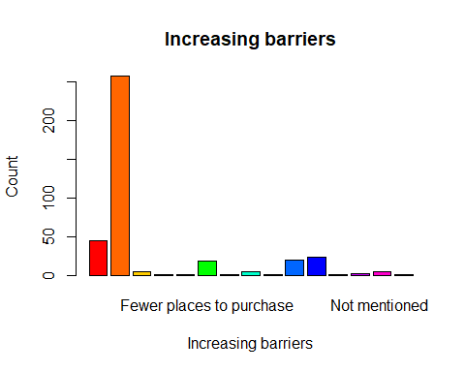

### Reasons

ggplot(fish_consumption, aes(x=reorder(reason, reason, function(x)-length(x)))) +  
 geom_bar(fill='pink') +   
 labs(x='Reason') +  
 scale_x_discrete(guide = guide_axis(n.dodge=5))

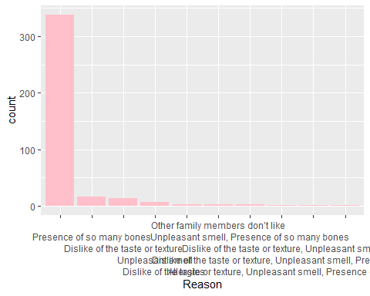

### Avarage freshwater fish consumption vs Time range

counts <- table(fish_consumption$time_range, fish_consumption$avg_amount)  
mosaicplot(counts, xlab='Time range', ylab='Avarage amount per day',main='Avarage freshwater fish consumption vs Time range', col='orange')

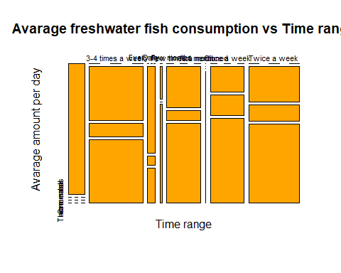

### Why does the child prefer freshwater fish ?

# Calculate the frequencies of each reason to prefer  
reason_to_prefer_counts <- table(reason_to_prefer)  
  
# Create a bar plot  
barplot(reason_to_prefer_counts, col = rainbow(length(reason_to_prefer_counts)),   
 xlab = "child's prefer", ylab = "Count", main = "Why does the child prefer freshwater fish ?")

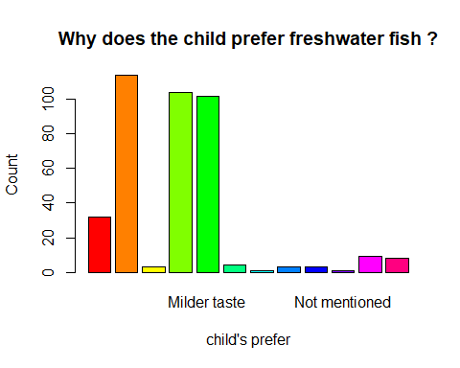

### Amount of freshwater fish consumed change over the last 3 years

ggplot(fish_consumption, aes(x = consumption_changing)) +  
 geom_bar() +  
 xlab("Changes of consumption") +  
 ylab("Frequency") +  
 ggtitle("Amount of freshwater fish consumed change over the last 3 years")

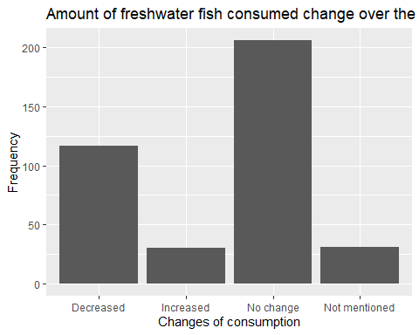

### Amount of freshwater fish consumed change over the last 3 years

# Create a list of values for each category  
values <- table(consumption_changing)  
  
# Calculate the percentages  
percentages = 100 * values / sum(values)  
percentages = round(percentages, 2)  
  
# Add the percentages to the bars  
text(x=barplot(values), y=percentages, labels=paste0(percentages, "%"), cex=0.5)

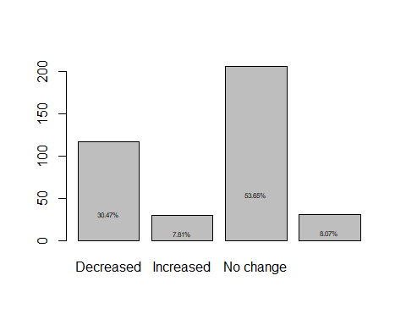

### Average freshwater fish consumption vs Time range

counts <- table(fish_consumption$reason_to_change,fish_consumption$consumption_changing)  
  
mosaicplot(counts, xlab='Time range', ylab='Average amount per day',main='Average freshwater fish consumption vs Time range', col='orange')

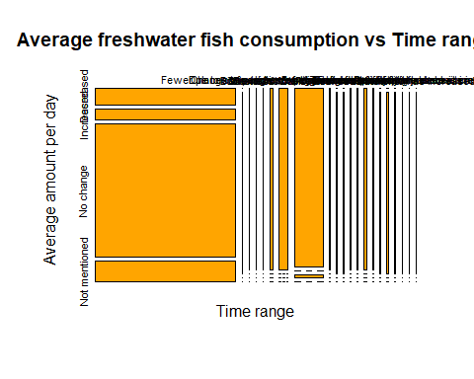

### Decremented of the fish consumption and reasons

fish_consumption_3 <- filter(fish_consumption, consumption_changing == "Decreased")  
 select(fish_consumption_3, consumption_changing, reason_to_change)

## consumption_changing  
## 1 Decreased  
## 2 Decreased  
## 3 Decreased  
## 4 Decreased  
## 5 Decreased  
## 6 Decreased  
## 7 Decreased  
## 8 Decreased  
## 9 Decreased  
## 10 Decreased  
## 11 Decreased  
## 12 Decreased  
## 13 Decreased  
## 14 Decreased  
## 15 Decreased  
## 16 Decreased  
## 17 Decreased  
## 18 Decreased  
## 19 Decreased  
## 20 Decreased  
## 21 Decreased  
## 22 Decreased  
## 23 Decreased  
## 24 Decreased  
## 25 Decreased  
## 26 Decreased  
## 27 Decreased  
## 28 Decreased  
## 29 Decreased  
## 30 Decreased  
## 31 Decreased  
## 32 Decreased  
## 33 Decreased  
## 34 Decreased  
## 35 Decreased  
## 36 Decreased  
## 37 Decreased  
## 38 Decreased  
## 39 Decreased  
## 40 Decreased  
## 41 Decreased  
## 42 Decreased  
## 43 Decreased  
## 44 Decreased  
## 45 Decreased  
## 46 Decreased  
## 47 Decreased  
## 48 Decreased  
## 49 Decreased  
## 50 Decreased  
## 51 Decreased  
## 52 Decreased  
## 53 Decreased  
## 54 Decreased  
## 55 Decreased  
## 56 Decreased  
## 57 Decreased  
## 58 Decreased  
## 59 Decreased  
## 60 Decreased  
## 61 Decreased  
## 62 Decreased  
## 63 Decreased  
## 64 Decreased  
## 65 Decreased  
## 66 Decreased  
## 67 Decreased  
## 68 Decreased  
## 69 Decreased  
## 70 Decreased  
## 71 Decreased  
## 72 Decreased  
## 73 Decreased  
## 74 Decreased  
## 75 Decreased  
## 76 Decreased  
## 77 Decreased  
## 78 Decreased  
## 79 Decreased  
## 80 Decreased  
## 81 Decreased  
## 82 Decreased  
## 83 Decreased  
## 84 Decreased  
## 85 Decreased  
## 86 Decreased  
## 87 Decreased  
## 88 Decreased  
## 89 Decreased  
## 90 Decreased  
## 91 Decreased  
## 92 Decreased  
## 93 Decreased  
## 94 Decreased  
## 95 Decreased  
## 96 Decreased  
## 97 Decreased  
## 98 Decreased  
## 99 Decreased  
## 100 Decreased  
## 101 Decreased  
## 102 Decreased  
## 103 Decreased  
## 104 Decreased  
## 105 Decreased  
## 106 Decreased  
## 107 Decreased  
## 108 Decreased  
## 109 Decreased  
## 110 Decreased  
## 111 Decreased  
## 112 Decreased  
## 113 Decreased  
## 114 Decreased  
## 115 Decreased  
## 116 Decreased  
## 117 Decreased  
## reason_to_change  
## 1 High consumption of other animal sources  
## 2 Expensive   
## 3 Inflation   
## 4 Expensive   
## 5 Expensive   
## 6 Expensive   
## 7 Expensive   
## 8 Expensive   
## 9 Expensive   
## 10 Economic Difficulties   
## 11 Expensive   
## 12   
## 13 Less availability   
## 14 Economic Difficulties   
## 15   
## 16 Expensive   
## 17 Economic Difficulties   
## 18   
## 19 Expensive   
## 20 Economic Difficulties   
## 21 Expensive   
## 22   
## 23 Economic Difficulties   
## 24 Due to consumption of eggs  
## 25 Economic Difficulties   
## 26 Economic Difficulties   
## 27 Expensive   
## 28   
## 29 Economic Difficulties   
## 30 Economic Difficulties   
## 31 Inflation   
## 32   
## 33 Expensive   
## 34 Expensive   
## 35   
## 36   
## 37 Inflation   
## 38 Expensive   
## 39   
## 40 Expensive   
## 41 Expensive   
## 42   
## 43 Expensive   
## 44 Expensive   
## 45 Economic Difficulties   
## 46 Inflation   
## 47 Economic Difficulties   
## 48 Expensive   
## 49 Expensive   
## 50 Economic Difficulties   
## 51 Expensive   
## 52 Economic Difficulties   
## 53   
## 54 Expensive   
## 55   
## 56 Expensive   
## 57   
## 58 Economic Difficulties   
## 59 Dislikeness   
## 60 Economic Difficulties   
## 61 Economic Difficulties   
## 62 Economic Difficulties   
## 63   
## 64 Expensive   
## 65 Expensive   
## 66   
## 67 Expensive   
## 68   
## 69   
## 70 Expensive   
## 71   
## 72 Expensive   
## 73 Economic Difficulties   
## 74 Due to Corona  
## 75   
## 76 Economic difficulties   
## 77 Higher prices  
## 78 Economic difficulties   
## 79 Economic difficulties   
## 80   
## 81 Expensive   
## 82 Economic difficulties   
## 83 Expensive   
## 84 Expensive   
## 85 Expensive   
## 86   
## 87 Expensive   
## 88 Expensive   
## 89 Expensive   
## 90 Expensive   
## 91 Expensive   
## 92 Expensive   
## 93 Expensive   
## 94 Expensive   
## 95 Expensive   
## 96 Expensive   
## 97 Expensive   
## 98 Expensive   
## 99 Expensive   
## 100   
## 101 Expensive   
## 102 Economic difficulties   
## 103 Expensive   
## 104 Expensive   
## 105 Expensive   
## 106 Expensive   
## 107 Expensive   
## 108 Expensive   
## 109 Economic difficulties   
## 110 Fewer places to purchase and seafood consumption as an alternative   
## 111 Expensive   
## 112 Expensive   
## 113   
## 114   
## 115 Expensive   
## 116   
## 117

table_5 <- table(fish_consumption_3$consumption_changing, fish_consumption_3$reason_to_change)   
table_5

##   
## Dislikeness Due to consumption of eggs Due to Corona  
## Decreased 26 1 1 1  
##   
## Economic difficulties Economic Difficulties Expensive   
## Decreased 6 18 56  
##   
## Fewer places to purchase and seafood consumption as an alternative   
## Decreased 1  
##   
## High consumption of other animal sources Higher prices Inflation   
## Decreased 1 1 4  
##   
## Less availability   
## Decreased 1

### Incremented of the fish consumption and reasons

fish_consumption_4 <- filter(fish_consumption, consumption_changing == "Increased")  
 select(fish_consumption_4, consumption_changing, reason_to_change)

## consumption_changing reason_to_change  
## 1 Increased   
## 2 Increased Readily available   
## 3 Increased   
## 4 Increased   
## 5 Increased Preference of the child has increased   
## 6 Increased   
## 7 Increased freshness  
## 8 Increased Nutrients  
## 9 Increased   
## 10 Increased   
## 11 Increased   
## 12 Increased   
## 13 Increased   
## 14 Increased   
## 15 Increased   
## 16 Increased High consumption   
## 17 Increased The number of family members increased   
## 18 Increased Change of residence   
## 19 Increased   
## 20 Increased The number of family members increased  
## 21 Increased the number of family members iincreased   
## 22 Increased   
## 23 Increased   
## 24 Increased   
## 25 Increased Preference of the child has increased   
## 26 Increased Readily available   
## 27 Increased   
## 28 Increased   
## 29 Increased Preference of the child has increased   
## 30 Increased

table_6 <- table(fish_consumption_4$consumption_changing, fish_consumption_4$reason_to_change)   
table_6

##   
## Change of residence freshness High consumption Nutrients  
## Increased 18 1 1 1 1  
##   
## Preference of the child has increased Readily available   
## Increased 3 2  
##   
## the number of family members iincreased   
## Increased 1  
##   
## The number of family members increased  
## Increased 1  
##   
## The number of family members increased   
## Increased 1

Most popular cooking type among students

# Calculate the frequencies of each preparing way  
preparing_way_counts <- table(preparing_way)  
  
# Create a bar plot  
barplot(preparing_way_counts, col = rainbow(length(preparing_way_counts)),   
 xlab = "child's prefer", ylab = "Frequency", main = "Most popular preparing type among students")

