8 7 6 5 4 3 2

60

D
10.8
38
17.5
D

114 (PCD)

6
0
30 - 0.013
11
A

C C
60
0
136 - 0.04

A
M28x2
30

38 78
B
10 CENTER OF BALL
B

0
30 - 0.2

Unless otherwise specified,
36
NAME
DATE
DO NOT SCALE DRAWING
DIMENSIONS ARE METRIC

tolerance to be:CNS 4018 IT 14 Linear measures
DRAWN
M Dank July 25, 2012
TITLE:

A
A-A

0.5~3
3~6
6~30
30~120
120~315
± 0.1
± 0.1
± 0.2
± 0.3
± 0.5
CHECKED
ENG APPR.
SPHERICAL ROLLING JOINT A
SRJ SERIES

PROPRIETARY AND CONFIDENTIAL
THE INFORMATION CONTAINED IN THIS

SIZE PRT. NO. REV

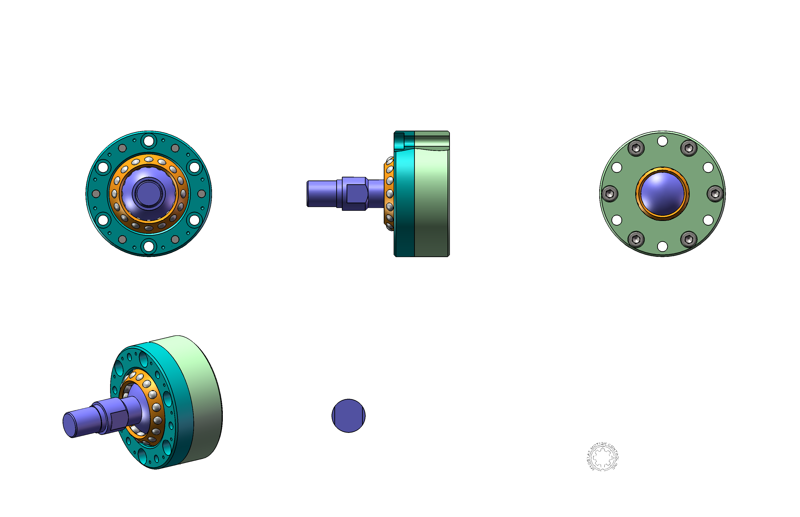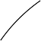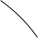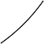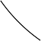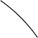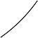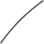

8 7 6 5
DRAWING IS THE SOLE PROPERTY OF MYOSTAT MOTION CONTROL INC. ANY REPRODUCTION IN PART OR
AS A WHOLE WITHOUT WRITTEN PERMISSION IS PROHIBITED.

4 3
Myostat Motion Control Inc.
17817 Leslie St, Unit 43 Newmarket , ON - L3Y 8C6 Canada

www.coolmuscle.com

2
B

SCALE: 1:2
SRJ048C
WEIGHT: -
1.0

SHEET 1 OF 1
1

