Risk Matrix for the Irrigation Recommendation System

Raulie Raulerson

# **Risk Matrix**

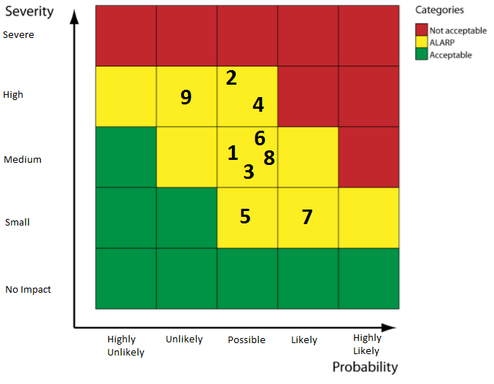

|  |  |  |  |  |  |  |
| --- | --- | --- | --- | --- | --- | --- |
| **ID** | **Risk** | **Category** | **Sub-category** | **Likelihood (HU/U/P/L/HL)** | **Impact (NI/SM/M/H/S)** | **Matrix Category** |
| 1 | Underestimated project budget | Planning | Estimating | P | M | ALARP |
| 2 | Design is difficult to implement | Modeling | Design | P | H | ALARP |
| 3 | Ambiguous requirements provided by client. | Communication | Requirements Gathering | P | M | ALARP |
| 4 | Project will fall behind schedule | Planning | Tracking | P | H | ALARP |
| 5 | Product will not integrate well with other existing data sources | Deployment | Delivery | P | SM | ALARP |
| 6 | Frequent changes in requirements. | Communication | Requirements Gathering | P | M | ALARP |
| 7 | End user will not be willing to utilize the product. | Deployment | Feedback | L | SM | ALARP |
| 8 | Issues with project code encountered while testing. | Construction | Testing | P | M | ALARP |
| 9 | Negative and insurmountable feedback from client and/or mentor/management. | Deployment | Feedback | U | H | ALARP |

All risks that have been identified fall into the as low as reasonably practicable (ALARP) category for the Risk Matrix that was used.

**References**

CGE Risk Management Solutions. (2017). Risk Matrices. Retrieved June 25, 2017, from https://www.cgerisk.com/knowledge-base/risk-assessment/risk-matrices