CSE-344 System Programming Homework-2

Author: Hacı Hasan Savan
1901042704

Algorithm Design:

This the algorithm that shows how the code functions step by step, ensuring seamless communication and synchronization between processes:
The algorithm begins by generating an array of random numbers based on the size of the command line argument provided by the user. Two FIFOs, named fifo1 and fifo2, are then created for communication between Child1 and Child2 processes. Subsequently, Child1 and Child2 processes are spawned. Child1 opens fifo1 for reading and waits for 10 seconds using the sleep function. Similarly, Child2 opens fifo2 for reading and waits for 10 seconds. Meanwhile, the main process opens fifo1 and fifo2 for writing and sequentially writes the arrays of random numbers into them. Then, the main process writes the "multiply" command into fifo2. Child1 receives the array from fifo1, performs summation, and sleep 1 second here for synchronization and after that writes the result into fifo2. Child2 reads the array and the "multiply" command from fifo2, calculates the product, and waits for Child1's sum value to be written into fifo2. Upon receiving the sum value, Child2 prints the sum, product, and sum+product values to screen. Simultaneously, the main process runs in the background, printing "proceeding" every 2 seconds. The signal handler function in the background monitors the termination of child processes. Once the child processes finish their tasks, they exit.

Interrupt Handling:
The sigchld_handler function is a signal handler designed to handle the SIGCHLD signal, which is emitted when a child process terminates. It enters a loop to continuously reap terminated child processes using the waitpid() function with the WNOHANG option, allowing it to return immediately if there are no terminated child processes. When a child process is reaped, it prints out the child process ID and its exit status. If the exit status indicates an error, the handler attempts to determine the other child process's ID and sends a SIGTERM signal to it to terminate it gracefully. The function keeps track of the number of terminated child processes by incrementing the child_count variable. If an error occurs during the termination signal sending process, it prints an error message and exits the program with a failure status.
Overall, this handler ensures proper cleanup and management of child processes in a multi-process environment. If a child process exit with a failure (syscall fails like read,close etc.) the other child process will be exited aswell because the two process depends each others.

Bonus Sections:
- Zombie protection achieved by using waitpid in sigchld_handler function. If a function ends of its job, it will absolutely be reaped.
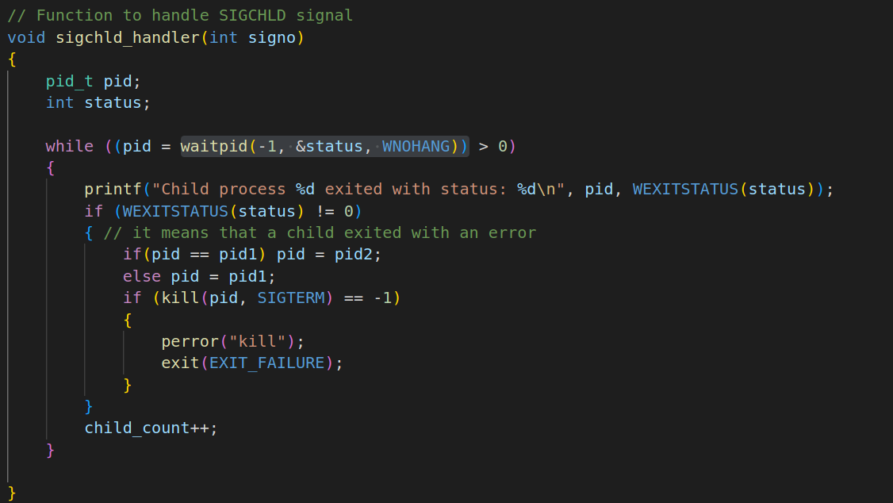
- Exit status of all process are printed in to the screen in all scenarios either success or failure:

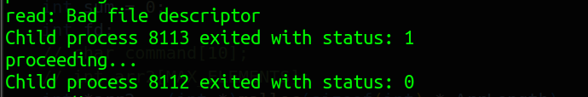

Memory Leak Checks:
The code checked with valgrind if there is a memory leak or not. There is no memory leak:
These are the ss from valgrind for each processes (if you want to control it by self just run code with a valgrind keyword):

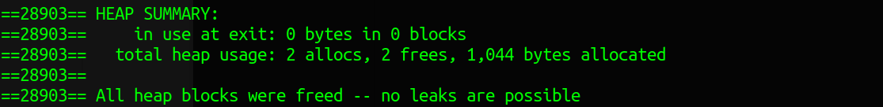
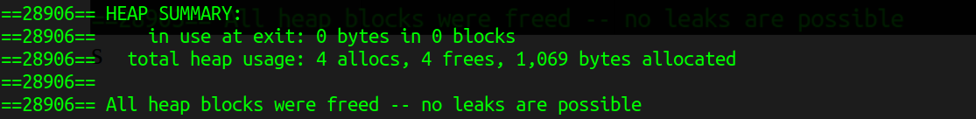
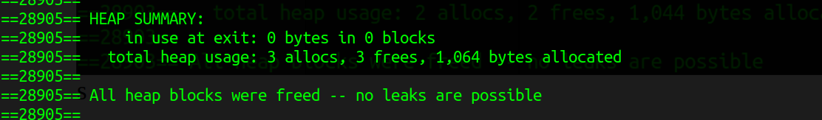

Error Scenarios:

- All error scenarios that described handled.

Example Runs:

with a 1000 random numbers (result is correct):

