Implementation Report –
How to write a model-checker?

This document describes the implementation-details of a B-method tool written in python by John Witulski in 2012-2013. The tool is a simple checker of solutions generated by the proB tool and will also be used as a tool for animating b-machines e.g to perform model-based testing or online-supervision of adhocracy or even direct execution of b code as part of the adhocracy project. In this text, the python B-tool will be called 'pyB'.

0. Introduction and Motivation:

One approach to construct safe software is the b-method. A software system is modeled in a mathematical language: the b-language. This model can be verified to some predicates (the invariant) and be proven to hold this safety conditions. Under this view software is a state-machine and every action change the state which is the set of all variables and there values.

Before the model is refined to executable implementations it can be checked by software tools called model checkers. These tools explore the whole state-space (the set of all states) and check the invariant (a safety-predicate) on every state.

Because proving, date-validation or model-checking without tools is not possible in reasonable time a weak point of this formal method can be the tools. If a tool contains a bug an possible error may not been detected. Because the formal prove of complex software (like model-checkers) can be difficult one possibility to raise trust in these tools is double-checking.

Double-checking means that every result (checking of an invariant in a state) is checked again by an other tool. E.g a tool like ProB checks the invariant for every state of the state-space and a tool like pyB checks it again. If pyB gets the same result like ProB after every check the trust in Prob can be raised. PyB is a clean-room implementation which uses only the same parser like ProB at the moment.

PyB started as simple python-based predicated checker i.e software which can read in variable and constant values and evaluates if a predicate is true or false, like Predicate B of the Ovado-project.
Now pyB is able to animate b-machines i.e executing operations inside an interactive operation mode and show the state and the status of the invariant after every execution. Also pyB contains a repl to quick evaluate predicated or expressions. PyB was implemented test-driven and passes more than 500 tests.

TODO: general informations about pyB and the b-method, data-verification/validation

0. Index:

- Tool SetUp and Configuration
- Parsing of B files and future implementation
- Processing of definitions
- TypeChecking
- State-space and state-management, internal data representation
- Enumeration and B-machine animation
- UI, repl. and pretty printer
- Interpretation and quick evaluation
- Reasons for failure
- Case Study: Alstom
- Related work
- Future work

1. Tool SetUp and Configuration

The Tool needs at least python 2.7 (json python module) and a java vm 5. It can be downloaded on github by typeing: “git clone git@github.com:hhu-stups/pyB.git”. To build the jars yourself you also need gradlescript (./gradlew -jar), check out the parser, replace the java files, move the visitors to bparser/src/main/java/de/be4/classicalb/core/parser/analyse/python (or json).
If desired, the tool can be configured via config.py.
Todo: License

2. Parsing of B files and future implementation

To avoid the new implementation of a bparser, pyB uses (a fork of ) the same parser like proB. This parser is written in java (sablecc and some classes) and his jar files can be generated by a gradle buildscript. So an installed jvm is a requirement for parsing (in pyB).

After pyB calls the jvm/jars, a special python-visitor (ASTPython.java) prints the AST as python objects to the console. The dynamic exec python command generates the objects (on the python level) from the string for further processing.

To enable a translation of pyB via pypy it is necessary to eliminate all dynamic constructs at runtime. To make this possible a second json visitor has already been implemented. The parsing of a json-AST instead of a python-AST can be implemented without the dynamic exec. The python side of the json-parser is not fully done, while the visitor implementation on the java level has been finished.
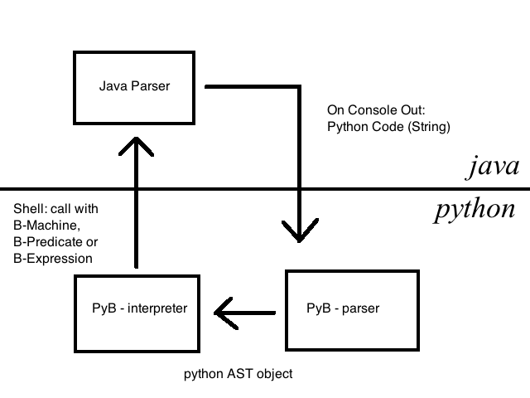

3. Processing of definitions

The B definitions can be compared to C-makros. Before the typechecking and interpretation is done, pyB runs some recursive definition replacement functions over the parsed AST.

The definition processing consists of two phases. The first phase collects all expression-, predicate- and substitution-definitions defined in the DEFINITIONS section into a map. The second phase searches the remaining AST for matching definitions and replace the sub-ASTs with the saved definition-body

4. TypeChecking

It is necessary to evaluate quantified predicates, lambda expressions and set comprehensions to animate b-machines by pyB, but also to check proB solutions, because the prob-solution-files do not contain any informations about bound variable values inside such predicates. This is the reason why pyB needs typeinformations.

Like proB, pyB uses unification to gain typeinformations. The goal is the feature to type every predicate by pyB, that can be typed by proB i.e. the order of subpredicates inside a predicate doesn't effect the typing-success. Unlike prolog (proB) python (pyB) has no build in unification, so it is more complicated to write such a typechecker. Another problem are the possible identical names of identifiers in different scopes and the ambiguity of the subtraction and multiplication of integers or sets.

The typechecker walks the AST and collects informations about the nodes via unification. The typechecking method returns for every subtree (or leaf) a b-type object or an unknown-type object. Unification is implemented by a pointer of an unknown-type object to an concrete type object whenever possible. One important case is the visit of an identifier node: in this special case the idNode (not the id name) is mapped to a type object. This could be a unknown type object that points to a concrete or another unknown type object. After the processing of the hole predicate, every chain of unknown types objects must point at a concrete type or the typechecking fails. This final mapping of idNodes to b-types is called resolve, but it turned out that a single resolve-phase after the processing of a scope doesn't succeed in all cases. So every (unknown) type object is unified with an expected type corresponding to the visited node(see Figure 2), to gain information even before the resolve-phase. So the processing of an AST-node returns at least the minimum typeinformations known at this time.

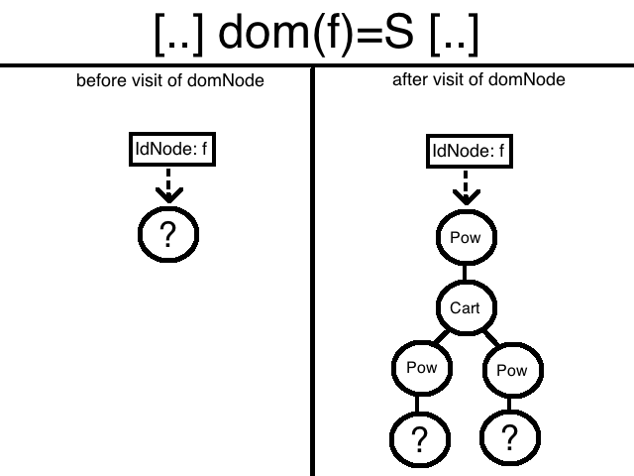

In the resolve-phase every idNode is mapped to an basic (string, integer, boolean, set) type object or an composed (cart, power, struct) type object. IdNodes that point to the special unknown type objects (PowORIntegerType type or PowCartORIntegerType) must be resolved in the final resolve-phase or the typechecking fails.

Typechecking is performed before any interpretation for all b-machines and there seen, includes, used or extended b-machines.
TODO: why prolog is better: unification build in
TODO: explain why seen/used mch can be animated (out of control of the seer) ans this impl. Is transitive but seen not
TODO: sees uses,...

5. Statespace and state-management, internal data representation

The pyB Tools was originally developed to evaluate single predicates. Later it processed expressions, substitutions and than entire b-machines. Today pyB has many modes of operation and what a state is and how it is represented differs from case to case.

In every case pyB holds exactly one environment. This environment encapsulates the state. In case of a simple predicate or expression evaluation the state is just a map from names of identifiers to a value.

In case of the processing of a entire B-machine or even an animation, the state is something more complicated. The environment holds a single statespace object. At this moment it is just a stack of state objects to enable the undo function while animation. If pyB develops to a modelchecker (for some reason), this will be replaced with some other data-structure.

A state object represents the state of the machine at a distinct time. Every state is a stack of maps to enable scoping. The maps map from identifier-names to values. The reason for a push on the map is for example the interpretation of a operation-body or the evaluation of a quantified predicate.

The 'primitive B values' string, integer and bool are represented with the corresponding python types. Sets are represented via the frozenset datatype and not the set datattype to enable set of sets. Functions are represented as sets of python two-tuples. The elements of enumerated sets are represented by strings with the same name.

6. Enumeration and B-machine animation

To evaluate quantified predicated, lambda expressions, set comprehension or enable animation of b-machines it is necessary to generated some sets or find solutions for some predicates.

The interpreter of pyB is designed only to evaluate predicates, compute expressions and perform (deterministic) substitutions on the machine state. This is not enough to enable an efficient animation.

At the beginning pyB used a “brute force enumeration” to check e.g. quantified predicates by generating all values of the quantified variables and simply checking for a false or true predicates in the domain of the variable type and ignoring every constraint inside the predicate. It is easy to construct examples where this strategy leads to big performance problems.

Because of this problems pyB now uses an extern constraint solving module (integer finite domains) which can constrain the size of possible solutions of a predicate while using a pyB B-notation wrapper. This constraint solver uses a (potentially large) domain and a predicate to return some solution candidates. If the constraint solving fails, e.g because of missing implementations inside the wrapper, the bruteforce (generate all values) strategy is used as fallback. Of course every solution is double- checked by the interpreter.

The task of the animation module is to generate of list of operation/parameter pairs.
Every item in this list represents a an operation on the abstract machine which execution (with the found parameter solution) leads from the current machine-state to a different one. Two clients may be interested into this data: a user who is animating the machine or a modelchecker which trys to find a invalid state. A user may also interested 'getter-operations' which produce return values but do not change the machine state and also those operation with satisfiable preconditions but no effect on the machine.

Other papers uses an informal concept of animation. The use formulations like “the next possible events” or “show the user a dynamic model”. This lead to the question: “what are the next possible operations?” or more general: “what is a correct animation?”.

The classical B-Method defines every operation to be executed when its precondition is true. Every operation without a precondition has the implicit precondition true. If you define “next possible operations” like this. Every operation without a precondition is enabled and must be shown by the animation. Even those operations which do not change the state, like “op = if x>0 and x<0 Then S END”.

Xxxx

The animation uses the top level precondition or select predicates of operations to check which operations are enabled. It assumes that the parameters of an operation can be constraint by the predicate of the top-level substitution i.e. that operations can be executed if the top-level predicate can be satisfied on the current machine state. This assumption can be false! In other words the animation module is trying to reduce the set of possible operations to those which may change the state of the machine after execution, but maybe add operations which do not change the machine state. The reason for this behavior can be parameter constraints scattered through predicates somewhere inside the operation. This Implementation is still correct for an animation tool used by the user or a later model checking implementation.

The alternative-implementation would be finding all operation/parameter combinations which lead from the current state to another state by a state changing substitution.
Xxxx

TODO: nondeterminism and op-calls
TODO: Trennung eval and exec_subst.
TODO: why prolog is the better language to write an interpreter for nondeterministic substitutions.
TODO: MCH tree and op caching

7. UI, repl. and pretty printer

PyB was intended to be a tool just used for checking proB results. A tool like that doesn't need a userinterface.

Today pyB is much more. It is intended to expand its capabilities to animation of B-machines and later partial integration into adhocracy. For this reason there exists a minimalistic ui. The ui is just a console output. If there is a need for a graphical ui in the future it is intended to use an other gui like that of rodin. The first reason is reusing existing work done in the past and the most important second reason is the fact that it is not possible to translate a gui with pypy.

PyB has also a read-eval-print-loop. This mode reads the userinput from the console and give it as an predicate to the parser. If this fails it trys to give it as an expression.
The generate AST is typechecked and interpreted. The result is printed to the console.

PyB uses helper methods to print the result of an expression (internally represented by python datatypes) in a b-notation. Never the less pyB has also a pretty printer to print ASTs to the console in b-notation. This is uses for error reporting, e.g. To print the false subpredicate of an invariant to the user.

8. Interpretation and quick evaluation

The pyB interpretation module is designed only as a simple checker. It will be some work to build a model checker out of this tool because of refactoring of the eval. of the non deterministic substations.

The interpreter uses some strategies to avoid the computation of large sets. On is the quick member check. If the left side of a memberOfNode is known, pyB doesn't generate the right side but only checks if the element can be generated by the expression on the left side.

Also the the interpreter trys to use constraint solving when ever possible to produce a better performance.

9. Reasons for failure and missing features

PyB does not support the tree-types or predicates and prolog build-in functions like append.
TODO: Missing trees..and more
TODO: write more

10. Case Study: Alstom

The case study consists of 6 B-machines. Every machine was model-checked with proB. Two machines where faulty. They defined a partial surjection to an infinite set and initialized it with the empty set. After the correction to a partial function the machine still contains a deadlock-state.

The procedure of the double-checking was as follows:
Every machine was animated n times with proB. After every animation the state of the machine (only constants and variables) where written to a file. The data was loaded by pyB. PyB evaluated the properties and invariant of the machine and returned the result.

After the correct configuration of the MAX_INT and MIN_INT values pyB successfully checked 3 of 6 B-machines by double-checking of 32 to 42 states of the machines in 5 minutes per machine. One machine doesn't works with pyB because of the missing support of extern functions like append (Strings). The remaining machines fail at the same point like proB (described above). The animation with pyB (and without ProB) of all machines fails.

It may be possible to speed up this slow checking by replacing the file by a socket communication (~40% of the time) with proB or using the pypy technology on pyB

TODO: image

11. Related work

TODO: (Ovado, ProB,...)

12. Future work

    - Use Rodin as userinterface
    - Integration with adhocracy to enable model based testing
    - Better constraint solving to enable successful animation of more B-machines
    - Eliminate all dynamic code to enable pypy translation to C
    - more...

The tool can be downloaded at https://github.com/hhu-stups/pyB

13.06.2013 John Witulski hhu

