

**Weather Application**

– Ho Chi Minh, December 2023 –

**Table of Contents**

I. Introduction 3

1. Overview 3

2. Project Information 3

3. Project team 3

II. Requirement Specification 4

1. Summarize the project objectives 4

2. User requirements 4

3. Functionalities 4

3.1 Dashboard 4

3.2 Map 5

3.3 Chart 6

3.4 Settings 8

III. Design Document 10

1. The software architecture 10

IV. User Manual and Developer Guide 11

1. How to use the app 11

1.1 Screen Flow 11

1.2 Screen Descriptions 11

1.3 Screen Authorization 11

1.4 Non-Screen Functions 12

2. How the code is structured 12

2.1 Logical Data Model 12

2.2 Data Dictionary 12

2.3 Reports 13

2.4 State transition diagram 14

# I. Introduction

## 1. Overview

The objective of this weather application is to provide users with a comprehensive and user-friendly tool for accessing accurate and up-to-date weather information on the Android platform. Recognizing the increasing importance of weather awareness in daily life, our application aims to deliver a seamless experience for users seeking reliable weather forecasts and real-time updates.

The application fetches data from reputable weather APIs, utilizing a variety of sources to ensure accuracy and reliability. Users can expect to access information such as current temperature, humidity levels, wind speed, and precipitation forecasts. The data is presented through an intuitive and visually appealing interface, offering users a quick and easy way to grasp the current weather conditions and predictions.The weather app allow users to confidently plan their activities.

In summary, this weather application aims to provide a reliable, accessible, and user-centric solution for individuals seeking timely and accurate weather information on the Android platform. Through a combination of intuitive design and robust technological features, the app strives to become an essential tool for users to stay informed and make informed decisions based on current and forecasted weather conditions.

## 2. Project Information

Project name: Weather App

Group name: 3

Software type: Mobile application

## 3. Project team

a. Supervisor

|  |  |  |
| --- | --- | --- |
| **Full Name** | **Email** | **Title** |
| Thai Huy Tan | tanth@uit.edu.vn | Lecturer |
| Le Kim Hung | hunglk@uit.edu.vn | Lecturer |

b. Team Members

|  |  |  |  |
| --- | --- | --- | --- |
| **Full Name** | **Student code** | **Email** | **Title** |
| Le Phi Hung | 21522115 | 21522115@gm.uit.edu.vn | Leader |
| Nguyen Duc Cuong | 21521904 | 21521904@gm.uit.edu.vn | Member |

# II. Requirement Specification

## 1. Summarize the project objectives

In summary, this weather application aims to provide a reliable, accessible, and user-centric solution for individuals seeking timely and accurate weather information on the Android platform. Through a combination of intuitive design and robust technological features, the app strives to become an essential tool for users to stay informed and make well-informed decisions based on current and forecasted weather conditions.

## User requirements

Users can view detailed information about the current weather, including temperature, humidity, wind speed, and weather conditions. The application will provide a 7-day weather forecast, helping users plan for upcoming events or activities. The user interface is aesthetically pleasing, user-friendly, and easy to navigate, featuring visually appealing icons and colors.

## Functionalities

### Dashboard

View Current Weather Information: Users have the ability to monitor all changes in the current weather, including temperature, highest temperature of the day, lowest temperature of the day, humidity, wind speed, and general weather conditions.

Weather Forecast for the Next 7 Days: The app will provide a detailed weather forecast for the next 7 days, helping users plan events, trips, or other activities based on weather conditions expected during that period.

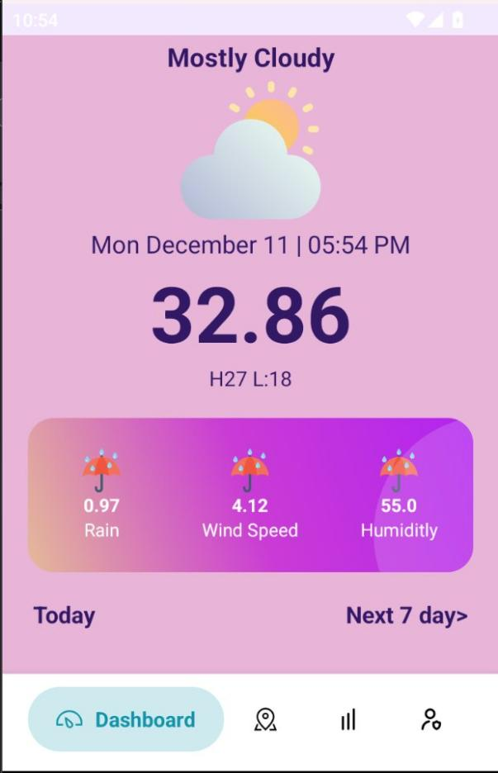

### Map

Displays the coordinates of weather data collection devices via a map.

### Chart

Users can select a start and end time, and the application will provide a temperature trend chart for that period. Ensure that the chart is designed for easy readability and understanding, with clear annotations and appropriate colors. These charts can enhance interactivity and help users gain a better understanding of the weather forecast.

### Settings

Edit profile: helps change user personal information such as phone number, username,...

Night Mode: Allows users to switch between day and night interfaces, reducing glare and blue light, helping to reduce fatigue and improve the evening usage experience.

Notifications: Manage notification settings from the app, including notifications about current weather conditions, special weather alerts, or notifications about data updates.

Private Account: Allows users to manage account security and privacy-related features, including setting the level of disclosure of personal information.

Security & Privacy: Provides options to keep personal information and data secure, which may include password settings, two-factor verification, and privacy management.

Text Size: Allows users to adjust the text size on the application to suit their preferences and conveniently read weather information.

Language: Allows users to select the language displayed in the application, meeting the needs of multilingual users.

Send Us a Message: Provides a direct communication channel between users and the support team, where users can submit questions, suggestions, or report problems.

About Us: Displays information about the development team and goals of the weather app.

FAQs (Frequently Asked Questions): Provide a frequently asked questions section with answers to help users quickly answer questions.

Log Out: Allows users to log out of their account on the weather app.

# III. Design Document

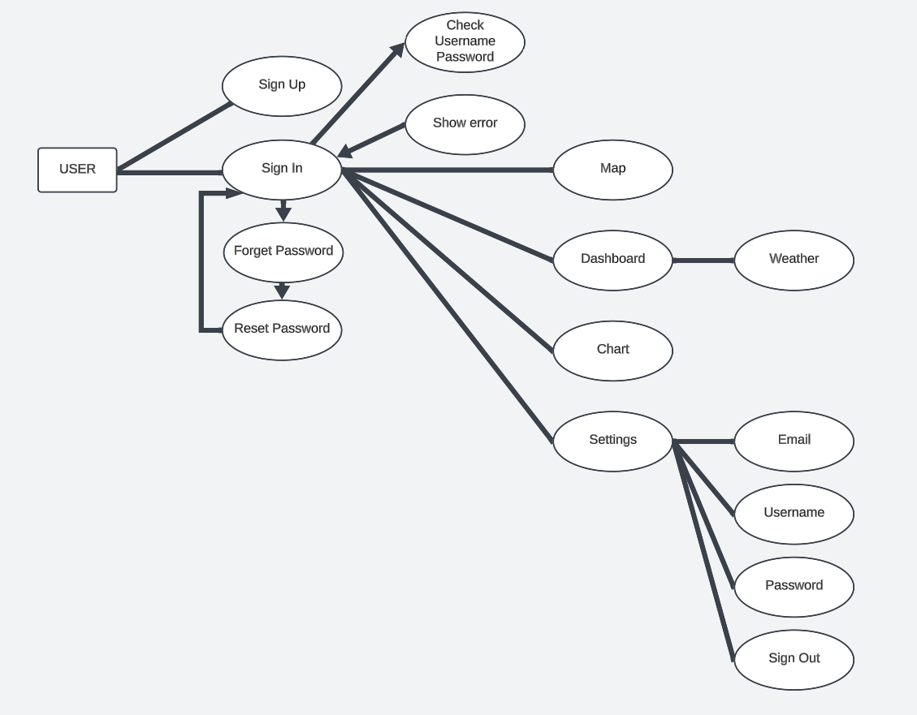

User in the authentication activity. There are two options, which are sign in and sign up. If the user login successfully, there are four fragments for user to experience including Map, Dashboard, Chart and Settings. In the contrary, the user will get error, retype the account or reset the password.