CME1001 Algorithms and Programming I
LAB 3

Questions

Upload the answers of the following questions from http://lectures.cs.deu.edu.tr web site until October 18, 2015.

1- Write a program that converts Turkish shoes numbers to ABD or UK shoes numbers.

Turkey | ABD | UK
36 | 6 | 3.5
37 | 6.5 | 4
37.5 | 7 | 4.5
38 | 7.5 | 5
39 | 8 | 5.5
39.5 | 8.5 | 6
40 | 9 | 6.5

Examples:
Inputs: 38 Inputs: 40 Inputs: 36 Inputs: 39.5
ABD UK UK ABD
Output: 7.5 Output: 6.5 Output: 3.5 Output: 8.5

2- Write a program that converts kitchen metrics (WaterGlass (WG), TeaCup, CoffeeCup, TableSpoon) to gram for the following foods.

Walnut (Ceviz) Milk (Süt) Wheat (Bulgur) Cocoa (Kakao)
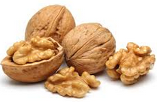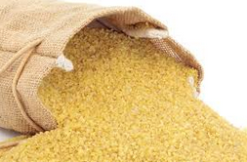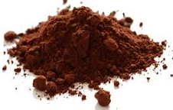

WG - WaterGlass (Su Bardağı)  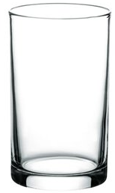 | TC - TeaCup (Çay Bardağı)  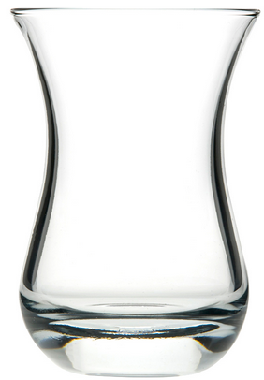 | CC - CoffeeCup (Kahve Fincanı)  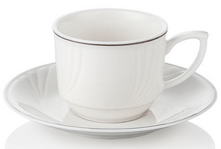 | TS - TableSpoon (Çorba Kaşığı)  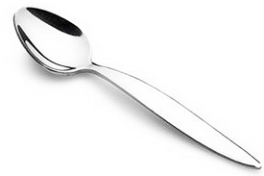

Note: Use the metrics in this web site - http://www.birimcevir.com/gida-olculeri/mutfak-birimleri.aspx

Examples:
Inputs: 8 Inputs: 40 Inputs: 5 Inputs: 2
WG CC TS TC
Walnut Milk Cocoa Wheat
Output: 800 gram Output: 3000 gram Output: 40 gram Output: 130 gram

3- Write a program that takes the current date and time in Turkey from the user and prints the date and time in Japon.

Note: Don’t use date and time commands in C# such as DateTime.AddHours(),AddDays, CompareTo(DateTime) etc.

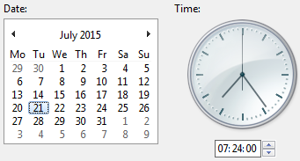
Examples:
Turkey 08/10/2015 10:24 AM
Tokyo 08/10/2015 04:24 PM

Inputs: day = 08
month = 10
year = 2015
hour = 10
minute = 24
PM
Output: 08/10/2015 04:24 PM

