CME1001 Algorithms and Programming I
LAB 4

Questions

Upload the answers of the following questions from http://lectures.cs.deu.edu.tr/ web site until October 25, 2015.

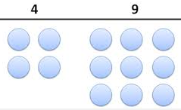
1- Write a program that takes a number n (between 1 and 999) from the user and finds “how many times the digits 4 and 9 occurs from 1 to n”.

Example :
Input: 100
Output: 40

(because 4 9 14 19 24 29 34 39 49 41 42 43 44 45 46 47 48 49 54 59 64 69 74 79 84 89 90 91 92 93 94 95 96 97 98 99)

2- Write a C# program that takes a number from the user and prints one of the followings:
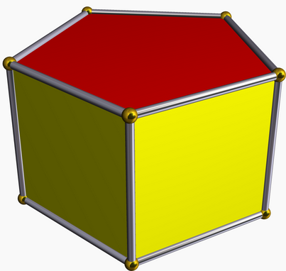
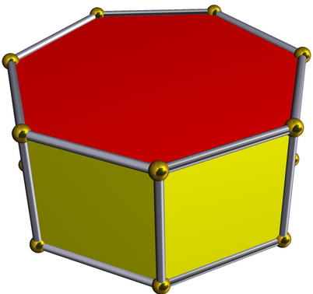
- pentagonal and heptagonal
- Not pentagonal but heptagonal
- Pentagonal but not heptagonal
- Neither pentagonal nor heptagonal

A pentagonal number is a number of the form P_{n} = n(3n−1)/2.
The first few are 1, 5, 12, 22, 35, 51, 70, 92, 117, 145, 176, 210, 247, 287, 330, 376, 425, 477, 532, 590, 651, 715, 782, 852, 925, 1001... etc.

A heptagonal number is a number of the form H_{n} = n(5n-3)/2.
The first few are 1, 7, 18, 34, 55, 81, 112, 148, 189, 235, 286, 342, 403, 469, 540, 616, 697, 783, 874, 970, 1071... etc.

Examples:
Input: 4347 Input: 590
Output: pentagonal and heptagonal Output: Pentagonal but not heptagonal

3- Write a program which that takes the values of x and a from the user and calculates the result of the following mathematical formula:


