Algorithms and Programming I
LAB 7

Questions

Upload the answers of the following questions from http://lectures.cs.deu.edu.tr/ web site until November 22, 2015.


1- Assume that we have a game board with NxM dimensions. Some cells in the game board include diamonds, others include numbers which indicate you how many diamonds there are adjacent to that cell. The aim of the game is to fill the gaps which are represented with letters in the field.

Write a program that finds the values of the cells represented by letters in Diamond Miner Game.

Note: Don’t take the values of arrays from the user. Assign them in the code.

Examples:
{{‘Δ’,’4’,’Δ’,’Δ’,’1’,’0’,’1’,’1’,’n’},  {’Δ’,’4’,’Δ’,’k’,’4’,’2’,’2’,’Δ’,’1’},  {’2’,’3’,’m’,’Δ’,’Δ’,’Δ’,’2’,’2’,’2’},  {’1’,’Δ’,’2’,’3’,’Δ’,’3’,’1’,’1’,’Δ’}}  Δ4ΔΔ1011n  Δ4Δk422Δ1  23mΔΔΔ222  1Δ23Δ311Δ  Outputs:  k=5  m=3  n=1 | {{‘2’,’Δ’,’Δ’,’3’,’1’,’0’,’1’,’1’,’1’,’0’},  {’Δ’,’x’,’Δ’,’Δ’,’4’,’2’,’2’,’Δ’,’1’,’0’},  {’2’,’5’,’Δ’,’Δ’,’Δ’,’Δ’,’2’,’2’,’y’,’1’},  {’1’,’Δ’,’Δ’,’Δ’,’Δ’,’3’,’1’,’1’,’Δ’,’1’},  {’z’,’2’,’3’,’3’,’2’,’1’,’t’,’1’,’1’,’1’}}  2ΔΔ3101110  ΔxΔΔ422Δ10  25ΔΔΔΔ22y1  1ΔΔΔΔ311Δ1  z23321t111  Outputs:  x=5  y=2  z=1  t=0

2- Write a program that determines a matrix is a Toeplitz Matrix or not.

A Toeplitz Matrix is a matrix in which each descending diagonal from left to right is constant.

Note: Don’t take the values of arrays from the user. Assign them in the code.

Examples:
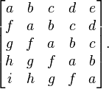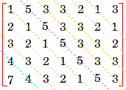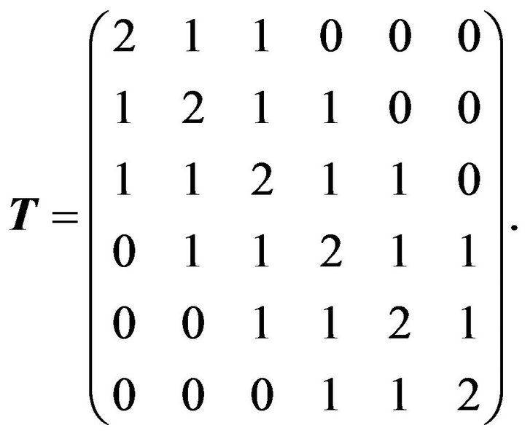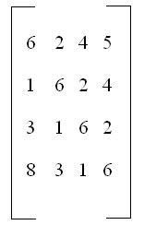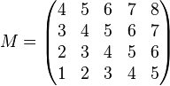

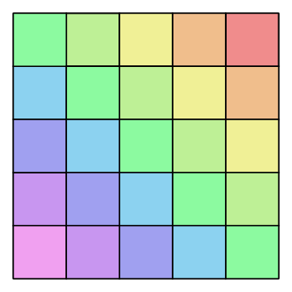
Example:
int[,] a = new int[,] {{1, 5, 3, 3, 2, 1, 3},
{2, 1, 5, 3, 3, 2, 1},
{3, 2, 1, 5, 3, 3, 2},
{4, 3, 2, 1, 5, 3, 3},
{7, 4, 3, 2, 1, 5, 3}};
Output: true

Example:
int[,] a = new int[,] {{3, 5, 8},
{2, 3, 5},
{9, 6, 3}};
Output: false

