CME1002 Algorithms and Programming II
Assignment 4

Upload this assignment from Lectures (http://lectures.cs.deu.edu.tr/) until 19 April 2016, 15:00.

In this assignment, you will understand DNA language. You will find the secret of life !!! ☺

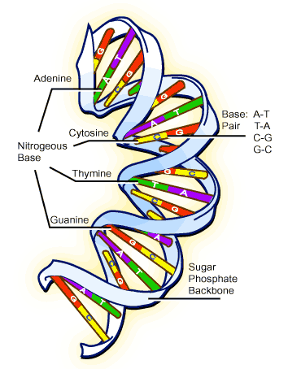
DNA language is the language of life. The DNA language has an alphabet of four symbols or “letters”, A, C, G and T, which are ordered to convey a specific piece of information. In our cells, the four DNA letters are linked together in a precise order in very long molecular chains, which convey genetic information to our cells.

The genetic code is carried by DNA (DeoxyriboNucleic Acid) molecules. DNA is composed of matched base pairs, where bases are Adenine (A), Cytosine (C), Guanine (G) and Thymine (T).

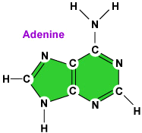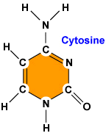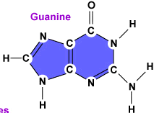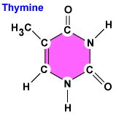

C is always paired with G, and A is always paired with T. The backbone of the DNA strand is made from alternating phosphate and sugar residues.

We can represent a DNA fragment as a linked list of the base letters of one side of the DNA helix.

Example:
head

A |  |  | A |  |  | A |  |  | A |  |  | T |  |  | A |  |  | G |  |  | T |  |  | G |  |  | C

Write a Single Linked List class that includes necessary operations such as;
add()
display()
etc.

Write a main program that randomly generates a DNA piece with length 30 as a “Single Linked List (SLL)” and then carried outs the following DNA operations:
- Complement
- Amino Acids
- Crossover

Notes:
1- In the main program, you can use getHead() function to obtain the value of the head of the single linked list.

SLL dna = new SLL();
dna.add(...);
Node temp = dna.getHead();

2- Don’t use String data type.

3- Don’t use ENIGMA library.

4- Don’t use other data structures such as array, stack and queue.

Complement

The complement of a DNA sequence is a sequence of the complementary letters (A-T, C-G) of the sequence.

The main program should construct a new single linked list which contains the complement of the DNA sequence.

Example:

SLL1 - Randomly generated DNA sequence
head1

A |  |  | A |  |  | A |  |  | G |  |  | T |  |  | G |  |  | A |  |  | T |  |  | A

SLL2 - The complement of this sequence
head2

T |  |  | T |  |  | T |  |  | C |  |  | A |  |  | C |  |  | T |  |  | A |  |  | T

Amino Acids

A DNA sequence codes for a sequence of amino acids that make up a protein. Each 3 letters of DNA code for one amino acid.

The following amino acids should be inserted into single linked lists (i.e. SLL3 and SLL4)

SLL3.add(“AAA”); SLL4(“Lys”);  SLL3.add(“ACA”); SLL4(“Thr”);  SLL3.add(“ATA”); SLL4(“Ile”);  SLL3.add(“AGA”); SLL4(“Arg”);  SLL3.add(“CAA”); SLL4(“Gln”);  SLL3.add(“CCA”); SLL4(“Pro”);  SLL3.add(“CTA”); SLL4(“Leu”);  SLL3.add(“CGA”); SLL4(“Arg”); | SLL3.add(“AAC”); SLL4(“Asn”);  SLL3.add(“ACC”); SLL4(“Thr”);  SLL3.add(“ATC”); SLL4(“Ile”);  SLL3.add(“AGC”); SLL4(“Ser”);  SLL3.add(“CAC”); SLL4(“His”);  SLL3.add(“CCC”); SLL4(“Pro”);  SLL3.add(“CTC”); SLL4(“Leu”);  SLL3.add(“CGC”); SLL4(“Arg”); | SLL3.add(“AAT”); SLL4(“Asn”);  SLL3.add(“ACT”); SLL4(“Thr”);  SLL3.add(“ATT”); SLL4(“Ile”);  SLL3.add(“AGT”); SLL4(“Ser”);  SLL3.add(“CAT”); SLL4(“His”);  SLL3.add(“CCT”); SLL4(“Pro”);  SLL3.add(“CTT”); SLL4(“Leu”);  SLL3.add(“CGT”); SLL4(“Arg”);
SLL3.add(“AAG”); SLL4(“Lys”);  SLL3.add(“ACG”); SLL4(“Thr”);  SLL3.add(“ATG”); SLL4(“Met”);  SLL3.add(“AGG”); SLL4(“Arg”);  SLL3.add(“CAG”); SLL4(“Gln”);  SLL3.add(“CCG”); SLL4(“Pro”);  SLL3.add(“CTG”); SLL4(“Leu”);  SLL3.add(“CGG”); SLL4(“Arg”); | SLL3.add(“TAA”); SLL4(“(STOP)”);  SLL3.add(“TCA”); SLL4(“Ser”);  SLL3.add(“TTA”); SLL4(“Leu”);  SLL3.add(“TGA”); SLL4(“(STOP)”);  SLL3.add(“TAC”); SLL4(“Tyr”);  SLL3.add(“TAT”); SLL4(“Tyr”);  SLL3.add(“TAG”); SLL4(“(STOP)”);  SLL3.add(“TCC”); SLL4(“Ser”); | SLL3.add(“TTC”); SLL4(“Phe”);  SLL3.add(“TGC”); SLL4(“Cys”);  SLL3.add(“TCT”); SLL4(“Ser”);  SLL3.add(“TCG”); SLL4(“Ser”);  SLL3.add(“TTT”); SLL4(“Phe”);  SLL3.add(“TTG”); SLL4(“Leu”);  SLL3.add(“TGT”); SLL4(“Cys”);  SLL3.add(“TGG”); SLL4(“Trp”);
GAA Glu GAC Asp GAT Asp GAG Glu
GCA Ala GCC Ala GCT Ala GCG Ala
GTA Val GTC Val GTT Val GTG Val
GGA Gly GGC Gly GGT Gly GGG Gly

The main program should construct a new single linked list which contains the sequence of amino acids specified by a DNA sequence.

Example:

SLL1 - Randomly generated DNA sequence
head1

A |  |  | A |  |  | A |  |  | G |  |  | T |  |  | G |  |  | A |  |  | T |  |  | A

SLL5 - The amino acids
head5

Lys |  |  | Val |  |  | Ile

Crossover

Crossover is a genetic operator that combines two DNA sequences (parents) to produce new sequences (offspring).

One crossover point is randomly selected and then all data beyond that point is swapped between the two DNA sequences.
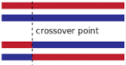

Example:

SLL1
head1

A |  |  | A |  |  | A |  |  | G |  |  | T |  |  | G |  |  | A |  |  | T |  |  | A

SLL6
head6

C |  |  | C |  |  | T |  |  | T |  |  | A |  |  | T |  |  | T |  |  | C |  |  | T

Randomly generated crossover point: 3

After crossover:

SLL1
head1

A |  |  | A |  |  | A |  |  | T |  |  | A |  |  | T |  |  | T |  |  | C |  |  | T

SLL6
head6

C |  |  | C |  |  | T |  |  | G |  |  | T |  |  | G |  |  | A |  |  | T |  |  | A

