Assignment 5
(Last Assignment)

Upload this assignment from Lectures (http://lectures.cs.deu.edu.tr/) until May 10, 2016, 15:00.

Write a Double Linked List class which includes the following methods:
- insert (which inserts odd numbers from the head, even numbers from the tail)
- display (which prints all items in the list from tail to head)

Write a Multi Linked List class which includes the following methods:
- insert (which inserts numbers according to their modulo operation result by 7)
- display (which prints all items in the list)

MLL will contain the numbers as follows:
- The first row should include the numbers whose modulo remainder by 7 is 0
- The second row should include the numbers whose modulo remainder by 7 is 1
- ...
- The last row should include the numbers whose modulo remainder by 7 is 6

Write a main program that
- randomly generates 14 numbers between 1 and 30

- calls DLL.insert(...) and MLL.insert(...) functions to insert them into both DLL and MLL.

- calls DLL.display() to print all items in the DLL from tail to head

- calls MLL.display() to print all elements in the MLL.

Sample Output:

After generating 14 random numbers and inserting them into both DLL and MLL

DLL
11 25 15 3 11 17 24 20 12 18 22 8 6 18

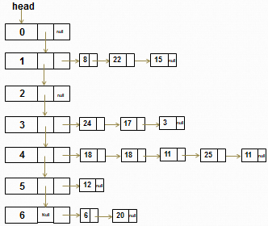
MLL
0 →
1 → 8 22 15
2 →
3 → 24 17 3
4 → 18 18 11 25 11
5 → 12
6 → 6 20

