DOKUZ EYLUL UNIVERSITY
ENGINEERING FACULTY
DEPARTMENT OF COMPUTER ENGINEERING

CME2001 – Data Structure

AVL-Tree & Augmented AVL-Tree Report

Submitted by:
Hasan Hüseyin Pay

Submitted to:
Asst. Prof. Zerrin Işık

December, 2016
İZMİR

INTRODUCTION

The aim of this report is to give information about the progress of Assignment (AVL-Augmented-AVL Tree). The deadline of Project is 20tieth of December and time was given approximately four weeks for completing the assignment. The purpose of the assignment is to implement the capabilities of AVL and Augmented AVL tree data structures except Deletion capability and compare GETSUM and Insert functions of AVL and Augmented-AVL tree data structures.

ASSIGNMENT DESCRIPTION
In this assignment, implementing a balanced search tree (specifically an AVL-Tree) which performs operations and queries displayed below was expected from us. Then we required to improve it by augmenting the tree structure to make some queries faster.

Design and code AVL--Tree data structure with the following capabilities:

INSERT: Insert an input item with a given key ( an integer number)
GETSUMSMALLER: Get summation of items smaller than a given input key
GETMAX: Get maximum value of all items.
GETMIN: Get minimum value of all items.
GETSUM: Get summation of all items in tree.
PRINT: Display all items of the tree by applying in-order tree walk.

Improving the AVL-Tree class by augmented the structure so that each node holds an additional field: the sum of all items (keys) that are smaller than the current node item. Also, Augmented-AVL Tree contains all capabilities which AVL-Tree data structure has.

Table.1- AVL-Tree Outputs in JAVA
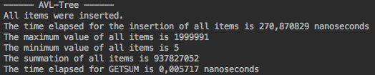
Table.1 above demonstrates the outputs of AVL-Tree data structure in java application.

Table.2- Augmented AVL-Tree Outputs in JAVA
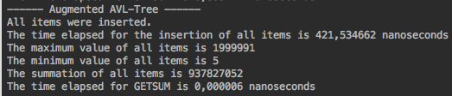

Table.2 above demonstrates the outputs of Augmented AVL-Tree data structure in java application. Besides, the items of Augmented AVL-Tree has another feature. The items have the sum of all items (keys) that are smaller than themselves.

Progress Summary

AVL – Tree data structure is faster than Augmented-AVL Tree data structure in some cases. For example; The insertion method of AVL-Tree data structure is more effective than Augmented AVL-Tree. Besides sometimes Augmented –AVL can be efficient more than AVL-Tree. If we need to get sum of the all items in tree, we can choose Augmented-AVL form to get sum of the all items quickly.

Comparıson table
DATA STRUCTURE  N(number of Items) | AVL-TREE  1000 10.000 100.000 | Augmented-AVL-TREE  1000 10.000 100.000
INSERT  RUNNING  TIME  GETSUM | 0,027266 1,552554 270,870829  0,000511 0,001032 0,005717 | 0,025997 1,355108 421,534662  0,000010 0,000006 0,000006
TABLE 3 Comparison Table

Overall Assessment of the Project

Designing and coding AVL-Tree and Augmented AVL-Tree data structures and their methods (INSERT, GETSUM, GETSUMSMALLER, GETMAX, GETMIN, PRINT and AUGMENTED SUM).

REFERENCE

https://rosettacode.org/wiki/AVL_tree#Java

