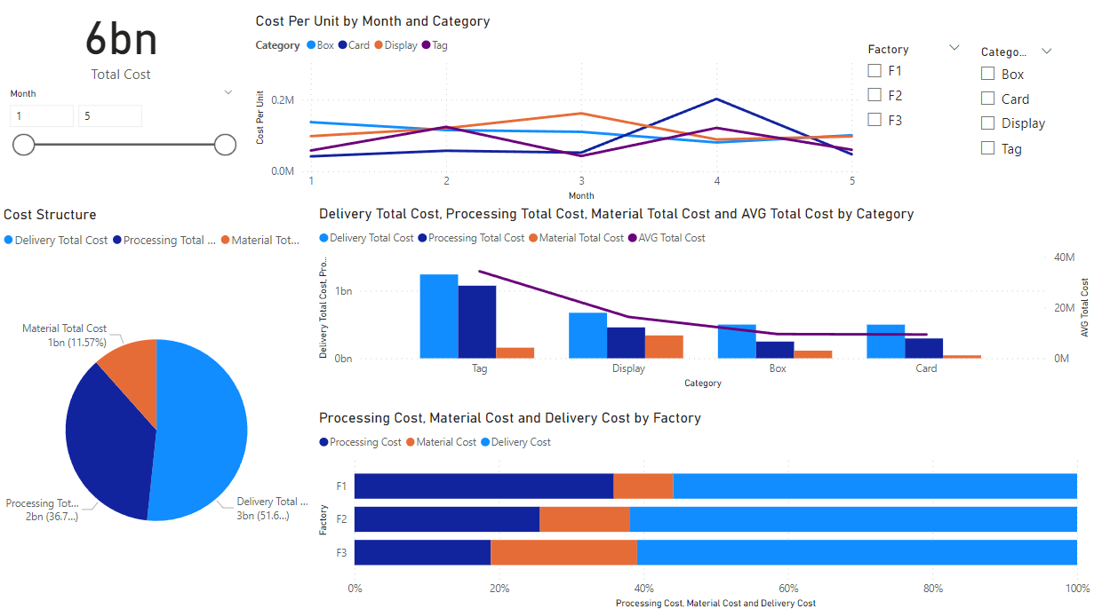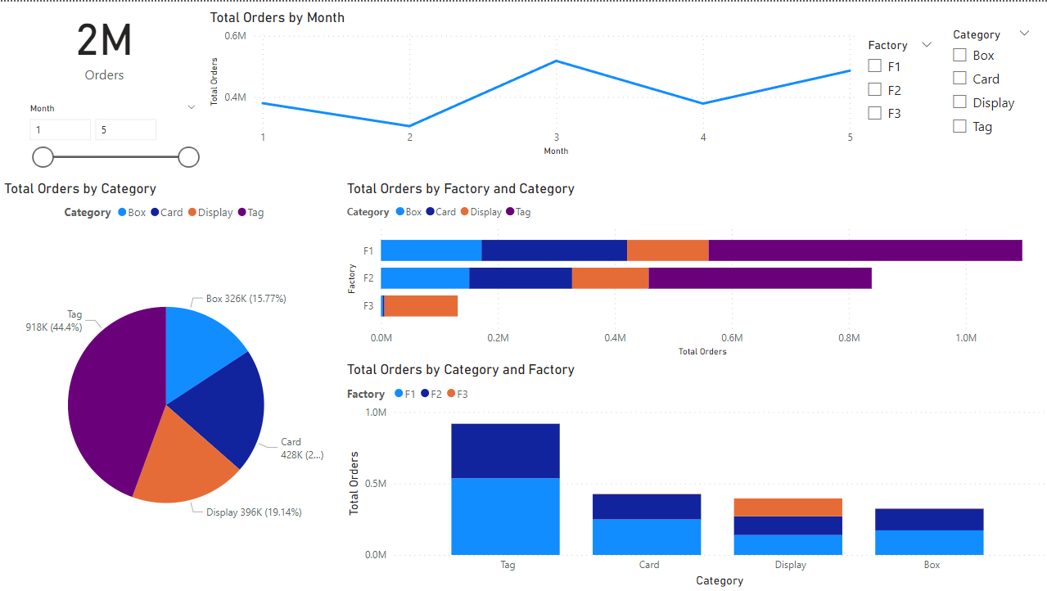

According to the information given, it is clear that the company has 3 factories (F1, F2, and F3) and operates in the Tag, Box, Card, and Display domains. Tag is attributed to F1, F2, and makes up the majority (44.4%) of orders. F3 concentrates on the Display while F1 is where the most orders are distributed throughout all 4 categories.

Material Cost, Processing Cost, and Delivery Cost are three categories of expenses that are combined for generating Product Cost. Product Costs total $6 billion in just five months. Overall, Material Costs make up little over 10% of Product Cost while Delivery Costs account for more than 50% of the total.

More specifically, Tag is the group with the most Orders, and as a result, it accounts for the most Products Cost. The section that incurs the highest Delivery Total Cost and Processing Total Cost is the segment. However, the Material Total Cost is only 2.7%, which is quite low.

Although Display has the fewest Orders, it is still the second-largest Product Cost array after Tag, which is not too difficult to understand. Despite not differing greatly from Box and Card in terms of Delivery Total Cost and Processing Total Cost. Box and Card have a nearly identical costs structure and make up roughly 15% of the total cost.

The Factory with the most orders, F1, has the highest Product Cost (more than 50% of Product Total Cost), but the lowest Material Cost (8.2% of F1 Total Cost).

1. What is your recommended for processing and delivery cost based on the data?

We can observe from the data that the main components of Total Cost continue to be Delivery Cost and Processing Cost. It is highly obvious in F3 (particularly in the Display segment) when the Delivery Cost is quite high and it is important to find a specialized local shipping partner with extensive routes. In contrast to F1, F2 can be more adaptable when it comes to selecting a shipping partner with a vast shipping network when it receives a variety of Orders from various sources of customers. More warehouses could be constructed as well to support the necessary transportation plans.

Regarding processing costs, regular operations audits are required to identify spots for improvement quickly or to update automation models to reduce labor costs.