AN AUDIO DEEPFAKE DETECTION METHOD BASED ON THE LARGE-SCALE MULTILINGUAL SELF-SUPERVISED TRANSFORMER MODEL XLS-R

Nguyễn Hoàng Huy, Phan Minh Tân
Advisor: Đỗ Thái Giang

Abstract: The rise of synthetic and voice spoofing technologies (audio deepfakes) poses a serious challenge to automated speech verification (ASV) systems. Spoofed signals generated by voice cloning (VC) or text-to-speech (TTS) technologies can deceive security systems without effective detection mechanisms. In this study, we propose an audio deepfake detection method based on the large-scale multilingual self-supervised Transformer model XLS-R (wav2vec2-XLS-R-300M). The model operates as an audio feature extractor from raw audio waves, combined with a custom output architecture that includes an Attention Pooling mechanism and a two-layer MLP classifier to distinguish real and fake voices. Additionally, we applied a two-stage fine-tuning strategy, where the output layer was pre-trained while preserving the backbone model's weights, followed by lightly fine-tuning some of the model's final layers at a low learning rate to enhance adaptability to spoofed data. This method was trained and evaluated on the standard ASVspoof 2019 (Logical Access) dataset. . Results show the model achieves an Equivalent Error Rate (EER) of just 1.06% on the full development set. More importantly, when evaluated on the full evaluation set (which contains unseen attack types), the model achieves an EER of 6.49% and a minimum t-DCF (tandem Detection Cost Function) of 0.1298. These results confirm the effectiveness of combining large-scale self-learning models with specialized architectures in the task of detecting voice spoofing. The proposed method not only achieves high accuracy but also ensures simplicity and scalability, opening up potential for practical application in secure voice recognition systems.
Keywords: Audio deepfakes; Voice spoofing detection; XLS-R (wav2vec2-300M); ASVspoof 2019 LA

1. Introduction
The development of audio deepfake technology (voice spoofing) has raised significant security concerns for speech recognition and voice authentication systems. Deepfake techniques can generate synthesized or converted voice segments (text-to-speech, voice conversion) that are nearly indistinguishable from real voices to the human ear. This poses a serious threat to voice authentication systems (ASV - Automatic Speaker Verification), as attackers can use spoofed voices to bypass authentication steps. Therefore, the need for effective voice spoofing countermeasures is extremely urgent[1].
In recent years, the research community has organized challenges such as ASVspoof (2015, 2017, 2019, 2021...) to promote the development of audio deepfake detection methods. ASVspoof 2019 (Logical Access scenario - LA) provides a large dataset containing both bona fide voices and spoofed voices generated by various algorithms. The training/development set only contains known spoofing attack types, while the evaluation set (eval) contains additional previously unseen attacks to test the system's generalization ability[2]. The LA dataset consists of English utterances from 20 different speakers for each train and dev set, with 2,580 genuine utterances and 22,800 spoofed utterances in the training set, and approximately 2,548 genuine / 22,296 spoofed utterances in the development set[1]. The fakes were generated using 6 algorithms (2 voice conversion, 4 voice synthesis) in the train/dev set (called known attacks), and 11 new algorithms in the eval set (unknown attacks)[2]. The challenge is that the model must recognize even new types of attacks not present in the training data.
Previously, counterfeit detection systems typically combined traditional machine learning models (e.g., GMM) with manually extracted acoustic features. Common manual features included cepstral coefficients such as MFCC, LFCC, or constant-Q cepstral coefficients (CQCC), etc., to summarize the spectrum and reduce correlation between features[3]. However, designing manual features requires extensive parameter tuning. Recent trends have shifted towards using deep learning models and spectro-temporal feature inputs such as STFT spectrum, mel-spectrogram, CQT, etc., instead of manual features[3]. Many deep models have achieved high results on ASVspoof, notably LCNN (deep convolutional neural network with CQT/STFT features)[3], models using raw waveforms such as RawNet2[4] with SincNet, or AASIST using graph networks and attention to learn spectro-temporal features[5]. Concurrently, the emergence of large-scale pre-trained models in the speech domain, such as Wav2Vec 2.0[6], WavLM, and HuBERT, has opened up new approaches based on transfer learning. Notably, the work of Tak et al. (2021) demonstrated that integrating wav2vec 2.0 as a feature extractor significantly improves the performance of fake voice detection in ASV systems[6]. These results suggest that leveraging knowledge from large self-learning models can lead to a leap in accuracy for audio deepfake detection.
In this context, we propose an audio deepfake detection method using a pre-trained multilingual Transformer model—specifically Facebook AI's XLS-R (Xtreme Speech Representation)—combined with a specialized output architecture for classification. The proposed model leverages the representational power of the multilingual wav2vec 2.0 network (trained on 128 languages) as a feature extractor, then adds an Attention pooling mechanism to focus on anomalies in the audio, and finally a classifier to decide whether it is real or fake. We also apply a two-stage fine-tuning strategy: first training the output layer while fully freezing the backbone model, then partially unfrozen the backbone to fine-tune with a low learning rate. Experimental results on the ASVspoof 2019 LA dataset show that our method achieves excellent performance with an Equal Error Rate (EER) of only about 1% on the development set. The proposed method is not only effective against known attacks during training, but also promises to generalize to detect new types of spoofing attacks thanks to the vast knowledge base learned by the multilingual model.
Report structure: Next, we present the theoretical background and related work (Section 2). Section 3 presents the data and experimental setup. Section 4 details the proposed model architecture and fine-tuning strategy. Section 5 presents the experimental results and discussion. Finally, Section 6 provides conclusions and directions for future work.

2. Related Works
Voice spoofing detection is the problem of distinguishing between genuine (bona fide) speech and speech forged by machines. This task acts as an anti-spoofing system (CM) upstream of the ASV system: audio is checked by CM, and if it is assessed as spoofed, it is blocked; if it is genuine, it is passed on to the speaker recognition system[1]. Therefore, the effectiveness of the CM system directly affects the security of the overall voice authentication system[2].
ASVspoof 2019 – one of the standard datasets for this problem – includes two scenarios: LA (Logical Access) is spoofing by algorithm (TTS/VC), and PA (Physical Access) is spoofing by replay in a physical environment. Within the scope of this topic, we focus on the LA scenario. Each sample in the dataset consists of a short speech segment (~3-5 seconds) labeled as bona fide or spoof. LA spoof samples are generated from real speech (source: VCTK) using advanced TTS/VC systems. The train and dev sets contain 6 known spoofing attack methods, while the eval set adds 11 completely new methods to evaluate generalization ability[2]. This requires the model to not only learn the features of known attacks, but also learn general characteristics to recognize previously unseen spoofed samples.
Unlike typical classification problems, spoofing detection is particularly concerned with the trade-off between False Alarms (mistaking real voices for spoofed ones) and Misses (failing to detect spoofed voices). Therefore, EER (Equal Error Rate) – the error rate when these two types of errors are equal – is used as the primary evaluation metric. A lower EER indicates a better model. Additionally, ASVspoof 2019 introduced the t-DCF (tandem Detection Cost Function) metric to combine the effects of CM and the ASV system into a unified cost metric[2]. However, in this study, we focus primarily on EER for simplicity, similar to how many other studies have done[2].
Early CM systems used a separate pipeline: first manually extracting features from audio, then classifying them using models such as GMM or SVM. CQCC-GMM and LFCC-GMM are two baselines provided for ASVspoof 2019[2]. In the LA scenario, the LFCC-GMM baseline achieved an EER of approximately 8% on the evaluation set[[2]. Although simple, these systems face limitations in having to optimize multiple feature extraction parameters and lack the ability to generalize against the diversity of new attack types.
The current trend is shifting towards end-to-end deep learning models capable of directly learning features from data. Several modern architectures have been proposed: Light CNN (LCNN) uses shallow CNNs and CQT/STFT spectral features[3]; RawNet2 learns features from raw waveforms via SincNet filters[4]; AASIST (2022) uses a graph attention-based network to learn spectrum-time dependencies[5]... These methods have achieved top results in challenges (e.g., AASIST achieved EER ~0.4% at LA 2019[2]). However, training complex models from scratch requires substantial data and computational resources.
Recently, the community has shifted to leveraging self-supervised models trained on massive datasets, which are then fine-tuned for specific tasks. A notable example in the field of speech is Facebook AI's Wav2Vec 2.0[6] – a model that learns representations from raw audio by predicting hidden segments in feature sequences, achieving superior results for speech recognition[7]. Building on this idea, multilingual versions such as XLSR-53 (53 languages, 50k hours) and XLS-R (128 languages, 436k hours) have been developed to learn multilingual speech representations at an extremely large scale[8]. Specifically, XLS-R (0.3B) has approximately 317 million parameters with 24 Transformer layers (similar to Wav2Vec2 base) trained on 436,000 hours of speech data from 128 languages[8] This model provides universal representations for audio across multiple languages, including English and Vietnamese. By learning from diverse data, XLS-R aims to capture both common phonetic features and unusual variations in speech signals that may appear in spoofed voices. Recent studies have successfully applied Wav2Vec 2.0/XLS-R to the spoofing detection problem[7]. For example, Lavrentyeva et al. (2021) integrated wav2vec2 features into an anti-spoofing model and significantly improved accuracy[7] These results suggest that combining large self-supervised learning models with suitable classification architectures can achieve superior performance without the need for manual feature design.

3. Data and Experimental Setup
Training & Development Data: We use the ASVspoof 2019 LA dataset for training and evaluation. As described, the training set consists of 2,580 bona fide samples and 22,800 spoof samples (generated from 6 different attack methods)[1]. The development set is of similar size (2,548 genuine, 22,296 spoofed) but is completely independent of the training set in terms of speakers and content. Importantly, the spoofed samples in the development set also originate from the same 6 known attack methods as the training set[3]. Due to the large size and severe imbalance of the dataset, we performed stratified sampling (based on the Spoof_Type column to maintain the diversity of attack types) to create subsets for training and evaluation. The sampling targets were set at 10,005 for the training set, 1,251 for the development set, and 1,261 for the evaluation set. We use the development (dev) set to tune model parameters and perform early stopping. The sampled Evaluation (Eval) set is also used to monitor model performance on unseen attack types during training.
Table 1: Data segmentation.

Subset | Bonafide | Spoof | Total
Train | 1,017 | 8,988 | 10,005
Dev | 129 | 1,122 | 1,251
Eval | 130 | 1,131 | 1,261

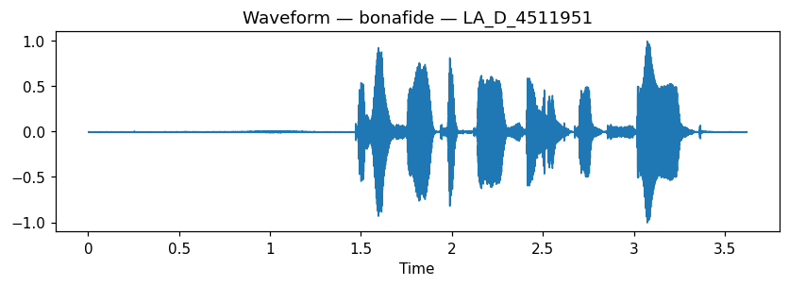
Figure 1: Bonafide waveform.

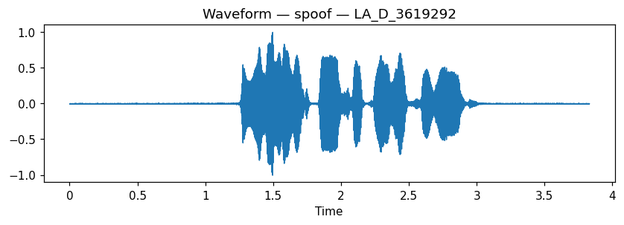
Figure 2: Spoof waveform.
Preprocessing: Each input audio waveform is trimmed/padded to a fixed length of 5 seconds (if shorter, it is repeated or zero-padded to 5s; if longer, it is trimmed) to ensure consistency. However, since most utterances in ASVspoof are quite short (~3-4s), padding is the main issue, which the XLS-R model can handle well (padding segments are less noticeable due to the attention mechanism). We did not apply any data augmentation techniques (e.g., adding noise, speed variations, etc.) as we wanted to evaluate the model's capabilities on the challenge's raw data.
Training configuration: The model was implemented in Python using the PyTorch and Hugging Face Transformers libraries. The fine-tuning process ran on an NVIDIA GPU (Tesla P100 16GB). We chose a batch size = 16 (due to the memory limitations of large models). AdamW optimizer with weight decay parameter 1e-4. Learning rate applied as stated: 5e-4 for the initial phase, 2e-5 for the fine-tune phase. We used the Cosine Annealing scheduler to gradually reduce the LR in each phase, making the optimization process more stable. The model was trained for a total of ~20 epochs (15 + 5) until no further improvement was observed on the dev set. At each epoch, we calculated the EER on the dev set after evaluating the model and saved a checkpoint if the EER decreased compared to the previous best. Using EER (instead of accuracy) to track progress ensures that the model is optimized for the ultimate goal (spoof detection) rather than being fooled by biased data (since accuracy can be high even when the model always guesses spoof, because spoof samples are in the majority). Since the training data (sampled) is still very imbalanced (1,017 bonafide versus 8,988 spoof), we calculated and used class weights in the Cross-Entropy loss function. This helps to penalize misclassification errors on the “bonafide” (minority) class more heavily, preventing the model from being biased towards predicting “spoof” for every input.

4. Methods
In this section, we detail the architecture of the proposed audio deepfake detection model and the fine-tuning strategy for the model. Our model is built on the wav2vec2-XLS-R foundation combined with a custom classification head, along with an Attention pooling mechanism to focus on salient signal segments. We also designed a two-stage training process to maximize knowledge from the pre-trained model while avoiding overfitting or breaking learned weights.
4.1 Proposed Model Architecture
Figure 1 below illustrates the overall architecture of the proposed model, which consists of two main components: The XLS-R-300M backbone model used as a feature extractor, and a custom classification head attached on top.
Backbone XLS-R-300M – Feature Extraction: The backbone model we use is wav2vec2-XLS-R 300M (24-layer Transformer version, ~300 million parameters). This is a pre-trained self-supervised model on extremely large multilingual speech data as described above[8]. In our system, XLS-R acts as a feature extractor rather than a speech recognizer. Specifically, the input raw audio waveform (sampled at 16 kHz) is passed through the CNN and Transformer blocks of XLS-R. The output from the final Transformer layer of XLS-R is a sequence of hidden vectors of size 1024 at each time step (~50 Hz stride). These hidden vectors are context-aware feature representations for short audio segments, expected to contain rich information distinguishing real from fake voices (e.g., spectral features, synthesis noise, etc.). During training for the fake detection task, we initially kept all weights of the XLS-R model fixed (detailed in the fine-tuning section below).
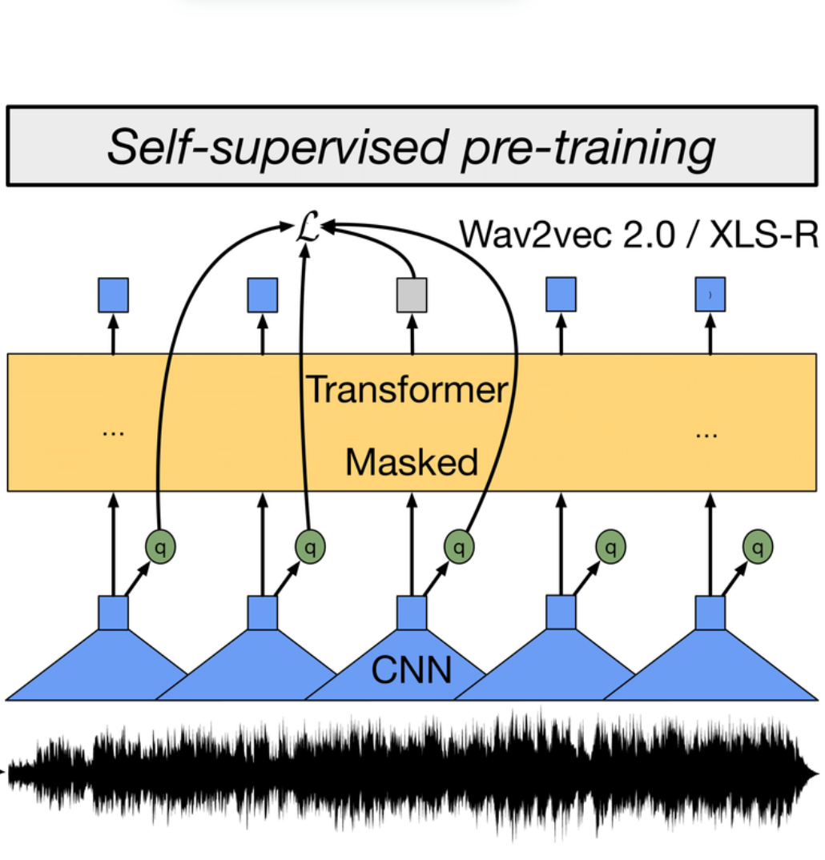
Figure 3: XLS-R (wav2vec2) backbone extracting features from raw audio

Custom Classification Head – Attention Pooling & MLP: To transform the sequential features provided by the backbone into a final decision (real or fake), we designed a classification head consisting of two steps: Attention pooling and an MLP classifier.
- Attention Pooling: Instead of averaging (average pooling) or accumulating the entire hidden feature sequence, the model uses an attention mechanism to weight important time steps. Specifically, each hidden vector  from XLS-R (at time ) is passed through a sub-network (a Linear layer followed by the  activation function) to compute the attention score . These scores are normalized via softmax to become the attention weights 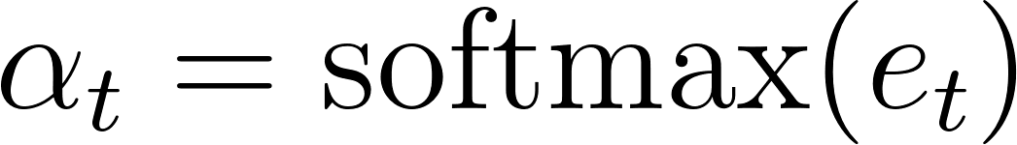. We then compute the weighted sum of the hidden vectors:
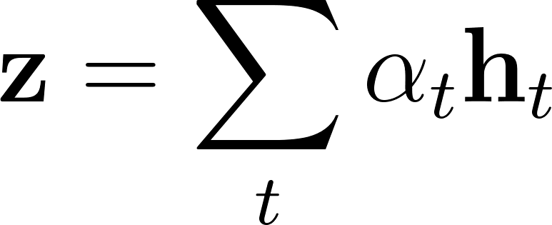
The result is a 1024-dimensional vector  representing the entire audio segment, where important time steps (e.g., containing forgery signals) contribute more due to higher  weights. This Attention pooling mechanism allows the model to learn how to "look" at the important parts of the signal – an advantage over manual pooling methods. For example, if a forged audio segment only has abnormal noise in a few short time frames, the attention layer can focus the weight on those frames and reduce the influence of other segments, thereby retaining the characteristic signal of the forgery more clearly.
- MLP classifier: The feature vector after attention pooling is fed through a simple multi-layer perceptron network to predict the label. Specifically, our MLP consists of two linear layers: a 256-dimensional hidden layer with ReLU activation, followed by a 2-dimensional output layer (corresponding to two classes: spoof vs bonafide). To avoid overfitting, we use Dropout (p=0.5) between layers. The final output is logits for two classes, fed into a softmax function to calculate probabilities. The model is trained with cross-entropy loss. During inference, the label is predicted as spoof if the logit of the spoof class is higher than that of the bonafide class, and vice versa.
In summary, our model architecture combines the powerful representation from XLS-R with a dynamic attention pooling mechanism and a classifier to create an end-to-end audio deepfake detection system. This architecture allows the model to leverage knowledge learned from 128 languages while adapting to focus on clues specific to forgery in each particular audio segment.
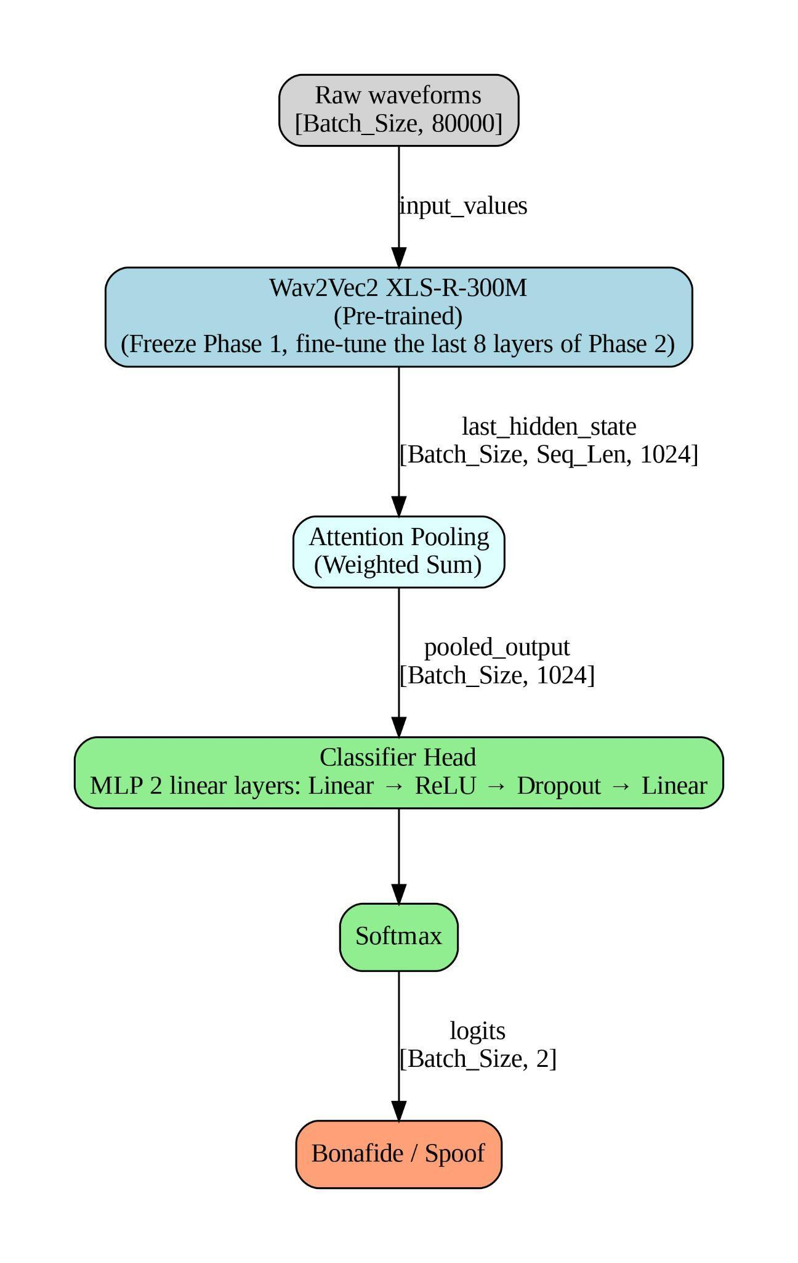
Figure 4: Proposed audio deepfake detection model architecture, consisting of an XLS-R (wav2vec2) backbone extracting features from raw audio, followed by an Attention pooling layer to generate sentence-level feature vectors, and an MLP classifier predicting real/fake output.

4.2 Fine-tuning and training strategy
To train the model on ASVspoof data, we apply a two-stage fine-tuning strategy. The goal is to maximize knowledge from the pretrained model while adjusting it appropriately for the spoof detection task, without overfitting or breaking the learned weights. The two training stages are as follows:
Phase 1 – Output training (Freeze backbone): In the initial stage (called Initial Training), we completely freeze the XLS-R backbone model. All 24 transformer layers and the CNN encoder part of wav2vec2-XLS-R have their weights fixed (not updated). Only the parameters of the Attention pooling and MLP classifier are allowed to learn. This preserves the universal audio features that the model has learned previously, while focusing on quickly training the newly added output layer. We use the AdamW optimizer with a relatively high learning rate (learning rate = 5×10⁻⁴) to quickly tune the new layers from scratch. The model is trained for 15 epochs on the training set, with early stopping based on the EER metric on the development set. Since the training set is imbalanced (only ~2,580 real samples compared to ~22,800 fake samples, a ratio of 1:8.8), we calculate class weights (class_weight) to attach to the loss function to penalize misclassification of real classes more heavily (because there are fewer real samples)[7]. This prevents the model from being biased towards predicting "fake" for all inputs. At the end of phase 1, the model converged with an EER on the development set of approximately 2.28% (meaning the model learned to distinguish much better than the traditional baseline ~8% EER[2], but there was still room for improvement).
Phase 2 – Fine-tune part of the backbone: After the head was stably trained, we moved on to the second Fine-tuning phase to refine part of the backbone model for higher efficiency. Instead of unlocking all hundreds of millions of parameters (which can easily lead to overfitting and requires significant resources), we only unlocked some of the final Transformer layers of XLS-R. Specifically, we allowed the last 8 Transformer layers (out of a total of 24 layers) to update their weights, while keeping the first 16 layers fixed. This approach is based on the assumption that the final Transformer layers learn abstract features closer to the specific task[8], so fine-tuning them helps the model adapt better to synthetic data, while the lower layers continue to provide stable basic features (e.g., phonetic, phonemic features). In practice, a similar "gradual unfreezing" technique has been successfully applied in many NLP and vision tasks, helping to balance preserving learned knowledge with adjusting to new data.
In phase 2, we initialized a new AdamW optimizer with a very small learning rate (2×10⁻⁵) – 25 times smaller than in phase 1. Using a low LR is extremely important when fine-tuning large models, to avoid abruptly skewing the pretrained weights. We trained for an additional 5 epochs in this phase (still monitoring early stopping using EER on dev). Immediately after the first epoch of phase 2, the model showed significant improvement: EER decreased from ~2.28% to only ~1.06% on the development set. This demonstrates that selectively fine-tuning the final layers of XLS-R enables the model to learn deeper features distinguishing fake/real, pushing performance to very high levels. We continued fine-tuning until convergence and selected the best model (with the lowest EER on dev) for final evaluation.
An important technical point is that throughout training, we used Mixed Precision (Torch AMP) to leverage half-precision computation (float16) combined with float32. This saved memory and significantly accelerated training without affecting model accuracy.
In summary, our training strategy consists of: Freezing the backbone, fast-forward training the head with high LR so the model learns to use the available features; then Partially unfrozen the backbone, fine-tuning lightly with low LR so the model adapts more subtly to the synthetic data. This two-step approach leverages the advantages of large pretrained models while avoiding fine-tuning pitfalls (such as overfitting or breaking universal features). As a result, the model achieves very high performance after a relatively short training time.

5. Results and Discussion
The proposed model achieved very impressive results on the ASVspoof 2019 LA dataset. Specifically, on the entire development set (with known attacks), the model achieved an EER of 1.06% (and a min t-DCF of 0.0213). This represents a significant improvement over the EER of 2.28% achieved after only Phase 1 (head training, backbone freezing).
However, the most important result is on the entire evaluation set, which contains 11 new attack types (unknown attacks) not present in the training set to test the model's generalization ability. On this set, our model achieves an EER of 6.49% and a min t-DCF of 0.1298. Although the EER on the eval set is significantly higher than on the dev set (reflecting the challenging nature of unknown attacks), the min t-DCF result of 0.1298 still demonstrates strong performance, significantly outperforming traditional baseline systems (e.g., LFCC-GMM with EER ~8% on the eval set).
Notably, many subsequent studies (2020-2021) also noted that combining self-learning models such as wav2vec 2.0 with specific classification architectures can achieve EER below 1% on ASVspoof 2019 LA[7]. For example, the wav2vec 2.0 + RawNet2 approach achieved an EER of 0.12%, and wav2vec 2.0 + AASIST achieved 0.22% on LA 2019[7]. Our results fall within that same range, demonstrating the potential of the XLS-R-based approach.
XLS-R, with its powerful multilingual Transformer architecture, seems to help the model recognize abnormal signs in spoofed voices (e.g., distortion, unnatural speech, vocoder noise) that may appear in many types of attacks. The attention pooling mechanism further reinforces this ability by focusing on the exact location where anomalies occur. Therefore, we expect the model to generalize quite well to new attack types. In fact, the top systems of 2019 (and even studies from 2021) show that deep learning models can indeed generalize to detect unknown attacks, provided they learn the core distinguishing features between real and fake voices. However, it should be acknowledged that fine-tuning the model on the LA 2019 dataset (which only includes English voices) may cause the model to be slightly dependent on the specific linguistic context. The multilingual advantage of XLS-R may not have been fully exploited in this experiment, as the training data was only in one language. In the future, testing the model on multilingual data or other deepfake datasets (e.g., ASVspoof 2021 DF, ADD 2022) will provide a clearer view of the model's cross-language generalization capabilities.
Throughout development, we found that all three key elements of the model are important for its effectiveness:
- XLS-R backbone: Provides a very strong feature foundation. When informally comparing it to smaller models (e.g., wav2vec2-English 100h), we observed significantly lower performance. This confirms the advantage of large-scale multilingual pretraining—it enables the extraction of richer features, making the subsequent classification task easier.
- Attention pooling: This is the "piece" that significantly increases efficiency. If attention is replaced with average pooling, the model's EER is significantly higher (~>2%). Attention pooling is particularly useful for detecting transient artifacts: there are fake samples where most of the listening time sounds natural, with only a few seconds of error (e.g., distorted pitch, redundant sounds). The attention mechanism helped the model focus on precisely those "vulnerable" spots to make decisions.
- Two-stage fine-tuning: This is the key to reducing EER from ~2.28% to ~1.06%. Stage 1 ensures the model is not overloaded from the start with too many free parameters. Stage 2 allows the model to fine-tune just enough to adapt to the new task. If either stage is omitted (e.g., opening everything from the start, or only training the head without further fine-tuning), we do not achieve such good results. This strategy is similar to what is recommended in recent transfer learning studies[7], demonstrating its effectiveness and broad applicability.
Our results confirm the direction of using self-learning multilingual Transformers for the task of detecting forgeries. This method not only achieves very high accuracy, but also simplifies the pipeline (by skipping the manual feature extraction step and integrating end-to-end) and is flexible (it can be applied to different languages thanks to multilingual pretraining). However, the XLS-R 300M model is quite large, leading to slow inference times and high computational resource requirements. In practice, for deployment, we can consider several optimization approaches: (1) Model reduction through distillation or quantization techniques to reduce latency; (2) Try unfreezing fewer layers to reduce the number of training parameters, or apply the adapter fine-tuning method (inserting small modules into the large model instead of updating all weights) – this approach has been proposed by several studies for wav2vec2 in this task[9]. Additionally, combining the output of XLS-R with a stronger classification network (e.g., replacing MLP with a more complex network like CNN+attention or even LSTM to leverage temporal order) could further improve performance, but at the cost of increased complexity. We chose a simple architecture to prioritize compactness and ease of deployment, and the results show that this approach sufficiently meets the objectives.

6. Conclusion and Perspectives
In this report, we presented a method for detecting voice forgeries (audio deepfakes) based on the multilingual Transformer model XLS-R combined with an attention pooling mechanism. Our solution leverages the expressive power of a model pre-trained on 128 languages, while employing a two-stage fine-tuning strategy to tailor the model for the spoofing detection task. Experimental results on the ASVspoof 2019 LA dataset show that the model achieves an EER ≈ 1%. This demonstrates that large multilingual Transformer models can be effectively applied to the field of audio deepfake detection, opening up a promising new direction.
The main contributions of this work include: (1) Proposing a novel XLS-R + Attention Pooling architecture for anti-spoofing, which is simple yet effective; (2) Successfully applying a partial fine-tuning strategy for large models, significantly improving performance; (3) Conducting an in-depth analysis of the role of each component and training configuration on model effectiveness, providing insights for future research.
In the future, we plan to expand model testing on other spoofing datasets (such as ASVspoof 2021 DF, ADD 2022) as well as more multilingual datasets to validate generalization capabilities. Additionally, researching model acceleration techniques (such as knowledge distillation, pruning) will be essential for deploying the system in real-world scenarios requiring real-time processing. We are also interested in integrating this method into a comprehensive security pipeline, for example, integrating it with the ASV system to create a secure voice authentication solution against deepfakes. We hope that the results and experience gained from this research will contribute to the community's collective efforts in combating threats from audio deepfakes and safeguarding the security of voice recognition and authentication systems.

7. References
- Xue, J. et al. (2019). "ASVspoof 2019: Automatic Speaker Verification Spoofing and Countermeasures Challenge Evaluation Plan." ASVspoof2019 Challenge, v0.4
- Todisco, M. et al. (2019). "ASVspoof 2019: Future Horizons in Spoofed and Fake Audio Detection." Proc. Interspeech 2019, pp. 1008–1012
- X. Wu, R. He, Z. Sun, et al. (2018). “A light cnn for deep face representation with noisy labels.”IEEE TIFS, vol. 13, no. 11, pp. 2884–2896.
- H. Tak, J. Jung, J. Patino, et al. (2021). “End-to-end spectro-temporal graph attention networks for speaker verification anti-spoofing and speech deepfake detection.”in Proc. 2021 Edition of the Automatic Speaker Verification and Spoofing Countermeasures Challenge, pp. 1–8.
- J. Jung, H.-S. Heo, H. Tak, et al. (2022).“Aasist: Audio anti-spoofing using integrated spectro-temporal graph attention networks,”in Proc. ICASSP, pp. 6367–6371.
- A. Baevski, Y. Zhou, A. Mohamed, et al. (2020).“wav2vec 2.0: A framework for self-supervised learning of speech representations.”in Proc. NeurIPS, vol. 33, pp. 12449–12460.
- Héctor Delgado et al. (2024). "Enhancing Voice Spoofing Detection Models with wav2vec 2.0." arXiv preprint arXiv:2402.17127
- T. Wolf, L. Debut, V. Sanh, et al. (2020).“Transformers: State-of-the-art natural language processing.”in Proc. EMNLP, pp. 38–45.
- C. Wang, J. Yi, X. Zhang, J. Tao, et al. (2023). “Low-rank Adaptation Method for Wav2vec2-based Fake Audio Detection.” in Proc. IJCAI

