An Illustrative Manuscript: Steady Diffusion in a Square Plate
A. Author^{1*}, B. Author²
¹Department of Example Studies, Example University, City, Country
²Example Research Institute, City, Country
Corresponding author: corresponding-author@example.org
Abstract
This synthetic manuscript demonstrates the document layout produced by the Skill. A steady diffusion problem in a square plate is used only as a vehicle for inline and display equations, a figure, a table and cross-references. No result in this document is research data.
Keywords: Layout test; Diffusion; Boundary-value problem.
1. Introduction
Steady diffusion in a homogeneous plate is a classical boundary-value problem. It is used here only to show how equations, figures and tables are set in the manuscript layout.
The unknown field is denoted by [FORMULA PREVIEW ONLY] and the plate occupies the domain [FORMULA PREVIEW ONLY] .
1.1 Governing equations
The flux is related to the gradient of the field by
[FORMULA PREVIEW ONLY] (1)
where q is the flux vector and k > 0 is the diffusivity. The weak form of the balance equation reads
[FORMULA PREVIEW ONLY] (2)
for every admissible test function v. A two-node discretisation leads to the matrix equation
[FORMULA PREVIEW ONLY] (3)
The relation in Eq. (1) and the weak form Eq. (2) are the reference model of the following section.
2. Illustrative numerical layout
The figure and the table below contain schematic data for layout testing only and must not be reported as research findings.
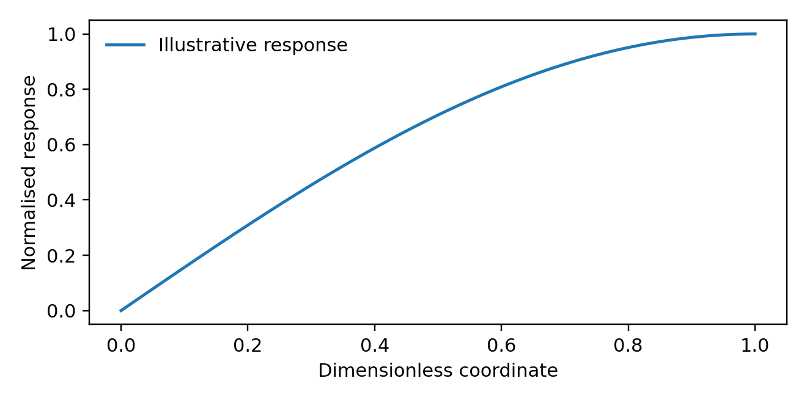
Figure 1. Illustrative variation of a normalised response with a dimensionless coordinate (layout demonstration only).
Table 1. Illustrative values used to test table formatting (not research data).
Case | Number of elements | Relative error
A | 4 | 0.010
B | 16 | 0.006
C | 64 | 0.003
Note: All values are synthetic.
The illustration is shown in Figure 1 and summarised in Table 1. Both are formatting examples only.
3. Conclusions
The example demonstrates a document workflow that combines a consistent manuscript layout with editable MathType equations, figures and tables. No physical conclusion is drawn from the illustrative data.
References
[1] Example reference entry: replace with a verified bibliographic record before submission.

