朱素果，女，河南人。2012年之前分别就读于河南师范大学（河南，新乡）和广东工业大学（广东，广州），所学专业为计算机科学与技术和计算机应用技术。2012年至2016年期间，就读于北京邮电大学计算机学院智能通信软件与多媒体北京市重点实验室，主要对视频目标的检测与跟踪进行研究，于2016年7月获得计算机科学与技术专业博士学位。2016年8月起任职于杭州电子科技大学计算机学院，并成为图形图像研究所计算机动画于多媒体分析实验室(Computer Animation and Multimedia Analysis LAB, CAMALAB)和复杂系统建模与仿真教育部重点实验室的成员。主要从事计算机视觉中的目标检测、目标跟踪等的研究工作，对机器学习中的稀疏表示与编码、字典学习、监督学习以及神经网络具有浓厚的兴趣。参与国家自然科学基金项目多项，发表SCI论文3篇，会议论文1篇。

She received is currently with School of Computer Science and Technology in Hangzhou Dianzi University (HDU), and a member of Computer Animation and Multimedia Analysis Lab (CAMA-LAB), led by Prof. Jun Yu. She received the B.S. Degree in School of Computer Science and Technology from Henan Normal University, Xinxiang, China, Master’s Degree from School of Computer from Gugangdong University of Technology, Guangzhou, China and Ph.D. Degree in School of Compute Science and Technology from Beijing University of Posts and Telecommunications, Beijing, China, respectively. Her Ph.D. advisor is Prof. Junping Du. Her research interests mainly include object detection, object tracking ( discriminate / generative ) in the field of computer vision and sparse representation/coding, dictionary learning, supervised learning and neural network in machine learning. She

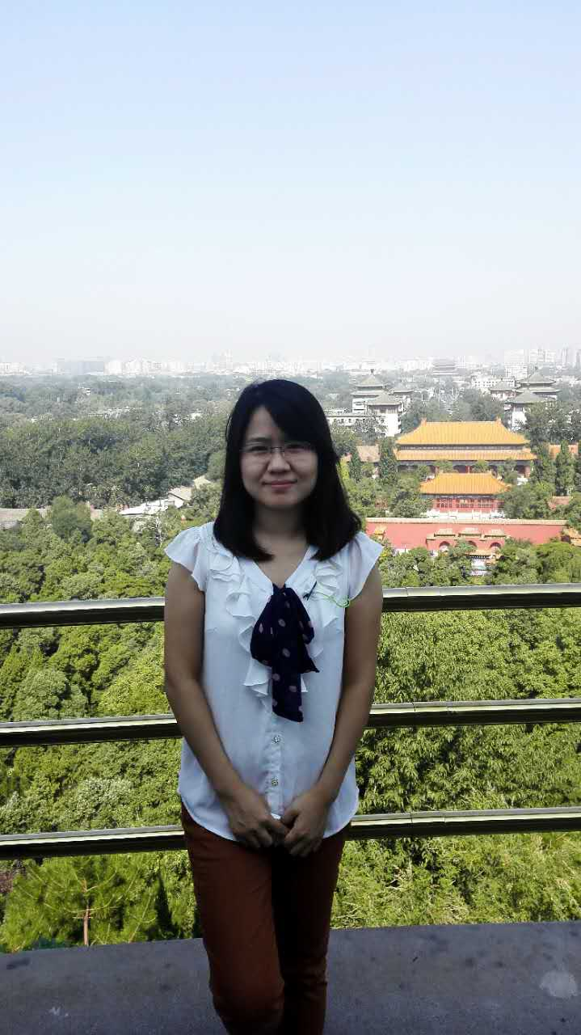

---------------------------------------------------------------------------

Ph.D in School of Computer Science and Technology

Beijing Key Lab of Intelligent Telecommunication Software and Multimedia

Beijing University of Posts and Telecommunications

Faculty Member of CAMA-LAB

School of Computer Science and Technology

Hangzhou Dianzi University

For teaching or research related issues: [zsg2016@hdu.edu.cn](mailto:zsg2016@hdu.edu.cn)

https://github.com/victoryguo

Biography

She is currently with School of Computer Science and Technology in Hangzhou Dianzi University (HDU), and a member of Computer Animation and Multimedia Analysis Lab (CAMA-LAB), led by Prof. Jun Yu. She received the B.S. Degree in School of Computer Science and Technology from Henan Normal University, Xinxiang, China, Master’s Degree from School of Computer from Gugangzhou University of Technology, Guangzhou, China and Ph.D. Degree in School of Compute Science and Technology from Beijing University of Posts and Telecommunications, Beijing, China, respectively. Her Ph.D. advisor is Prof. Junping Du.

Education

Beijing University of Posts and Telecommunications, Sep. 2012 – July 2016

Ph.D Degree in School of Computer Science and Technology, Advisor: Prof. Junping Du.

Guangzhou University of Technology, Sep. 2009 – July 2012

Master’s Degree in School of Computer

Correspondence:

P-CONTACT

Suguo Zhu

School of Computer Science and Technology

Hangzhou Dianzi University

Hangzhou 310018, China

CAMA-LAB, Room 512/514,

North First Building of Teaching and Research,

Xiasha Campus of Hangzhou Dianzi University

Research Interests

Computer vision: object detection, object tracking ( discriminate / generative )

Machine Learning: Sparse representation / coding, dictionary learning, supervised learning, neural network, etc.