Assignment 3

Huan Shiuan Huang

CSMC 203

Grigoriy A. Grinberg

7/12/2020

Pseudocode

stringInBounds(String plainText)

Declare a boolean variable called bool

For i from 0 to the size of plainText

If the number i character of plainText is less than LOWER_BOUND or

This character is greater than UPPER_BOUND

Bool is equal to false

End if

End for

Return bool

End method

encryptCaesar(String plainText, int key)

Declare a String variable called encryptText initialize to “”

Declare a char variable called temp

For i from 0 to the size of plainText

Temp equal to (char)(plainText.charAt(i)+key)

While temp is greater than UPPER_BOUND

Temp equal to temp – RANGE

End while

encryptedText equal to encryptedText + temp

End for

Return encryptedText

End method

encryptBellaso(String plainText, String bellasoStr)

Declare a String called encryptText initialize to “”

Declare a char variable called temp

Declare a int variable called key

For i from 0 to the size of plainText

key equal to bellasoStr.charAt(i%bellasoStr.length())

temp equal to (char)(plainText.charAt(i)+key)

while temp is larger than UPPER_BOUND

temp equal to temp – RANGE

End while

encryptedText equal to encryptedText + temp

End for

Return encryptedText

End method

decryptCaesar(String encryptedText, int key)

Declare a String called decryptText initialize to “”

Declare a int variable called temp

For i from 0 to the size of encryptedText

Temp equal to encryptedText.charAt(i)-key

While temp is lower than LOWER_BOUND

Temp equal to temp + RANGE

End while

decryptText equal to decryptText + (char)temp

End for

Return decryptText

End method

decryptBellaso(String encryptedText, String bellasoStr)

Declare a String called decryptText initialize to “”

Declare a int variable called temp

Declare a int variable called key

For i from 0 to the size of encryptedText

key equal to bellasoStr.charAt(i%bellasoStr.length());

While temp is lower than LOWER_BOUND

Temp equal to temp + RANGE

End while

decryptText equal to decryptText + (char)temp

End for

Return decryptText

End method

Test Plan

|  |  |  |  |  |  |
| --- | --- | --- | --- | --- | --- |
| Input text | Input Key | Encrypted (method1) | Encrypted (method2) | Decrypt (method1) | Decrypt (method2) |
| MY NAME IS HUAN SHIUAN HUANG | 15 | \(/]P\T/X"/W$P]/"WX$P]/W$P]V |  | MY NAME IS HUAN SHIUAN HUANG |  |
| I AM A STUDENT IN CMSC 203 | 50 | ;R3?R3REFG67@FR;@R5?E5R$"% |  | I AM A STUDENT IN CMSC 203 |  |
| MY NAME IS HUAN SHIUAN HUANG | COMPUTER |  | P(-^V!J2L"-X*US2VWV%V"%ZXP[W |  | MY NAME IS HUAN SHIUAN HUANG |
| I AM A STUDENT IN CMSC 203 | MONTGOMERY |  | V/O!'P-X&.QT\('X[%U& R.F7B |  | I AM A STUDENT IN CMSC 203 |
| HELLO EVERYONE~~~~~~ | 5 | MJQQT%J[JW^TSJCCCCCC |  | HELLO EVERYONE>>>>>> |  |

Screen snapshots

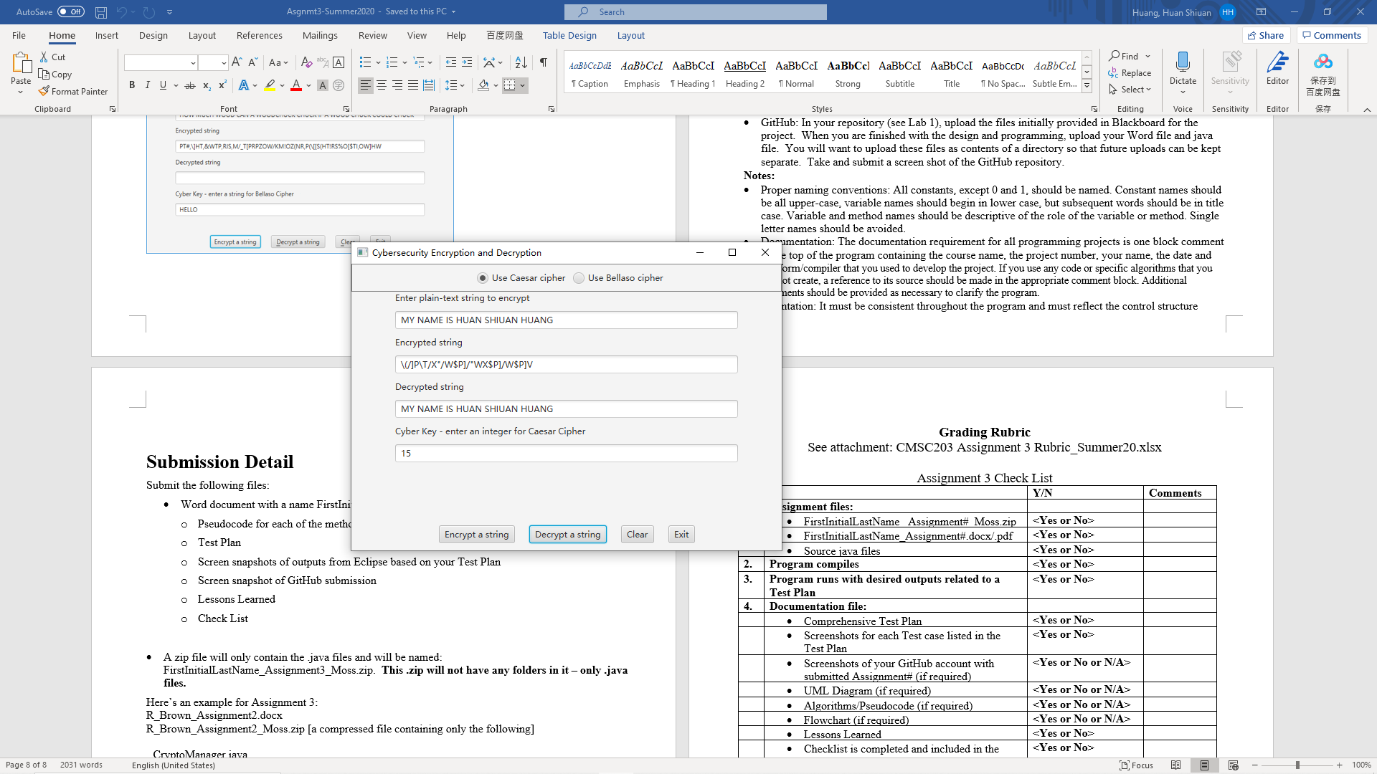

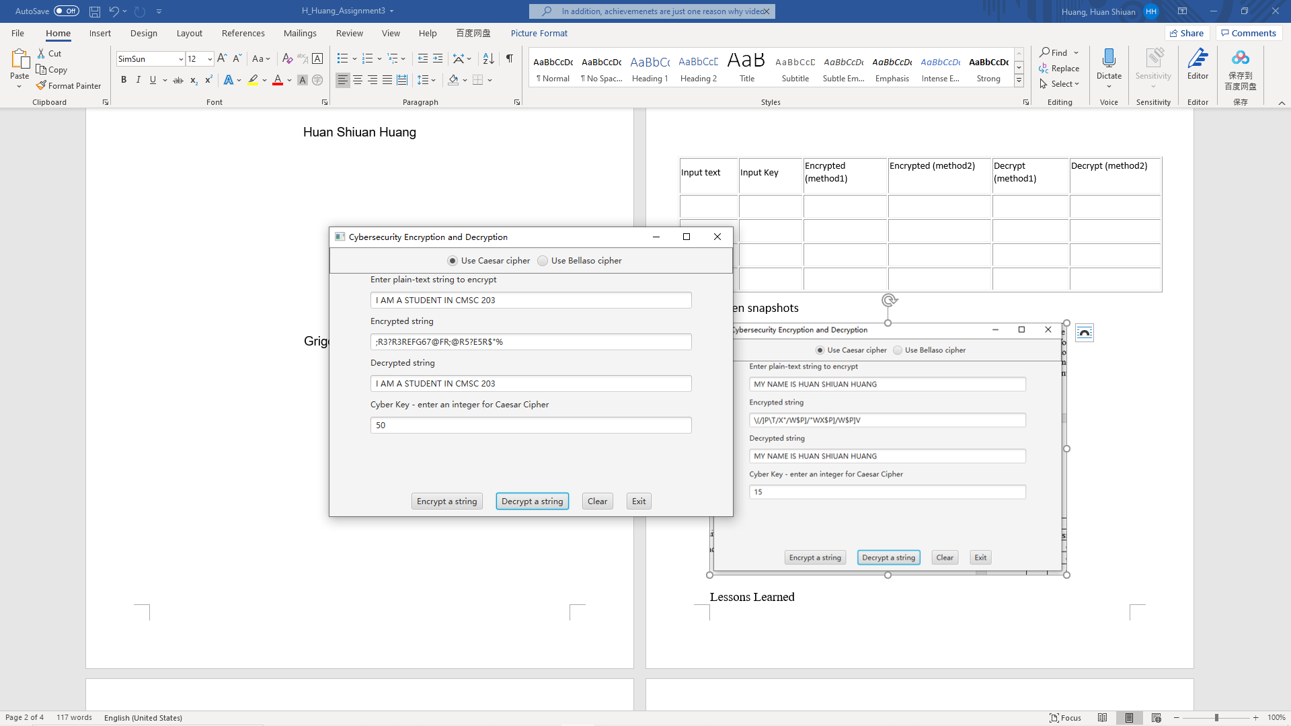

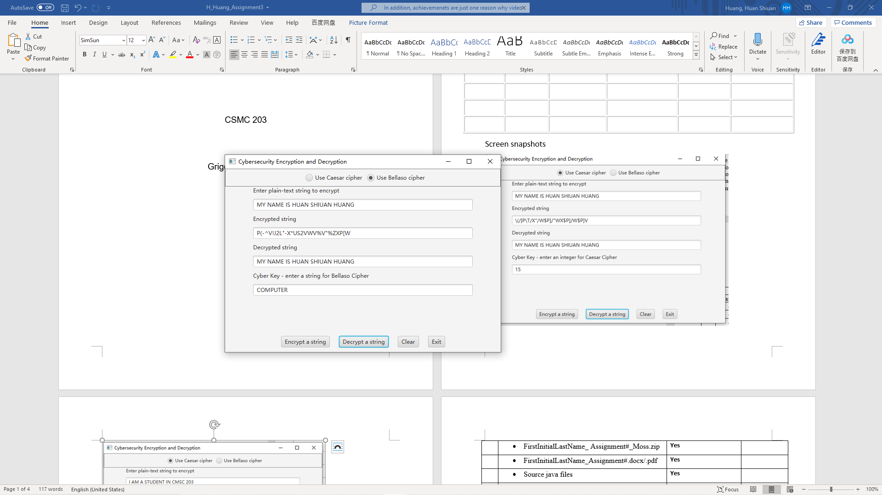

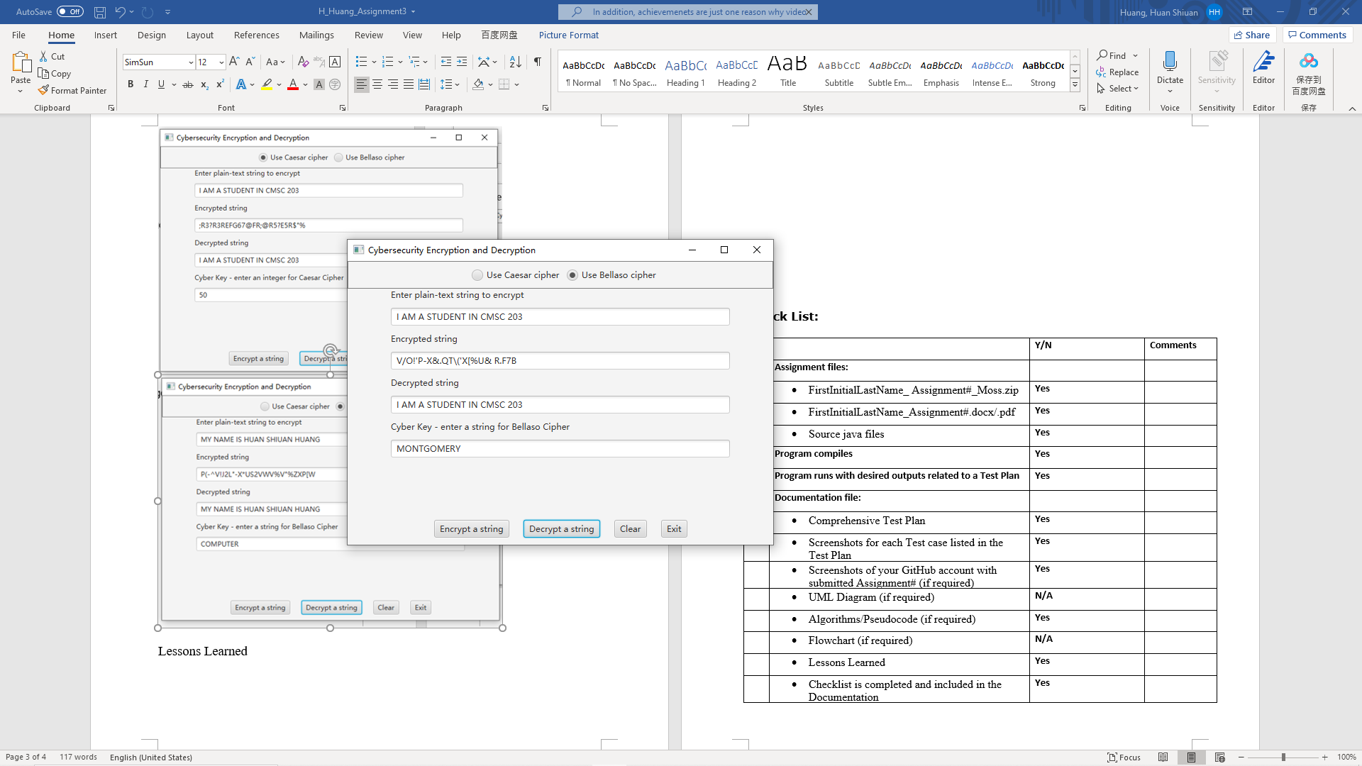

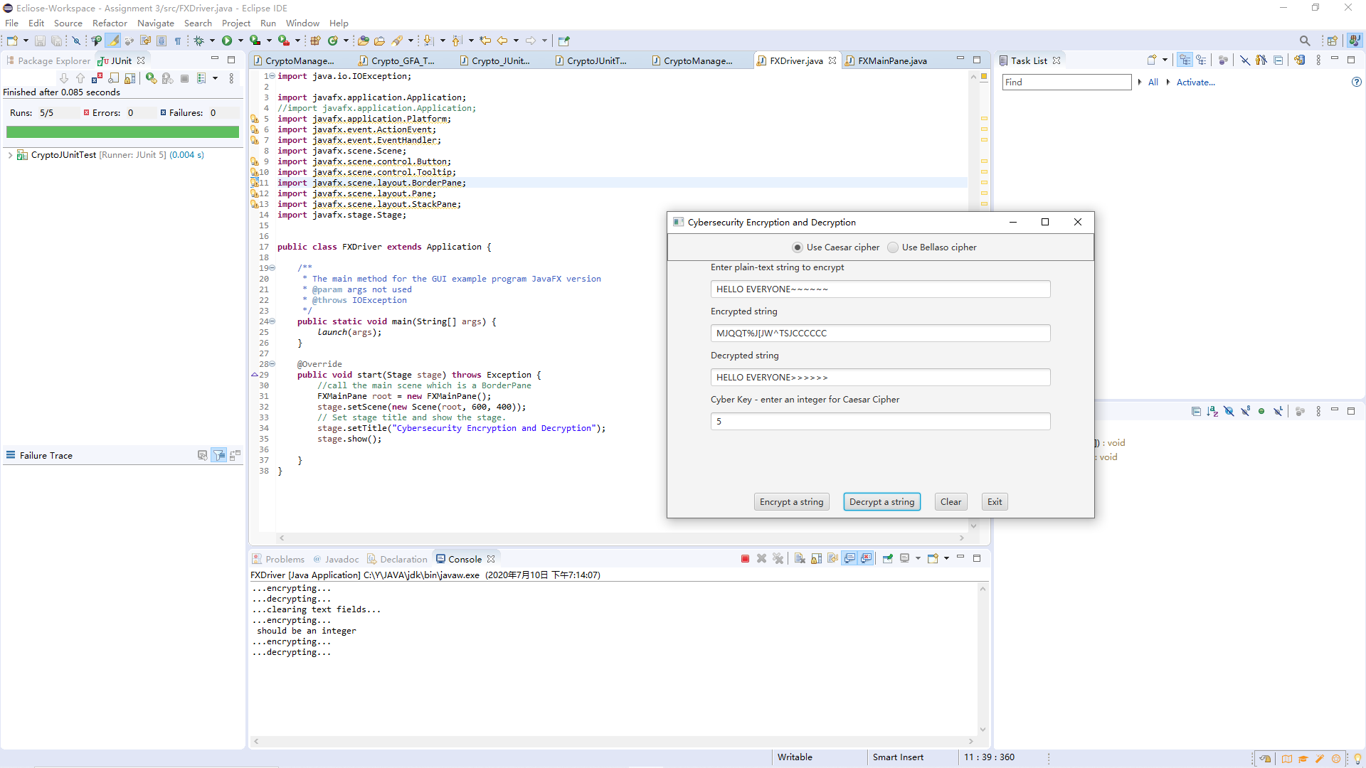

Lessons Learned

**Check List:**

|  |  |  |  |
| --- | --- | --- | --- |
| **#** |  | **Y/N** | **Comments** |
|  | **Assignment files:** |  |  |
|  | * FirstInitialLastName_ Assignment#_Moss.zip | **Yes** |  |
|  | * FirstInitialLastName_Assignment#.docx/.pdf | **Yes** |  |
|  | * Source java files | **Yes** |  |
|  | **Program compiles** | **Yes** |  |
|  | **Program runs with desired outputs related to a Test Plan** | **Yes** |  |
|  | **Documentation file:** |  |  |
|  | * Comprehensive Test Plan | **Yes** |  |
|  | * Screenshots for each Test case listed in the Test Plan | **Yes** |  |
|  | * Screenshots of your GitHub account with submitted Assignment# (if required) | **Yes** |  |
|  | * UML Diagram (if required) | **N/A** |  |
|  | * Algorithms/Pseudocode (if required) | **Yes** |  |
|  | * Flowchart (if required) | **N/A** |  |
|  | * Lessons Learned | **Yes** |  |
|  | * Checklist is completed and included in the Documentation | **Yes** |  |