Huan Shiuan Huang

CMSC 204

11/23/2020

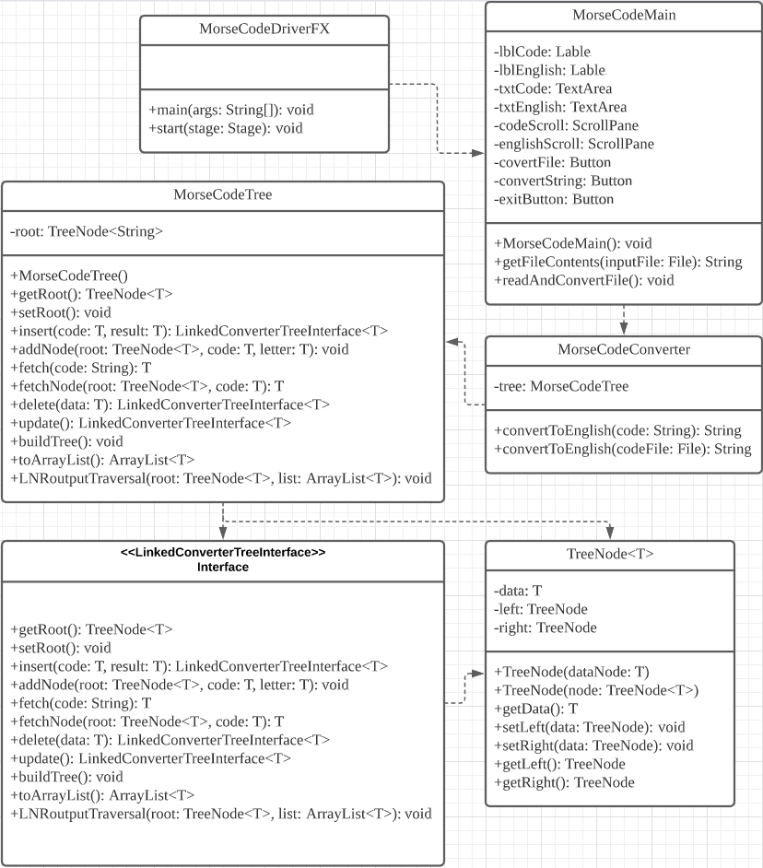

Learning Experience

What I learn from this project is that how to create a tree and using recursion method. How to insert the node.

What I struggle with is how to find an error from my code. I spend many time in fixing my program.

I will also do my best in the next project.

GitHub

