青 岛 理 工 大 学
课程实验报告

课程名称 | Jsp 开发技术 | 班级 | 软件186 | 实验  日期 | 2021-4-07
姓名 | 侯宇轩 | 学号 | 201811050392 | 实验  成绩
实验  名称 | 实验3：简历查询与菜单权限设置
实验  目的  及要  求 | 实验目的：  1. 本实验任务实现“Q-ITOffer”锐聘网站后台管理系统的用简历分野查询、简历详情展示、依据用户角色的操作菜单展示功能  2. 通过本次实验掌握相关知识的灵活应用：  a) EL表达式中与范围有关的隐含对象  b) EL表达式中pageContext隐含对象  c) JSTL核心标签库  实验要求：  1. 简历分页查询  2. 简历详情展示  3. 依据用户角色的操作菜单展示。
实  验  环  境 | JDK 1.8、 Eclipse、Tomcat8、MySql数据库
实  验  内  容 | - 简历分页查询：  - 首先通过菜单目录发起一个分页查询简历列表数据的Servlet请求，通过此请求查询显示出第一页的简历列表数据。  - 创建简历信息请求处理Servlet文件ResumeServlet.java，再次Servlet中调用数据库操作类ResumeDAO.java获得请求页分页信息，将请求页分页信息封装到一个通用的分页JavaBean类PageBean的对象中，然后将此分页JavaBean对象存入请求域属性响应回简历分页列表页面resumeLise.jsp  - 创建简历信息数据库操作DAO类ResumeDAO.java，实现对简历总记录数的查询以及对请求页码的数据查询  - 创建简历基本信息JavaBean文件ResumeBasicinfo.java用来封装从数据库中查询到的简历基本信息数据  - 创建通用分页JavaBean文件PageBean.java，实现对每页显示记录数、当前页码、总页数、总记录数、请求页数据、是否有上一页、是否有下一页的封装。  - 创建简历分页列表JSP页面resumeLise.jsp，从请求域中获取请求页简历数据，进行行遍历显示。  - 简历详情展示：  - 在简历分页显示页面resumeList.jsp中发起对某个简历详情进行查看的Servlet请求  - 在简历信息处理Servlet文件ResumeServlet.java中增加对简历详情查看请求的处理，在此请求中调用简历数据库操作类ResumeDAO获取并封装该简历的详细数据，再将封装的数据对象转发到简历详情展示页面resumeView.jsp。  - 创建简历信息数据库操作DAO类ResumeDAO.java，实现对简历详细数据的查询和封装。  - 创建简历详情展示JSP页面resumeView.jsp，从请求域中获取简历信息JavaBean对象进行数据输出显示  - 依据用户角色的系统菜单设置  - 通过模版top.html 文件创建系统主界面的头部JSP页面top.jsp，从而使用EL表达式获取并输出显示当前登录的用户姓名。  - 通过模版left.html文件创建系统主界面的操作菜单页面left.jsp，从而使用JSTL和EL依据用户的角色进行相应操作菜单的展示。  - 修改主界面文件main.html中对新头部文件和操作菜单文件的链接地址。
算  法  描  述  及  实  验  步  骤 | - 简历分页查询  首先简历一个简历Bean类，每个对象存储一条简历记录的所有数据，在简历一个PageBean类，存储页面记录信息，用来存储不同页码下的所有记录数量，其中属性有一个List 用来存储这个页面的所有简历数据，总页数通过总记录数实现类似上取整进行计算，所以在Servlet操作类中，查询一页2条记录时候要更新pageSize属性，并根据查询数据库获得的记录数量先更新pageBean的总记录数，在根据总记录数和pageSize 更新总页数  - 简历详情展示  通过url参数来判断查询的类别，只实现了查询全部简历的功能，通过JSTL将当前页面下PageBean存储的记录显示，总页数也通过pageBean 的属性获得，上一页通过Servlet 处理将结果pageBean存入，然后再转至当前页面，通过EL表达式根据当前的pageBean类进行显示。
调  试  过  程  及  实  验  结  果 | 第一页  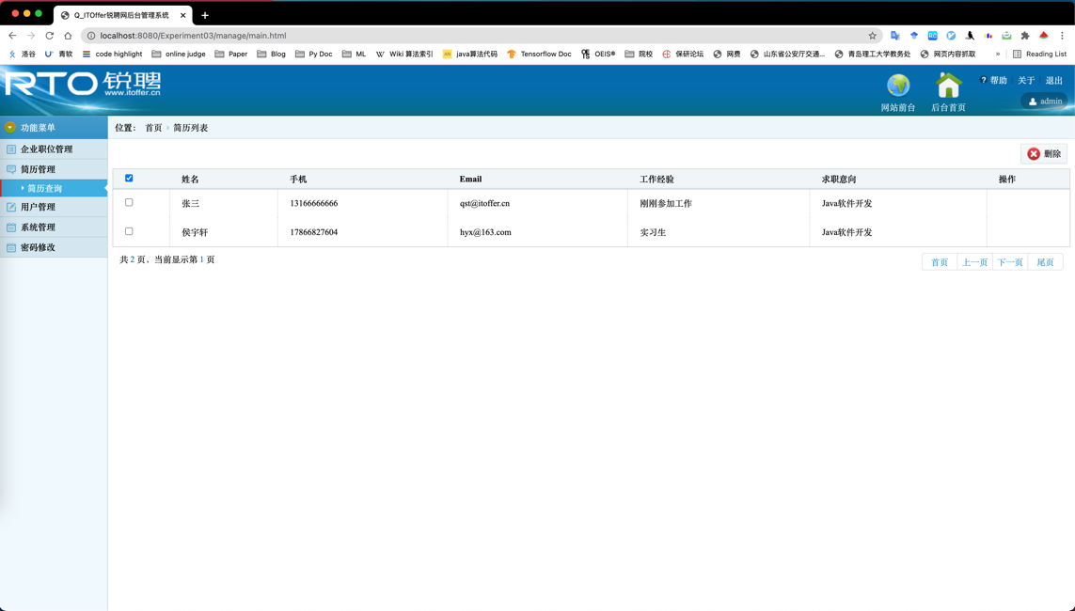  第二页  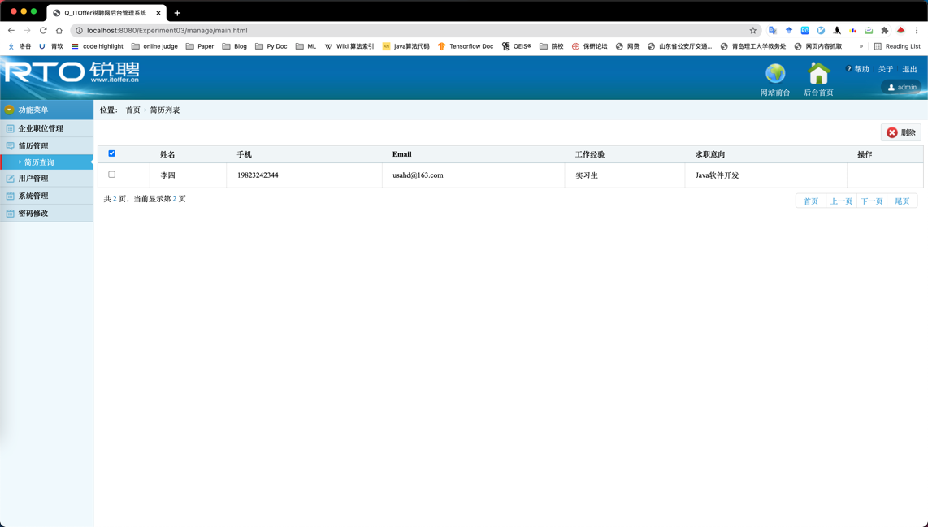
总  结 | 通过定义Bean类，并将对象存入会话域，可以实现根据不同的操作动态的分页查询以及分页显示，是一个分页显示的经典解决方案，在后期学习框架时可以看看使用框架时如何实现的。

关键代码：
实验二基础上新增代码：
ResumeBasicinfo.java
package com.hyx.javabean;

import java.text.ParseException;
import java.text.SimpleDateFormat;
import java.util.Date;

public class ResumeBasicinfo {
// 简历标识
private int basicinfoId;
// 姓名
private String realName;
// 性别
private String gender;
// 出生日期
private Date birthday;
// 当前所在地
private String currentLoc;
// 户口所在地
private String residentLoc;
// 手机
private String telephone;
// 邮件
private String email;
// 求职意向
private String jobIntension;
// 工作经验
private String jobExperience;
// 头像
private String headShot;
// 简历信息更新结果
private String resumeUpdateResult;
// 出生日期的字符串形式
private String strbirthday;

public ResumeBasicinfo() {}

public ResumeBasicinfo(String realName, String gender, Date birthday,
String currentLoc, String residentLoc, String telephone,
String email, String jobIntension, String jobExperience) {
super();
this.realName = realName;
this.gender = gender;
this.birthday = birthday;
this.currentLoc = currentLoc;
this.residentLoc = residentLoc;
this.telephone = telephone;
this.email = email;
this.jobIntension = jobIntension;
this.jobExperience = jobExperience;
}

public String getResumeUpdateResult(){
return resumeUpdateResult;
}

public void setStrbirthday(String strbirthday){
this.strbirthday = strbirthday;
SimpleDateFormat sdf = new SimpleDateFormat("yyyy-MM-dd");
Date birthdayDate = null;
try {
birthdayDate = sdf.parse(strbirthday);
} catch (ParseException e) {
birthdayDate = null;
}
this.setBirthday(birthdayDate);
}
public String getStrbirthday(){
return strbirthday;
}
public int getBasicinfoId() {
return basicinfoId;
}
public void setBasicinfoId(int basicinfoId) {
this.basicinfoId = basicinfoId;
}
public String getRealName() {
return realName;
}
public void setRealName(String realName) {
this.realName = realName;
}
public String getGender() {
return gender;
}
public void setGender(String gender) {
this.gender = gender;
}
public Date getBirthday() {
return birthday;
}
public void setBirthday(Date birthday) {
this.birthday = birthday;
SimpleDateFormat sdf = new SimpleDateFormat("yyyy-MM-dd");
this.strbirthday = sdf.format(birthday == null ? "" : birthday);
}
public String getCurrentLoc() {
return currentLoc;
}
public void setCurrentLoc(String currentLoc) {
this.currentLoc = currentLoc;
}
public String getResidentLoc() {
return residentLoc;
}
public void setResidentLoc(String residentLoc) {
this.residentLoc = residentLoc;
}
public String getTelephone() {
return telephone;
}
public void setTelephone(String telephone) {
this.telephone = telephone;
}
public String getEmail() {
return email;
}
public void setEmail(String email) {
this.email = email;
}
public String getJobIntension() {
return jobIntension;
}
public void setJobIntension(String jobIntension) {
this.jobIntension = jobIntension;
}
public String getJobExperience() {
return jobExperience;
}
public void setJobExperience(String jobExperience) {
this.jobExperience = jobExperience;
}

public String getHeadShot() {
return headShot;
}

public void setHeadShot(String headShot) {
this.headShot = headShot;
}

}

PageBean.java
package com.hyx.javabean;

import java.util.ArrayList;
import java.util.List;

import com.hyx.javabean.ResumeBasicinfo;
import com.hyx.dao.ResumeBasicinfoDao;
import com.hyx.dao.UserDao;

public class PageBean<T> {
// 每页显示记录数
private int pageSize = 10;
// 当前页码
private int pageNo = 1;
// 总页数
private int totalPages;
// 总记录数
private int recordCount;
// 每页数据记录集合
private List<T> pageData = new ArrayList<T>(); // 泛型数据

// 是否有下一页
private boolean hasNextPage;
// 是否有上一页
private boolean hasPreviousPage;
public int getPageSize() {
return pageSize;
}
public void setPageSize(int pageSize) {
this.pageSize = pageSize;
}
public int getPageNo() {
return pageNo;
}
public void setPageNo(int pageNo) {
this.pageNo = pageNo;
}
public int getTotalPages() {
// 实现上取整
return (recordCount + pageSize - 1) / pageSize;
}
public void setTotalPages(int totalPages) {
this.totalPages = totalPages;
}
public int getRecordCount() {
return recordCount;
}
public void setRecordCount(int recordCount) {
this.recordCount = recordCount;
}
public List<T> getPageData() {
return pageData;
}
public void setPageData(List<T> pageData) {
this.pageData = pageData;
}
public boolean isHasNextPage() {
return hasNextPage;
}
public void setHasNextPage(boolean hasNextPage) {
this.hasNextPage = hasNextPage;
}
public boolean isHasPreviousPage() {
return hasPreviousPage;
}
public void setHasPreviousPage(boolean hasPreviousPage) {
this.hasPreviousPage = hasPreviousPage;
}
public PageBean(int pageSize, int pageNo, int totalPages, int recordCount, List<T> pageData, boolean hasNextPage,
boolean hasPreviousPage) {
super();
this.pageSize = pageSize;
this.pageNo = pageNo;
this.totalPages = totalPages;
this.recordCount = recordCount;
this.pageData = pageData;
this.hasNextPage = hasNextPage;
this.hasPreviousPage = hasPreviousPage;
}
public PageBean() {
super();
}
}

ResumeServlet.java
package com.hyx.servlet;

import java.io.IOException;

import javax.lang.model.element.TypeElement;
import javax.servlet.ServletException;
import javax.servlet.annotation.WebServlet;
import javax.servlet.http.HttpServlet;
import javax.servlet.http.HttpServletRequest;
import javax.servlet.http.HttpServletResponse;

import com.hyx.service.ResumeService;
import com.hyx.javabean.PageBean;
import com.hyx.javabean.ResumeBasicinfo;
import java.util.*;

@WebServlet("/ResumeServlet")
public class ResumeServlet extends HttpServlet {
private static final long serialVersionUID = 1L;

public ResumeServlet() {
super();
}

// URl 参数
protected void doGet(HttpServletRequest request, HttpServletResponse response) throws ServletException, IOException {
// 接受请求参数
request.setCharacterEncoding("utf-8");
String type = request.getParameter("type");

// type = list 查找所有简历
if("list".equals(type)) {
String t = request.getParameter("pageNo");
String str = t == null ? "1" : t;
int pageNo = Integer.valueOf(str);

ResumeService service = new ResumeService();

int Pagesz = 2;
List <ResumeBasicinfo> list = service.get(pageNo, Pagesz);
PageBean <ResumeBasicinfo> pageBean = new PageBean<>();
int count = service.getCount();
pageBean.setPageSize(Pagesz);
pageBean.setPageNo(pageNo);
pageBean.setRecordCount(count);
pageBean.setPageData(list);
pageBean.setTotalPages(pageBean.getTotalPages());

request.setAttribute("pageBean", pageBean);
request.getRequestDispatcher("manage/resumeList.jsp").forward(request, response);
}
// 查找 指定 id 简历
else {

}
}

protected void doPost(HttpServletRequest request, HttpServletResponse response) throws ServletException, IOException {
doGet(request, response);
}
}

ResumeService.java
package com.hyx.service;

import java.util.List;

import com.hyx.dao.ResumeBasicinfoDao;
import com.hyx.javabean.ResumeBasicinfo;

public class ResumeService {

public List<ResumeBasicinfo> get(int pageNo, int pageSize) {
ResumeBasicinfoDao dao = new ResumeBasicinfoDao();
return dao.select(pageNo, pageSize);
}

public int getCount() {
// 调用数据层得到
ResumeBasicinfoDao dao = new ResumeBasicinfoDao();
return dao.selectCount();
}

}

ResumeBasicinfoDAO.java
package com.hyx.dao;

import java.sql.ResultSet;
import java.sql.SQLException;
import java.util.ArrayList;
import java.util.List;

import com.hyx.javabean.ResumeBasicinfo;
import com.hyx.util.DBUtil;
import com.mysql.cj.protocol.Resultset;

public class ResumeBasicinfoDao {

public int selectCount() {
int cnt = 0;
java.sql.Connection conn = DBUtil.getConnection();
java.sql.PreparedStatement pstmt = null;
String sql = "select count(*) from itoffer.tb_resume_basicinfo";
Resultset rs = null;

try {
pstmt = conn.prepareStatement(sql);
rs = (Resultset) pstmt.executeQuery();
if(((ResultSet) rs).next()) {
cnt = ((ResultSet) rs).getInt(1);
}
} catch (SQLException e) {
e.printStackTrace();
}
return cnt;
}

public List<ResumeBasicinfo> select(int pageNo, int pageSize) {
List <ResumeBasicinfo> list = new ArrayList <ResumeBasicinfo> ();
java.sql.Connection conn = DBUtil.getConnection();
java.sql.PreparedStatement pstmt = null;

String sql = "select * from itoffer.tb_resume_basicinfo limit ?,?";
Resultset rs = null;

try {
pstmt = conn.prepareStatement(sql);
pstmt.setInt(1, (pageNo - 1) * pageSize);
pstmt.setInt(2, pageSize);
rs = (Resultset) pstmt.executeQuery();

while(((ResultSet) rs).next()) {
ResumeBasicinfo resume = new ResumeBasicinfo();
resume.setBasicinfoId(((ResultSet) rs).getInt("basicinfo_id"));
resume.setRealName(((ResultSet) rs).getString("realname"));
resume.setTelephone(((ResultSet) rs).getString("telephone"));
resume.setEmail(((ResultSet) rs).getString("email"));
resume.setJobExperience(((ResultSet) rs).getString("job_experience"));
resume.setJobIntension(((ResultSet) rs).getString("job_intension"));
list.add(resume);
}
} catch (Exception e) {
e.printStackTrace();
}
return list;
}
}

left.html
<!DOCTYPE html PUBLIC "-//W3C//DTD XHTML 1.0 Transitional//EN" "http://www.w3.org/TR/xhtml1/DTD/xhtml1-transitional.dtd">
<html xmlns="http://www.w3.org/1999/xhtml">
<head>
<meta http-equiv="Content-Type" content="text/html; charset=utf-8" />
<title>Q_ITOffer锐聘网后台管理系统</title>
<link href="../css/left.css" rel="stylesheet" type="text/css" />
<script language="JavaScript" src="../js/jquery.js"></script>
<script type="text/javascript">
$(function(){
//导航切换
$(".menuson li").click(function(){
$(".menuson li.active").removeClass("active")
$(this).addClass("active");
});

$('.title').click(function(){
var $ul = $(this).next('ul');
$('dd').find('ul').slideUp();
if($ul.is(':visible')){
$(this).next('ul').slideUp();
}else{
$(this).next('ul').slideDown();
}
});
})
</script>
</head>
<body style="background:#f0f9fd;">
<div class="lefttop"><span></span>功能菜单</div>
<dl class="leftmenu">
<dd>
<div class="title"> <span><img src="../images/leftico01.png" /></span>企业职位管理</div>
<ul class="menuson">
<li><cite></cite><a href="jobApplyList.html" target="rightFrame">职位申请查看</a><i></i></li>
<li><cite></cite><a href="jobList.html" target="rightFrame">职位管理</a><i></i></li>
<li><cite></cite><a href="companyList.html" target="rightFrame">企业管理</a><i></i></li>
</ul>
</dd>
<dd>
<div class="title"> <span><img src="../images/leftico02.png" /></span>简历管理</div>
<ul class="menuson">
<li><cite></cite><a href="../ResumeServlet?type=list" target="rightFrame">简历查询</a><i></i></li>
</ul>
</dd>
<dd>
<div class="title"><span><img src="../images/leftico03.png"/></span>用户管理</div>
<ul class="menuson">
<li><cite></cite><a href="userList.html" target="rightFrame">用户管理</a><i></i></li>
</ul>
</dd>
<dd>
<div class="title"><span><img src="../images/leftico04.png" /></span>系统管理</div>
<ul class="menuson">
<li><cite></cite><a href="userOnline.html" target="rightFrame">在线用户</a><i></i></li>
</ul>
</dd>
<dd>
<div class="title"><span><img src="../images/leftico04.png" /></span>密码修改</div>
</dd>
</dl>
</body>
</html>

resumeList.jsp
<%@ page language="java" contentType="text/html; charset=UTF-8"
pageEncoding="UTF-8"%>

<%@taglib prefix="c" uri="http://java.sun.com/jsp/jstl/core"%>

<!DOCTYPE html>
<html>
<head>
<meta charset="utf-8">

<%
String path = request.getContextPath();
String basePath = request.getScheme() + "://" + request.getServerName() + ":" + request.getServerPort() + path + "/";

%>

<base href="<%=basePath%>">
<title>简历列表</title>
<link href="css/manageadmin.css" rel="stylesheet" type="text/css" />
</head>
<body>
<div class="place"> <span>位置：</span>
<ul class="placeul">
<li><a href="index.html">首页</a></li>
<li>简历列表</li>
</ul>
</div>
<div class="rightinfo">
<div class="tools">
<ul class="toolbar">
<li><span><img src="images/t03.png" /></span><a href="#">删除</a></li>
</ul>
</div>
<table class="imgtable">
<thead>
<tr>
<th ><input name="" type="checkbox" value="" checked="checked"/></th>
<th>姓名</th>
<th>手机</th>
<th>Email</th>
<th>工作经验</th>
<th>求职意向</th>
<th>操作</th>
</tr>
</thead>

<tbody>
<c:forEach items = "${requestScope.pageBean.pageData}" var="resume">
<tr height = "50px">
<td><input name = "" type = "checkbox" value = "" /></td>
<td>${resume.realName }</td>
<td>${resume.telephone } </td>
<td>${resume.email}</td>
<td>${resume.jobExperience}</td>
<td>${resume.jobIntension}</td>
<td><a href = "ResumeServlet?type=select&resumeId=${resume.basicinfoId}" class></td>

</tr>
</c:forEach>
</tbody>
</table>

<div class="pagin">
<div class="message">共<i class="blue"> ${pageBean.getTotalPages()} </i>页，当前显示第&nbsp;<i class="blue">${pageBean.pageNo}&nbsp;</i>页</div>
<ul class="paginList">
<li class="paginItem"><a href="ResumeServlet?type=list&pageNo=1">首页</a></li>
<li class="paginItem"><a href="ResumeServlet?type=list&pageNo=${pageBean.pageNo - 1}">上一页<span class="pagepre"></span></a></li>
<li class="paginItem"><a href="ResumeServlet?type=list&pageNo=${pageBean.pageNo + 1}">下一页<span class="pagenxt"></span></a></li>
<li class="paginItem"><a href="ResumeServlet?type=list&pageNo=${pageBean.totalPages}">尾页</a></li>
</ul>
</div>
</div>
</body>
</html>

