课程实验报告
课程名称 | 《Java程序设计》 | 班级 | 软件186 | 实验日期 | 2020.5.28
姓名 | 侯宇轩 | 学号 | 201811050392 | 实验成绩
实验名称 | 实验7：JDBC的应用
实  验  目  的  及  要  求 | 掌握Java JDBC的使用方法
实  验  环  境 | Win 7 或 Win 10  Jdk1.7或以上版本  Eclipse 4.4或以上版本  MySQL5.7或以上版本
实  验  内  容 | 利用String、GUI、JDBC等类实现一个信息管理系统（如学籍管理系统、工资管理系统等），编程实现如下功能：  （1）在MySQL数据库中建立一个数据库、表，表中至少设置4个字段；  （2）搭建GUI图形化操作界面；  （3）注册相关事件，在GUI界面上实现数据的增、删、改、查功能；  （4）系统要有一定的数据合法性的检查功能；  （5）体现出是自己的工作量，界面至少显示作者的班级、姓名、学号。
算  法  描  述  及  实  验  步  骤 | 运用数据库可视化软件建立表，插入一些初始的数据  封装一个数据库连接类，其他功能需要连接数据库直接调用即可  查询全部功能，直接执行sql 语句即可  根据Sno查询  增加功能，  从textField输入数据  修改功能，根据Sno找到并updata即可  判断是否为空  弹出成功提示框  将数据将入到show这个textarea中显示  修改功能，根据Sno找到并updata即可  判断是否为空  判断是否为空  判断是否为空  弹出正确输入的提示框  False  弹出成功提示框  False  弹出正确输入的提示框  弹出成功提示框  False  弹出成功提示框  False  True  True
调  试  过  程  及  实  验  结  果 | - 通过mysql 数据库可视化软件创建表格  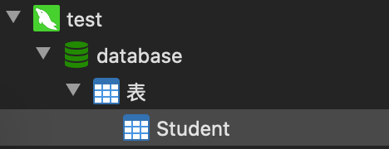  2. 通过mysql 数据库可视化软件插入一定的初始数据  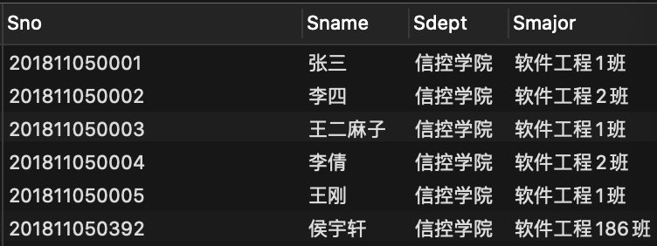  3.通过windowbuilder 搭建界面  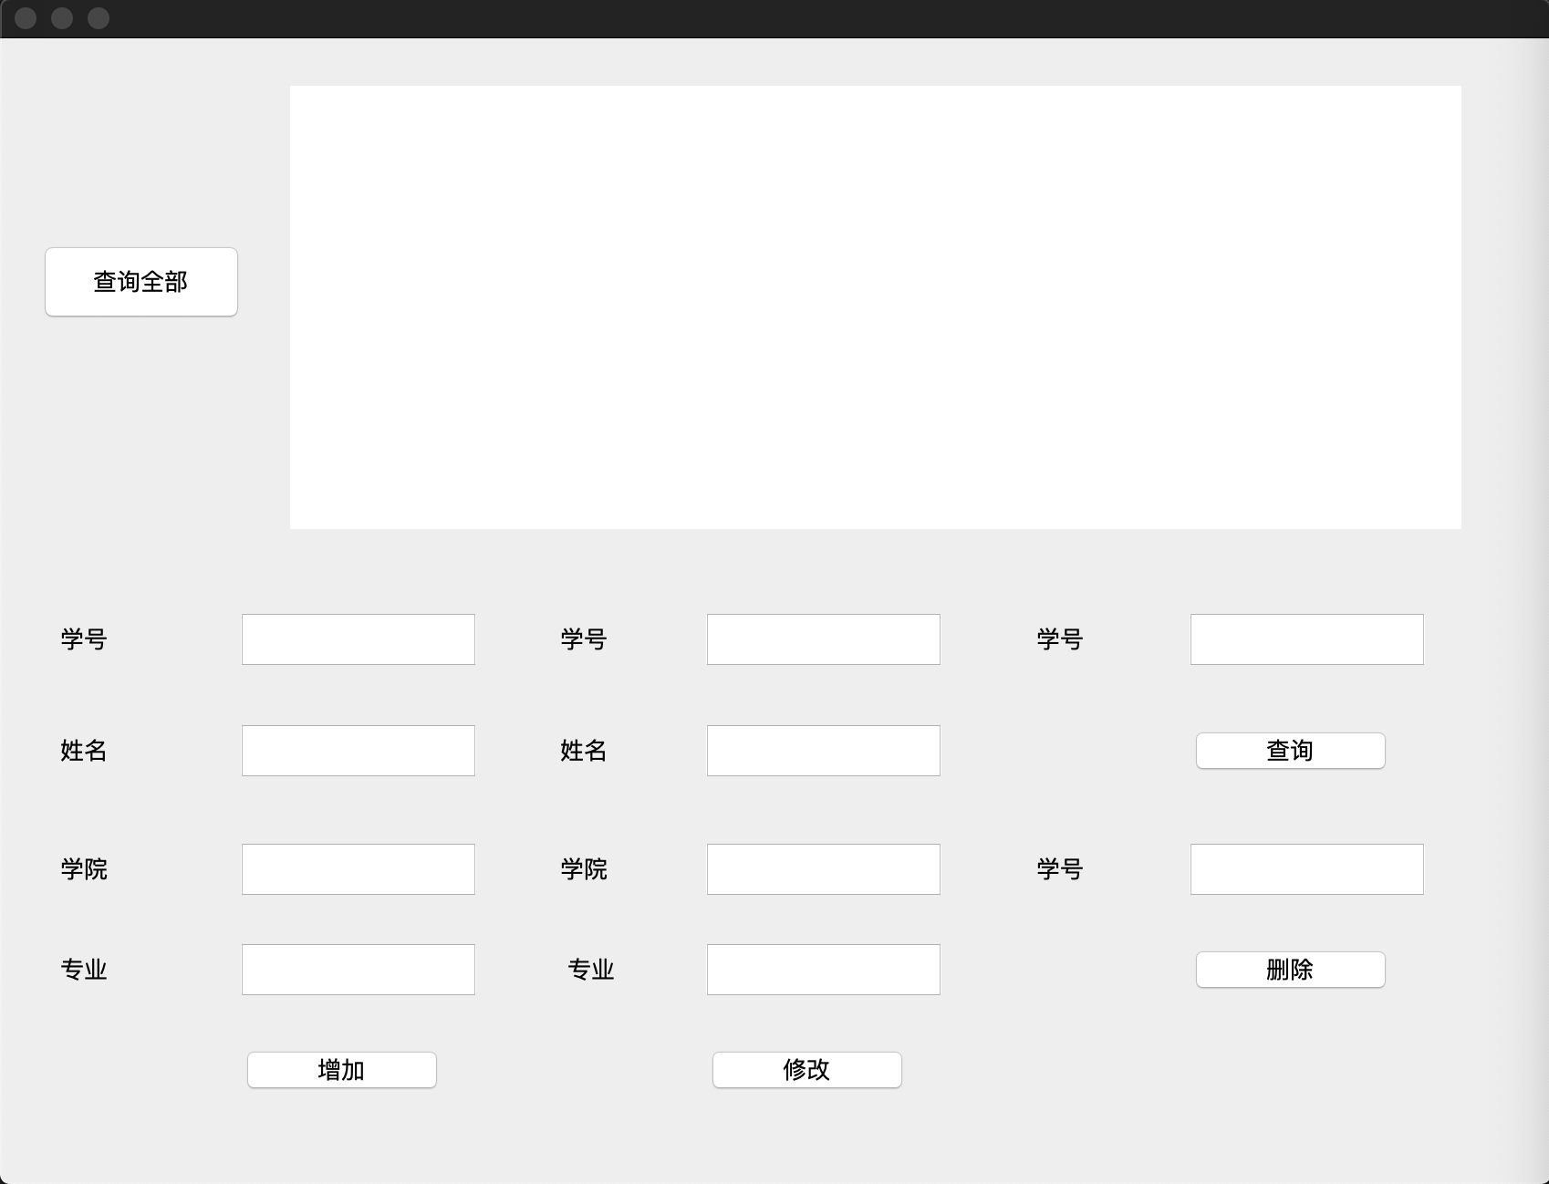  4.查询全部功能  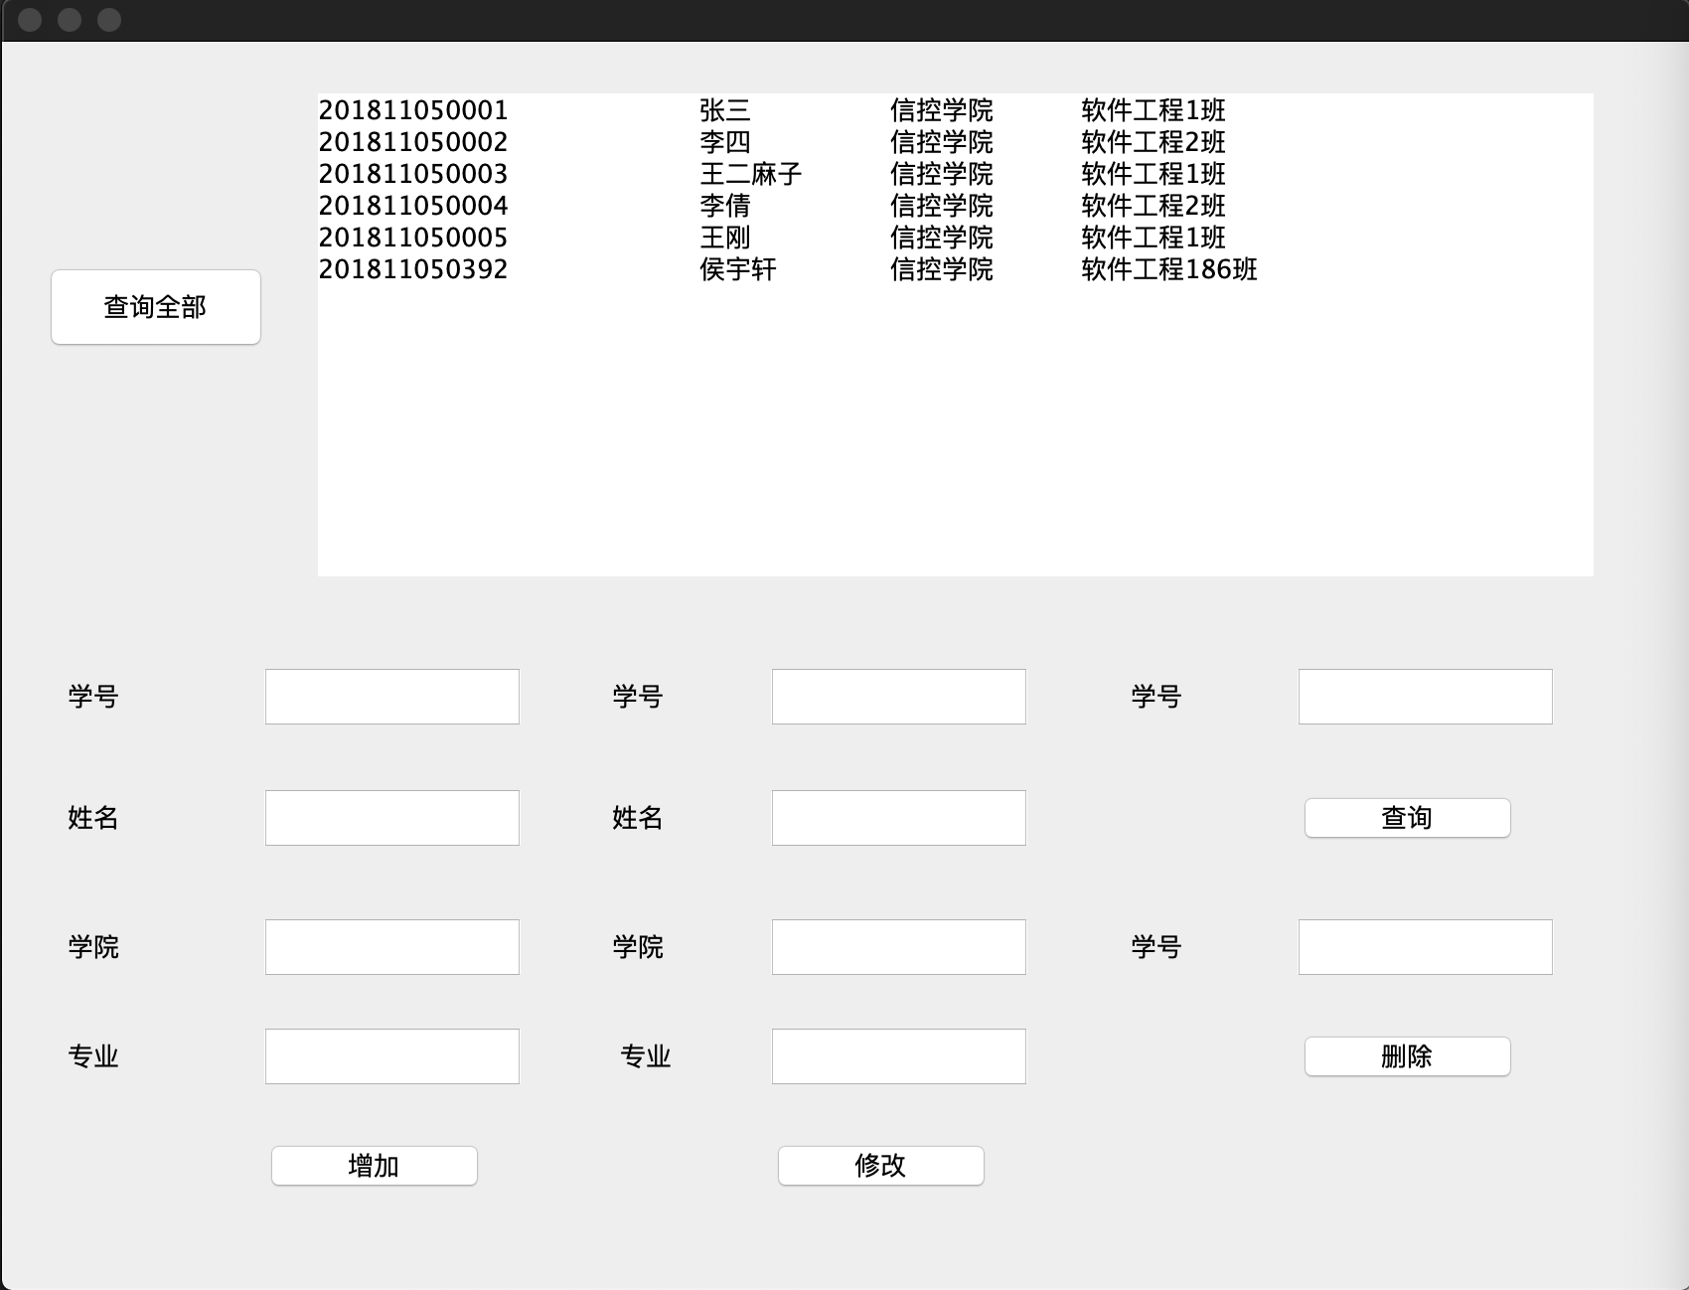  5．增加功能及合法性检验  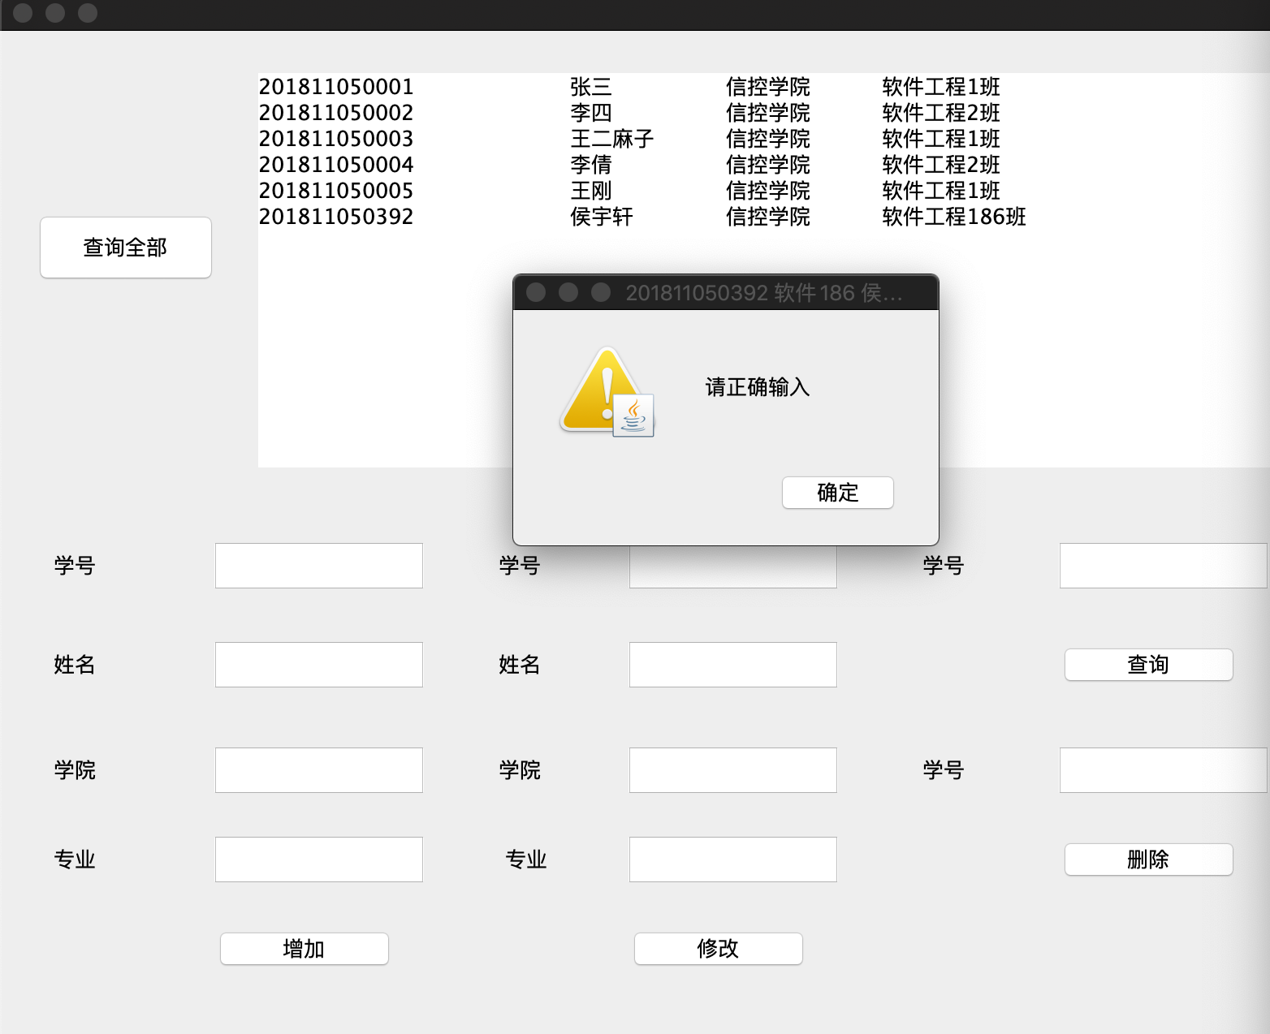  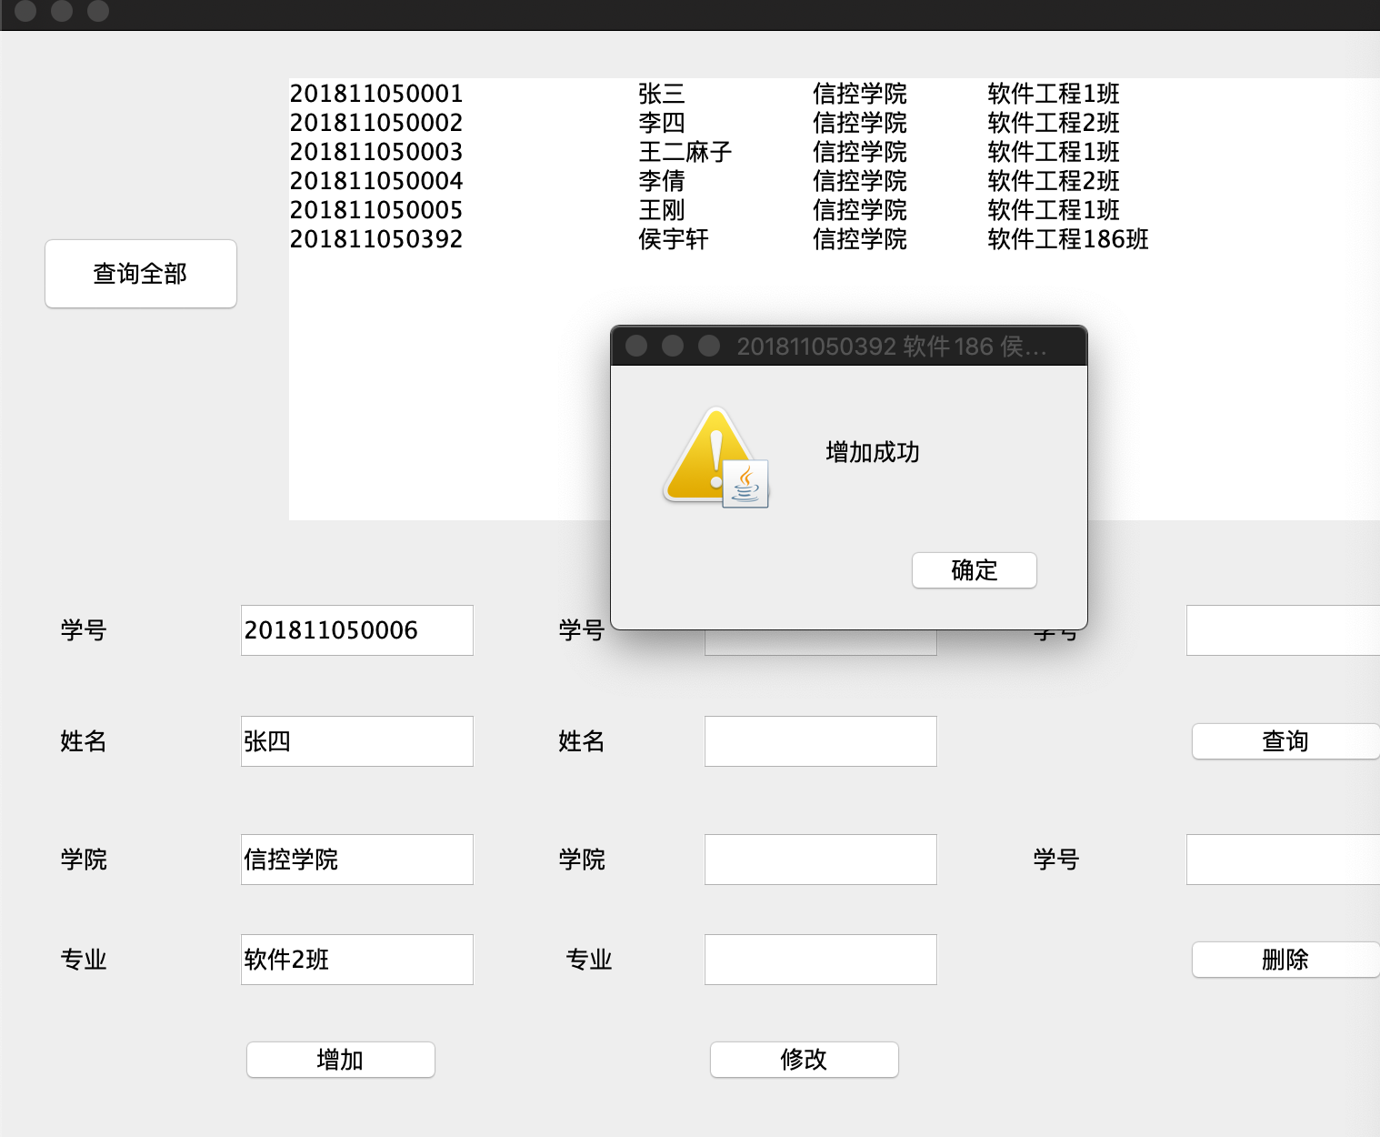  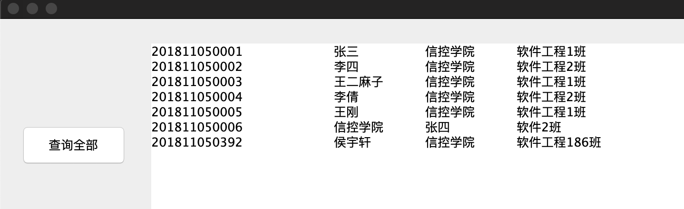  6. 修改功能及合法性检验  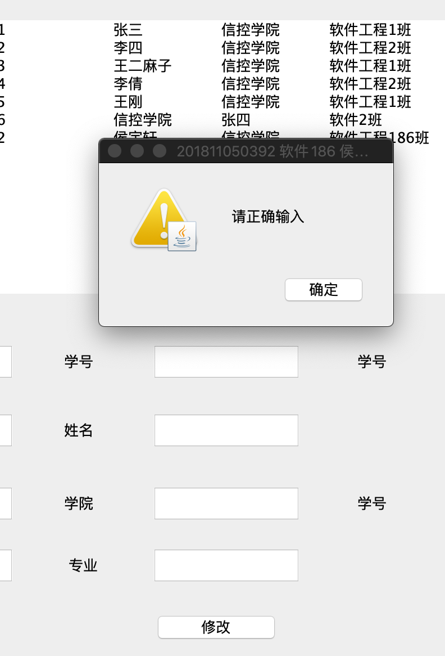  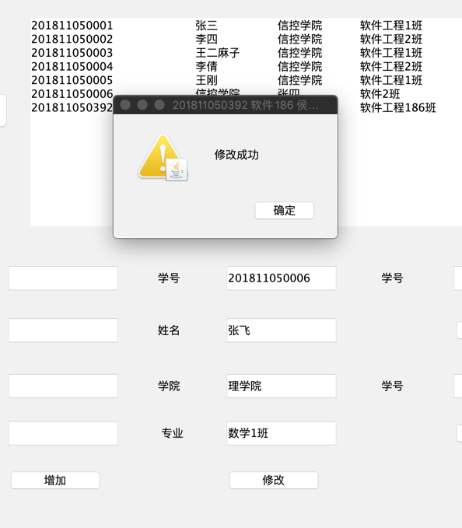  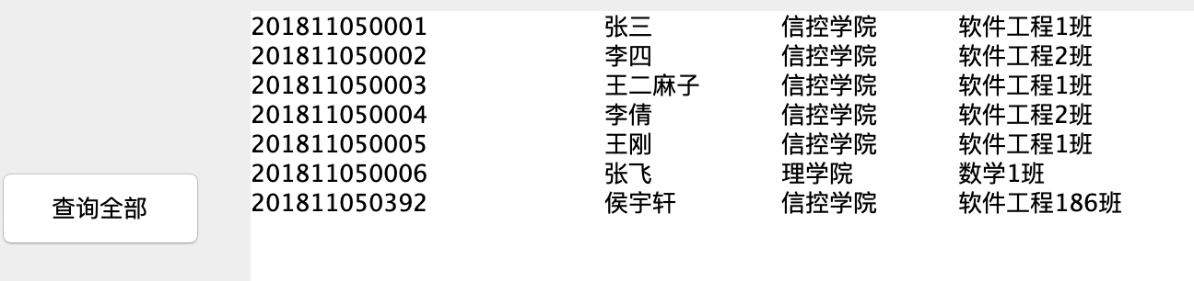  7.根据表的主键学号Sno查询以及合法性检验  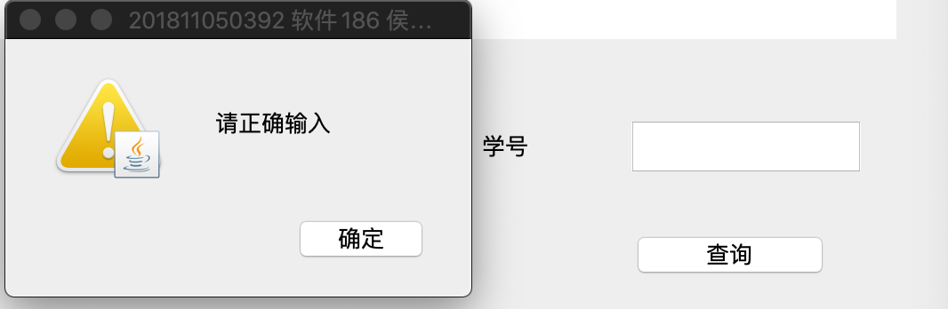  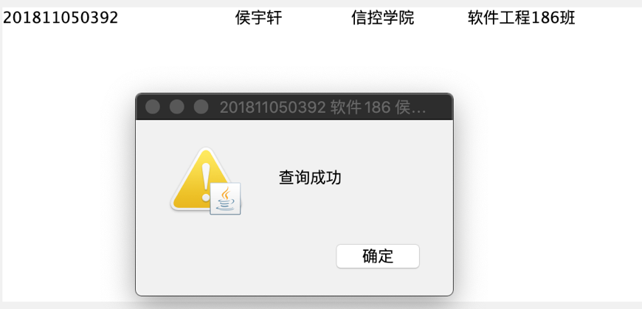  8.根据主键学号Sno 删除某一条记录  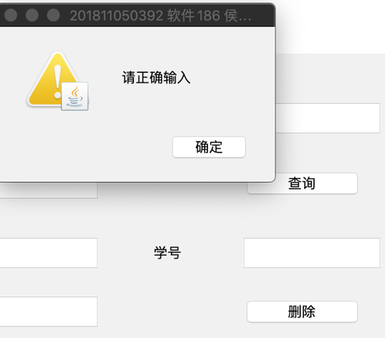  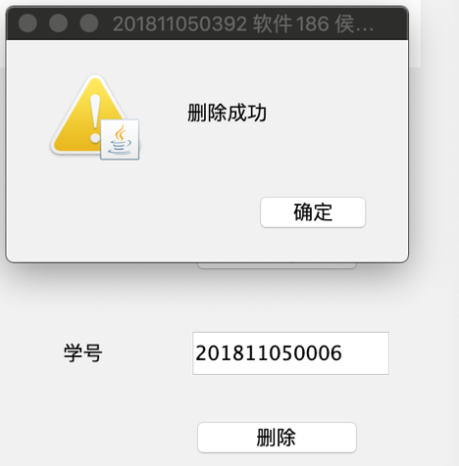  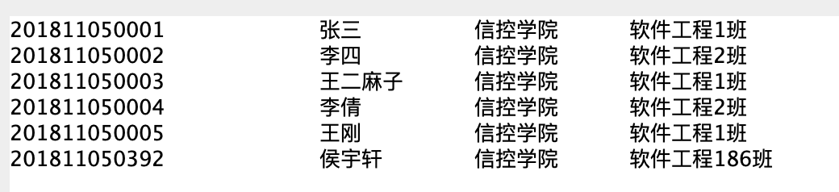
总  结 | Java编写桌面应用程序使用mysql作为程序的数据库可以很方便的在java内执行增删改查的功能，数据的合法性检查需要做的详细，这样可以提高程序的交互体验，界面搭建上，使用windowbuilder可以很快速的实现，但需要将每一个区域对象名区分清楚，避免功能出错。
附  录 | - 通过mysql 数据库可视化软件创建表格  - create table Student(  - Sno char(50),  - Sname char(50),  - Sdept char(50),  - Smajor char(50),  - primary key(Sno)  - );  2. 通过mysql 数据库可视化软件插入一定的初始数据  - insert Student values('201811050392','侯宇轩','信控学院','软件工程186班');  - insert Student values('201811050001','张三','信控学院','软件工程1班');  - insert Student values('201811050002','李四','信控学院','软件工程2班');  - insert Student values('201811050003','王二麻子','信控学院','软件工程1班');  - insert Student values('201811050004','李倩','信控学院','软件工程2班');  - insert Student values('201811050005','王刚','信控学院','软件工程1班');  3. 主界面搭建  - package 实验七;  - import java.sql.*;  - import java.util.*;  - import java.awt.EventQueue;  - import java.awt.TextArea;  - import javax.swing.JFrame;  - import javax.swing.JTextField;  - import com.sun.jdi.connect.spi.Connection;  - import javax.swing.JLabel;  - import javax.swing.JOptionPane;  - import javax.swing.JButton;  - import java.awt.event.ActionListener;  - import java.beans.Statement;  - import java.awt.event.ActionEvent;  - import javax.swing.JTextArea;  - public class win {  - private JFrame frame;  - private JTextField left1;  - private JTextField left2;  - private JTextField left3;  - private JTextField left4;  - private JTextField mid1;  - private JTextField mid2;  - private JTextField mid3;  - private JTextField mid4;  - private JLabel lblNewLabel_1;  - private JLabel lblNewLabel_2;  - private JLabel lblNewLabel_3;  - private JTextField right1;  - private JTextField right2;  - /**  - * Launch the application.  - */  - public static void main(String[] args) {  - EventQueue.invokeLater(new Runnable() {  - public void run() {  - try {  - win window = new win();  - window.frame.setVisible(true);  - } catch (Exception e) {  - e.printStackTrace();  - }  - }  - });  - }  - /**  - * Create the application.  - */  - public win() {  - initialize();  - }  - /**  - * Initialize the contents of the frame.  - */  - private void initialize() {  - frame = new JFrame();  - frame.setBounds(250, 250, 850, 650);  - frame.setDefaultCloseOperation(JFrame.EXIT_ON_CLOSE);  - frame.getContentPane().setLayout(null);  - JTextArea show = new JTextArea();  - show.setBounds(159, 26, 642, 243);  - frame.getContentPane().add(show);  - left1 = new JTextField();  - left1.setBounds(129, 312, 135, 35);  - frame.getContentPane().add(left1);  - left1.setColumns(10);  - left2 = new JTextField();  - left2.setColumns(10);  - left2.setBounds(129, 438, 135, 35);  - frame.getContentPane().add(left2);  - left3 = new JTextField();  - left3.setColumns(10);  - left3.setBounds(129, 373, 135, 35);  - frame.getContentPane().add(left3);  - left4 = new JTextField();  - left4.setColumns(10);  - left4.setBounds(129, 493, 135, 35);  - frame.getContentPane().add(left4);  - mid1 = new JTextField();  - mid1.setColumns(10);  - mid1.setBounds(384, 312, 135, 35);  - frame.getContentPane().add(mid1);  - mid2 = new JTextField();  - mid2.setColumns(10);  - mid2.setBounds(384, 373, 135, 35);  - frame.getContentPane().add(mid2);  - mid3 = new JTextField();  - mid3.setColumns(10);  - mid3.setBounds(384, 438, 135, 35);  - frame.getContentPane().add(mid3);  - mid4 = new JTextField();  - mid4.setColumns(10);  - mid4.setBounds(384, 493, 135, 35);  - frame.getContentPane().add(mid4);  - JLabel lblNewLabel = new JLabel("学号");  - lblNewLabel.setBounds(33, 321, 61, 16);  - frame.getContentPane().add(lblNewLabel);  - lblNewLabel_1 = new JLabel("姓名");  - lblNewLabel_1.setBounds(33, 382, 61, 16);  - frame.getContentPane().add(lblNewLabel_1);  - lblNewLabel_2 = new JLabel("学院");  - lblNewLabel_2.setBounds(33, 447, 61, 16);  - frame.getContentPane().add(lblNewLabel_2);  - lblNewLabel_3 = new JLabel("专业");  - lblNewLabel_3.setBounds(33, 502, 61, 16);  - frame.getContentPane().add(lblNewLabel_3);  - JButton btnNewButton = new JButton("查询全部");  - btnNewButton.addActionListener(new ActionListener() {  - public void actionPerformed(ActionEvent e) {  - ArrayList<String>list = queryall.getqueryall();  - show.setText(null);  - for(String record: list) {  - show.append(record+'\n');  - }  - }  - });  - btnNewButton.setBounds(22, 112, 111, 44);  - frame.getContentPane().add(btnNewButton);  - right1 = new JTextField();  - right1.setColumns(10);  - right1.setBounds(649, 312, 135, 35);  - frame.getContentPane().add(right1);  - right2 = new JTextField();  - right2.setColumns(10);  - right2.setBounds(649, 438, 135, 35);  - frame.getContentPane().add(right2);  - JButton add = new JButton("增加");  - add.addActionListener(new ActionListener() {  - public void actionPerformed(ActionEvent e) {  - String no=left1.getText();  - String name=left2.getText();  - String dept=left3.getText();  - String major=left4.getText();  - if((no ==null || no.length()==0) ||  - (name ==null || name.length()==0)  - ||(dept ==null || dept.length()==0)||(major ==null ||  - major.length()==0)) {  - JOptionPane.showMessageDialog(null,"请正确输入",  - "201811050392 软件186 侯宇轩",  - JOptionPane.WARNING_MESSAGE);  - }  - else {  - getInsert.get_Insert(no,name,dept,major);  - JOptionPane.showMessageDialog(null,"增加成功",  - "201811050392 软件186 侯宇轩",JOptionPane.WARNING_MESSAGE);  - left1.setText(null);  - left2.setText(null);  - left3.setText(null);  - left4.setText(null);  - }  - }  - });  - add.setBounds(129, 552, 117, 29);  - frame.getContentPane().add(add);  - JButton change = new JButton("修改");  - change.addActionListener(new ActionListener() {  - public void actionPerformed(ActionEvent e) {  - String no=mid1.getText();  - String name=mid2.getText();  - String dept=mid3.getText();  - String major=mid4.getText();  - if((no ==null || no.length()==0) || (name ==null ||  - name.length()==0)||  - (dept ==null || dept.length()==0)||  - (major ==null || major.length()==0)) {  - JOptionPane.showMessageDialog(null,"请正确输入",  - "201811050392 软件186 侯宇轩",JOptionPane.WARNING_MESSAGE);  - }  - else {  - dochange.getchange(no,name,dept,major);  - JOptionPane.showMessageDialog(null,"修改成功",  - "201811050392 软件186 侯宇轩",JOptionPane.WARNING_MESSAGE);  - mid1.setText(null);  - mid2.setText(null);  - mid3.setText(null);  - mid4.setText(null);  - }  - }  - });  - change.setBounds(384, 552, 117, 29);  - frame.getContentPane().add(change);  - JButton ask = new JButton("查询");  - ask.addActionListener(new ActionListener() {  - public void actionPerformed(ActionEvent e) {  - String s=right1.getText();  - System.out.println(s);  - if(s ==null || s.length()==0) {  - JOptionPane.showMessageDialog(null,"请正确输入",  - "201811050392 软件186 侯宇轩",JOptionPane.WARNING_MESSAGE);  - }  - else {  - ArrayList<String> list_ = querybynumber.getquerybynumber(s);  - show.setText(null);  - for(String record: list_) {  - show.append(record);  - show.append("\n");  - }  - JOptionPane.showMessageDialog(null,"查询成功",  - "201811050392 软件186 侯宇轩",JOptionPane.WARNING_MESSAGE);  - right1.setText(null);  - }  - }  - });  - ask.setBounds(649, 377, 117, 29);  - frame.getContentPane().add(ask);  - JButton move = new JButton("删除");  - move.addActionListener(new ActionListener() {  - public void actionPerformed(ActionEvent e) {  - String s=right2.getText();  - if(s ==null || s.length()==0) {  - JOptionPane.showMessageDialog(null,"请正确输入",  - "201811050392 软件186 侯宇轩",JOptionPane.WARNING_MESSAGE);  - }  - else {  - dodelete.getdelete(s);  - JOptionPane.showMessageDialog(null,"删除成功",  - "201811050392 软件186 侯宇轩",JOptionPane.WARNING_MESSAGE);  - right2.setText(null);  - }  - }  - });  - move.setBounds(649, 497, 117, 29);  - frame.getContentPane().add(move);  - JLabel lblNewLabel_4 = new JLabel("学号");  - lblNewLabel_4.setBounds(307, 321, 61, 16);  - frame.getContentPane().add(lblNewLabel_4);  - JLabel lblNewLabel_5 = new JLabel("姓名");  - lblNewLabel_5.setBounds(307, 382, 61, 16);  - frame.getContentPane().add(lblNewLabel_5);  - JLabel lblNewLabel_6 = new JLabel("学院");  - lblNewLabel_6.setBounds(307, 447, 61, 16);  - frame.getContentPane().add(lblNewLabel_6);  - JLabel lblNewLabel_7 = new JLabel("专业");  - lblNewLabel_7.setBounds(311, 502, 61, 16);  - frame.getContentPane().add(lblNewLabel_7);  - JLabel lblNewLabel_4_1 = new JLabel("学号");  - lblNewLabel_4_1.setBounds(568, 321, 61, 16);  - frame.getContentPane().add(lblNewLabel_4_1);  - JLabel lblNewLabel_4_2 = new JLabel("学号");  - lblNewLabel_4_2.setBounds(568, 447, 61, 16);  - frame.getContentPane().add(lblNewLabel_4_2);  - }  - }  4. 查询全部  - package 实验七;  - import java.beans.Statement;  - import java.sql.*;  - import java.util.ArrayList;  - public class queryall {  - public static void main(String args[]){  - getqueryall();  - }  - public static ArrayList<String> getqueryall() {  - //static 可以直接调用函数，不用创建对象  - ArrayList<String>list=new ArrayList<String>();  - java.sql.Connection con;  - java.sql.Statement sql;  - ResultSet rs;  - con = GetDBConnection.connectDB();  - try {  - sql=con.createStatement();  - rs = sql.executeQuery("select * from database.Student");  - while(rs.next()) {  - String Sno=rs.getString(1);  - String Sname=rs.getString(2);  - String Sdept=rs.getString(3);  - String Smajor=rs.getString(4);  - String record = Sno +"\t" + Sname + "\t" + Sdept +"\t" + Smajor;  - list.add(record);  - }  - con.close();  - }  - catch(SQLException e) {}  - return list;  - }  - }  5.增加记录  - package 实验七;  - import java.sql.PreparedStatement;  - import java.sql.SQLException;  - public class getInsert {  - public static void main(String args[]) {  - get_Insert("201811050392","侯宇轩","信控学院","软件186");  - }  - public static void get_Insert(String Sno,String Sname,  - String Sdept,String Smajor) {  - java.sql.Connection con;  - java.sql.PreparedStatement preSql; //预处理语句对象  - con = GetDBConnection.connectDB();  - if(con == null ) return;  - String sqlStr ="insert into database.Student  - values(?,?,?,?)";  - try {  - preSql = con.prepareStatement(sqlStr);  - preSql.setString(1,Sno);  - preSql.setString(2,Sname);  - preSql.setString(3,Sdept);  - preSql.setString(4,Smajor);  - int ok = preSql.executeUpdate();  - //预处理语句调用方法执行  - con.close();  - }  - catch(SQLException e) {  - System.out.println("记录中Sno值不能重复"+e);  - }  - }  - }  6.修改  - package 实验七;  - import java.sql.SQLException;  - public class dochange {  - public static void main(String args[]) {  - getchange("201811050392","侯宇轩","信控学院","软件186");  - }  - public static void getchange(String Sno,String Sname,  - String Sdept,String Smajor){  - java.sql.Connection con;  - java.sql.PreparedStatement preSql; //预处理语句对象  - con = GetDBConnection.connectDB();  - if(con == null ) return;  - String sqlStr ="update database.student set Sname=?,  - Sdept=?,Smajor=? where (Sno=?)";  - try {  - preSql = con.prepareStatement(sqlStr);  - preSql.setString(4,Sno);  - preSql.setString(1,Sname);  - preSql.setString(2,Sdept);  - preSql.setString(3,Smajor);  - int ok = preSql.executeUpdate();  - //预处理语句调用方法执行  - con.close();  - }  - catch(SQLException e) {  - System.out.println("记录中Sno值不能重复"+e);  - }  - }  - }  - 根据Sno查询  - package 实验七;  - import java.sql.ResultSet;  - import java.sql.SQLException;  - import java.util.ArrayList;  - public class querybynumber {  - public static void main(String args[]) {  - getquerybynumber("201811050392");  - }  - public static ArrayList<String> getquerybynumber(String str){  - //static 可以直接调用函数，不用创建对象  - ArrayList<String>list=new ArrayList<String>();  - java.sql.Connection con;  - java.sql.Statement sql;  - ResultSet rs;  - con = GetDBConnection.connectDB();  - try {  - sql=con.createStatement();  - rs = sql.executeQuery("select * from database.Student  - where Sno=\""+str+"\"");  - while(rs.next()) {  - String Sno=rs.getString(1);  - String Sname=rs.getString(2);  - String Sdept=rs.getString(3);  - String Smajor=rs.getString(4);  - String record = Sno +"\t" + Sname + "\t" + Sdept +"\t" + Smajor;  - list.add(record);  - }  - con.close();  - }  - catch(SQLException e) {}  - return list;  - }  - }  - 根据Sno删除  - package 实验七;  - import java.sql.SQLException;  - public class dodelete {  - public static void main(String args[]) {  - getdelete("201811050392");  - }  - public static void getdelete(String no) {  - java.sql.Connection con;  - java.sql.Statement sql;  - con = GetDBConnection.connectDB();  - try {  - sql=con.createStatement();  - sql.executeUpdate("delete from database.Student  - where Sno=\""+no+"\"");  - con.close();  - }  - catch(SQLException e) {}  - }  - }  - 建立数据库连接  - package 实验七;  - import java.sql.*;  - public class GetDBConnection {  - public static Connection connectDB() {  - try{ //建立JDBC-MySQL8.0连接:  - Class.forName("com.mysql.jdbc.Driver");  - //加载MYSQL JDBC驱动程序  - System.out.println("Success loading Mysql Driver!");  - }  - catch(Exception e){  - System.out.print("Error loading Mysql Driver!");//连接失败  - }  - Connection con = null;  - try{  - con = DriverManager.getConnection("  - jdbc:mysql://127.0.0.1:3306/mySql",  - "root","qwerasdf811013");  - System.out.println("Success connect Mysql server!");  - }  - catch(SQLException e){  - System.out.println(e);  - }  - return con;  - }  - }

