青 岛 理 工 大 学
课程实验报告

课程名称 | 软件设计与体系结构 | 班级 | 软件186 | 实验  日期 | 2021-5-26
姓名 | 侯宇轩 | 学号 | 201811050392 | 实验  成绩
实验  名称 | 实验3：SpringMVC 环境搭建实验
实验  目的  及要  求 | 实验要求：  1) 掌握SpringMVC应用的执行流程;  2) 掌握基于注解配置请求处理的方法;  3) 熟练掌握SpringMVC的表单标签库、类型转换器、数据验证等技术。
实  验  环  境 | JDK 1.8、Idea、Tomcat9、Spring
实  验  内  容 | 1. 搭建项目架构添加相应jar包  2. 添加配置文件  3. 创建主页面及跳转的控制器  4. 创建用户注册页面  5. 编写注册控制层的代码  6. 创建注册成功后的登陆页面
算  法  描  述  及  实  验  步  骤 | - 建立Address类，作为User类的属性  - 首先建立User类，其中将id设置为static初始为0，id不需要用户输入，在用户注册成功后实现自增然后通过set方法给用户对象赋值  - 建立Controller方法，定义请求映射处理方法，对于用户名和密码进行非空检验，如果为空就将报错信息设置在Model中，在前台通过EL表达式显示  - 建立前台页面，通过form表单使用户输入注册信息，form表单中的name与User类中的保持一致，便于将表单输入作为User中属性值，然后将整个User实例作为参数传入进行检查  - 建立success.jsp页面，如果通过数据校验，就跳转至这个页面，否则跳转至本页面
调  试  过  程  及  实  验  结  果 | - 用户名非空检验  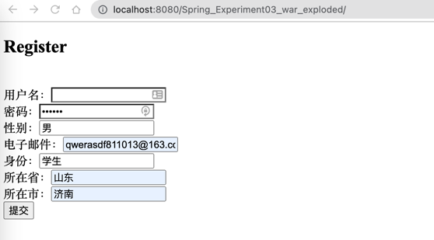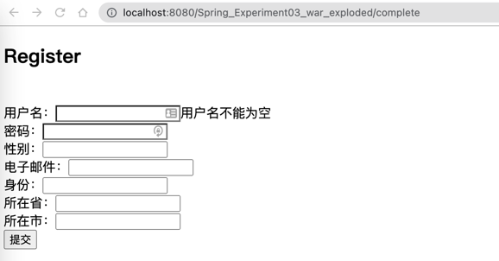  - 密码非空检验  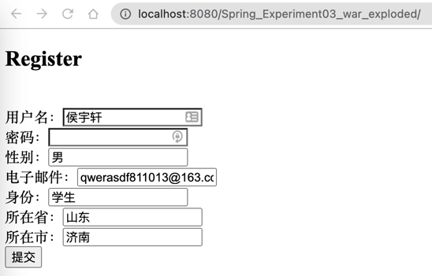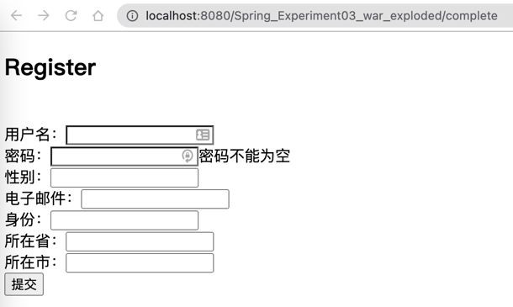  - 同时检验  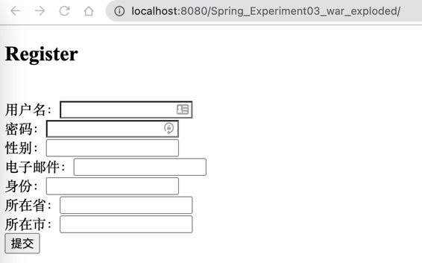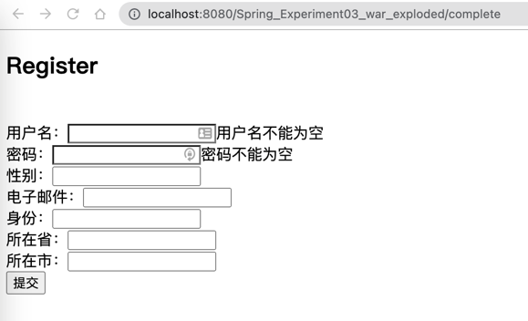  - 正常输入跳转  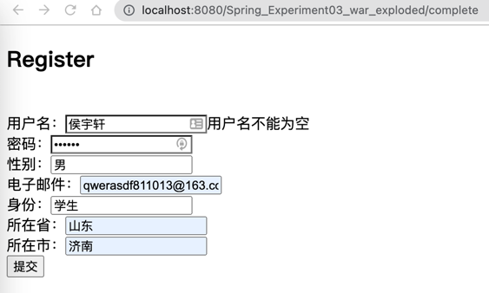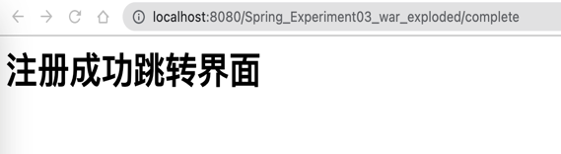  - ID 自增
总  结 | 可以通过传递输入参数在控制器实现输入数据验证，然后通过设置Model中的属性将错误信息放回到相应页面中，SpringMVC中对于定义的Bean形式对象能够在RequestMapping方法中自动根据表单中的name对应类中属性创建类的实例，作为参数传入，可以很方便的对其中的参数等进行验证

关键代码：
User.java
package com.Bean;
public class User {
private int id;
private String username;
private String pwd;
private String sex;
private String email;
private String role;
private Address address;
public User() {}
public User(int id, String username, String pwd, String sex, String email, String role, Address address) {
this.id = id;
this.username = username;
this.pwd = pwd;
this.sex = sex;
this.email = email;
this.role = role;
this.address = address;
}
@Override
public String toString() {
return "User{" +
"id=" + id +
", username='" + username + '\'' +
", pwd='" + pwd + '\'' +
", sex='" + sex + '\'' +
", email='" + email + '\'' +
", role='" + role + '\'' +
", address=" + address +
'}';
}
public int getId() {return id;}
public void setId(int id) {this.id = id;}
public String getUsername() {return username;}
public void setUsername(String username) {this.username = username;}
public String getPwd() {return pwd;}
public void setPwd(String pwd) {this.pwd = pwd;}
public String getSex() {return sex;}
public void setSex(String sex) {this.sex = sex;}
public String getEmail() {return email;}
public void setEmail(String email) {this.email = email;}
public String getRole() {return role;}
public void setRole(String role) {this.role = role;}
public Address getAddress() {return address;}
public void setAddress(Address address) {this.address = address;}
}

Address.java
package com.Bean;

public class Address {
private String province;
private String city;
public Address() {}
public Address(String province, String city) {
this.province = province;
this.city = city;
}
public String getProvince() {return province;}
public void setProvince(String province) {this.province = province;}
public String getCity() {return city;}
public void setCity(String city) {this.city = city;}
}

ControllerToRegister.java
package com.Controller;
import com.Bean.User;

import org.springframework.stereotype.Controller;
import org.springframework.ui.Model;
import org.springframework.web.bind.annotation.RequestMapping;

@Controller
public class ControllerToRegister {
static int id = 0;
@RequestMapping(value = "/complete")
public String complete(User user, Model model) {
if (user.getUsername().length() == 0 || user.getUsername() == null)
model.addAttribute("msg1", "用户名不能为空");
if (user.getPwd().length() == 0 || user.getPwd() == null)
model.addAttribute("msg2", "密码不能为空");
if ((user.getUsername().length() == 0) || (user.getPwd().length() == 0))
return "index.jsp";
else {
user.setId(++id);
System.out.println(user);

return "success.jsp";
}
}
}

SpringMVC.xml
<?xml version="1.0" encoding="UTF-8"?>
<beans xmlns="http://www.springframework.org/schema/beans"
xmlns:xsi="http://www.w3.org/2001/XMLSchema-instance"
xmlns:context="http://www.springframework.org/schema/context"
xmlns:mvc="http://www.springframework.org/schema/mvc"
xsi:schemaLocation="http://www.springframework.org/schema/beans
http://www.springframework.org/schema/beans/spring-beans.xsd
http://www.springframework.org/schema/context
http://www.springframework.org/schema/context/spring-context.xsd
http://www.springframework.org/schema/mvc
http://www.springframework.org/schema/mvc/spring-mvc.xsd">

<!-- 扫描注解 -->
<context:component-scan base-package="com"/>

</beans>

index.jsp
<%@ page language="java" contentType="text/html; charset=utf-8" pageEncoding="utf-8"%>
<%@ page isELIgnored="false" %>

<!DOCTYPE html PUBLIC "-//W3C//DTD HTML 4.01 Transitional//EN" "http://www.w3.org/TR/html4/loose.dtd">

<html>
<body>
<h2>Register</h2><br>
<form action = "complete" method = "post">
用户名：<input type = "text" name = "username"><span>${msg1}</span><br>
密码：<input type = "password" name = "pwd"><span>${msg2}</span></span><br>
性别：<input type = "text" name = "sex" ><br>
电子邮件：<input type = "text" name = "email"><br>
身份：<input type = "text" name = "role"><br>
所在省：<input type = "text" name = "address.province"><br>
所在市：<input type = "text" name = "address.city"><br>
<input type = "submit" value = "提交"><br>
</form>
</body>
</html>

success.jsp
<%@ page contentType="text/html;charset=UTF-8" language="java" %>
<html>
<head>
<title>Title</title>
</head>
<body>
<h1>注册成功跳转界面</h1>
</body>
</html>

