青 岛 理 工 大 学
课程实验报告

课程名称 | 软件设计与  体系结构 | 班级 | 软件186 | 实验  日期 | 2021-6-19
姓名 | 侯宇轩 | 学号 | 201811050392 | 实验  成绩
实验  名称 | 实验5：SSM三大框架整合实验
实验  目的  及要  求 | 实验目标：  1) 实现SpringMVC和Spring的整合  2) 实现MyBatis和Spring的整合  3) 使用SSM实现根据用户名称对用户表进行模糊查询。
实  验  环  境 | JDK 13.0.2、IDEA、Tomcat9、SpringMVC、Spring、MyBatis
实  验  内  容 | 1. 搭建项目架构添加相应jar包依赖  2. 添加配置文件对三大框架进行整合  3. 创建主页面及跳转的控制器并实现跳转到用户查询页面  4. 创建用户查找页面  5. 编写查找控制层的代码  6. 编写查找模型层的代码  7. 编写查找数据访问层的代码.  8. 编写查找后的结果显示页面
算  法  描  述  及  实  验  步  骤 | - 在数据库中建立User表  - 在模型层建立对应的User类  - 索引界面需要登陆后才能跳转至查询页面，创建登陆跳转的控制器Login.java，建立查询页面UserQuery.jsp，分别有查询所有用户，根据id 查询和根据账号密码查询三个查询，其中查询所有是超链接，id和账号密码是表单，然后建立跳转至查询结果页面的控制器Display.java  - 建立数据访问层Dao，实现三个查询，返回结果类型分别是User类型的List和User  - 建立服务层，使用MyBatis进行查询返回结果  - 在控制器Login.java中使用声明ValidateUser对象并调用方法验证是否账号密码，方法返回值是boolean类型，同时判断账号密码的输入是否正确，将信息加入Model，通过EL表达式在网页中显示错误信息  - 在控制器Display.java中的三个对应的方法中分别定义服务层的三个查询方法，得到查询结果，同时在前端进行一定验证，如果查询不到在前端通过Model  和El表达式输出，如果查询到了跳转至显示页面，对于List通过EL表达式结合JSTL输出，单个User通过EL表达式即可
调  试  过  程  及  实  验  结  果 | 1 数据库表  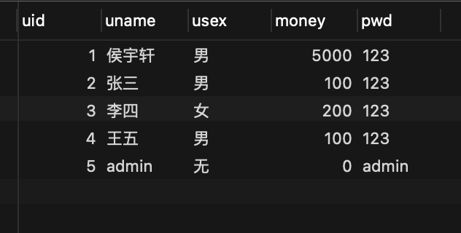  2 登陆  2.1 非空验证  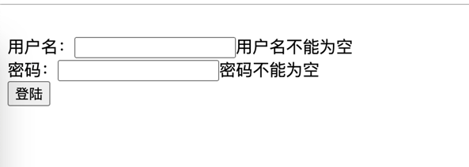  2.2 查表验证  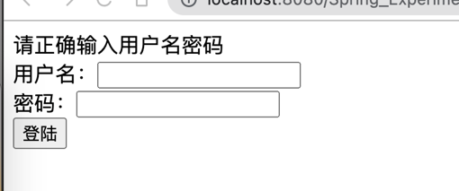  2.3 成功跳转至查询界面  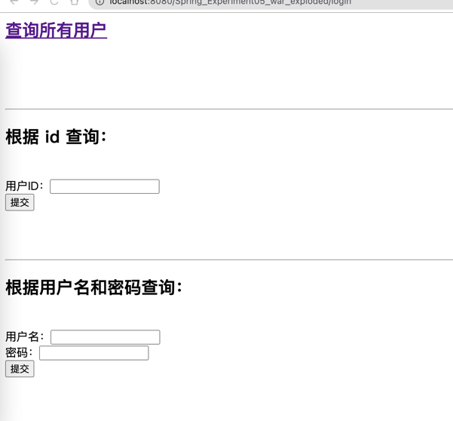  3 查询显示  3.1 查询所有用户  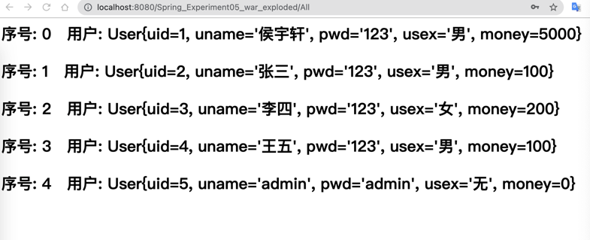  3.2 id查询  1) 非空验证  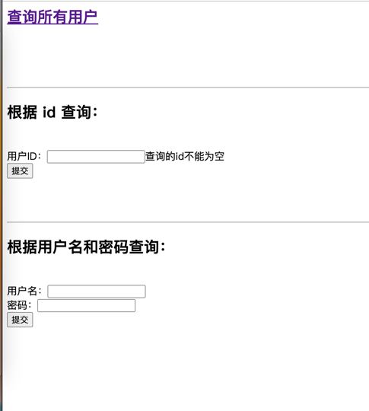  2) 前端显示不存在  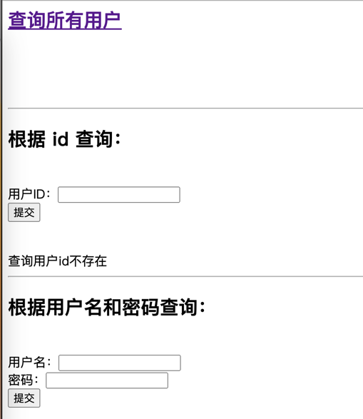  3) 结果显示  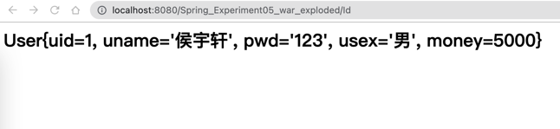  3.3 账号密码查询  1) 查询验证  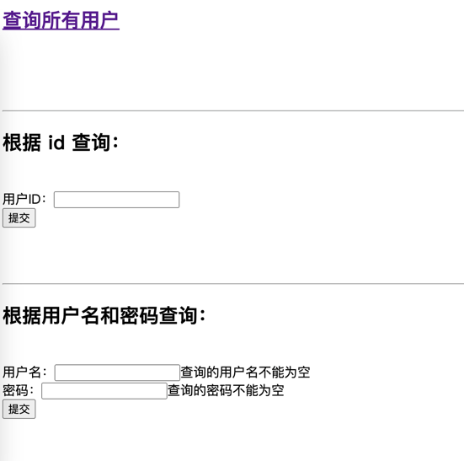  2) 前端显示不存在  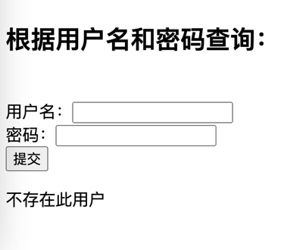  3) 跳转至结果显示页面  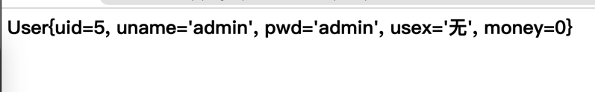
总  结 | Spring 最核心的就是解耦，三个框架整合，数据访问层、服务层、模型层等的代码都完全分离可以进行分布开发，各层之间通过调用接口使用其功能，通过注解控制器可以方便的对跳转的内容进行功能实现，可以积累一定的模版代码。其次，maven项目可以方便的导入大量的jar包。

关键代码：
index.jsp
<%@ page language="java" contentType="text/html; charset=utf-8" pageEncoding="utf-8"%>
<%@ page isELIgnored="false" %>
<html>
<body>
<form action = "login" method = "post">
<span>${msg3}</span><br>
用户名：<input type = "text" name = "uname"><span>${msg1}</span><br>
密码：<input type = "password" name = "pwd"><span>${msg2}</span></span><br>
<input type = "submit" value = "登陆"><br>
</form>
</body>
</html>

UserQuery.jsp
<%@ page language="java" contentType="text/html; charset=utf-8" pageEncoding="utf-8"%>
<%@ page isELIgnored="false" %>
<html>
<body>
<h2><a href = "All">查询所有用户</a></h2><br/><br/>
<span>${msg1}</span><br><hr>
<h2>根据 id 查询：</h2><br/>
<form action = "Id" method = "post">
用户ID：<input type = "text" name = "uid"><span>${msg2}</span><br>
<input type = "submit" value = "提交"><br>
</form><br/>
<span>${msg3}</span><br/><hr>
<h2>根据用户名和密码查询：</h2><br/>
<form action = "NamePwd" method = "post">
用户名：<input type = "text" name = "uname"><span>${msg4}</span><br>
密码：<input type = "password" name = "pwd"><span>${msg5}</span><br>
<input type = "submit" value = "提交"><br>
</form>
<span>${msg6}</span><br>
</body>
</html>

Display.jsp
<%@ page language="java" contentType="text/html; charset=utf-8" pageEncoding="utf-8"%>
<%@ page isELIgnored="false" %>
<%@taglib prefix="c" uri="http://java.sun.com/jsp/jstl/core"%>
<html>
<body>
<h2><span>${user}</span></h2>
<h2><span><c:forEach items="${userList}" var = "u" varStatus="ust">
<p>序号: ${ust.index} &nbsp; 用户: ${u}</p>
</c:forEach></span></h2>
</body>
</html>

SpringMVC.xml
<?xml version="1.0" encoding="UTF-8"?>
<beans xmlns="http://www.springframework.org/schema/beans"
xmlns:xsi="http://www.w3.org/2001/XMLSchema-instance"
xmlns:context="http://www.springframework.org/schema/context"
xmlns:mvc="http://www.springframework.org/schema/mvc"
xmlns:aop="http://www.springframework.org/schema/aop"
xsi:schemaLocation=
"http://www.springframework.org/schema/beans
http://www.springframework.org/schema/beans/spring-beans.xsd
http://www.springframework.org/schema/context
http://www.springframework.org/schema/context/spring-context.xsd
http://www.springframework.org/schema/aop
http://www.springframework.org/schema/aop/spring-aop.xsd
http://www.springframework.org/schema/mvc
http://www.springframework.org/schema/mvc/spring-mvc.xsd http://www.springframework.org/schema/tool http://www.springframework.org/schema/tool/spring-tool.xsd"> <context:component-scan base-package="com.controller"/>
<context:component-scan base-package="com"/>
<!-- 1、配置注解的处理器映射器 -->
<bean class="org.springframework.web.servlet.mvc.method.annotation.RequestMappingHandlerMapping"/>
<!-- 2、配置注解的处理器适配器 -->
<bean class="org.springframework.web.servlet.mvc.method.annotation.RequestMappingHandlerAdapter"/>
</beans>

MyBatisConfig.xml
<?xml version="1.0" encoding="UTF-8" ?>
<!DOCTYPE configuration
PUBLIC "-//mybatis.org//DTD Config 3.0//EN"
"http://mybatis.org/dtd/mybatis-3-config.dtd">
<configuration>
<settings>
<setting name="logImpl" value="LOG4J"/>
<!-- 将数据库列下划线转化为驼峰命名 -->
<setting name="mapUnderscoreToCamelCase" value="true"/>
</settings>
<environments default="development">
<environment id="development">
<transactionManager type="JDBC"/>
<dataSource type="POOLED">
<property name="driver" value="com.mysql.cj.jdbc.Driver"/>
<property name="url" value="jdbc:mysql://localhost:3306/Spring?characterEncoding=utf8"/>
<property name="username" value="root"/>
<property name="password" value="qwerasdf811013"/>
</dataSource>
</environment>
</environments>
<mappers>
<mapper class = "com.Dao.UserMapper"/>
</mappers>
</configuration>

Log4j.xml
<?xml version="1.0" encoding="UTF-8" ?>
<!DOCTYPE log4j:configuration SYSTEM "log4j.dtd">
<log4j:configuration xmlns:log4j = "http://jakarta.apache.org/log4j/">
<appender name="STDOUT" class="org.apache.log4j.ConsoleAppender">
<param name="Encoding" value="UTF-8" />
<layout class="org.apache.log4j.PatternLayout">
<param name="ConversionPattern" value="%-5p %d{MM-dd HH:mm:ss,SSS} %m (%F:%L) \n" />
</layout>
</appender>
<logger name="java.sql"><level value="debug" /></logger>
<logger name="org.apache.ibatis"><level value="info" /></logger>
<root><level value="debug" />
<appender-ref ref="STDOUT" />
</root>
</log4j:configuration>

User.java
package com.Bean;
import java.io.Serializable;
public class User implements Serializable { // 实现序列化
private int uid;
private String uname;
private String pwd;
private String usex;
private int money;
public User() {}
public String getPwd() {return pwd;}
public void setPwd(String pwd) {this.pwd = pwd;}
@Override
public String toString() {
return "User{" +
"uid=" + uid +
", uname='" + uname + '\'' +
", pwd='" + pwd + '\'' +
", usex='" + usex + '\'' +
", money=" + money +
'}';
}
public User(String uname, String pwd, String usex, int money) {
this.uname = uname;
this.pwd = pwd;
this.usex = usex;
this.money = money;
}
public int getUid() {return uid;}
public void setUid(int uid) {this.uid = uid;}
public String getUname() {return uname;}
public void setUname(String uname) {this.uname = uname;}
public String getUsex() {return usex;}
public void setUsex(String usex) {this.usex = usex;}
public int getMoney() {return money;}
public void setMoney(int money) {this.money = money;}
}

Display.java
package com.Controller;
import com.Bean.User;
import com.Service.QueryAll;
import com.Service.QueryById;
import com.Service.QueryByNamePwd;
import org.springframework.stereotype.Controller;
import org.springframework.ui.Model;
import org.springframework.web.bind.annotation.RequestMapping;
import java.io.IOException;
import java.util.List;
@Controller
public class Display {
@RequestMapping(value = "/All")
public String All(Model model) throws IOException {
QueryAll qa = new QueryAll();
List<User> list = qa.queryAll();
if(list == null) {
model.addAttribute("msg1", "数据库无用户");
return "UserQuery.jsp";
}
else {
model.addAttribute("userList", list);
return "Display.jsp";
}
}
@RequestMapping(value = "/Id")
public String Id(String uid, Model model) throws IOException {
QueryById qid = new QueryById();
User u = qid.queryById(uid);
if (uid.length() == 0 || uid == null) {
model.addAttribute("msg2", "查询的id不能为空");
return "UserQuery.jsp";
}
else if(u == null) {
model.addAttribute("msg3", "查询用户id不存在");
return "UserQuery.jsp";
}
else {
model.addAttribute("user", u);
return "Display.jsp";
}
}
@RequestMapping(value = "/NamePwd")
public String NamePwd(String uname, String pwd, Model model) throws IOException {
QueryByNamePwd qnp = new QueryByNamePwd();
User u = qnp.queryByNamePwd(uname, pwd);
if (uname.length() == 0 || uname == null) {
model.addAttribute("msg4", "查询的用户名不能为空");
}
if (pwd.length() == 0 || pwd == null) {
model.addAttribute("msg5", "查询的密码不能为空");
}
if ((uname.length() == 0) || (pwd.length() == 0)){
return "UserQuery.jsp";
}
else {
if(u == null) {
model.addAttribute("msg6", "不存在此用户");
return "UserQuery.jsp";
}
else {
model.addAttribute("user", u);
return "Display.jsp";
}
}
}
}

Login.java
package com.Controller;

import com.Service.ValidateUser;
import org.springframework.stereotype.Controller;
import org.springframework.ui.Model;
import org.springframework.web.bind.annotation.RequestMapping;
import java.io.IOException;
@Controller
public class Login {
@RequestMapping(value = "/login")
public String login(String uname, String pwd, Model model) throws IOException {
if (uname.length() == 0 || uname == null)
model.addAttribute("msg1", "用户名不能为空");
if (pwd.length() == 0 || pwd == null)
model.addAttribute("msg2", "密码不能为空");
if ((uname.length() == 0) || (pwd.length() == 0)){
return "index.jsp";
}
else {
ValidateUser vu = new ValidateUser();
if(vu.validateUser(uname, pwd))
return "UserQuery.jsp";
else {
model.addAttribute("msg3", "请正确输入用户名密码");
return "index.jsp";
}
}
}
}

UserMapper.java
package com.Dao;
import com.Bean.User;
import org.apache.ibatis.annotations.Param;
import java.util.List;
public interface UserMapper {
User queryById(@Param("uid") String uid);
List<User> queryAll();
User queryValidate(@Param("uname") String uname, @Param("pwd") String pwd);
}

UserMapper.xml
<?xml version="1.0" encoding="UTF-8" ?>
<!DOCTYPE mapper
PUBLIC "-//mybatis.org//DTD Mapper 3.0//EN"
"http://mybatis.org/dtd/mybatis-3-mapper.dtd">
<mapper namespace="com.Dao.UserMapper">
<cache></cache>
<!-- 1 查询all -->
<select id = "queryAll" resultType="com.Bean.User">
select * from Spring.Users
</select>
<!-- 2 id查询 -->
<select id = "queryById" resultType="com.Bean.User">
select * from Spring.Users where uid = #{uid}
</select>
<!-- 3 姓名、密码查询 -->
<select id = "queryValidate" resultType="com.Bean.User">
select * from Spring.Users where uname = #{uname} and pwd = #{pwd}
</select>
</mapper>

QueryAll.java
package com.Service;
import com.Bean.User;
import com.Dao.UserMapper;
import org.apache.ibatis.io.Resources;
import org.apache.ibatis.session.SqlSession;
import org.apache.ibatis.session.SqlSessionFactory;
import org.apache.ibatis.session.SqlSessionFactoryBuilder;
import java.io.IOException;
import java.io.InputStream;
import java.util.List;
public class QueryAll {
public List<User> queryAll() throws IOException {
String filename = "MyBatisConfig.xml";
InputStream inputStream = Resources.getResourceAsStream(filename);
// 数据库会话
SqlSessionFactory factory = new SqlSessionFactoryBuilder().build(inputStream);
SqlSession s1 = factory.openSession(); //true 表示自动提交事务
UserMapper um = s1.getMapper(UserMapper.class);
List<User> list = um.queryAll();
s1.close();
return list;
}
}

QueryById.java
package com.Service;

import com.Bean.User;
import com.Dao.UserMapper;
import org.apache.ibatis.io.Resources;
import org.apache.ibatis.session.SqlSession;
import org.apache.ibatis.session.SqlSessionFactory;
import org.apache.ibatis.session.SqlSessionFactoryBuilder;
import java.io.IOException;
import java.io.InputStream;
import java.util.List;
public class QueryById {
public User queryById(String uid) throws IOException {
String filename = "MyBatisConfig.xml";
InputStream inputStream = Resources.getResourceAsStream(filename);
// 数据库会话
SqlSessionFactory factory = new SqlSessionFactoryBuilder().build(inputStream);
SqlSession s1 = factory.openSession(); // 参数 true 表示自动提交事务
UserMapper um = s1.getMapper(UserMapper.class);
User u = um.queryById(uid);
s1.close();
return u;
}
}

QueryByNamePwd.java
package com.Service;
import com.Bean.User;
import com.Dao.UserMapper;
import org.apache.ibatis.io.Resources;
import org.apache.ibatis.session.SqlSession;
import org.apache.ibatis.session.SqlSessionFactory;
import org.apache.ibatis.session.SqlSessionFactoryBuilder;
import java.io.IOException;
import java.io.InputStream;
public class QueryByNamePwd {
public User queryByNamePwd(String uname, String pwd) throws IOException {
String filename = "MyBatisConfig.xml";
InputStream inputStream = Resources.getResourceAsStream(filename);
// 数据库会话
SqlSessionFactory factory = new SqlSessionFactoryBuilder().build(inputStream);
SqlSession s1 = factory.openSession(); // 参数 true 表示自动提交事务
UserMapper um = s1.getMapper(UserMapper.class);
User u = um.queryValidate(uname, pwd);
s1.close();
return u;
}
}

ValidateUser.java
package com.Service;
import com.Bean.User;
import com.Dao.UserMapper;
import org.apache.ibatis.io.Resources;
import org.apache.ibatis.session.SqlSession;
import org.apache.ibatis.session.SqlSessionFactory;
import org.apache.ibatis.session.SqlSessionFactoryBuilder;

import java.io.IOException;
import java.io.InputStream;

public class ValidateUser {
public boolean validateUser(String uname, String pwd) throws IOException {
String filename = "MyBatisConfig.xml";
InputStream inputStream = Resources.getResourceAsStream(filename);
// 数据库会话
SqlSessionFactory factory = new SqlSessionFactoryBuilder().build(inputStream);
SqlSession s1 = factory.openSession(); // 参数 true 表示自动提交事务
UserMapper um = s1.getMapper(UserMapper.class);
User u = um.queryValidate(uname, pwd);
s1.close();

if(u == null ) return false;
else return true;
}
}

