青 岛 理 工 大 学
课程实验报告

课程名称 | Jsp 开发技术 | 班级 | 软件186 | 实验  日期 | 2021-3-10
姓名 | 侯宇轩 | 学号 | 201811050392 | 实验  成绩
实验  名称 | 实验1：用户添加和企业信息添加
实验  目的  及要  求 | 实验目的：  1、学会servlet的基本应用  2、巩固jdbc操作数据库
实  验  环  境 | JDK 1.8、 Eclipse、Tomcat8、MySql数据库
实  验  内  容 | 1) 了解锐聘网站后台管理系统的需求分析、开发环境搭建以及数据库创建  2) 实现锐聘后台管理系统的用户添加和企业添加功能  3) 进行项目需求分析  4) 创建数据库  5) 搭建开发项目  6) 完成用户添加  7) 完成企业添加
算  法  描  述  及  实  验  步  骤 | - 添加用户  首先建立了用户类，将所要通过用户获取的信息封装，可以直接通过对象作为参数传递新建立的用户信息  封装了数据库连接类，每次只需要调用方法即可。  通过封装数据库插入类，每次都只需要将用户类作为参数调用即可  - 添加企业  类的关系与用户添加类似  通过Part类实现文件的上传  文件名通过系统时间拼接生成，可以有效避免用户上传的文件名存在重复的问题。
调  试  过  程  及  实  验  结  果 | - 用户添加  添加前：  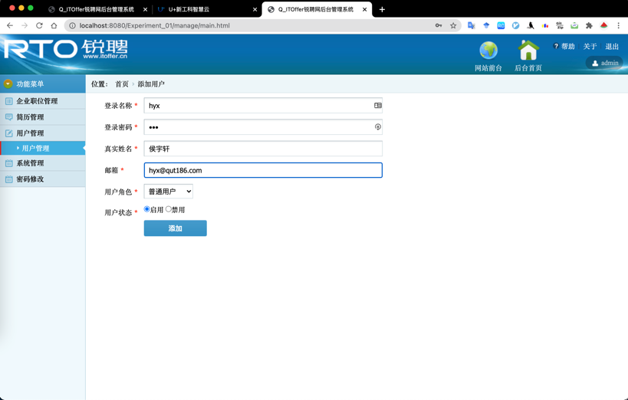  添加后跳转  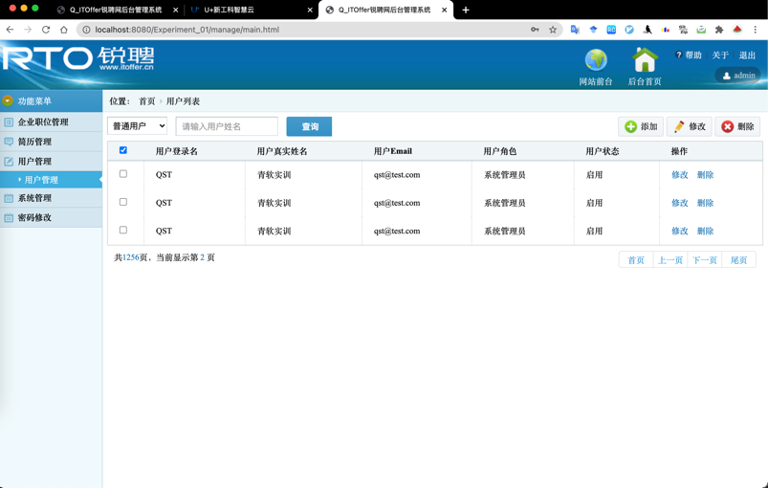  数据库：  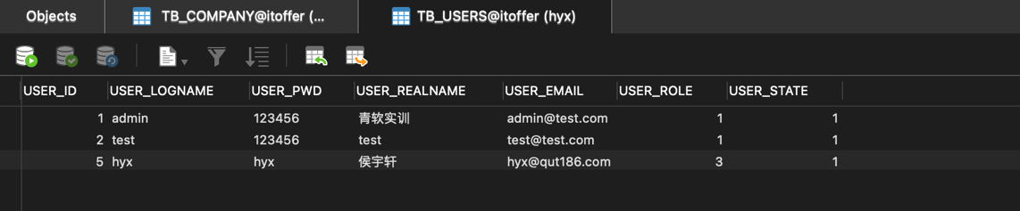  - 企业添加  添加前：  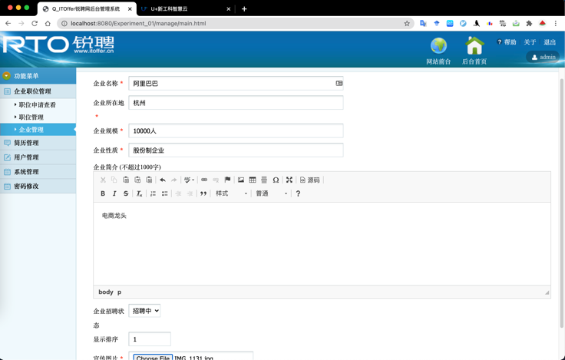  添加后：  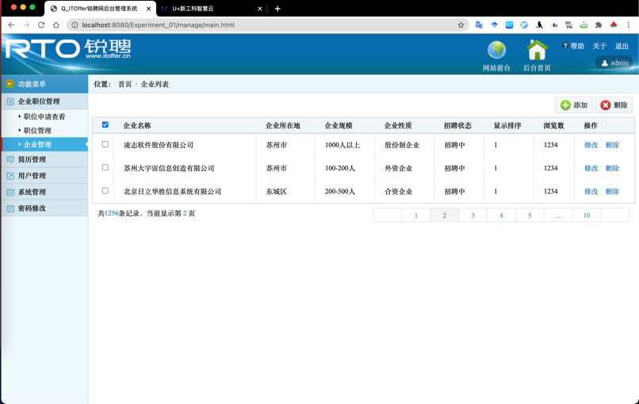  数据库：  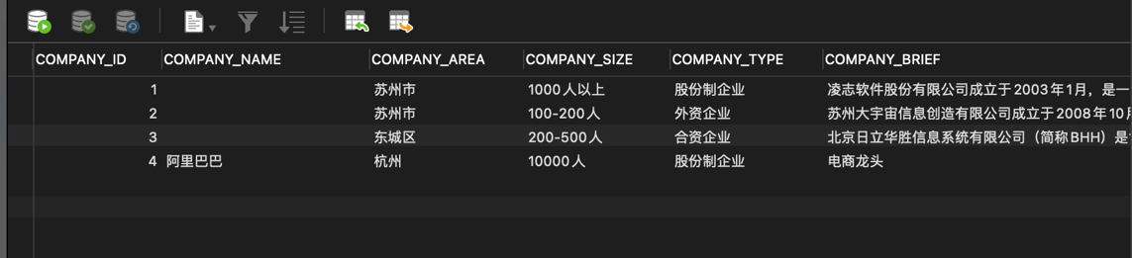
总  结 | - 学会通过报错信息从网络搜索解决方案  - 通过控制台输出的方式获取值便于判断程序执行是否达到了预期效果  - Post 方法比Get方法安全

关键代码：
- 数据库连接类
DBUtil.java
package com.hyx.util;
import java.io.IOException;
import java.sql.*;
public class DBUtil {
// 连接服务器的参数信息
public static String url="jdbc:mysql://localhost/itoffer";
public static String usr="root";
public static String pwd="qwerasdf811013";
// 静态语句块，在类加载（编译后的字节码加载到内存中）的时候只执行一次
static {
try {
Class.forName("com.mysql.jdbc.Driver");
} catch(ClassNotFoundException e) {
e.printStackTrace();
}
}
public static java.sql.Connection getConnection() {
java.sql.Connection conn = null;
try {
conn = DriverManager.getConnection(url, usr, pwd);
} catch(SQLException e) {
e.printStackTrace();
}
return conn;
}
public static void closeJDBC(ResultSet rs, Statement st, java.sql.Connection con) {
if(rs!=null) {
try {
rs.close();
} catch(SQLException e) {
e.printStackTrace();
}
}
if(st!=null){
try {
st.close();
} catch (SQLException e) {
e.printStackTrace();
}
}
if(con!=null) {
try {
con.close();
} catch (SQLException e) {
e.printStackTrace();
}
}
}
public static void main(String[] args) {
System.out.println("打开连接");
java.sql.Connection conn=DBUtil.getConnection();
System.out.println(conn);
System.out.println("关闭连接");
DBUtil.closeJDBC(null,null,conn);
}
}

1. 用户添加
User.java
package com.hyx.javabean;
public class User {
private String userId;
private String userLogname;
private String userPwd;
private String userRealname;
private String userEmail;
private int userRole;
private int userState;
public User() { }
// 带 id 的构造，查询使用
public User(String userLogname, String userPwd, String userRealname, String userEmail, int userRole,
int userState) {
super();
this.userLogname = userLogname;
this.userPwd = userPwd;
this.userRealname = userRealname;
this.userEmail = userEmail;
this.userRole = userRole;
this.userState = userState;
}

// 不带 id 的构造，插入的时候数据库表记录自增
public User(String userId, String userLogname, String userPwd, String userRealname, String userEmail, int userRole,
int userState) {
super();
this.userId = userId;
this.userLogname = userLogname;
this.userPwd = userPwd;
this.userRealname = userRealname;
this.userEmail = userEmail;
this.userRole = userRole;
this.userState = userState;
}
public String getUserId() {
return userId;
}
public void setUserId(String userId) {
this.userId = userId;
}
public String getUserLogname() {
return userLogname;
}
public void setUserLogname(String userLogname) {
this.userLogname = userLogname;
}
public String getUserPwd() {
return userPwd;
}
public void setUserPwd(String userPwd) {
this.userPwd = userPwd;
}

public String getUserRealname() {
return userRealname;
}
public void setUserRealname(String userRealname) {
this.userRealname = userRealname;
}
public String getUserEmail() {
return userEmail;
}
public void setUserEmail(String userEmail) {
this.userEmail = userEmail;
}
public int getUserRole() {
return userRole;
}
public void setUserRole(int userRole) {
this.userRole = userRole;
}
public int getUserState() {
return userState;
}
public void setUserState(int userState) {
this.userState = userState;
}
}

UserService.java
package com.hyx.service;
import com.hyx.dao.UserDao;
import com.hyx.javabean.User;

public class UserService {
public boolean addUser(User user) {
// 进行业务处理
// 调用DAO实现数据插入
UserDao userDao=new UserDao();
boolean flag=userDao.insert(user);
return flag;
}
}

UserAddServlet.java
package com.hyx.servlet;
import java.io.IOException;
import javax.servlet.ServletException;
import javax.servlet.annotation.WebServlet;
import javax.servlet.http.HttpServlet;
import javax.servlet.http.HttpServletRequest;
import javax.servlet.http.HttpServletResponse;

import com.hyx.javabean.User;
import com.hyx.service.UserService;

@WebServlet("/UserAddServlet")
public class UserAddServlet extends HttpServlet {
private static final long serialVersionUID = 1L;

public UserAddServlet() {
super();
}

protected void doGet(HttpServletRequest request, HttpServletResponse response) throws ServletException, IOException {
// 设置编码
request.setCharacterEncoding("utf-8");
response.setContentType("text/html;charset=UTF-8");

// 读取信息
String userLogname = request.getParameter("userLogname");
String userPwd = request.getParameter("userPwd");
String userRealname = request.getParameter("userRealname");
String userEmail = request.getParameter("userEmail");
int userRole=(request.getParameter("userRole")==null)?3:Integer.parseInt(request.getParameter("userRole"));
int userState=(request.getParameter("userState")==null)?1:Integer.parseInt(request.getParameter("userState"));

User user=new User(userLogname,userPwd,userRealname,userEmail,userRole,userState);
// 调用业务层
UserService userService=new UserService();
boolean flag=userService.addUser(user);

// 根据结果跳转到不同的页面
if(flag) {
response.sendRedirect("manage/userList.html");
// 相对的是当前的servlet 的根路径，即应用的根路径 Webcontent
} else {
response.getWriter().write("<script>alert('插入失败');location='manage/userList.html';</script>");
// 浏览器的路径是
}
}
protected void doPost(HttpServletRequest request, HttpServletResponse response) throws ServletException, IOException {
doGet(request, response);
}
}

UserDao.java
package com.hyx.dao;
import java.sql.SQLException;
import com.hyx.javabean.User;
import com.hyx.util.DBUtil;
import com.sun.jdi.connect.spi.Connection;

public class UserDao { // 数据库的增删改查
public boolean insert(User user) {
boolean flag=false;
java.sql.Connection conn = DBUtil.getConnection();
java.sql.PreparedStatement pstmt = null;

String sql="INSERT INTO ITOFFER.TB_USERS("
+ "USER_LOGNAME,"
+ "USER_PWD,"
+ "USER_REALNAME,"
+ "USER_EMAIL,"
+ "USER_ROLE,"
+ "USER_STATE) "
+ "VALUES(?,?,?,?,?,?)";
try {
pstmt = conn.prepareStatement(sql);
pstmt.setString(1, user.getUserLogname());
pstmt.setString(2, user.getUserPwd());
pstmt.setString(3, user.getUserRealname());
pstmt.setString(4, user.getUserEmail());
pstmt.setInt(5, user.getUserRole());
pstmt.setInt(6, user.getUserState());
pstmt.executeUpdate();
flag = true;
} catch (SQLException e) {
e.printStackTrace();
} finally {
DBUtil.closeJDBC(null, pstmt, conn);
}
return flag;
}
}

2. 企业添加
Company.java
package com.hyx.javabean;

public class Company {
private int companyId; // 企业标识
private String companyName; // 企业名称
private String companyArea; // 企业所在地区
private String companySize; // 企业规模
private String companyType; // 企业性质
private String companyBrief; // 企业简介
private int companyState; // 招聘状态: 1招聘中 2已暂停 3已结束
private int companySort; // 排序序号
private String companyPic; // 宣传图片
public Company() {
super();
}
public Company(String companyName, String companyArea,
String companySize, String companyType, String companyBrief,
int companyState, int companySort, String name) {
this.companyName = companyName;
this.companyArea = companyArea;
this.companySize = companySize;
this.companyType = companyType;
this.companyBrief = companyBrief;
this.companyState = companyState;
this.companySort = companySort;
this.companyPic = name;
}

public int getCompanyId() { return companyId; }
public void setCompanyId(int companyId) { this.companyId = companyId; }

public String getCompanyName() {return companyName;}
public void setCompanyName(String companyName) { this.companyName = companyName; }

public String getCompanyArea() { return companyArea; }
public void setCompanyArea(String companyArea) { this.companyArea = companyArea; }

public String getCompanySize() { return companySize; }
public void setCompanySize(String companySize) { this.companySize = companySize; }

public String getCompanyType() { return companyType; }
public void setCompanyType(String companyType) { this.companyType = companyType; }

public String getCompanyBrief() { return companyBrief; }
public void setCompanyBrief(String companyBrief) { this.companyBrief = companyBrief; }

public int getCompanyState() { return companyState; }
public void setCompanyState(int companyState) { this.companyState = companyState; }
public int getCompanySort() { return companySort; }
public void setCompanySort(int companySort) { this.companySort = companySort; }

public String getCompanyPic() { return companyPic; }
public void setCompanyPic(String companyPic) { this.companyPic = companyPic; }

}

CompanyService.java
package com.hyx.service;
import com.hyx.dao.CompanyDao;
import com.hyx.javabean.Company;
public class CompanyService {
public boolean addCompany(Company company) {
// 进行业务处理
// 调用DAO实现数据插入
CompanyDao comDao=new CompanyDao();
boolean flag=comDao.insert(company);
return flag;
}
}

CompanyAddServlet.java
package com.hyx.servlet;

import java.io.File;
import java.io.IOException;
import javax.servlet.ServletException;
import javax.servlet.annotation.MultipartConfig;
import javax.servlet.annotation.WebServlet;
import javax.servlet.http.HttpServlet;
import javax.servlet.http.HttpServletRequest;
import javax.servlet.http.HttpServletResponse;
import javax.servlet.http.Part;

import com.hyx.javabean.Company;
import com.hyx.service.CompanyService;

@WebServlet("/CompanyAddServlet")
@MultipartConfig
public class CompanyAddServlet extends HttpServlet {

public CompanyAddServlet() {
super();
}
@Override
protected void doGet(HttpServletRequest request, HttpServletResponse response) throws ServletException, IOException {}
@Override
protected void doPost(HttpServletRequest request, HttpServletResponse response) throws ServletException, IOException {
doGet(request, response);
request.setCharacterEncoding("utf-8");
response.setContentType("text/html;charset=UTF-8");

String companyName = request.getParameter("companyName");
String companyArea = request.getParameter("companyArea");
String companySize = request.getParameter("companySize");
String companyType = request.getParameter("companyType");
String companyBrief = request.getParameter("companyBrief");
Integer companyState=(request.getParameter("companyState")==null)?1:Integer.parseInt(request.getParameter("companyState"));
Integer companySort=(request.getParameter("companySort")==null)?0:Integer.parseInt(request.getParameter("companySort"));
// 获取文件上传域
Part part = request.getPart("companyPic");
String tmp = part.getHeader("Content-Disposition");
String fileName = tmp.substring(tmp.lastIndexOf("=")+2, tmp.length()-1);
// String fileName = part.getSubmittedFileName();

// 重构文件名
String newFileName = System.currentTimeMillis()+fileName.substring(fileName.indexOf('.'));
// 将上传的文件保存在服务器
String filepath = getServletContext().getRealPath("/");
filepath=filepath+"upload/companyPic";

Company company = new Company(companyName,companyArea,companySize,companyType,companyBrief,
companyState,companySort,newFileName);
System.out.println(company);
getServletContext().log("上传路径为："+filepath);
System.out.println("上传路径为"+filepath);

File f=new File(filepath);
if(!f.exists()) f.mkdirs();
part.write(filepath+"/"+newFileName);

CompanyService comService = new CompanyService();
Boolean flag = comService.addCompany(company);
if(flag) {
response.sendRedirect("manage/companyList.html");
} else {
response.getWriter().write("<script>alert('插入失败');location='manage/companyList.html';</script>");
}
}
}

CompanyDao.java
package com.hyx.dao;
import java.sql.SQLException;

import com.hyx.javabean.Company;
import com.hyx.javabean.User;
import com.hyx.util.DBUtil;
import com.sun.jdi.connect.spi.Connection;

public class CompanyDao {
public boolean insert(Company company) {
boolean flag=false;
java.sql.Connection conn = DBUtil.getConnection();
java.sql.PreparedStatement pstmt = null;
String sql="INSERT INTO ITOFFER.TB_COMPANY("
+"COMPANY_NAME,"
+"COMPANY_AREA,"
+"COMPANY_SIZE,"
+"COMPANY_TYPE,"
+"COMPANY_BRIEF,"
+"COMPANY_STATE,"
+"COMPANT_SORT,"
+"COMPANY_PIC) "
+ "VALUES(?,?,?,?,?,?,?,?)";

try {
pstmt = conn.prepareStatement(sql);

pstmt.setString(1, company.getCompanyName());
pstmt.setString(2, company.getCompanyArea());
pstmt.setString(3, company.getCompanySize());
pstmt.setString(4, company.getCompanyType());
pstmt.setString(5, company.getCompanyBrief());
pstmt.setInt(6, company.getCompanyState());
pstmt.setInt(7, company.getCompanySort());
pstmt.setString(8, company.getCompanyPic());
pstmt.executeUpdate();
flag = true;
} catch (SQLException e) {
e.printStackTrace();
} finally {
DBUtil.closeJDBC(null, pstmt, conn);
}
return flag;
}
}

