|  |  |
| --- | --- |
| **Ex.No:12**  **Date:25.05.2022** | **SIMULATION OF CLOUD SCENARIOS USING CLOUDSIM** |

**AIM:**

To implement the simulation of cloud scenario using cloudsim.

**PROCEDURE:**

1. Download Cloudsim5.0 from <https://github.com/Cloudslab/cloudsim/releases/tag/5.0>

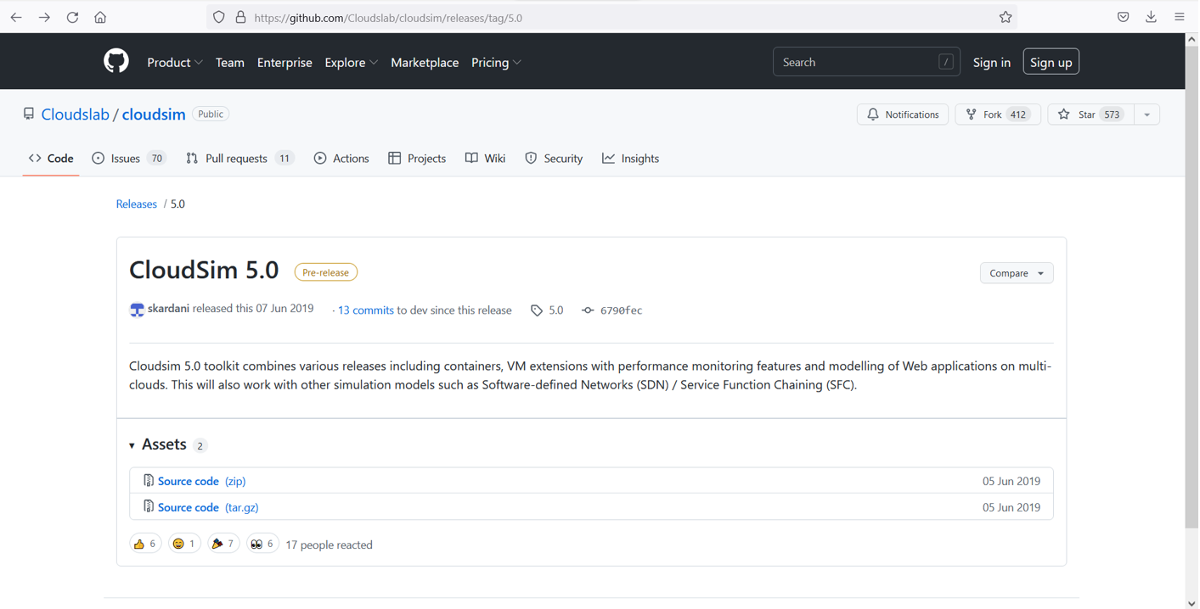

1. Add common math library

<https://commons.apache.org/proper/commons-math/download_math.cgi>

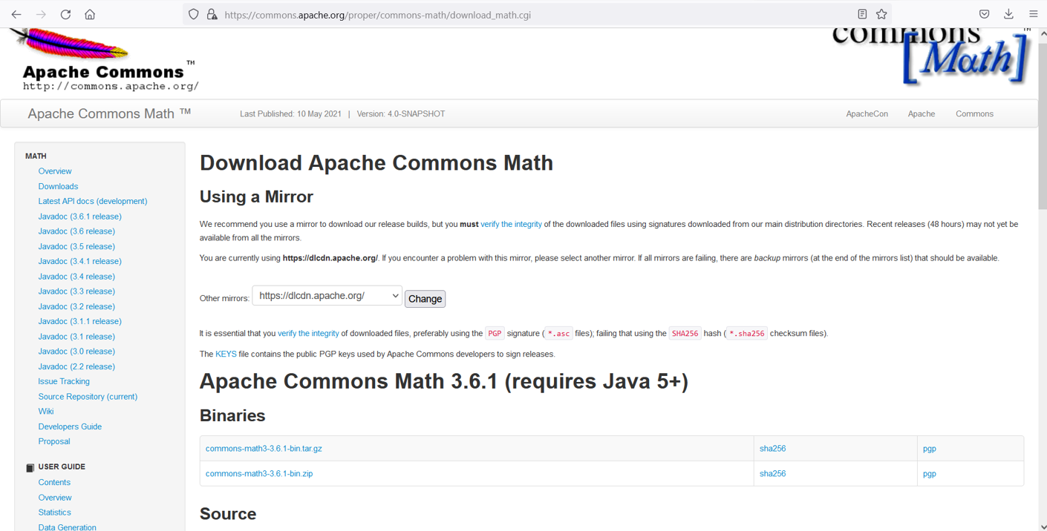

1. OpenEclipse.SelectNew>Project>JavaProject

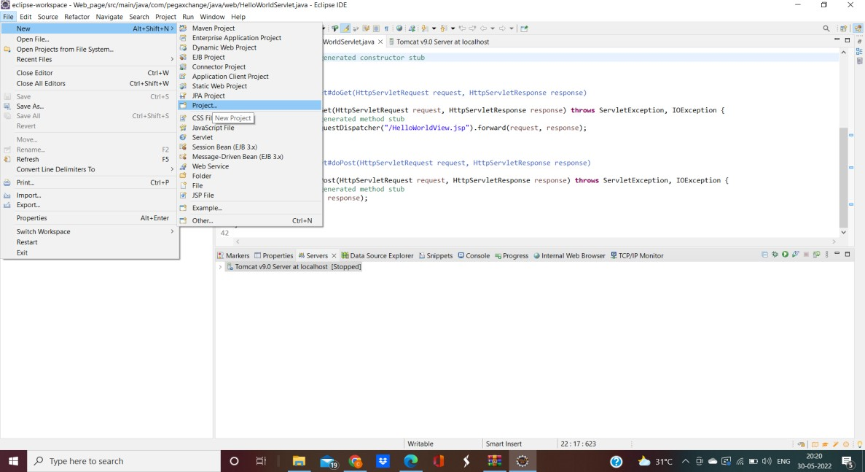

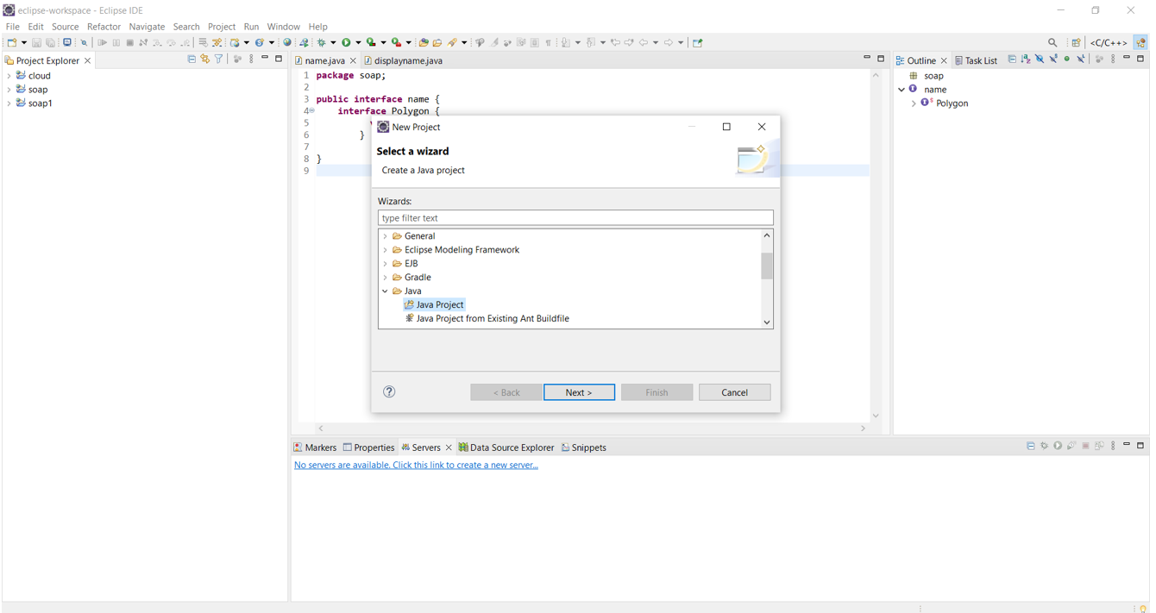

1. Theproject is named as Cloudsim and the location of the downloaded folder is specified.

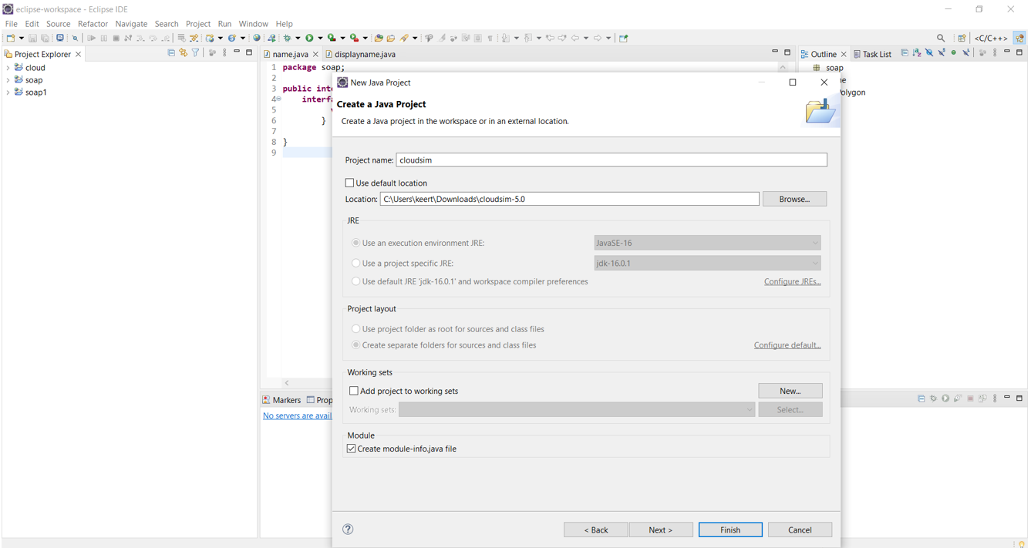

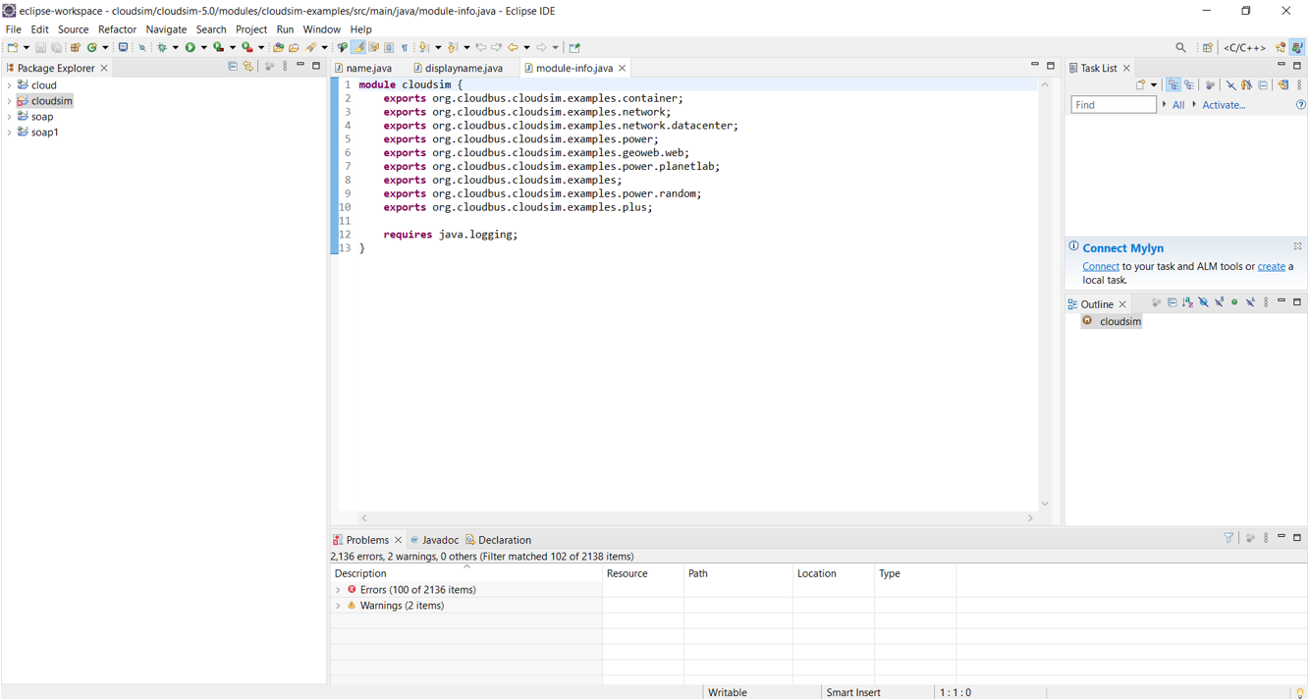

Once you click finish , the cloudsim project becomes view able in your package explorer as shown below

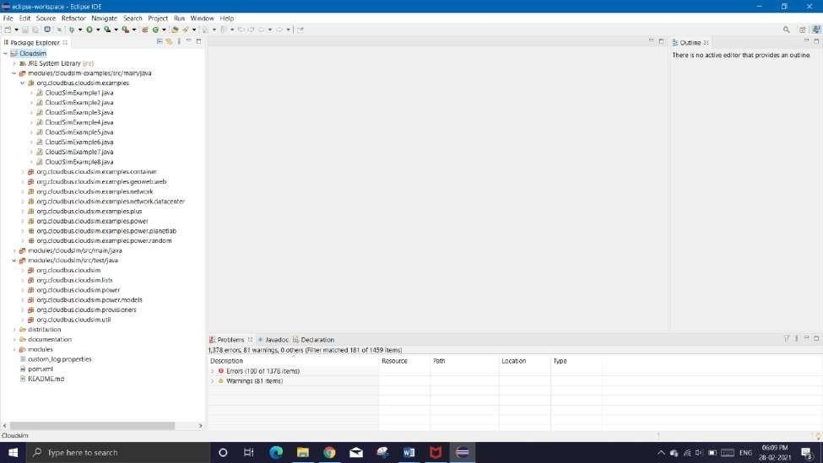

1. Click the created java project “Cloudsim” and select the properities.

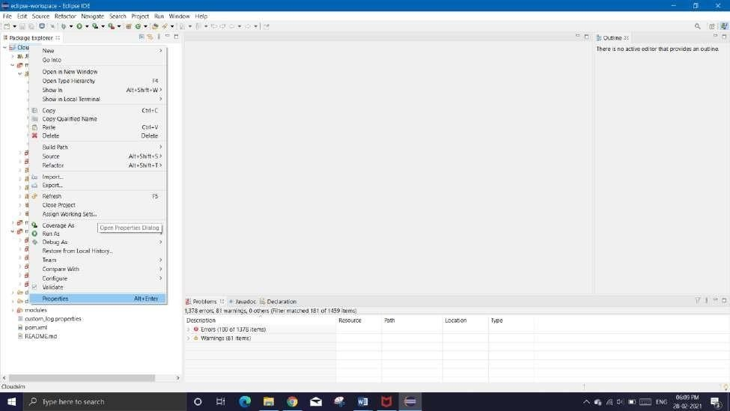

1. Click Java Build Path and select Module path and add external JARs

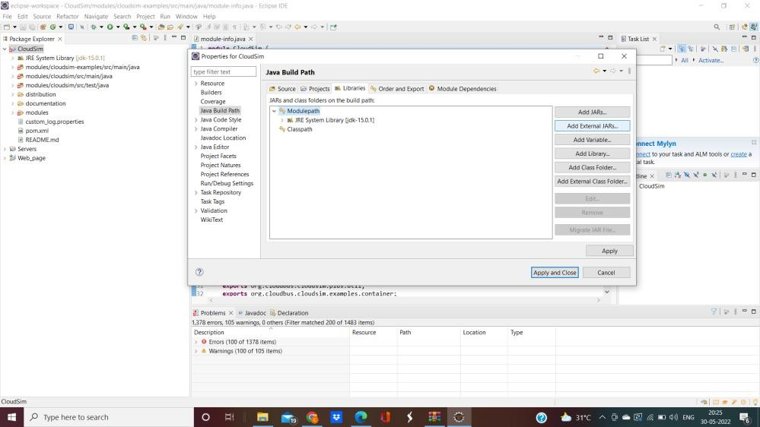

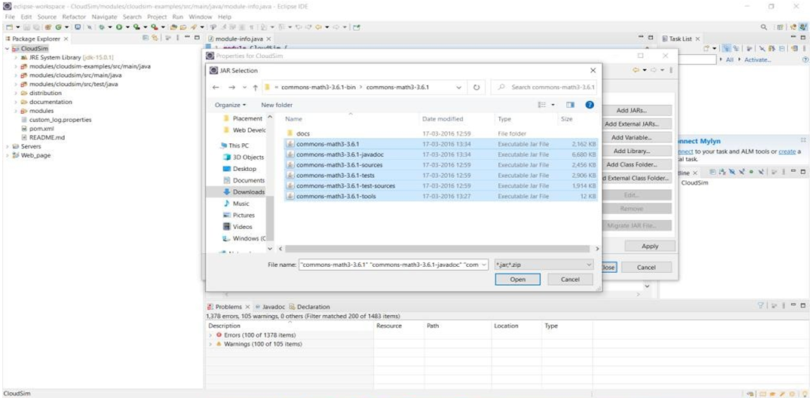

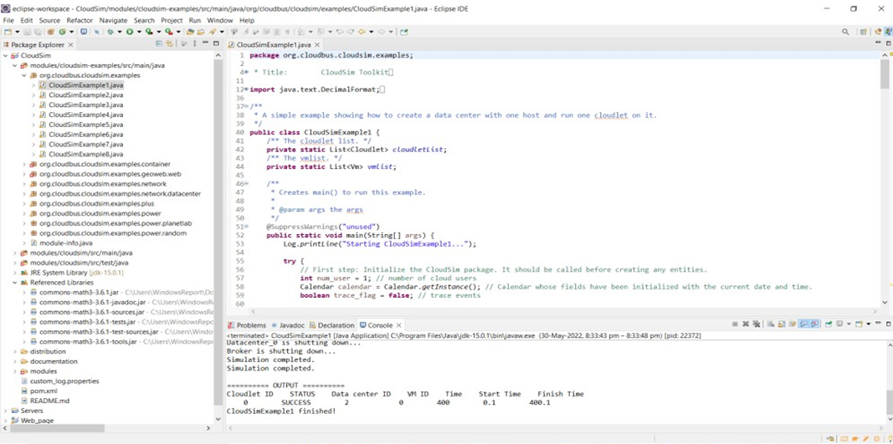

Hence,theinstallationiscompleted.

To simulate the cloud services,the Cloudsim Example codes are executed.

# Cloudsimexample6:

An example showing how to create scalable simulations. It means varying numbers of cloudlets as well as varying numbers of VMs.

# Description:

* + CreateVM,datacenters,cloudletsbyitsrespectivemethods.
  + To create powerdatacenter we need to create a list to store one or

moreMachines.A MachinecontainsoneormorePEsor CPUs/Cores.Therefore,shouldcreatealisttostorethesePEsbeforecreatinga Machine.

* + CreateHostswithitsidandlistofPEsandaddthemtothelistofmachines
  + Create a DatacenterCharacteristics object that stores the properties of adata center: architecture, OS, list of Machines, allocation policy: time- orspace-shared,time zoneanditsprice
  + Finally prints the Cloudlet objects

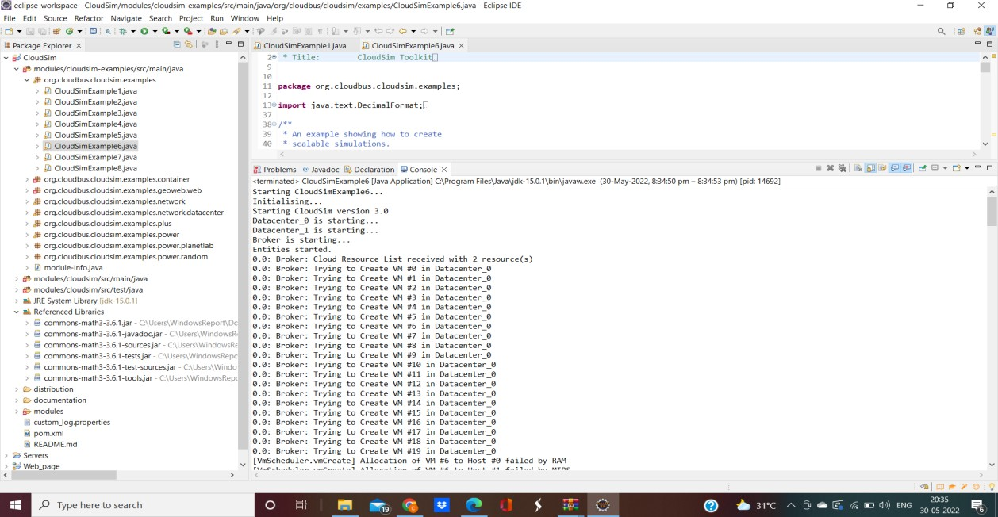

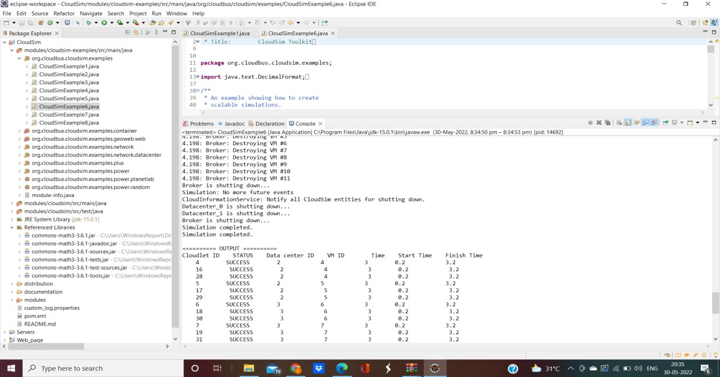

**RESULT:**

Hence the simulation of cloud scenario using cloudsim is verified.