|  |  |
| --- | --- |
| Ex No: 7 | **Database as a Service using Mongo DB** |
| Date: 25.04.2022 |

**Aim:**

To create the cluster in the Mango DB (open-source database) and also create the database in the cluster and performing following operations:

1) Insert One Record

2) Insert Many Records

3) List all the Records

4) List the Particular Record

5) Update the Record

6) Delete the Record

**Create a Database Cluster in the Cloud with MongoDB Atlas**

• Before you proceed, make sure you have the following installed and configured on your computer:

• Python 3.4 or higher

• pip 18.0 or higher

**1.Creating a Cluster**

To be able to use MongoDB's cloud services, you'll need a MongoDB Atlas account. To create one, go to its home page and press the Get started free button.

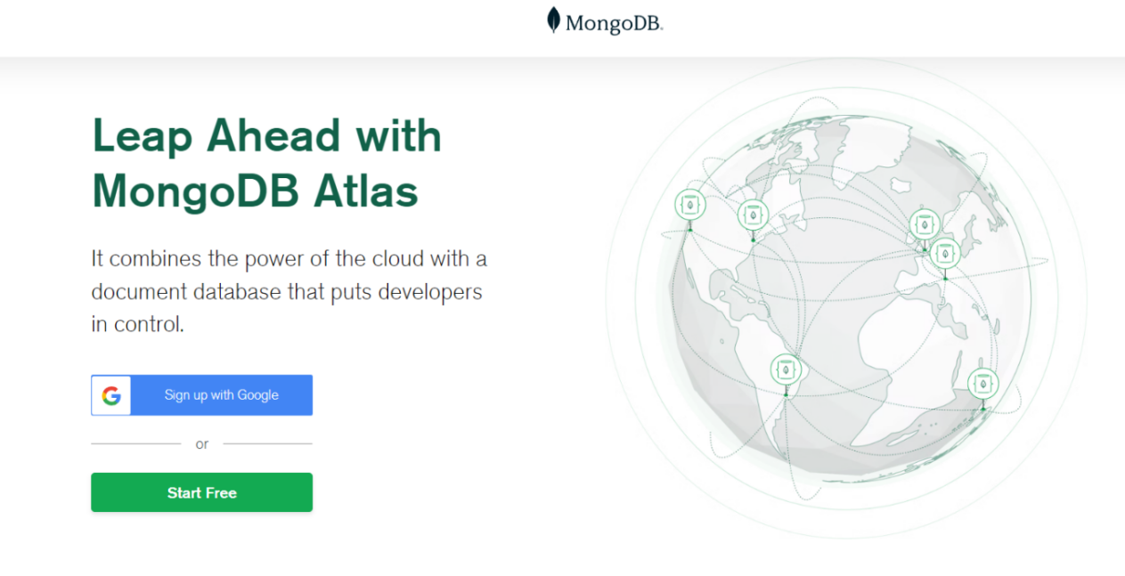

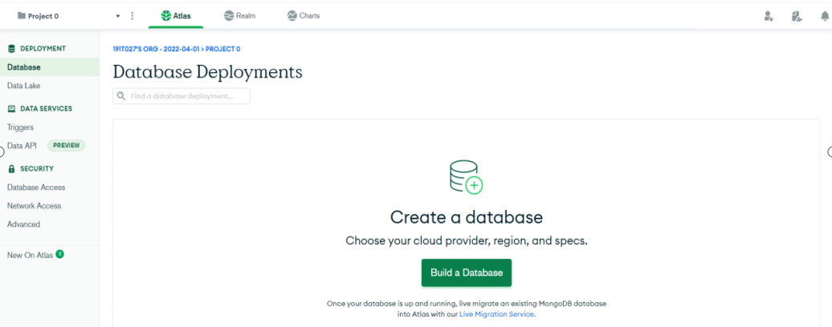

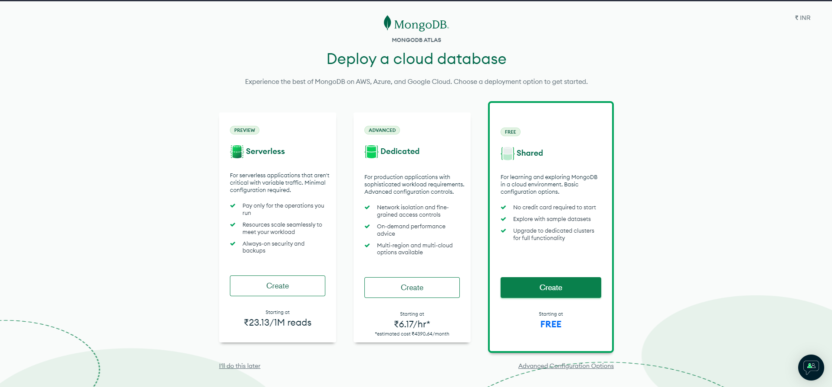

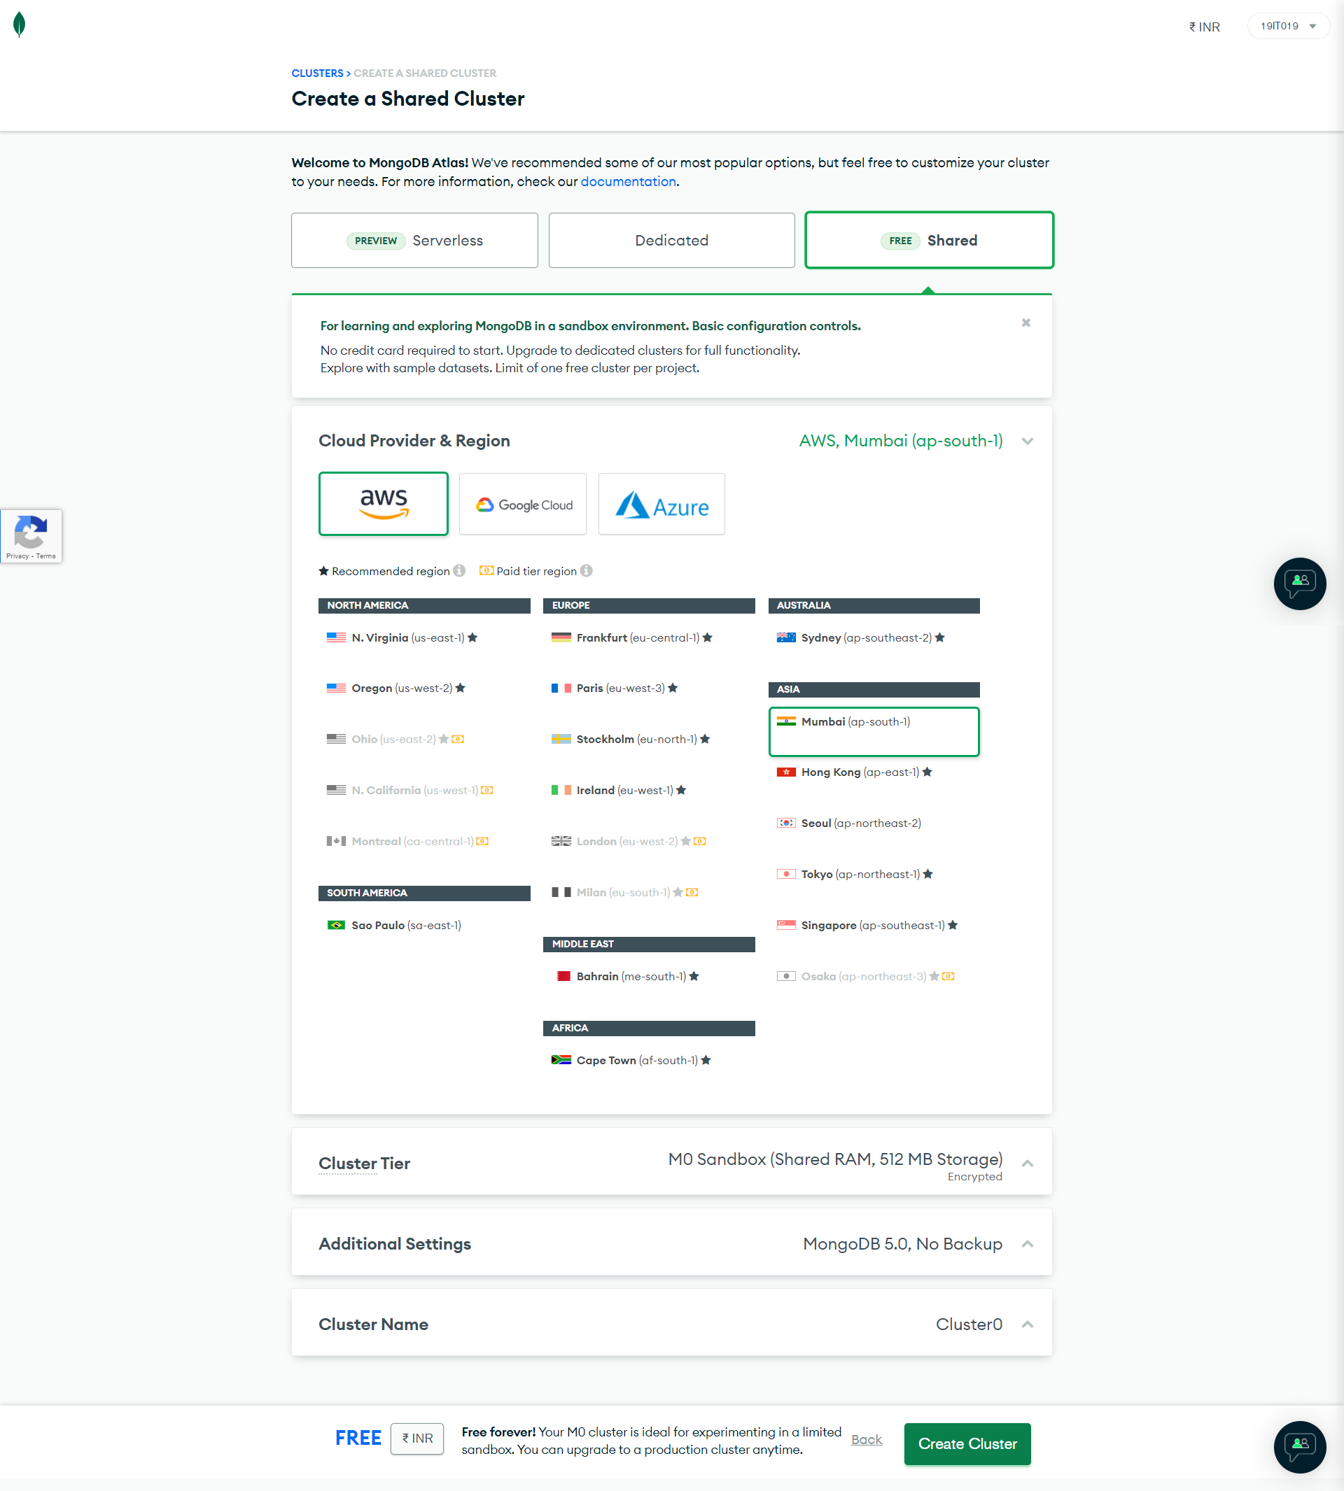

**2. Configuring the Cluster:**

Before you start using the cluster, you'll have to provide a few security-related details, so switch to the Security tab. First, in the MongoDB Users section, you must create a new user for yourself by pressing the Add new user button. In the dialog that pops up, type in your desired username and password, select the Read and write to any database privilege, and press the Add User button.

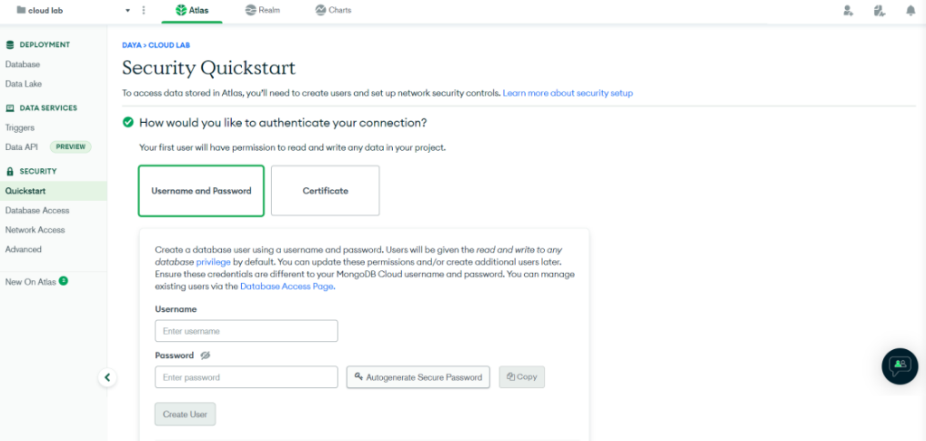

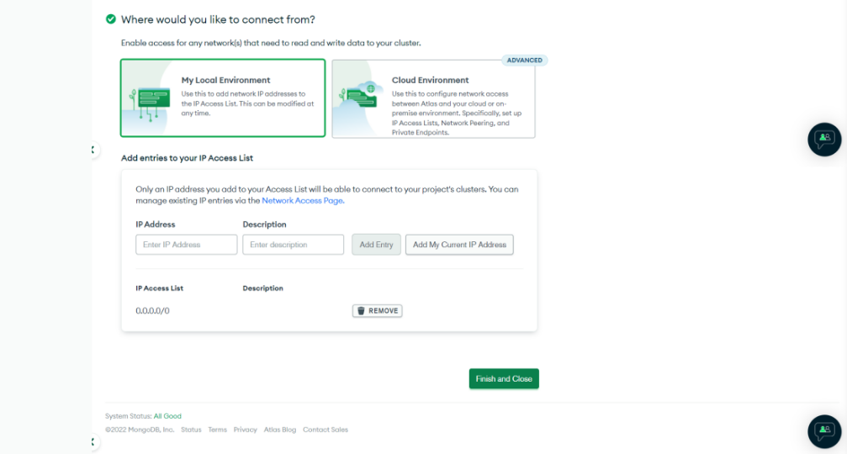

**3. Getting the Connection String:**

You'll need a valid connection string to connect to your cluster from your application. To get it, go to the Overview tab and press the Connect button

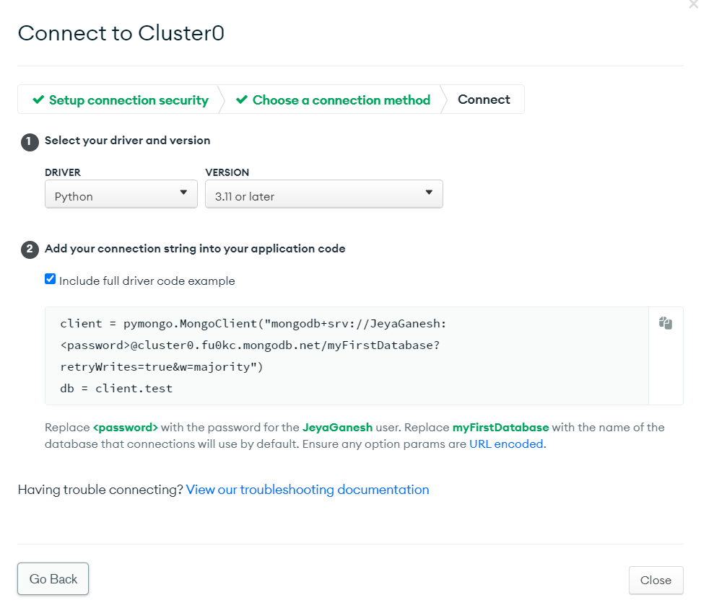

**4. Connecting to the Cluster**

**JUPYTER NOTEBOOK:**

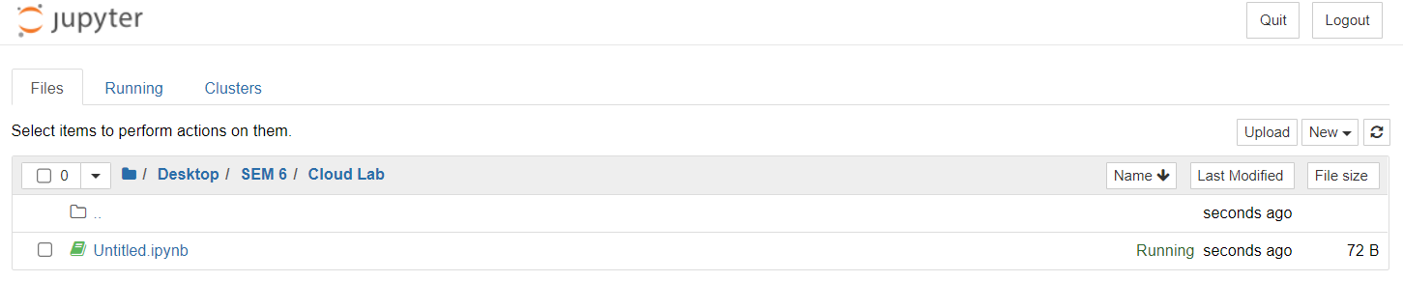

**5. Installing and Importing the required packages:**

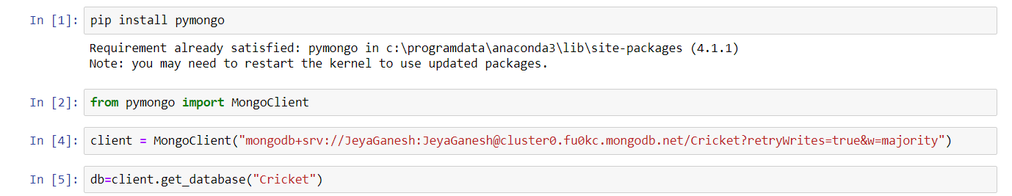

**6. Insert one Record into Database:**

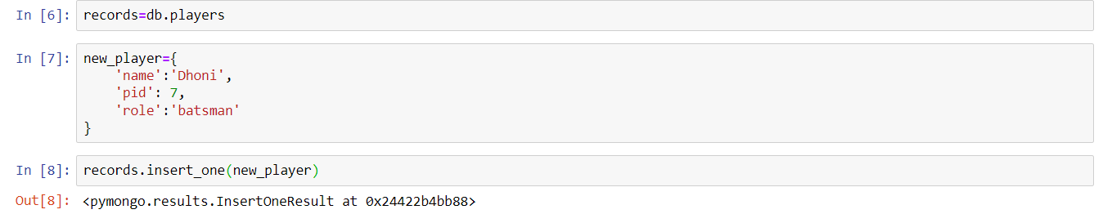

**7. Insert Many Records into the Database:**

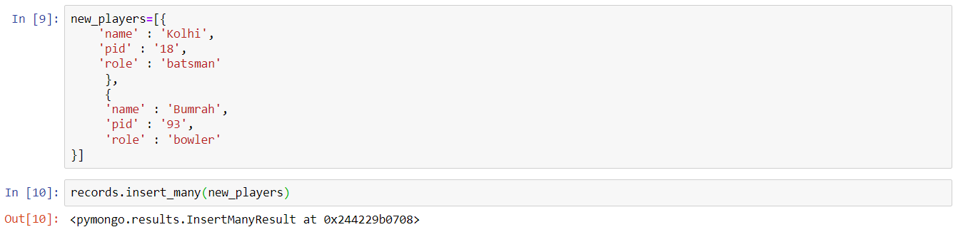

**8. List all the Records in Database:**

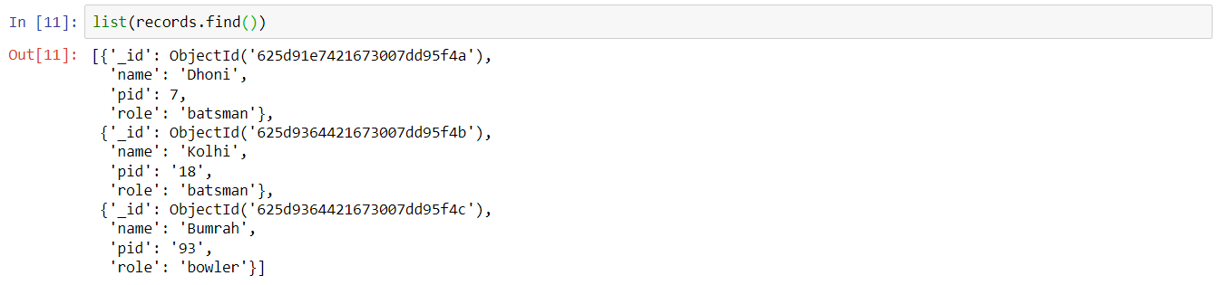

**9. Retrieve Particular Record from the Database:**

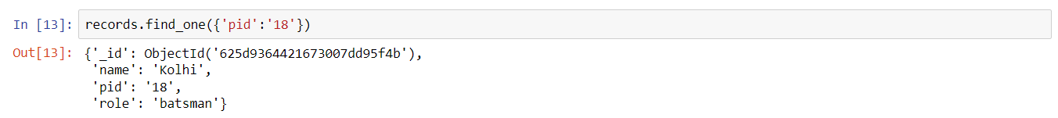

**10. Update the Records in Database:**

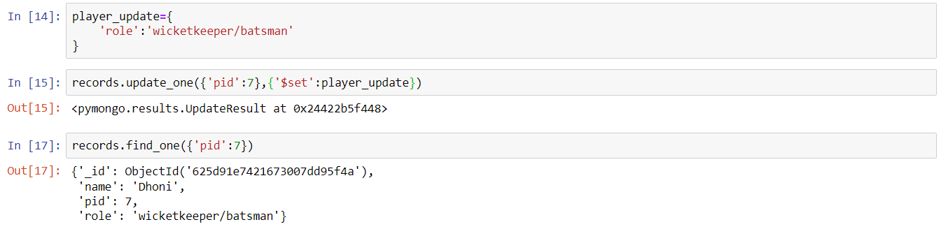

**11. Delete the Record from the Database:**



**12. After all operations Records in Mango DB:**

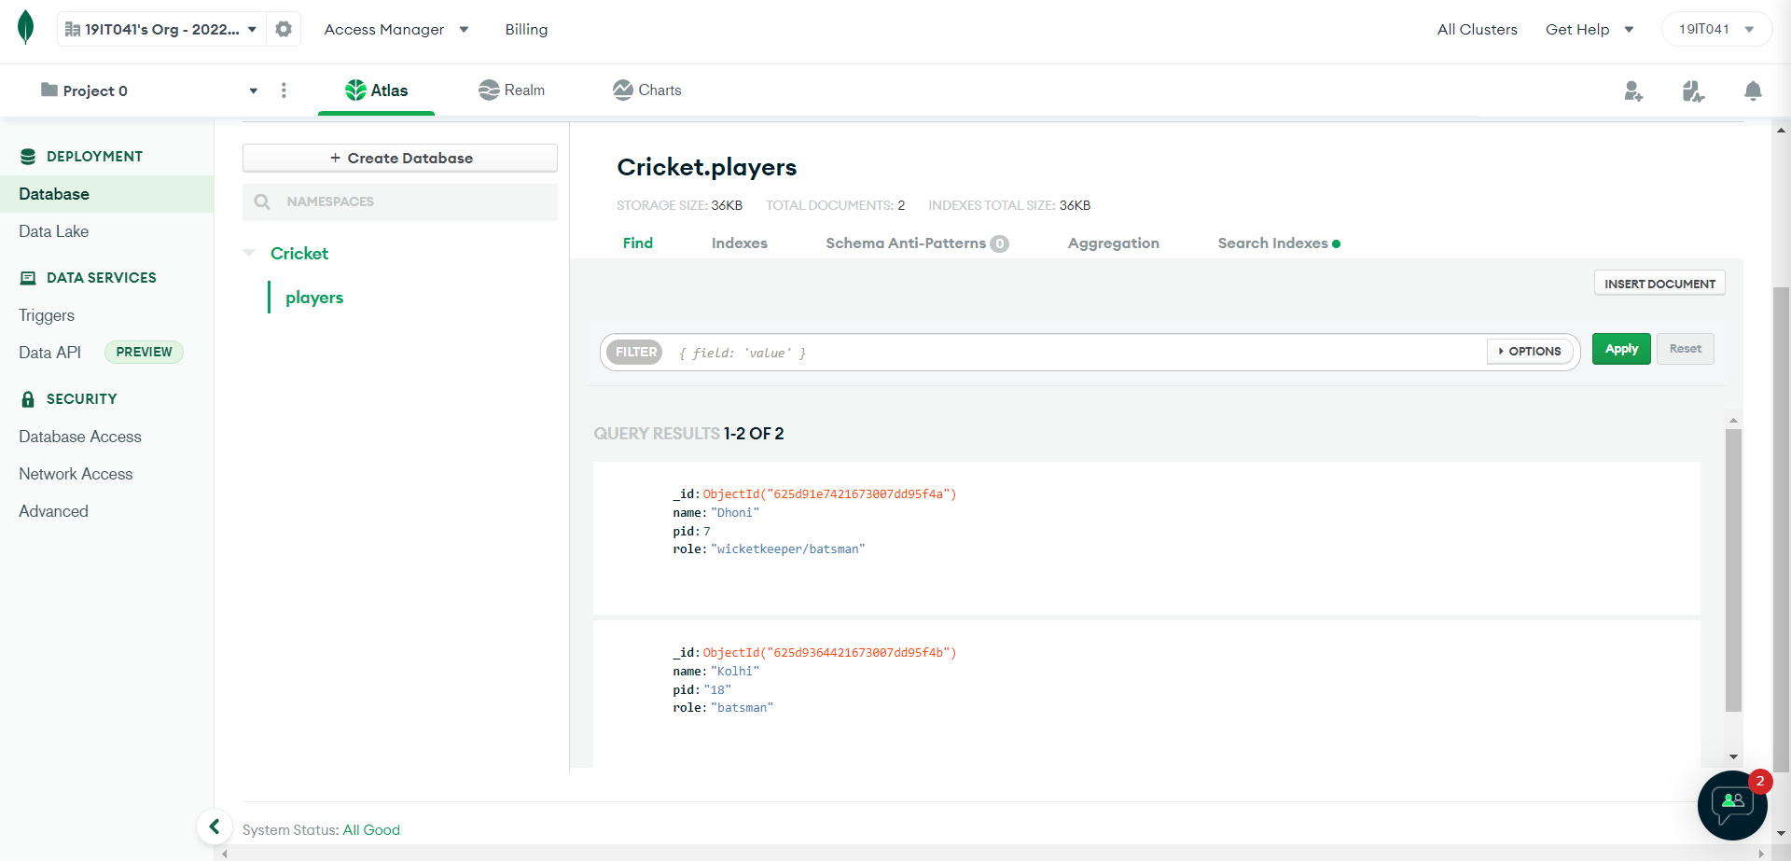

**Result:**

Thus, the operations like insert, update, delete, find records in the Mongo DB using python programming.