|  |  |
| --- | --- |
| Ex.no: 9 | **Implementation of Authentication as a Service** |
| Date: 25.04.2022 |

**Aim:**

To implement Authentication as a Service in a Java application using Auth0.

**Procedure:**

1. **Creating an account in Auth0 and try the default login box to login with your ID and get the brand identity and authentication.**

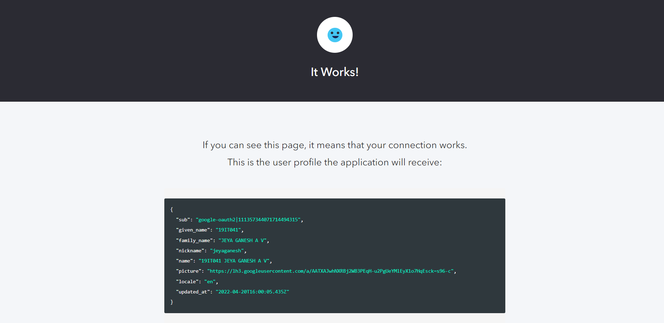

1. **Setup a new Regular Web application to use Auth0 for Authentication.**

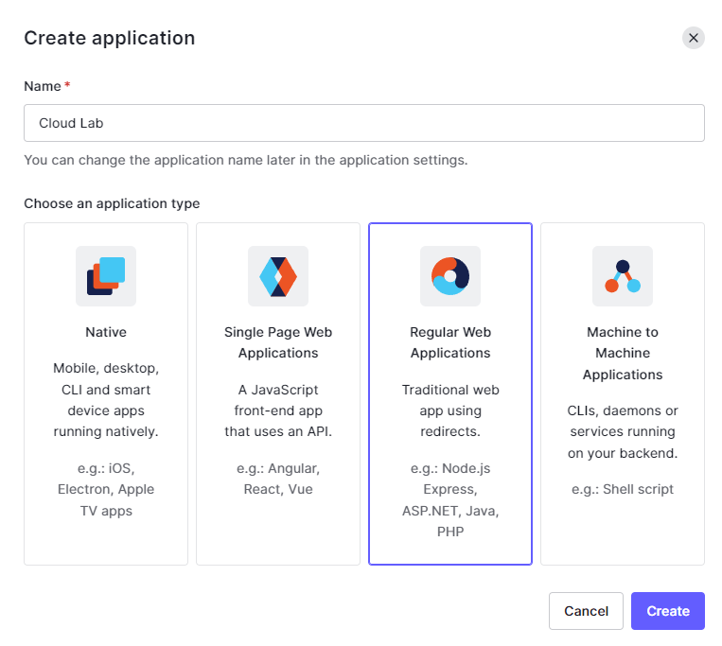

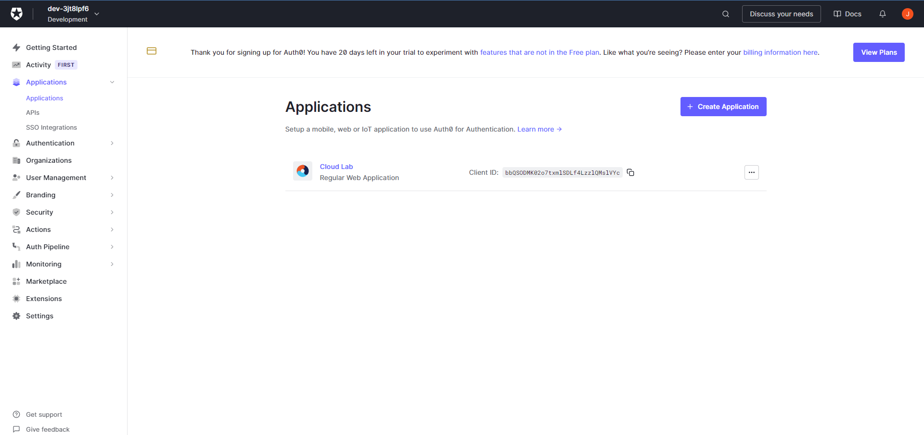

1. **Head to the Quick start section of the created application and select the Java Technology for your application and download the sample.**

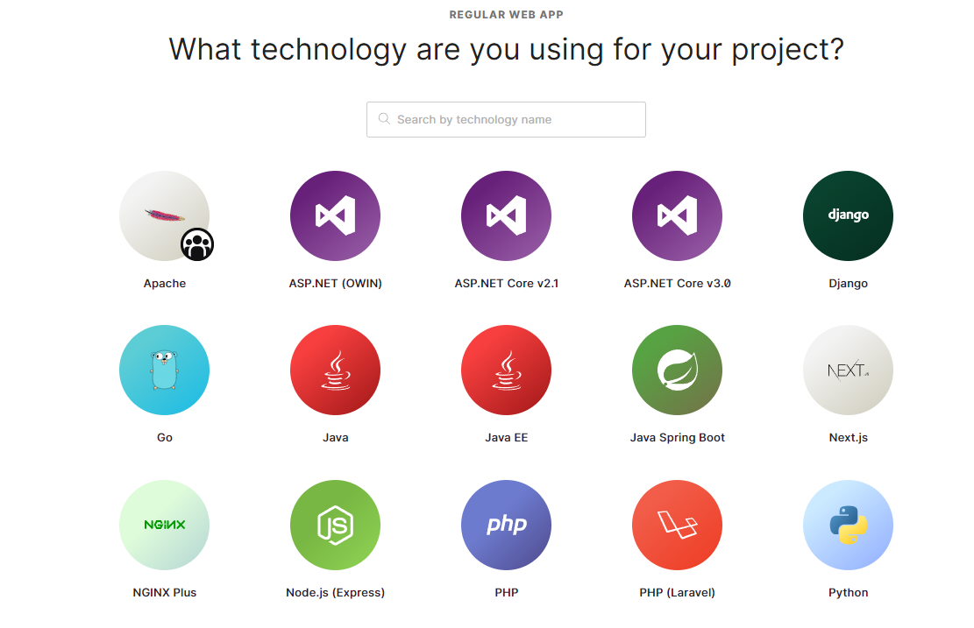

1. **Set allowed callback URL and allowed logout URL in settings for your respective Java Application.**

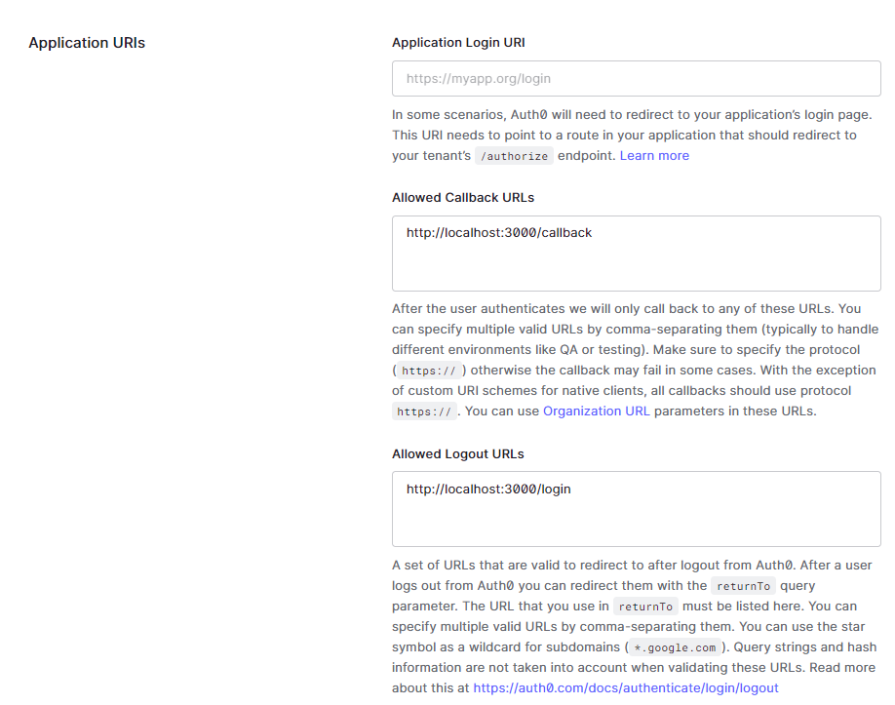

1. **Open the CMD prompt in the directory where the sample is downloaded and run the gradlew clean appRun command to run your application.**

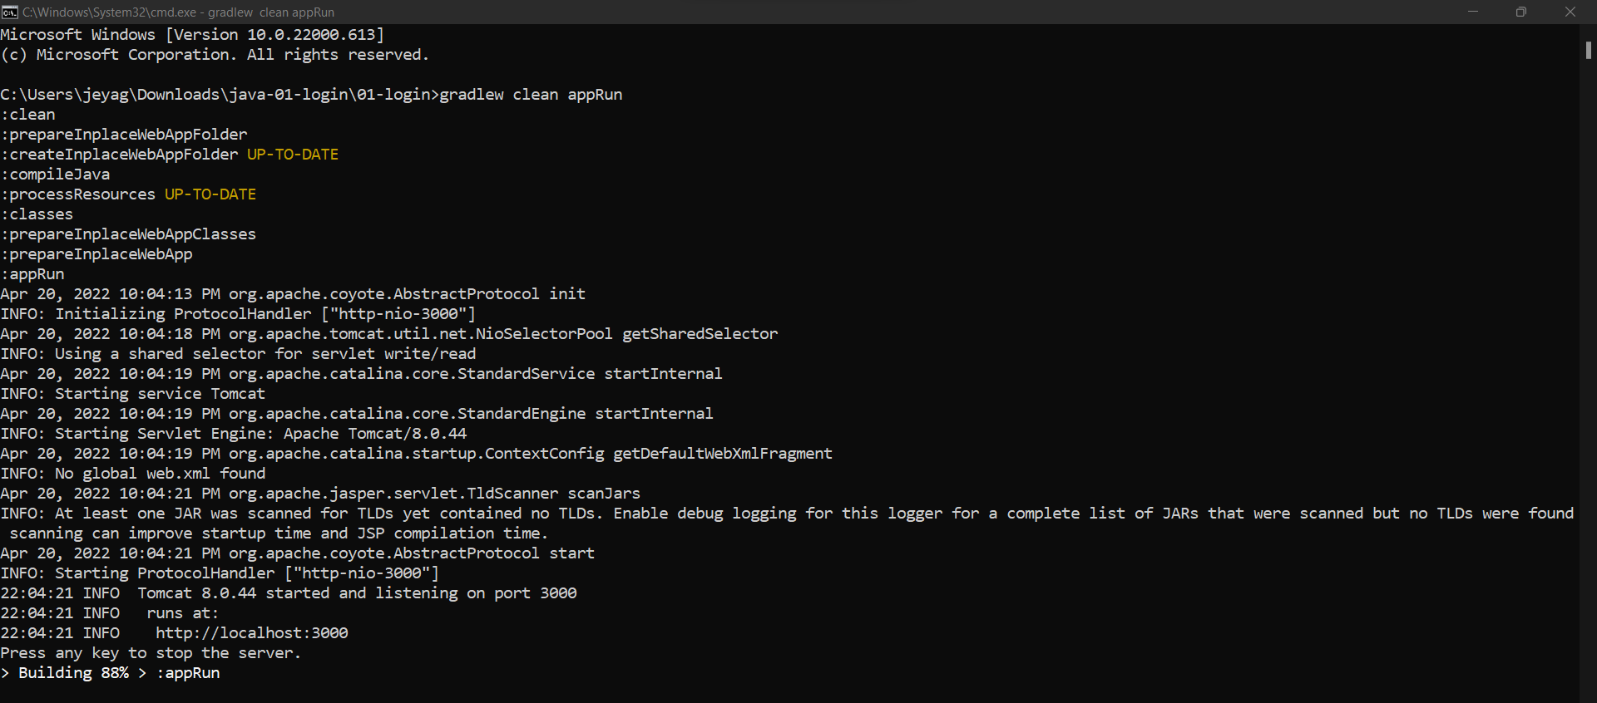

1. **Open your application on your web browser and go to “localhost:3000/portal/home” to authenticate using Auth0 and check the logs for your login in the Auth0 dashboard.**

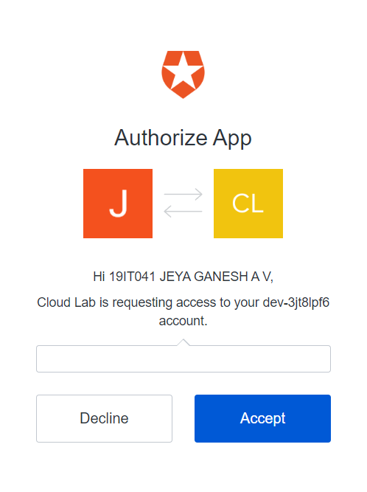

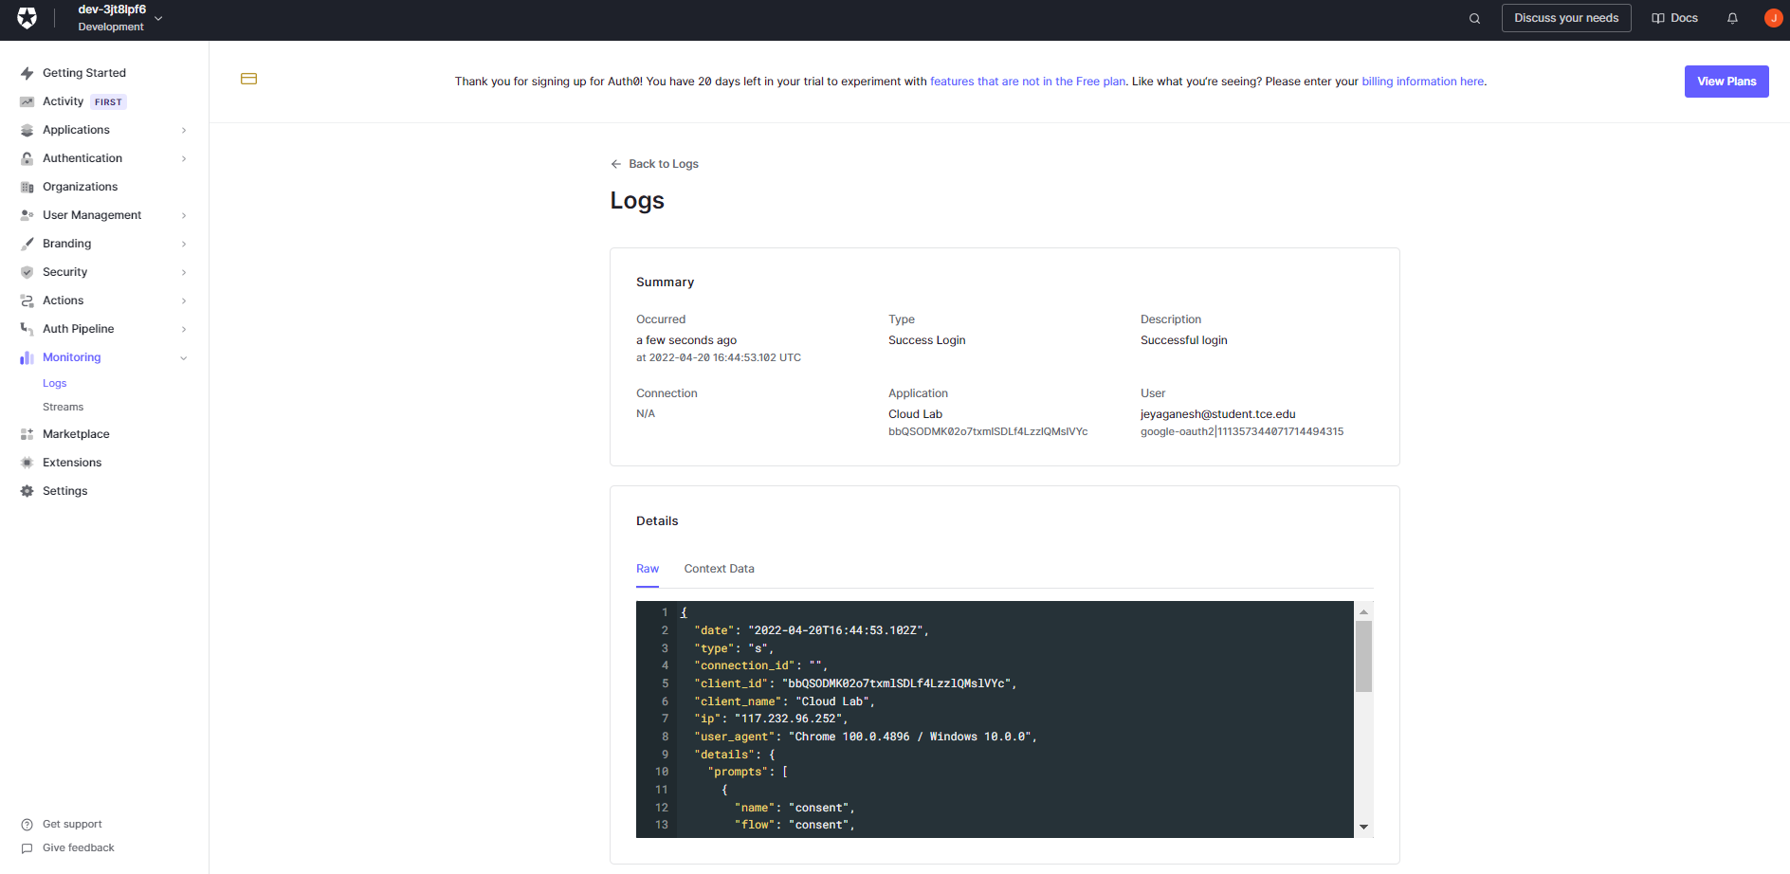

**Result:**

Thus, Authentication is implemented successfully in Java application using Auth0.