# Ex No : 10 Implementation of KVM as a virtual machine

# Date :

# 

**Aim :**

To run OS on top of KVM (Kernel-based Virtual Machine) virtual Machine manager.

**Procedure :**

* KVM can only runs on Linux OS. If you don’t have Linux OS install VMs like VMWhare and install Linux on top VMWhare
* Once that is done, we have to install KVM by following the bellow code(We have to be root user for perfoming following actions)
* Searching Package in Repository – apt -cache search qemu-kvm
* Installing Package from Repository - apt -get install qemu-kvm
* Opening libvrtd.conf file to change configurations by typing nano /etc/libvirt/libvirtd.conf
* Once it is opened in nano text editor
* Replace with the following code
* listen_addr = "0.0.0.0"
* unix_sock_group = "libvirt"
* unix_sock_ro_perms = "0777"
* unix_sock_rw_perms = "0777"
* unix_sock_dir = "/var/run/libvirt"
* auth_unix_ro = "none"
* auth_unix_rw = "none"
* Virsh list - Displays no of Virtual machine running
* Importing existing VM
* Selecting OS to import into VM

**Output :**



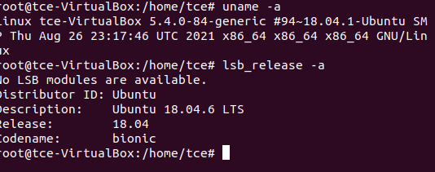

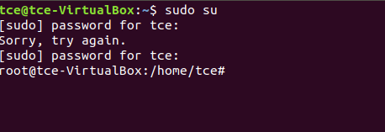

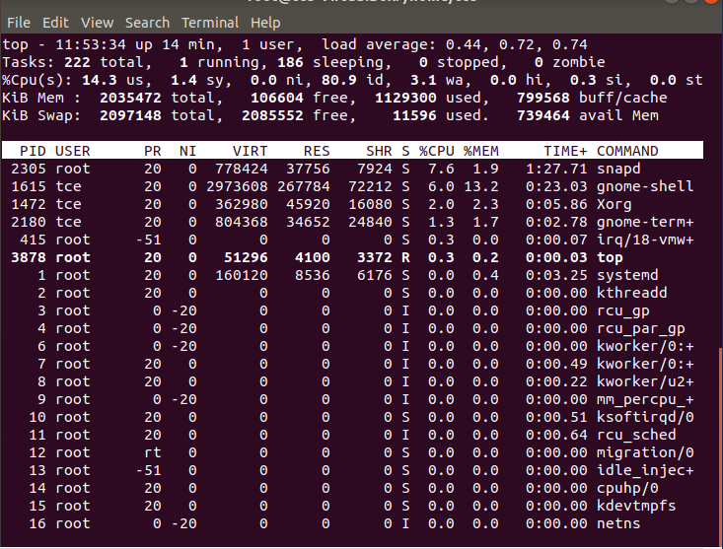



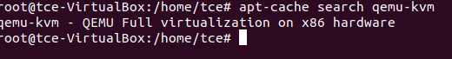

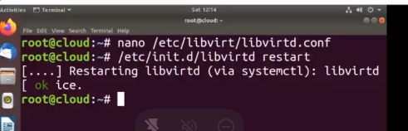

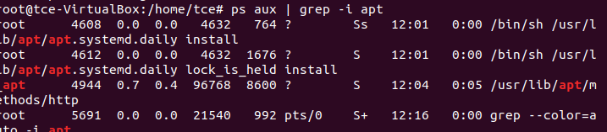

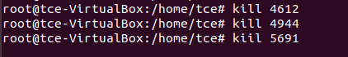

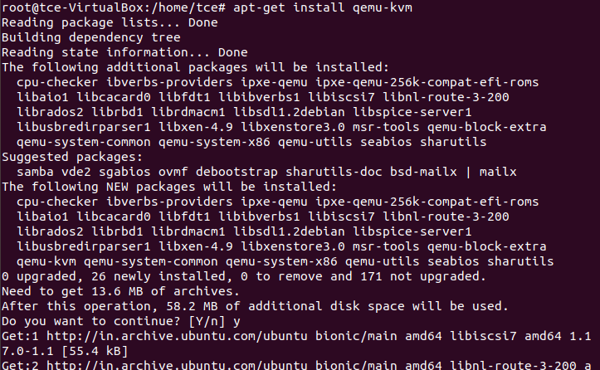

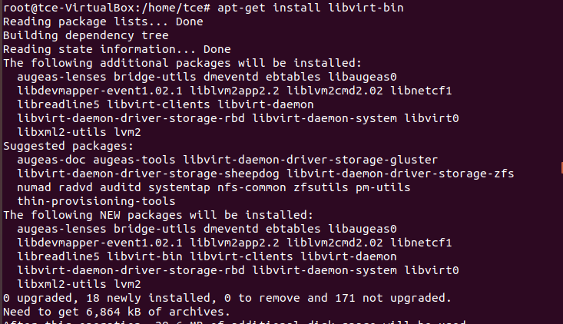

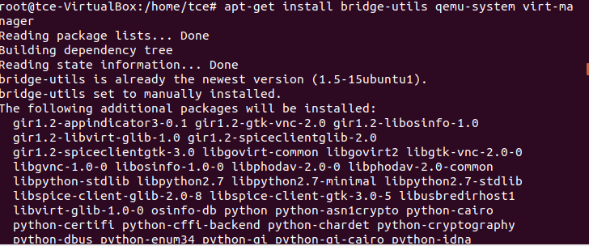

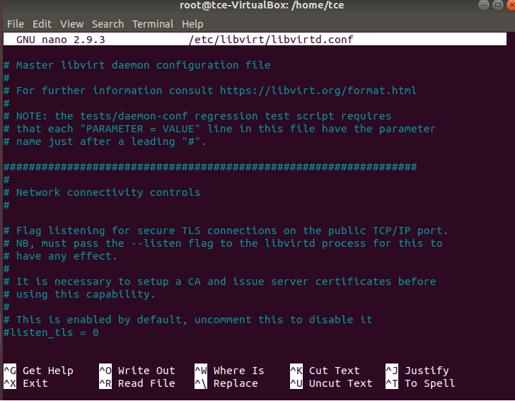

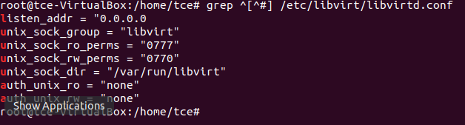

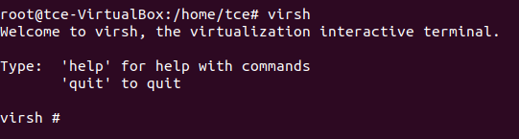

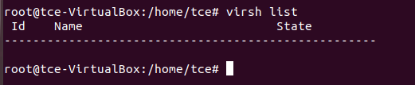

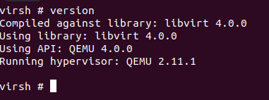

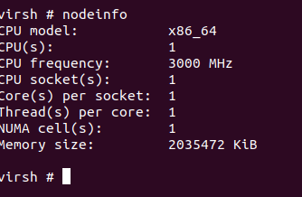

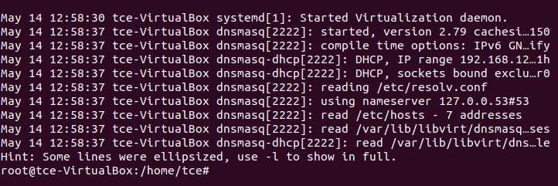

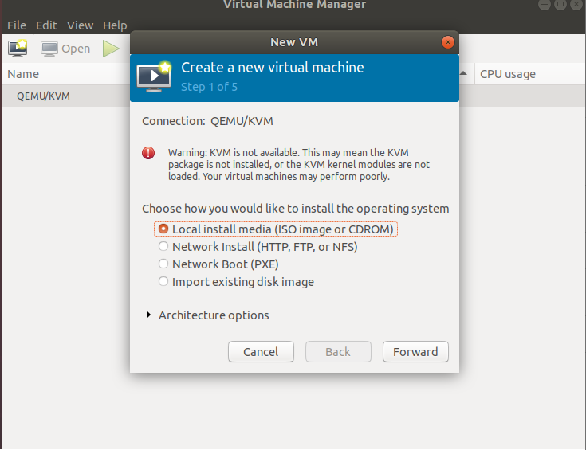

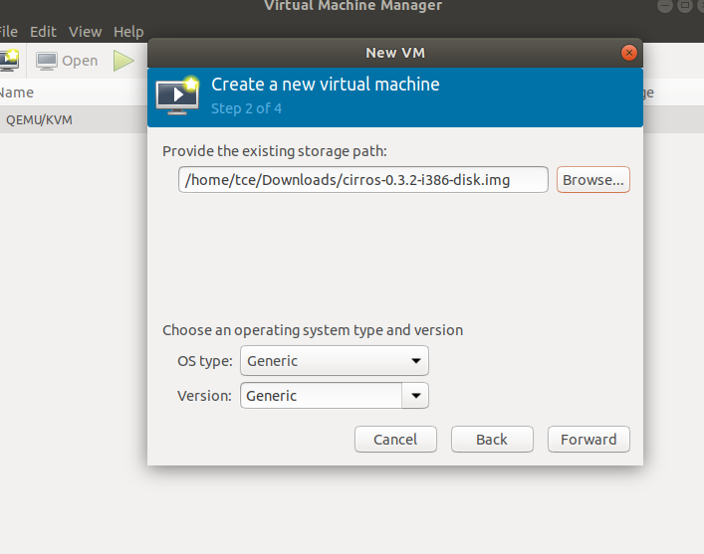

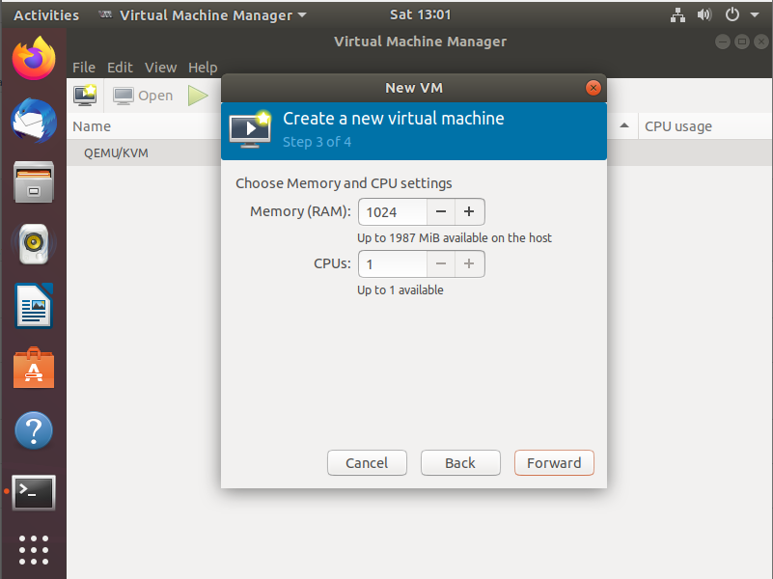

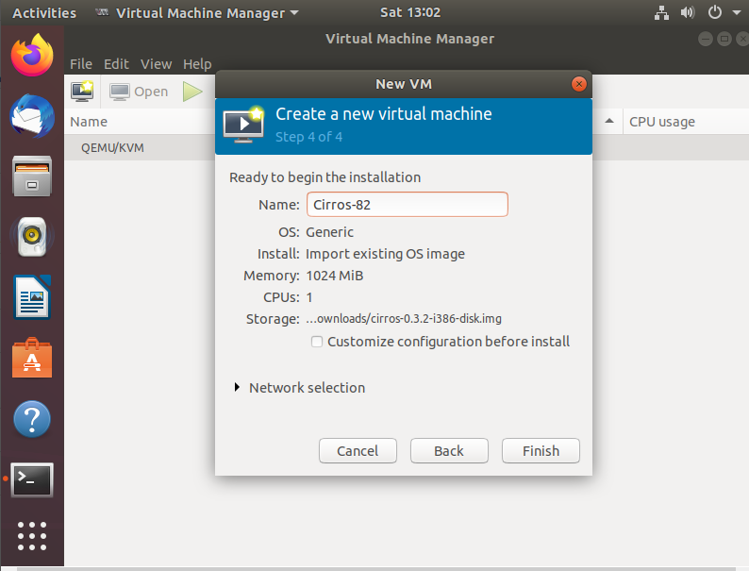

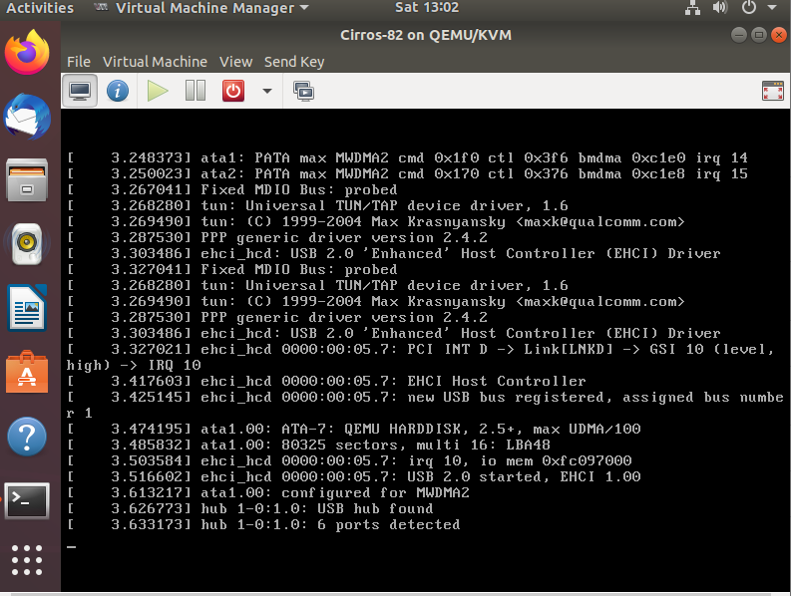

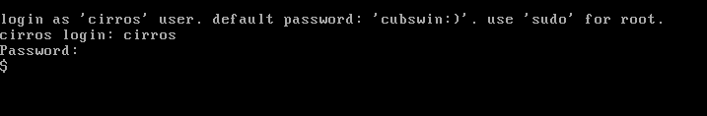

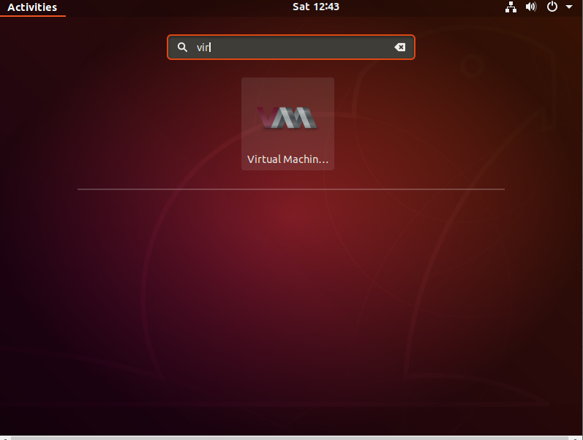

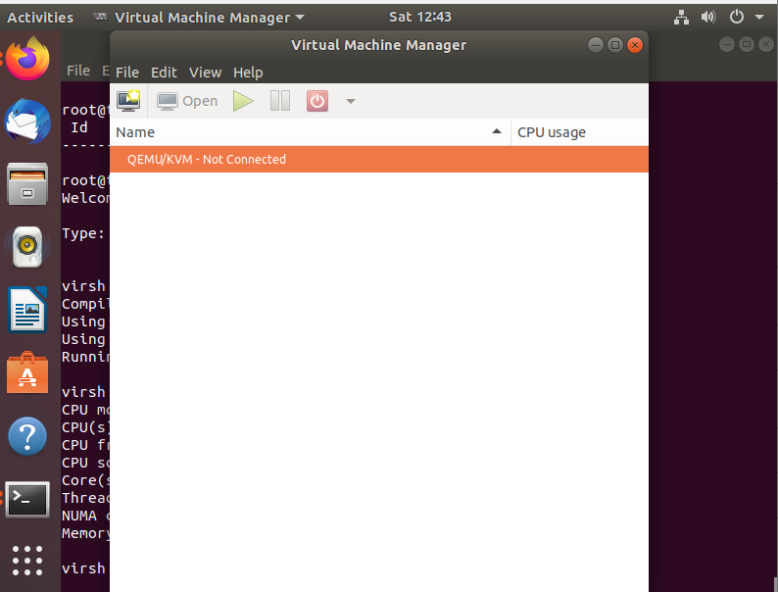

**Result:**

Thus, the implementation of KVM along with its operating System on top is executed.