# Ex No : 5 Platform as a Service

**Date :**

# Aim:

To implement platform as a service.

# Procedure and Screenshots:

1. Open pythonanywhere.com and create an account.

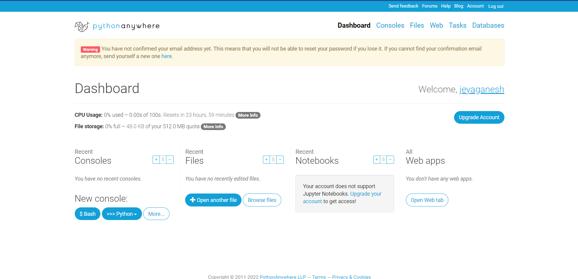

1. Create a domain name and host the website.

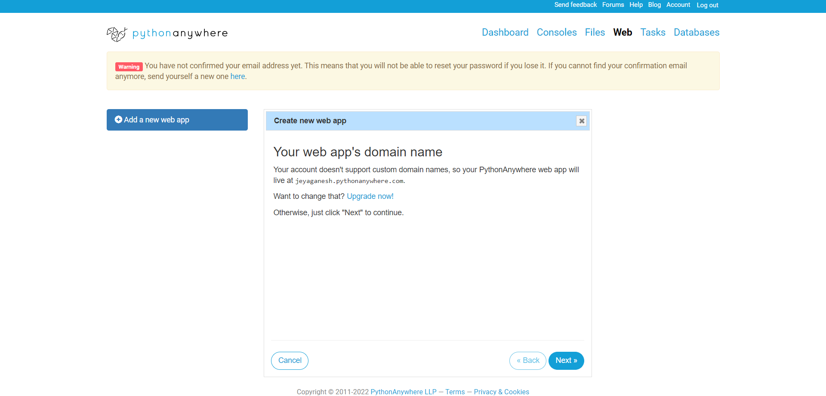

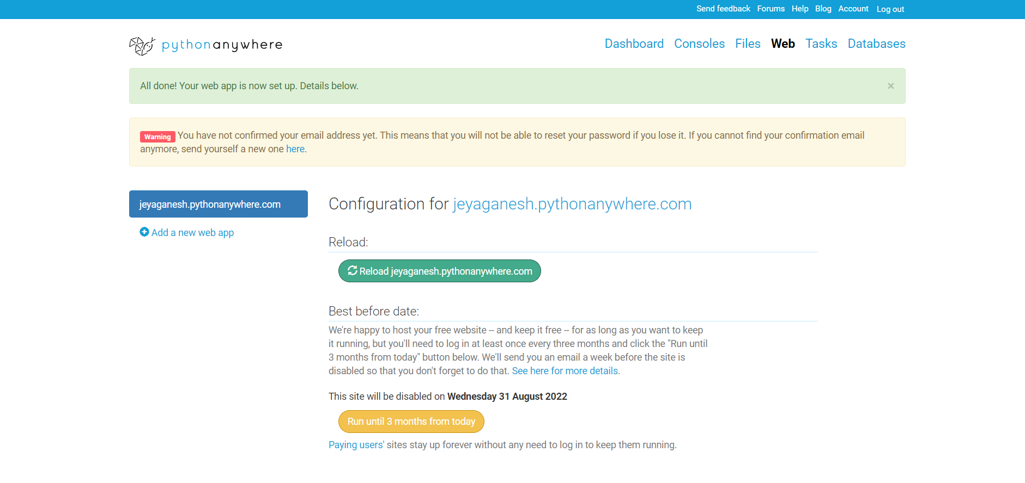

1. It contains a virtual environment that contains the runtime for our website.

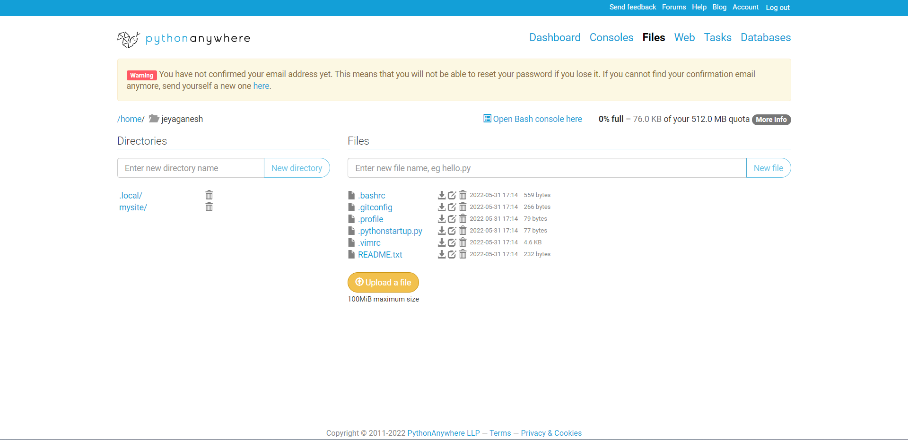

1. Upload the python file.

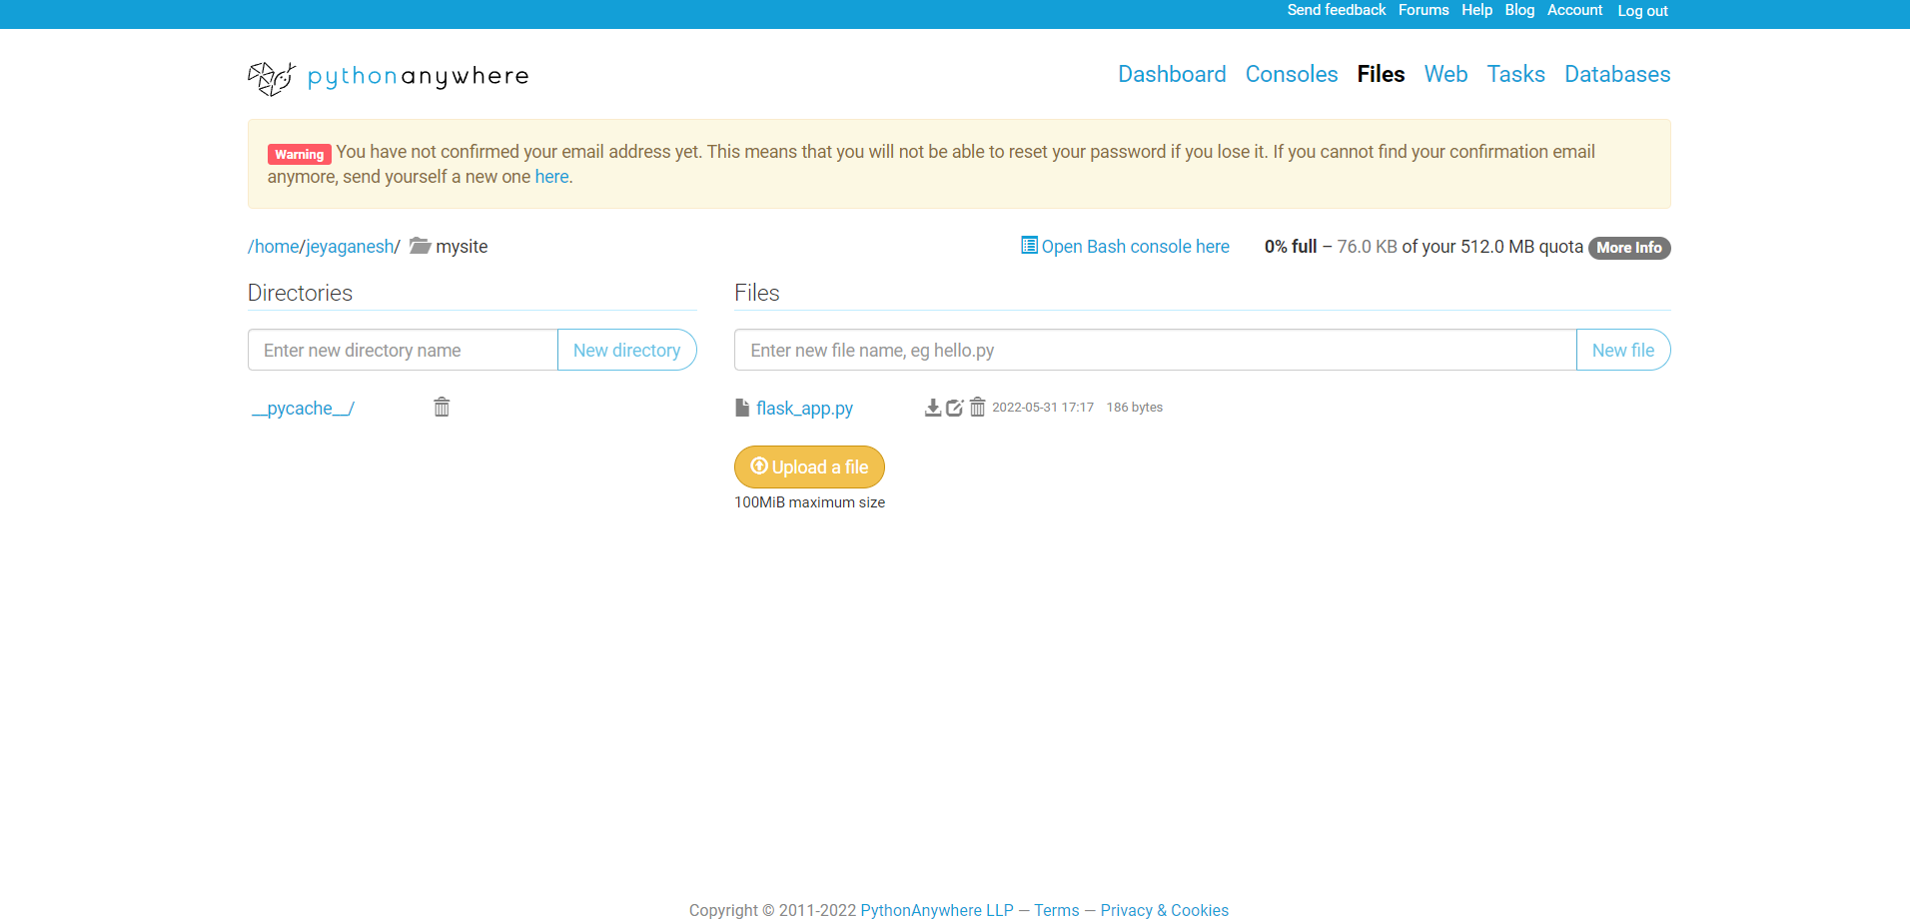

1. Use the IDE for editing and debugging your code.

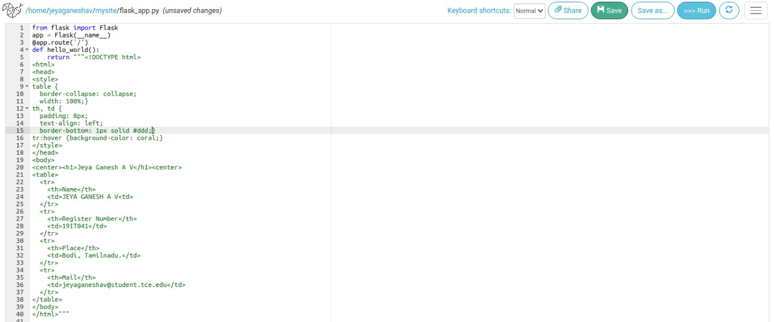

1. Test the implementation by opening the link in a browse.

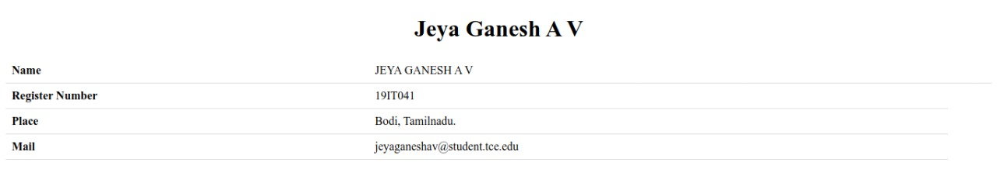

**Result:**

Hence the experiment was completed and the result is verified.