


Security Auditing
Penetration Testing

{{ title }}
Executive and Technical Report

This document is only for the use and benefit of {{ client.short_name }} and may not be disclosed, commented or copied, in whole or in part, without the prior written consent of LAYER8.
The understanding expressed in this document is confined to the conclusions that we specifically formulate in it. If any of these facts, assumptions and representations do not fully correspond to reality or are incomplete, it is imperative that we should be informed immediately of this circumstance, since the incompleteness, inaccuracy or inaccuracy of these facts may have a significant influence on the conclusions we reached.

Revisions and Approval History
Revision History
Version | Author | Date | Revision
0.9  1.0 | {{ team[0].name }} | {{ report_date }} | First version report  First revision

 | This document was approved by
 | Name |  |  | Date of Approval
 | Francisco Ferraz



Consulting Services
Maio 2013
Index
1 Executive Summary 5
1.1 Introduction 5
1.2 Scope 5
1.3 Audit Results 5
1.4 Recommended Initiatives 6
2 Methodology 7
2.1 Criteria 7
2.2 Testing Workflow 9
2.3 Vulnerability Classification 10
2.4 Deontology 14
2.5 Privacy and Information Protection 14
3 Vulnerability Details 15
3.1 Identified Vulnerabilities 15
3.1.1 ATUALIZA-ME 16
4 Annexes 17
4.1 Annex 1 – Scope 17

Executive Summary
  - Introduction
Due to its business activity, {{ client.short_name }} has an ongoing concern about information security in several of its diverse multilateral subjects. Inherently, the inclusion of the security strands – Confidentiality, Integrity and Availability – is part of the current processes and workflows. However, and due to the constant necessity to increase the access to information, workforce mobility, interplay with other entities and technological evolution, the infrastructures and information systems are in constant evolution, challenging the way security is implemented. The main challenge being, enhancing security considering the technological needs that support the business operations.
This report aims to evaluate the organization’s websites security levels, providing a general and widespread view regarding Confidentiality, Integrity and Availability of the information in {{ client.short_name }}’s infrastructure, enumerating key points and defining strategies to their optimization.

  - Scope
The scope for this audit was {{ client.short_name }}’s exposed websites on the Internet. The full list of addresses and URLs included in scope are shown in Chapter 4 – Scope. ADAPTAR
The infrastructure used by the auditor during the tests comprised of a windows and kali linux machines and {{ client.short_name }} provided two test accounts for the penetration test exercises. DETALHAR
The security tests were performed via internet between {{ project.start_date }} and {{ project.end_date }}.

  - Audit Results
The results of the audit performed to the web applications and hosts in scope, show that there is a strong level of concern by {{ client.short_name }} when dealing with Information Security and thus, a concern towards protecting its clients.
As a result of this security audit, it has been identified the following positive aspects:
- Resistance against code injection vulnerabilities;
- Strong Access Control Policies.

And the following negative aspects:
- Outdated Software;
- Session Managment;
- MFA configuration.

A total of {{ totals.findings }} vulnerabilities were discovered, and their distribution according to severity can be seen in the list below.
# | Vulnerabilities | Severity
{%tr for finding in findings %}
V{{ '%02d' % loop.index }} | {{ finding[‘title’] }} | {{r finding.severity_rt }}
{%tr endfor %}

Recommended Initiatives
Following the execution of this audit, the project team leaves a summary of recommended initiatives for {{ client.short_name }} to mitigate and prevent the main risks detected in this report. These initiatives should be framed with the strategic information security plan that {{ client.short_name }} already has in force, with the prioritization and calculation of effort of the same at the expense of the client.

Short/medium term remediations:
- It is recommended to address the V01
- And then V02 and V03 - PALHA
Medium/long term remediations:
- Vulnerability V04 should also be take in consideration, despite its low severity it can put in cause availability of the application.

Methodology

Criteria
All Penetration Tests conducted by LAYER8, have an extensive criteria and execution planning according to each customer’s needs. Each step of this plan is defined by the Penetration Test model “Durchführungskonzept für Penetrationstests”, of the German National Security Agency (Bundesamt für Sicherheit in der Informationstechnik).

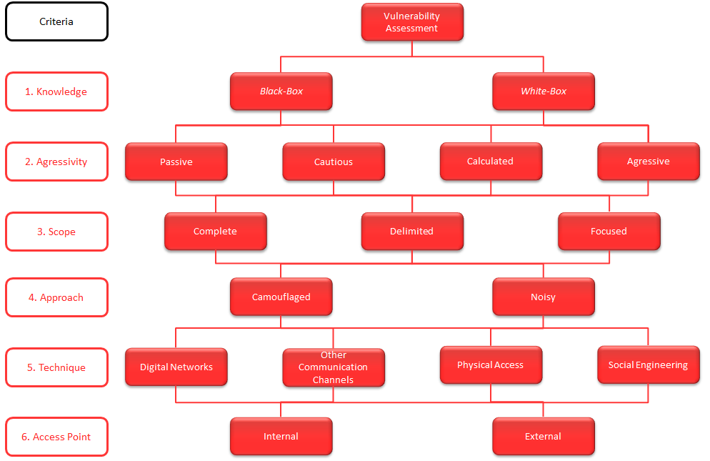

In this project context, LAYER8 approached the security assessment according to the following criteria:

Knowledge |  | Black-box
 | LAYER8’s auditors did not have previous knowledge of the infrastructure to audit.
Aggressiveness |  | Calculated
 | During this type of security assessment, there is always an associated security risk. LAYER8, used a set of risk analysis mechanisms in every exploitation attempt for each vulnerability, to avoid service disruption.
Scope |  | Delimited
 | The audited systems were identified as making part of {{ client.short_name }} infrastructure.
Approach |  | Noisy
 | LAYER8’s auditor didn’t use any stealth techniques to hide his actions. This way, {{ client.short_name }} could easily verify the efficiency of their security systems by analyzing the generated events.
Technique |  | Digital Network
 | The tests were conducted through a digital IP network connection.
Access Point |  | VPN/Internet
 | The tests were conducted via the internet.

Testing Workflow

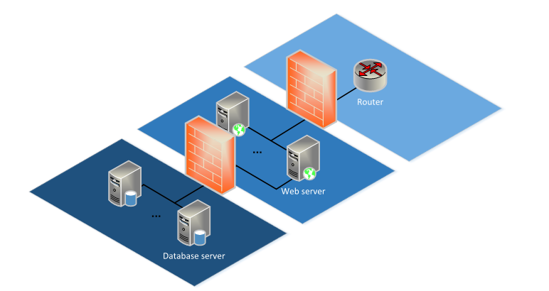
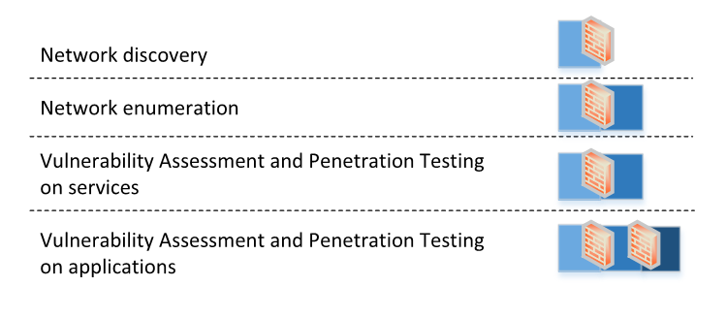
Reconnaissance
The reconnaissance phase serves as a start point to identify the hosts to audit, revealing potential targets, as well as their attributes and limitations.
Services and Systems Fingerprinting
Using the results obtained in the reconnaissance phase, this phase is focused on identifying operating systems and application server versions that are part within the scope to audit.
Systems and Services Vulnerability Identification and Exploitation
With the previously gathered knowledge, tests are made, to identify, exploit and validate found vulnerabilities.
Application Vulnerability Identification and Exploitation
Vulnerabilities related to systems and services are typically known and relatively easy to exploit in an automatic or semi-automatic method. When it comes to applications a manual testing approach becomes a must to accurately determine the level of application security controls.
The set of application tests performed by LAYER8 when related to web applications, considers, among others, the most common security flaws, covered by OWASP Top 10:
- Injection Flaws (SQL, LDAP, XPATH, etc.);
- Broken Authentication and Session Management;
- Cross-Site Scripting;
- Insecure Direct Object References;
- Security Misconfiguration;
- Sensitive Data Exposure;
- Missing Function Level Access Control;
- Cross Site Request Forgery (CSRF);
- Using Known Vulnerable Components;
- Unvalidated Redirects and Forwards;
- Denial of Service;
- Buffer Overflow; and
- Application Denial of Service;

  - Vulnerability Classification
The classification model used in this report distinguishes vulnerabilities based on their Identification, Taxonomy and Risk Metrics. For this, LAYER8 has developed a model based on three international systems:
- Identification - Common Vulnerabilities and Exposures (CVE);
- Taxonomy - Common Weakness Enumeration (CWE) and Open Web Application Security Project (OWASP); and
- Severity Scoring Metrics - Common Vulnerability Scoring System (CVSS).

1 – Vulnerability Identification (CVE – Common Vulnerabilities and Exposures)
The Common Vulnerabilities and Exposures (CVE) is a list of common names for vulnerabilities that are publicly known. The use of a common name makes it easier to share data between databases and applications, which, without this standard, were difficult to integrate. Thus, the use of CVE is central in sharing information related to system vulnerabilities.
This report is CVE compliant. In this way, it is easier to search for information (both for information and for solving vulnerabilities) in compatible databases.
CVE standards and names are listed on cve.mitre.org, which is owned and maintained by Mitre Corporation and has the support of the following:
- General Dynamics Corporation;
- SANS Institute;
- National Security Agent;
- CERIAS/Purdue University;
- CERT/CC;
- National Institute of Standards and Technology;
- IBM;
- Sun Microsystems;
- Cisco Systems;
- Symantec Corporation; and
- Internet Security Systems.

2 - Vulnerability Taxonomy (CWE – Common Weakness Enumeration)
The Common Weakness Enumeration (CWE) is a common taxonomic scheme for all known software vulnerabilities. Its use makes it possible to distinguish characteristics and behaviors from a development perspective, making it possible to understand the origin of the problem. Thus, the use of CWE becomes essential in sharing information in order to better understand software failures.
CWE counts with the collaboration and support of the following:
- Aspect Security;
- CERIAS/Purdue University;
- CERT/CC (Software Engineering Institute, Carnegie Mellon University);
- Core Security Technologies;
- Microsoft Corporation;
- MIT Lincoln Labs;
- National Institute of Standards and Technology (NIST);
- National Security Agency;
- Object Management Group;
- Open Web Application Security Project (OWASP);
- Oracle Corporation;
- Parasoft Corporation;
- Watchfire Corporation; and
- Web Application Security Consortium (WASC).

OWASP Top 10 2021
The OWASP Top 10 Project provides an internationally recognized method of classifying vulnerabilities in web applications, created by analyzing the following data:
- Threat Agents;
- Attack Vectors;
- Security Vulnerabilities;
- Security Controls;
- Technical Impact; and
- Business Impact.
The OWASP Project defines the Top 10 of vulnerability types that are seen on worldwide assessments. LAYER8 uses this classification for every Web vulnerability detected. The most recent Top 10 list (2021) is detailed next:
- A1:2021-Broken Access Control;
- A2:2021-Cryptographic Failures;
- A3:2021-Injection;
- A4:2021-Insecure Design;
- A5:2021-Security Misconfiguration;
- A6:2021-Vulnerable and Outdated Components;
- A7:2021-Identification and Authentication Failures;
- A8:2021-Software and Data Integrity Failures;
- A9:2021-Security Logging and Monitoring Failures;
- A10:2021-Server-Side Request Forgery.

3- Severity Scoring Metrics (CVSS – Common Vulnerability Scoring System)
The Common Vulnerability Scoring System (CVSS) consists of defining common metrics in order to make risk assessment a collaborative, global and uniform work.
The CVSS framework uses three groups of metrics: base, temporal, and environmental. The base metrics group consists of fundamental characteristics in the definition of each vulnerability, which are constant over time. The temporal metrics group consists of characteristics that depend on vulnerability maturation. Finally, the environmental metrics group consists of intrinsic characteristics of the system affected by the audit.
This three metric groups in CVSS are further detailed on the next image:
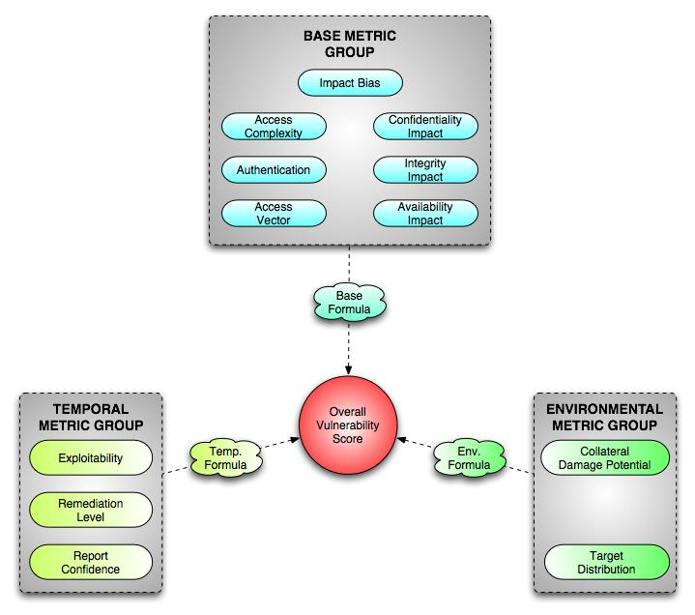
The CVSS can be consulted at www.first.org/cvss and is maintained by the Forum of Incident Response and Security Teams (FIRST). It is in production in the following organizations:
- Big Fix;
- E-Secure-IT;
- Internet Security Systems;
- MySDN;
- Tenable Network Security;
- National Institute of Standards and Technology;
- Oracle;
- Redseal;
- Skype;
- Symantec Corporation;
- Skybox Security;
- ThreatGuard, Inc.;
- Qualys; and
- United States Computer Emergency Readiness Team.

  - Deontology
LAYER8 auditors are members of Information Systems Audit and Control Association (ISACA), and Certified Information Systems Auditors (CISA), as such, being committed to comply with the deontological code of this association during their professional activity. LAYER8 commits to present its results in an impartial and objective manner.

  - Privacy and Information Protection
LAYER8 commits to take adequate measures to protect the confidentiality of the information hereby presented, as well as any associated sensitive data collected during the assessment, at rest or in transit.

Vulnerability Details
The following figure represents the structure used to describe the identified vulnerabilities. Its format complies with the methodology and the concepts presented in Chapter 2.
Full Vulnerability Name
Vulnerability Identifier
CVSS full vector by NIST
Vulnerability Classification

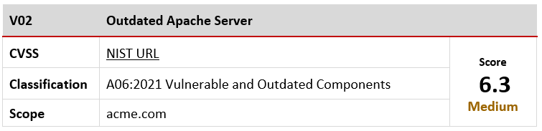

Affected Scope
Vulnerability severity score

The overall severity value appointed by LAYER8 to each vulnerability is given from a technical point of view, therefore {{ client.short_name }} should make its own risk analysis.

Identified Vulnerabilities
All vulnerabilities found during this audit, and evidence to help reproduce the issues, are enumerated next.
{% for finding in findings %}

    - {{ finding.title }}
V{{ '%02d' % loop.index }} | {{ finding.title }}
CVSS | {{ finding.cvss_vector_link_rt }} | Score  {{r finding.severity_rt }}
Classification | {{ finding.classification_rt }}
Scope | {{ finding.affected_entities_rt }}  {{ finding.cvss_score }}

Summary
{{p finding.description_rt }}

Impact
{{p finding.impact_rt }}

Details
{{p finding.replication_steps_rt }}

Recommendations
{{p finding.recommendation_rt }}

{% endfor %}

Annexes

Annex 1 – Scope
The details of the services available and the characteristics of the application infrastructure supporting them, which it was possible to identify, are described in the following table:

Scope
{%tr for item in scope %}
{{ item.scope }}
{%tr endfor %}

Francisco Ferraz
Offensive Security Unit Manager
Consulting Services
Mobile: +351 936 002 043
Email: francisco.ferraz@layer8.pt
Audit 2
Offensive Security Consultant
Consulting Services
Mobile: +351 93 993 9023
Email: audit.email@layer8.pt

{{ team[0].name }}
Offensive Security Consultant
Consulting Services
Mobile: +351 93 993 9023
Email: {{ team[0].email }}

LAYER8 - Shield Domain S.A.
Av. D. João II, Lote 1.06.2.1A, Escritório 602
Edifício Mythos
Parque das Nações
1990-095 Lisboa
Portugal

Phone: +351 218 248 480



