1. 調參過程
2. Lr=0.1、0.01、0.001、0.0001、0.00001

Batch size=300, epochs=20, validation=0.1

1. Class 0

0.7733132913221946

0.7763581353221175

0.7713476325374342

0.7714439883602167

0.7787477597271203

1. Class 1

0.7924989630405833

0.7960792018687101

0.7971707380967974

0.7896827995721178

0.7950749885388696

1. Class 2

0.7548554532110873

0.7535861927148702

0.7539407347529197

0.7529551078871421

0.7540116431605296

1. Lr=0.1、0.01、0.001、0.0001、0.00001

Batch size=300, epochs=20, validation=0.3

1. Class 0

0.7538494151201557

0.7579927154997976

0.7545624482087453

0.7583203252972577

0.76109537299339

1. Class 1

0.7847708865457245

0.7873032505948873

0.7840068111860633

0.7846617329229157

0.7914729189861811

1. Class 2

0.7476866132017274

0.7451339105277712

0.7435951980826366

0.7455168159288647

0.7435668347195927

1. Lr=0.1、0.01、0.001、0.0001、0.00001

Batch size=300, epochs=20, validation=0.05

1. Class 0

0.7725809870690485

0.7700950068412634

0.7737757992715499

0.774141951398123

0.7763195929930046

1. Class 1

0.7955552644792281

0.7970397537494269

0.80232278909337

0.8011657606915974

0.7974763682406619

1. Class 2

0.7528841994795323

0.7532529231991038

0.7533663766512796

0.7543094584724911

0.7537776454154169

Class 0: 選擇Accuracy與AUC最高之結果

Class 1: 選擇AUC最高或Accuracy最高、AUC僅低一點之結果

Class 2: 選擇Accuracy與AUC最高之結果

1. Class 0

* **Batch Size**

300

* **Epochs**

20

* **Learning Rate**

0.00001

* **Train**

ACC: 79.8%

MAE: 0.2828

MSE: 0.2107

* 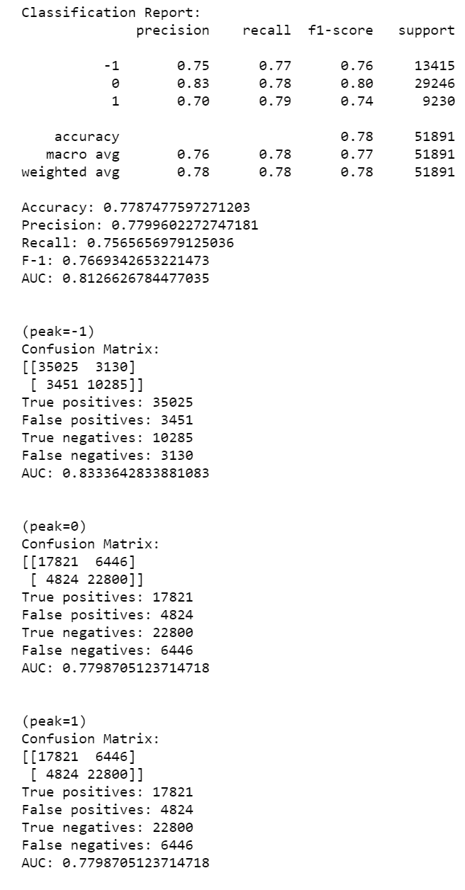**Validation(0.1)**

ACC: 70.6%

MAE: 0.2981

MSE: 0.2197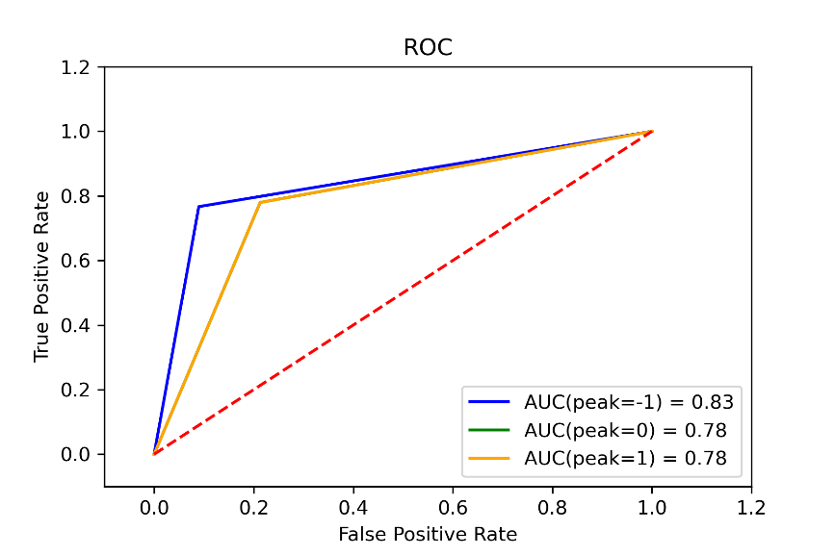

* **Test**

ACC: 77.9%

MAE: 0.2253

MSE: 0.2335

AUC: 0.8127

AUC(peak=-1): 0.83

AUC(peak=0): 0.78

AUC(peak=1): 0.78

1. 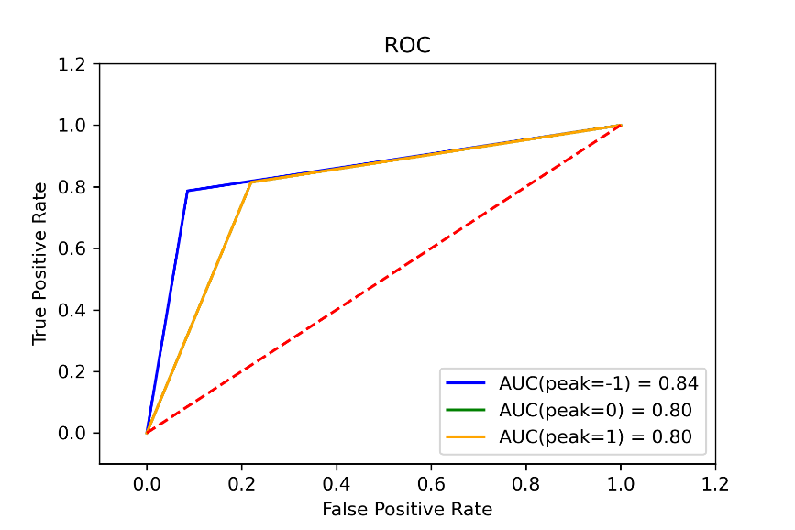Class 1

* **Batch Size**

300

* **Epochs**

20

* **Learning Rate**

0.00001

* **Train**

ACC: 81.2%

MAE: 0.2883

MSE: 0.2660

* **Validation(0.1)**

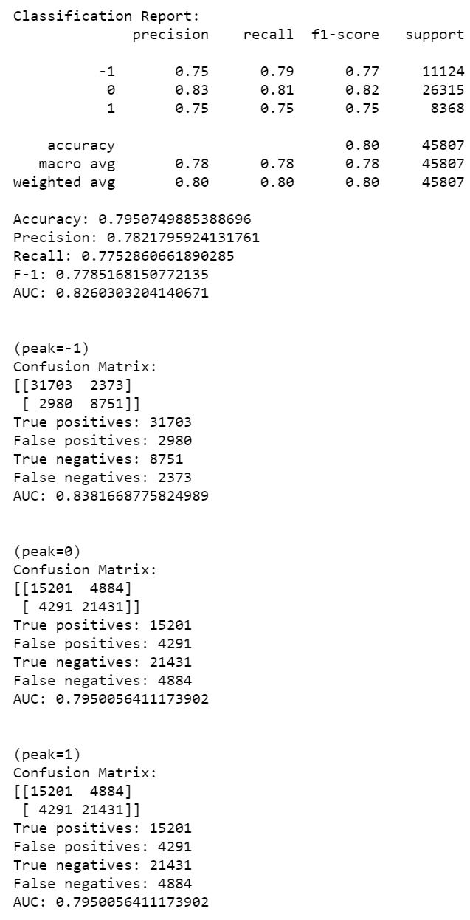ACC: 0.7539

MAE: 0.2973

MSE: 0.2474

* **Test**

ACC: 79.5%

MAE: 0.2188

MSE: 0.2096

AUC: 0.8260

AUC(peak=-1): 0.84

AUC(peak=0): 0.80

AUC(peak=1): 0.80

1. Class 2

* **Batch Size**

300

* **Epochs**

20

* **Learning Rate**

0.1

* 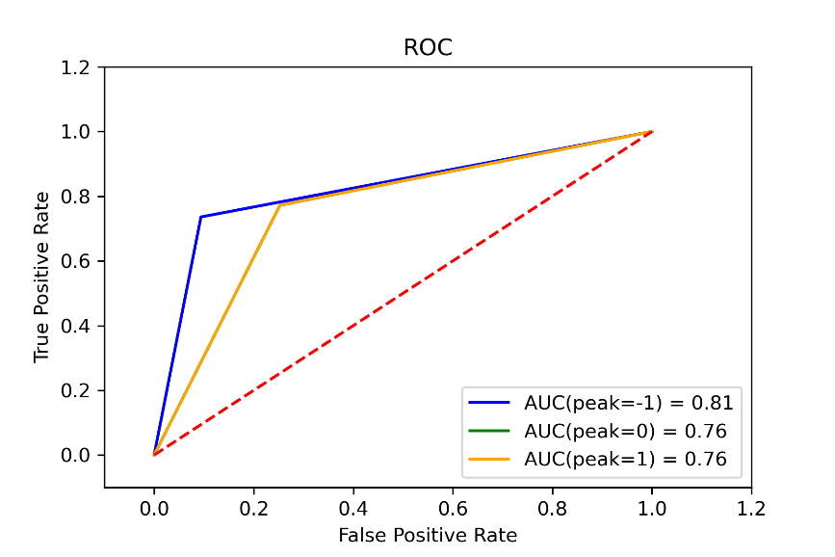**Train**

ACC: 76.7%

MAE: 0.2836

MSE: 0.1945

* 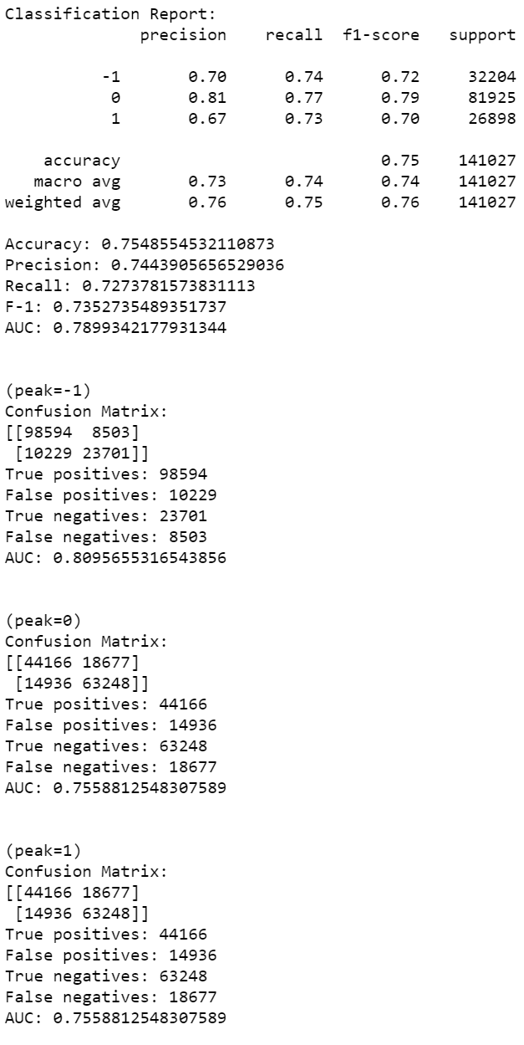**Validation(0.1)**

ACC: 72.7%

MAE: 0.2900

MSE: 0.2000

* **Test**

ACC: 75.5%

MAE: 0.2519

MSE: 0.2655

AUC: 0.7899

AUC(peak=-1): 0.81

AUC(peak=0): 0.76

AUC(peak=1): 0.76

1. 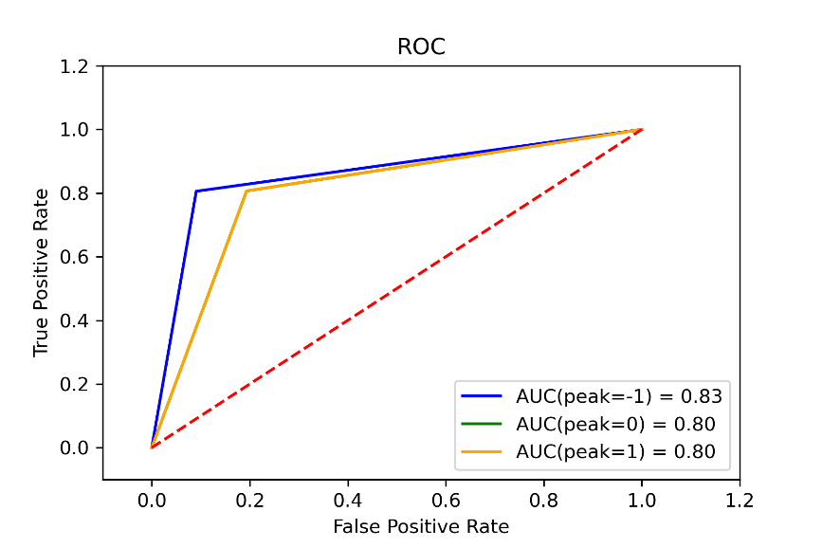Class 1

* **Batch Size**

300

* **Epochs**

20

* **Learning Rate**

0.001

* **Train**

ACC: 81.4%

MAE: 0.2899

MSE: 0.2311

* 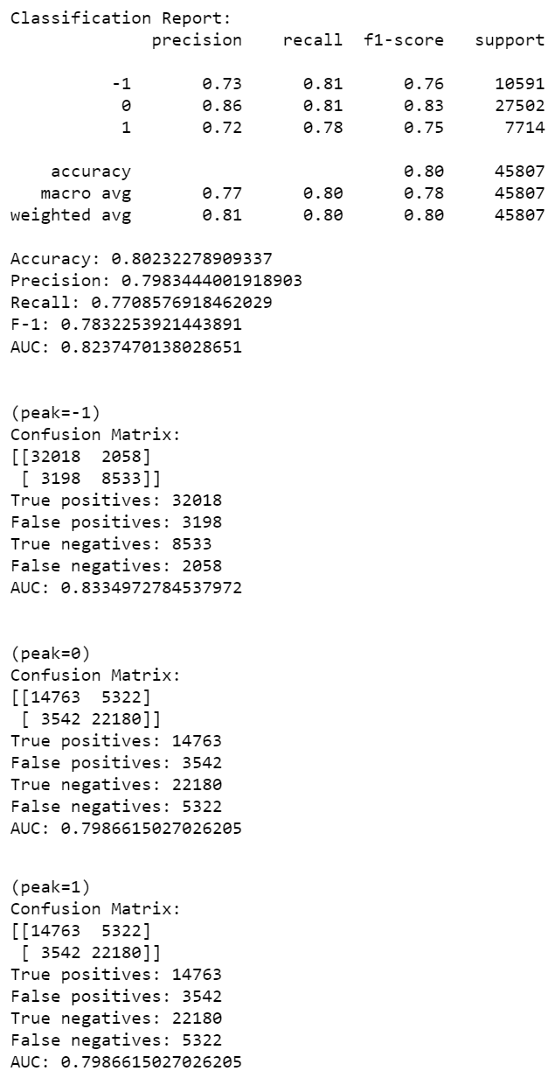**Validation(0.05)**

ACC: 81.8%

MAE: 0.2963

MSE: 0.2469

* **Test**

ACC: 80.2%

MAE: 0.2018

MSE: 0.2102

AUC: 0.8237

AUC(peak=-1): 0.83

AUC(peak=0): 0.80

AUC(peak=1): 0.80