**Class 0 調參**

1. Learning rate

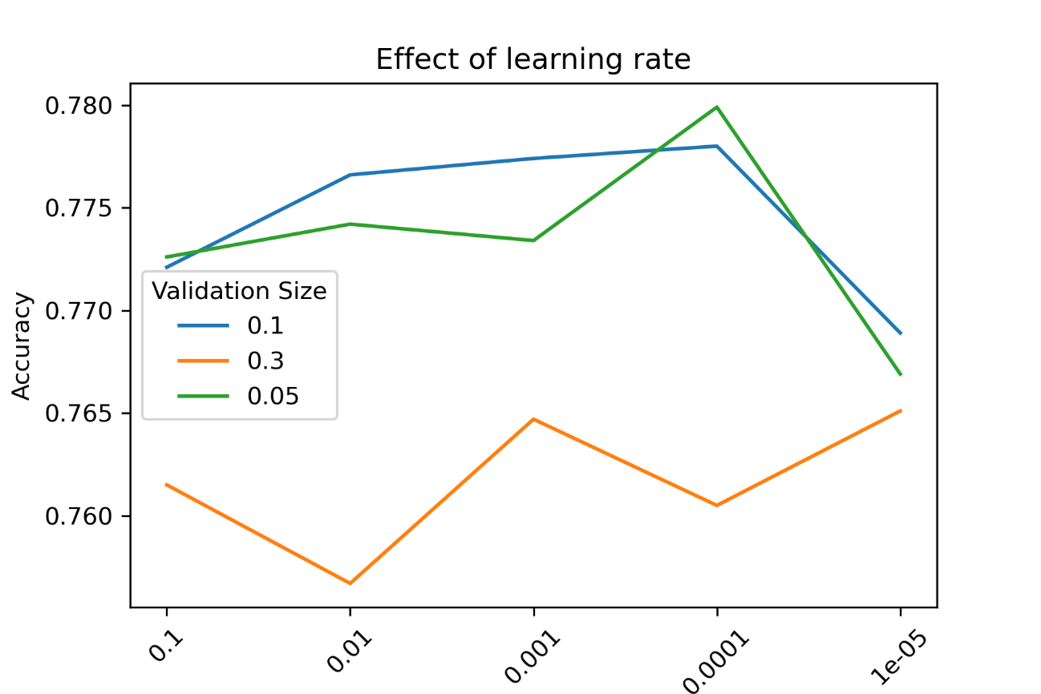

|  |  |  |
| --- | --- | --- |
| 0.05 | 0.1 | 0.3 |
| 0.772638800562718 | 0.7721377502842497 | 0.761500067449076 |
| 0.7741997648917924 | 0.7766086604613517 | 0.7566822763099574 |
| 0.773371104815864 | 0.7774373205372801 | 0.7647376230945636 |
| 0.7798847584359523 | 0.7779769131448614 | 0.7604594245630264 |
| 0.7669152646894452 | 0.7688809234742056 | 0.7650845040565801 |

**Class0 調參完(learning rate=0.0001 / batch size = 300 / epochs = 20 / validation split = 0.05)**

MSE – Train: 0.211

MSE – Validation: 0.222

MSE – Test: 0.232

MAE – Train: 0.283

MAE – Validation: 0.297

MAE – Test: 0.234

ACC – Train: 0.796

ACC – Validation: 0.645

ACC – Test: 0.780

* 最佳 Accuracy：78.0%
* 最佳 MSE：23.2%

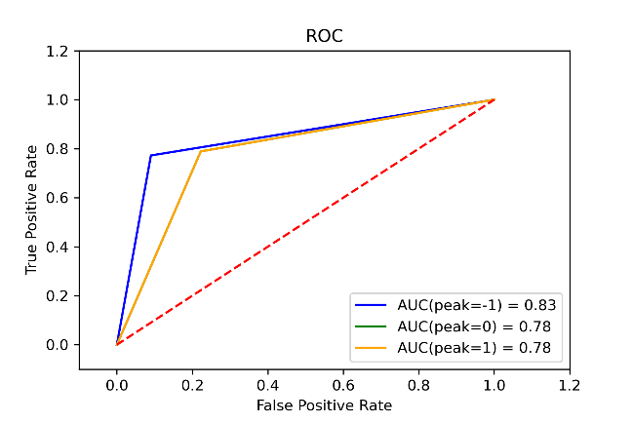 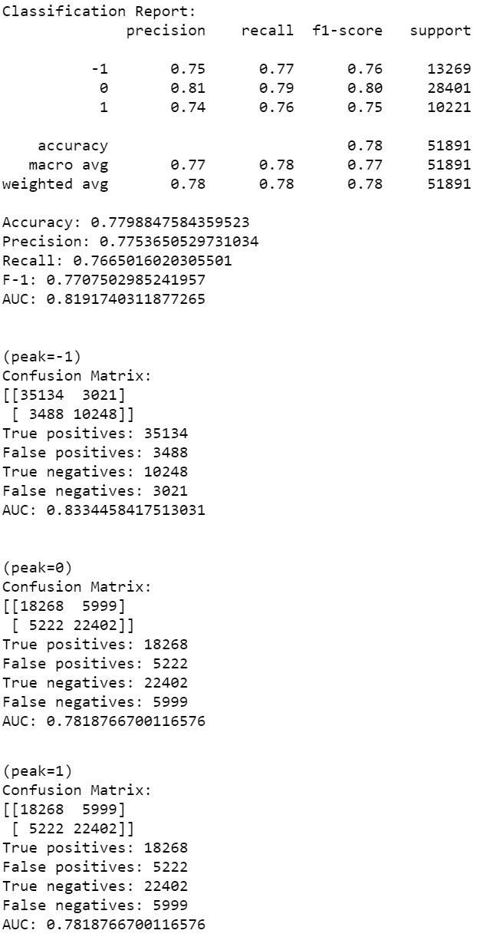

**Class 1 調參**

1. Learning rate

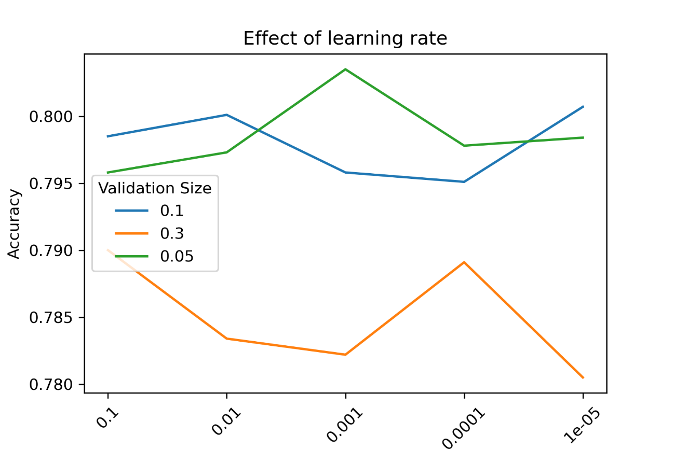

|  |  |  |
| --- | --- | --- |
| 0.05 | 0.1 | 0.3 |
| 0.7958390638985308 | 0.7985242430196258 | 0.7900320911651058 |
| 0.7972798917196062 | 0.8008601305477329 | 0.7833737201737726 |
| 0.8035016482197044 | 0.7958390638985308 | 0.7822166917719999 |
| 0.7977819983845263 | 0.7950749885388696 | 0.7890715392843889 |
| 0.7983714279476936 | 0.8006636540266772 | 0.7805138952561835 |

**Class1 調參完(learning rate=0.001 / batch size = 300 / epochs = 20 / validation split = 0.05)**

MSE – Train: 0.227

MSE – Validation: 0.243

MSE – Test: 0.209

MAE – Train: 0.288

MAE – Validation: 0.296

MAE – Test: 0.201

ACC – Train: 0.811

ACC – Validation: 0.804

ACC – Test: 0.755

* 最佳 Accuracy：80.4%
* 最佳 MSE：20.9%

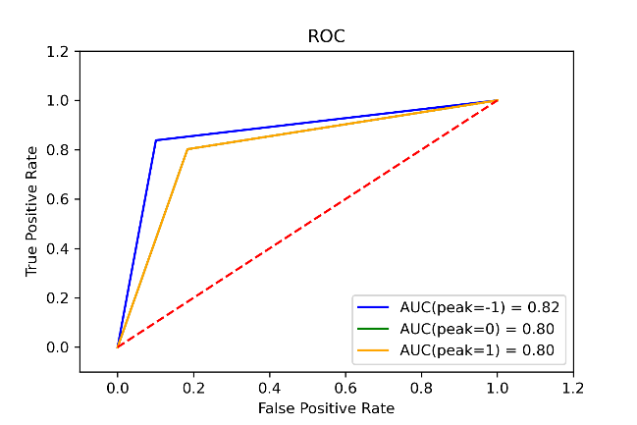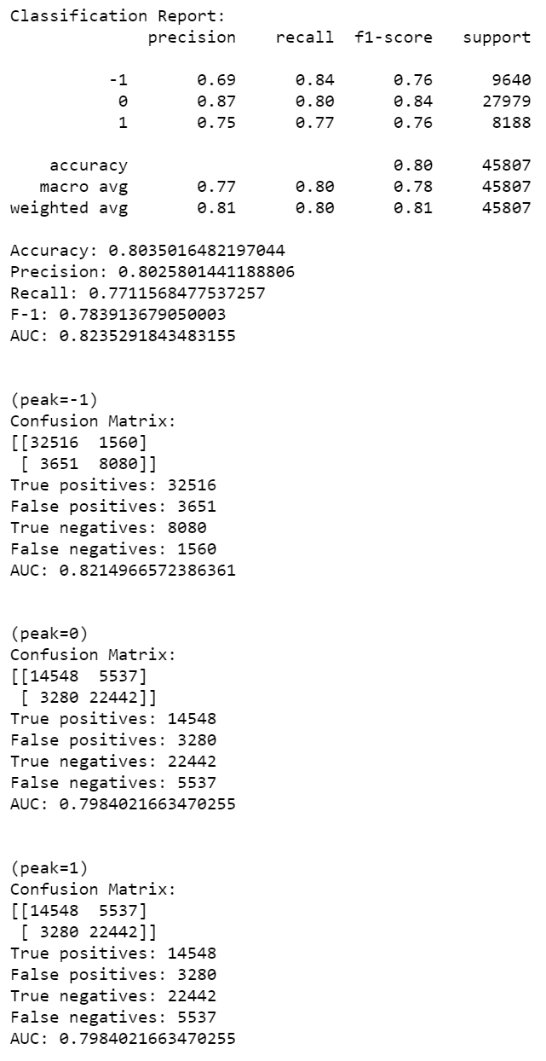

**Class 2 調參**

1. Learning rate

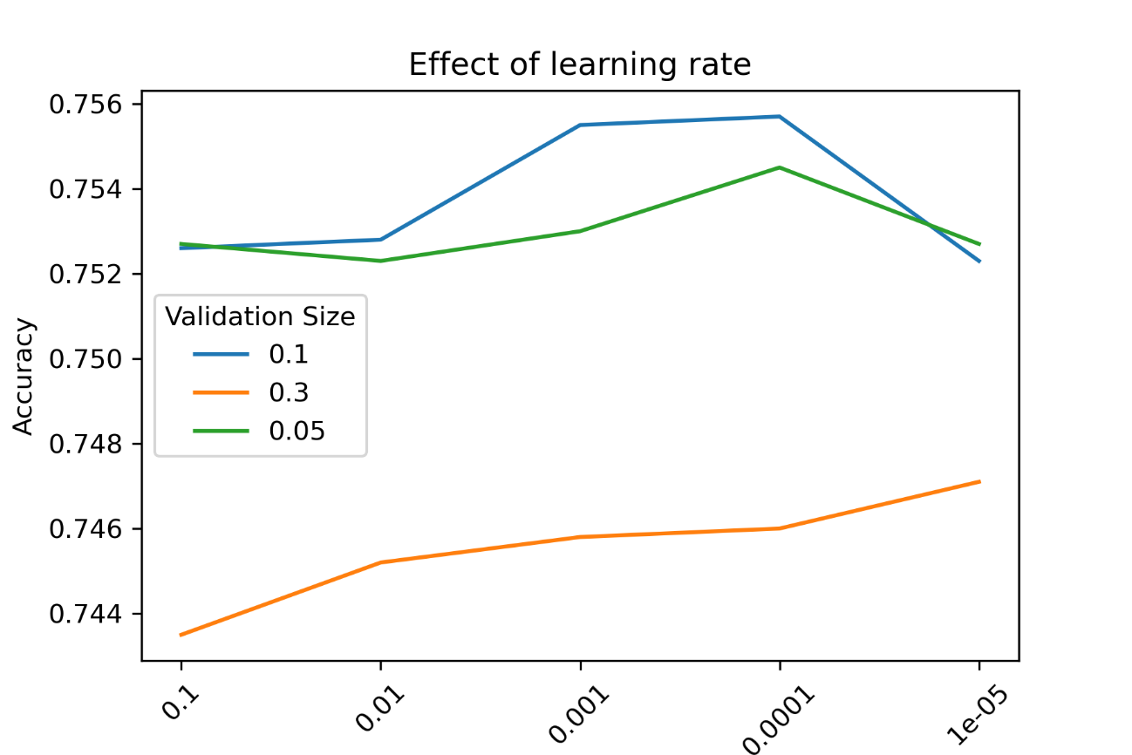

|  |  |  |
| --- | --- | --- |
| 0.05 | 0.1 | 0.3 |
| 0.7527352918235515 | 0.7526147475306147 | 0.7435030171527438 |
| 0.7522672963333262 | 0.7527920185496394 | 0.7452473639799471 |
| 0.7529551078871421 | 0.7554865380388153 | 0.7457649953554993 |
| 0.7545150928545598 | 0.7557418083062108 | 0.7460415381451778 |
| 0.7527069284605076 | 0.7523240230594141 | 0.7471335276223702 |

**Class2 調參完(learning rate=0.001 / batch size = 300 / epochs = 20 / validation split = 0.1)**

MSE – Train: 0.282

MSE – Validation: 0.188

MSE – Test: 0.265

MAE – Train: 0.278

MAE – Validation: 0.286

MAE – Test: 0.251

ACC – Train: 0.769

ACC – Validation: 0.730

ACC – Test: 0.755

* 最佳 Accuracy：75.5%
* 最佳 MSE：26.5%

