Practical Introduction to NodeJS

Overall Summary: -

In this module we are going to learn NodeJS, with some awesome and real world uses of NodeJS in our browser: -

* First thing first, with the help of NodeJS we will open up the browser and open our “Pepcoding” website.
* Then we will try to grab Wi-Fi information with the help of NodeJS.
* After that we will print “#Pepcoders” using command line with the help of NodeJS.
* At, the end we have to learn one newer module called “Path module”.

Introduction: -

What is NodeJS?

It allows us to take JavaScript out of the browser and it liberates it, allowing it to interact directly with the hardware of a computer.

Okay, let me explain you with an example, Consider NodeJS in an “Android Phone” and the phone have applications installed in it and by touching on the apps we can use them. Similarly, NodeJS have modules like – “FS, OS, Path, Child Process”. So, by the help of JavaScript we can call these modules and interact with your computer.

Let’s talk about all the modules that NodeJS provide with some cool and fun experiment.

1. Child Process: - Node.js runs in a single thread, it manages concurrency using an event-driven architecture. It also makes it easier to create child processes in order to take advantage of parallel processing on multi-core CPU platforms. **This is an inbuild module.**

Example –

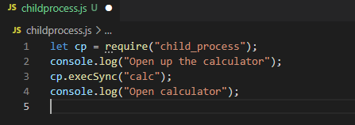

By running this command, you can open up the calculator.

Or similarly you can open up the VScode.

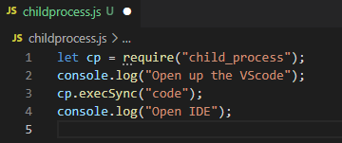

Let’s open up our lovely website,

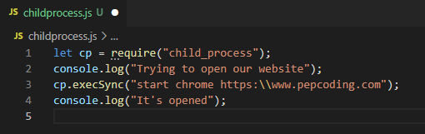

By looking at above examples we can say that “child Process” ***is a very modern module.***

1. OS module: - OS is a node module that provides information about the operating system of a computer. It provides the operating system's hostname and the amount of free ram in bytes.

Let me explain with some example –

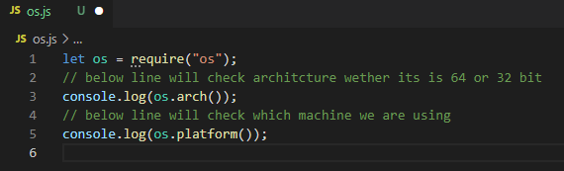

This code line gives the information about your Machine what you are using.

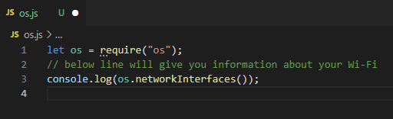

Using these code lines, you can check your Wi-Fi information [***You become Hacker Now***😂]

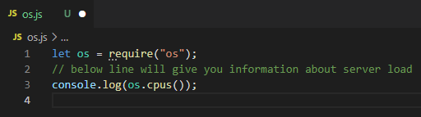

This code will gives us a very important information about our server that do we are using 64 or 32 bit architecture server.

1. FS(Filesystem): - The Node.js file system module allows you to interact with your computer's file system. We can read, create, update, delete and rename the file using “FS” module.

Let’s explore it with some examples.

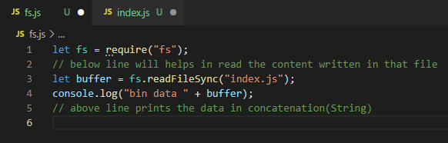

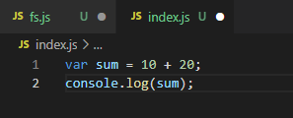

The above code helps you to read the file content.

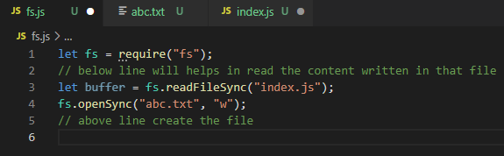

The above code will create the file

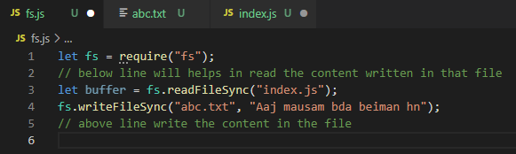

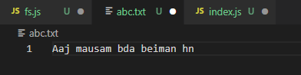

The above code helps to write in the file, but we face one problem in that i.e. if you write new content the old one will replace automatically

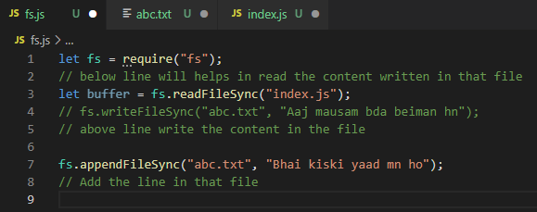

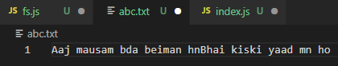

The above code helps to solve the problem of not replacing old content, it adds new content into the previous one.

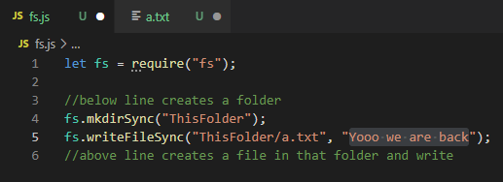

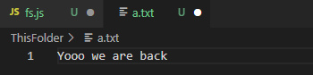

The above codes help to create a folder, and in that folder creates a file and write your content.

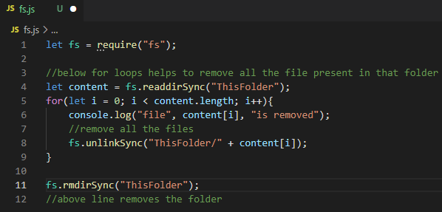

This command helps you to remove file present in a folder and that folder as well.

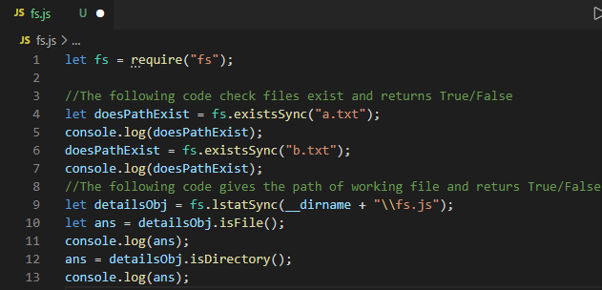

This command gives you existence of file and path, return true/false if present or not

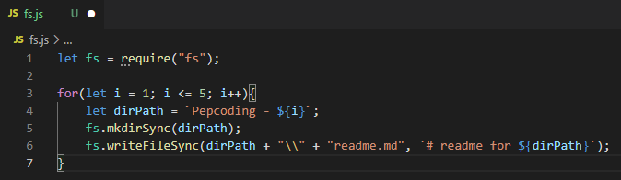

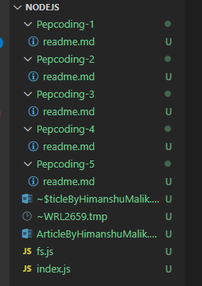

By using this command you will be able to create multiple folders and you can add each file in each folder.

1. Path: -