XENTRINOBOT BOARDS
2 WD Version



Distributed by:
Xentrino Tech

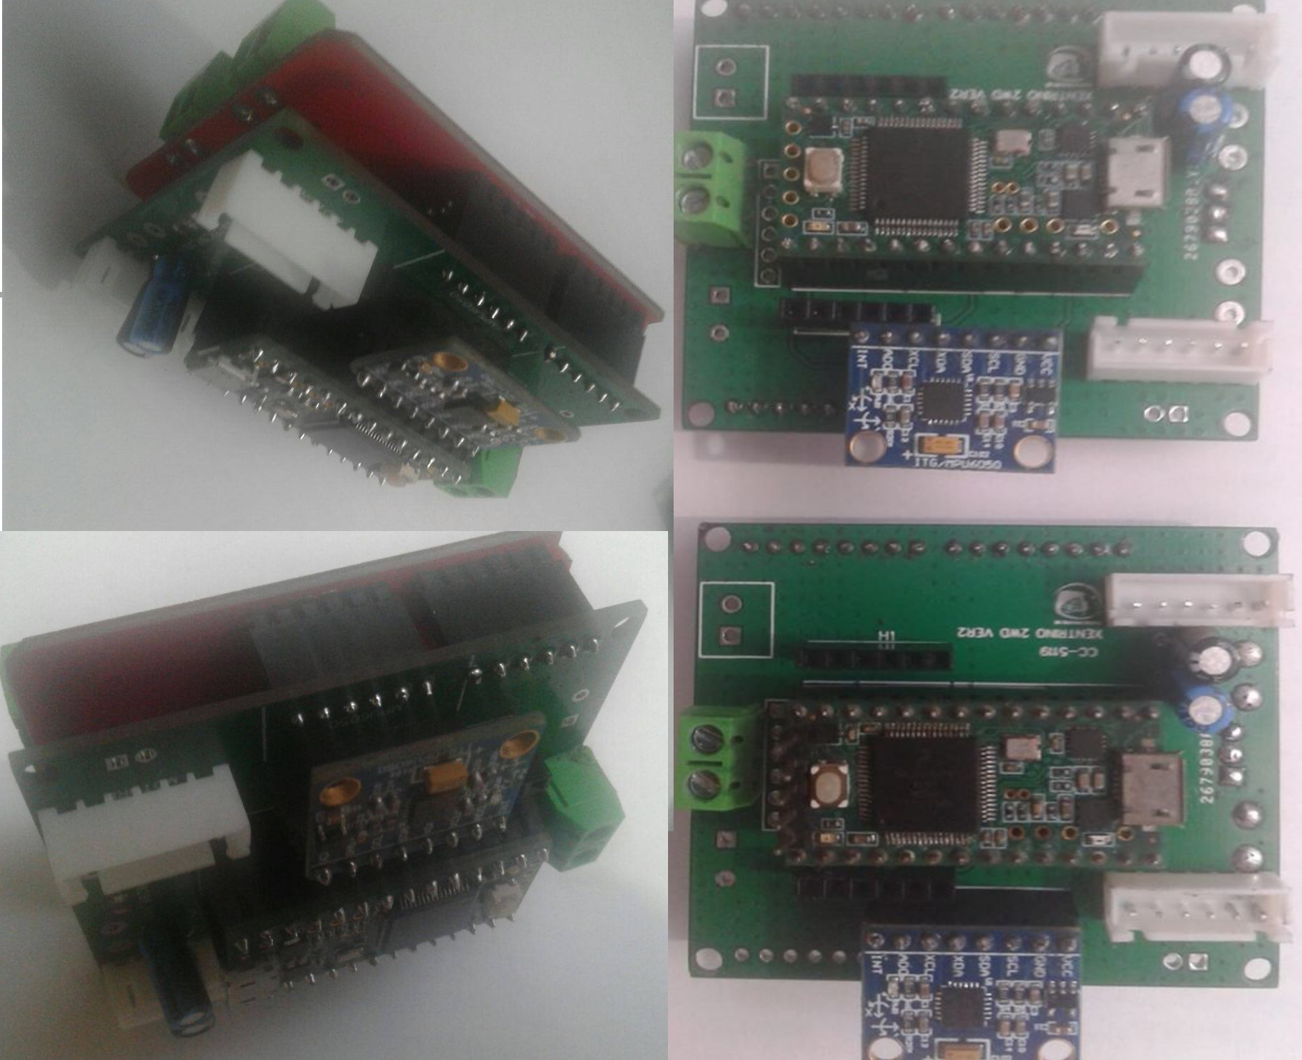

DESCRIPTIONS:
Xenrtrinobot Board is suitably design to drive wheeled mobile robots. The board contains a complete electronic modules that can be used to program and drive robots. The 2WD version include microcontroller, inertial measurement unit sensors (IMU) and motor controller. There are extra IOs ports grouped in header pins which can be used as external interface, i,e LCD,LDR, relays and etc.

The board was developed as an all in one electronic system for wheeled mobile robotics. The reason is to focus solely in automating robots and avoiding the difficulty of building messy circuits. Hence, the developer vision is to motivate hobbyists, enthusiast and more likely in the academe, research and development sectors to be involved in the using of Robotic Operating System.

The board define the means of simplifying robot controller to eliminate time consuming hardware setup experienced by building robots using ROS. Also the selected electronic modules are readily and locally available and the selected hardware is cost effective.

FEATURES:

- Teensy 3.20
- Monster Moto
- MPU6050/GY-85

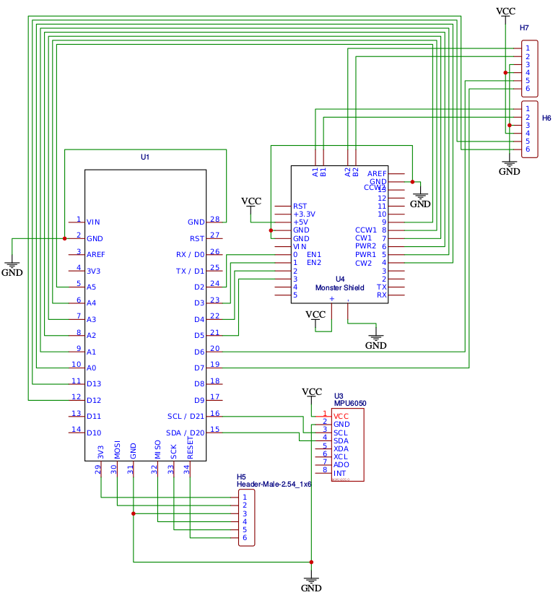
DOCUMENTATIONS:

Schematic

Gerber Block Diagram

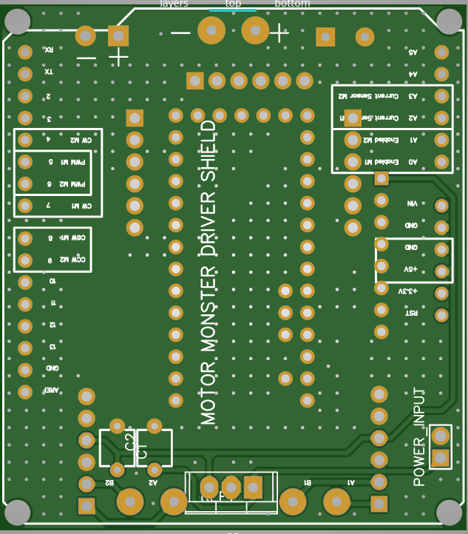
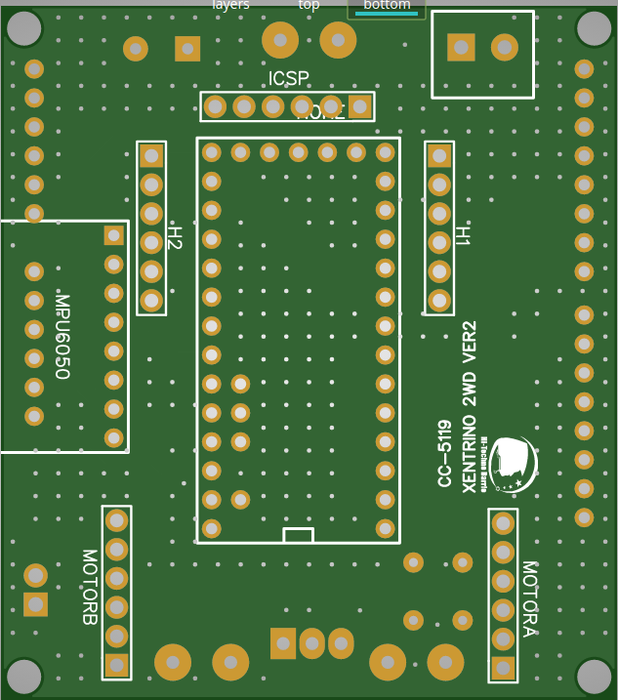

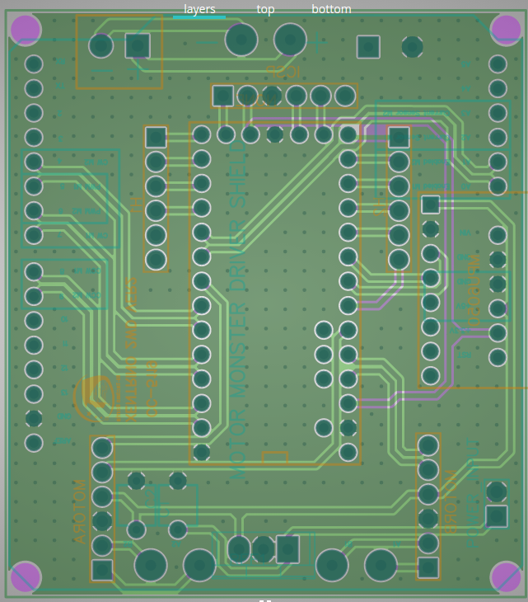

Graphical Datasheet
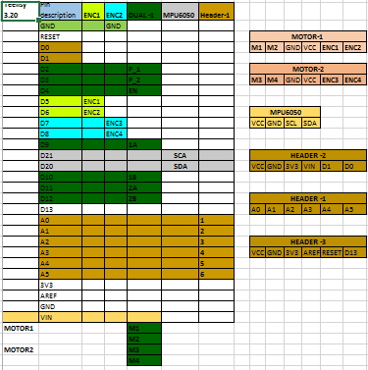
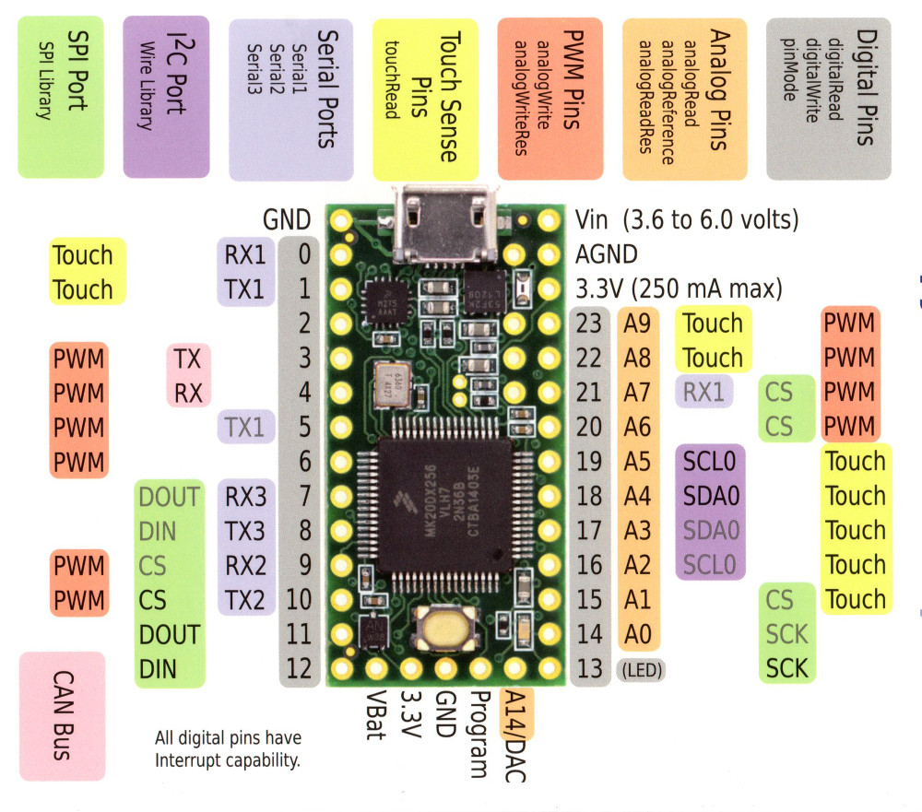

Datasheet

GiHub

