🔬 FinMetrics Suite — End-to-End User Manual
> AI-Powered Cross-Sectional Financial Analysis, Anomaly Detection & Strategic Benchmarking for NSE-Listed Sectors and Private Clients.

📖 Table of Contents
- [🚀 1. Executive Summary & Value Proposition](#-1-executive-summary--value-proposition)
- [⚙️ 2. Global Configuration & Sidebar Control](#%EF%B8%8F-2-global-configuration--sidebar-control)
- [🏃 3. Core Analytical Workflows](#-3-core-analytical-workflows)
- [Phase 1: Building Sector Benchmarks (e.g. AI: supermarket)](#phase-1-building-sector-benchmarks)
- [Phase 2: Standard Client CSV Comparison](#phase-2-standard-client-csv-comparison)
- [Phase 3: TallySync Journal & Ledger Ingestion](#phase-3-tallysync-journal--ledger-ingestion)
- [🖥️ 4. Dashboard Tab-by-Tab Visual Reference](#-4-dashboard-tab-by-tab-visual-reference)
- [Home Tab & Calibration Control](#home-tab)
- [Ratio Scorecard Tab (Kroger "KR" Case Study)](#ratio-scorecard-tab)
- [Outliers Tab](#outliers-tab)
- [Peer Benchmark Tab](#peer-benchmark-tab)
- [Composite Score Tab](#composite-score-tab)
- [Client Comparison Tab (Trial Balance, Scorecard, Composite, Distribution, SWOT)](#client-comparison-tab)
- [Export Tab](#export-tab)
- [📸 5. Visual Asset Directory](#-5-visual-asset-directory)

🚀 1. Executive Summary & Value Proposition
Traditional financial analysis suffers from major friction points: hours spent manually parsing PDF accounts, subjective normalization, and a lack of standardized benchmarking across peers.
The FinMetrics Suite v2.0 solves this by automating the entire pipeline from raw data collection to deep analytical scoring and narrative explanations in under 60 seconds.

The System Core Pillars:
- Automated Ingestion: Directly fetches quarterly and annual statements for 100+ major NSE-listed companies across 13 sectors using Yahoo Finance (yfinance), normalized instantly via a 60+ field alias-mapping engine.
- Statistical Outlier Scans: Implements Tukey Fences (IQR), robust standard deviations (Z-Score), and multi-variate unsupervised anomalies (Isolation Forest) to isolate erratic accounting cells.
- Strategic Benchmarking: Calculates 30+ ratios spanning Liquidity, Profitability, Solvency, Efficiency, Growth, Valuation, and Cash Flow. Ratios are scored using robust outlier-resistant scaling.
- Client Comparator: Benchmarks private companies (via standard CSV ratios or direct Tally ERP journal entries) directly against their public peer groups (e.g., matching the private FMCG Client to the public AI: supermarket peer group).
- SWOT Classifier: Converts comparative metrics into a strategic 2×2 SWOT matrix (Strengths, Weaknesses, Opportunities, Threats) featuring plain-English explanations.

⚙️ 2. Global Configuration & Sidebar Control
The sidebar acts as the global control center of the FinMetrics Suite v2.0. It manages security, performance, and clean memory states.
NOTE: All interface actions are designed to adapt instantly to your choices. The sidebar maintains persistent configurations across re-runs.

Sidebar Components & Controls:
- AI Search Integration & API Key Status
- Description: Scans the environment variables (.env file) or Streamlit secrets configuration for a valid GEMINI_API_KEY.
- Visual Indicators:
- 🟢 API Key loaded securely. — System is fully ready to perform natural-language AI Searches to locate public peer tickers.
- 🟡 API Key not found in environment variables. — System remains functional for local statistics, but AI Ticker Search is disabled.
- Use Data Cache (Toggle)
- Description: When toggled ON (default), the system reuses previously fetched company statements stored in parquet format under data/cache/. This avoids hitting yfinance rate limits and cuts loading times from minutes to milliseconds.
- Cache TTL: Set to a standard 12 hours.
- Clear All Cache (Action Button)
- Description: Deep-purges the system.
- Backend Actions:
- Clears Streamlit's internal RAM caches (st.cache_data.clear(), st.cache_resource.clear()).
- Deletes and recreates the persistent Parquet file cache under data/cache/.
- Deletes and recreates the benchmark database under data/benchmarks/.
- Triggers a clean app reload.

🏃 3. Core Analytical Workflows
The application operates as a dual-phase system: Phase 1 establishes the public sector baseline; Phase 2 hooks a private client to that baseline.

┌────────────────────────────────────────┐
│ PHASE 1: Build Sector │
│ Fetches public peers from NSE/yFinance│
└──────────────────┬─────────────────────┘
│
▼ Saves to Store
┌────────────────────────────────────────┐
│ PHASE 2: Ingest Private Client │
│ Upload CSV - OR - Upload TallySync CSV│
└──────────────────┬─────────────────────┘
│
▼
┌────────────────────────────────────────┐
│ COMPARATOR & STRATEGIC OUTPUTS │
│ Scorecard, Mapping, SWOT Grid, Excel │
└────────────────────────────────────────┘

Phase 1: Building Sector Benchmarks
To establish a benchmark (using the AI: supermarket sector as a standard case study):
- Navigate to the Home Tab.
- In section 1. Define Scope, select the Analysis Unit:
- Sector: Choose from 13 pre-mapped sectors (e.g., Automobile, IT, Supermarket).
- Industry: Choose sub-industries within those sectors.
- AI Search: Describe an industry in plain English (e.g., "supermarket sector"). The Gemini model will analyze the market, find the matching tickers, and populate the list.
- (Optional) Open the Ticker Override expander to manually type, edit, or copy-paste ticker codes (e.g., SFM, VLGEA, GO, WMK, NGVC, KR, ACI).
- (Optional) Adjust Calibration (Advanced) settings to tweak outlier sensitivity:
- IQR Multiplier: Controls the Tukey Fence width (default: 1.5).
- Z-Score Threshold: Magnitude of standard deviations to trigger a cell flag (default: 3.5).
- Isolation Forest (%): Contamination rate for multivariate anomaly scans (default: 10%).
- Click the primary action button: `Run Phase 1: Build Benchmark`.
- A progress container at the top of the screen will show real-time percentage completion as it downloads statements, standardizes statements, computes ratios, detects outliers, and saves the benchmark dataset.

Phase 2: Standard Client CSV Comparison
If you already have pre-computed financial ratios for a private client:
- Run Phase 1 for the target sector to save it to the local store.
- Under section 4. Client Comparison on the Home Tab, select the Standard CSV Upload sub-tab.
- Select the benchmark sector from the Compare against stored sector dropdown.
- Drag and drop your client's CSV file.
- The CSV must contain a header row of ratio codes matching our system (e.g., `current_ratio`, `gross_margin`, `debt_to_equity`) and a `ticker` column containing the client name.
- Click `Run Client Comparison`.
- The system binds the client ratios to the stored peer database and unlocks client analysis pages.

Phase 3: TallySync Journal & Ledger Ingestion
To benchmark a private client using raw transaction logs exported directly from Tally ERP exports:
- Export the Ledger Master List and Journal Vouchers from Tally into CSV format.
- On the Home Tab, scroll to 4. Client Comparison and click the TallySync Upload sub-tab.
- Upload the two CSV files:
- Journal CSV (JV): Raw transaction lines showing debits and credits.
- Ledger Master CSV: Master ledger directory mapping ledger names to parent Tally groups.

📋 Expected CSV Data Schemas:
- Ledger Master CSV:
Must contain these headers:

NAME,PRIMARYGROUP
"Capital Account",Capital Account
"State Bank of India",Bank Accounts
"Sales Local",Sales Accounts
"Sundry Creditors Local",Sundry Creditors
- Journal CSV (JV):
Must contain these headers:

PARTICULARS,DEBIT,CREDIT
"State Bank of India",100000.00,
"Sales Local",,100000.00

⚙️ How the Tally Ingestion Pipeline Works:
The TallyBridge class processes the uploads through a structured parser:
- Ledger Mapping: Parses the Ledger Master and maps each ledger's PRIMARYGROUP to one of 12 standard financial categories (revenue, cogs, opex, cash, receivables, inventory, other_current_assets, fixed_assets, payables, other_current_liabilities, debt, equity). Unmapped accounts are grouped as EXCLUDE.
- Journal Processing: Stream-processes the Journal CSV in chunks of 50,000 rows. It aggregates debit and credit values for each mapped ledger name.
- Balance Computation: Net balances are computed based on the financial nature of the group:
- Asset / Expense categories balance = Debit - Credit
- Liability / Equity / Income categories balance = Credit - Debit
- Ratio Generation: Executes core financial formulas to approximate the client's ratios (e.g., current_ratio = current_assets / current_liabilities).
- Trial Balance Output: Constructs a complete trial balance, net-aggregating ledger entries to display absolute Debit and Credit balances per ledger.
- Sector Benchmarking: Directs the resulting client ratio dictionary to the ClientComparator engine to run full percentile ranks and scoring against your chosen public sector.

🖥️ 4. Dashboard Tab-by-Tab Visual Reference

Home Tab & Calibration Control
This tab serves as the entry page and command hub. It contains scope selectors, parameter calibration sliders, and the TallySync/CSV file upload dropzones.

📸 Interface Capture:
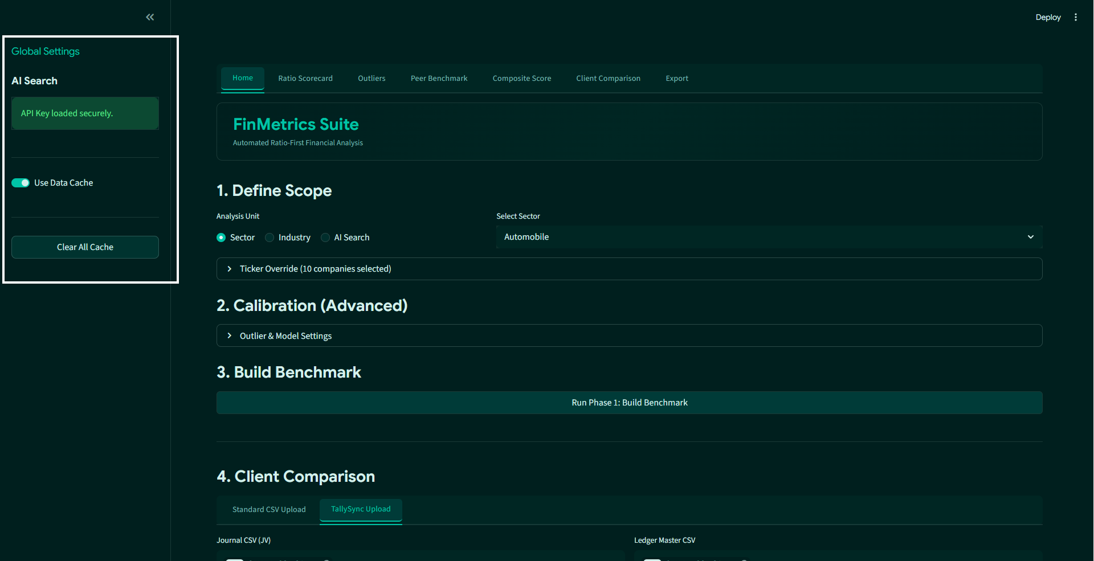
Figure: Sidebar & Home Tab Configuration

📝 Visual Elements & Controls to Note:
- Scope Selector Radio: Instantly toggles between standard Sectors, Industry sub-divisions, or AI search interfaces.
- Calibration Expander: Collapsible advanced settings card housing sliders for IQR Multiplier (Tukey width), Z-Score boundary, and Isolation Forest contamination percentage.
- Primary Execution Button: Large, full-width Run Phase 1: Build Benchmark button accented in the Abyss Teal style.
- Status Containers: Global status area at the top of the page showing real-time feedback (fetching ticker list, downloading yFinance statements, scaling matrices) to eliminate page layout shifts.

TallySync Upload Inputs
Located inside the Client Comparison section of the Home tab. This displays the active file dropzones for importing Tally ledger assets. In our trace below, we have loaded ledger assets for FMCG Client compared against the public AI: supermarket sector.

📸 Interface Capture:
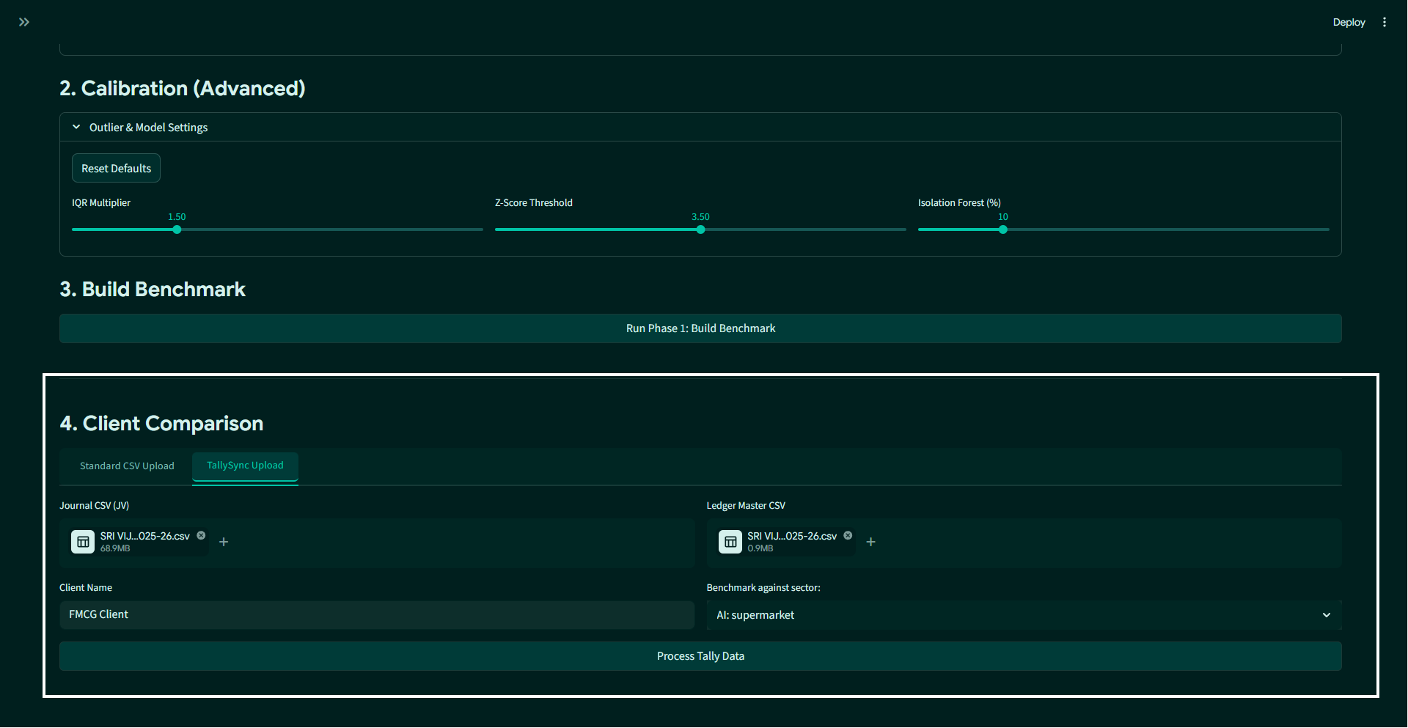
Figure: TallySync Upload Inputs

📝 Visual Elements & Controls to Note:
- Dual File Uploader Containers: Separate, dashed drag-and-drop boxes for uploading the Journal CSV (JV) and the Ledger Master CSV.
- Client Name Input Field: Interactive text field populated with the client's name (e.g., "FMCG Client").
- Sector Selection Dropdown: Selects which public benchmark peer group (cached during Phase 1) to compare the client against (e.g. "AI: supermarket").
- Process Tally Data Button: Triggers the TallyBridge background parser, showing a custom progress percentage bar.

Ratio Scorecard Tab
Displays the core benchmark scorecard for a selected company. It categorizes ratios as Above, At, or Below the benchmark. In our example, we analyze Kroger ("KR") benchmarked within the supermarket peer group.

📸 Interface Capture:
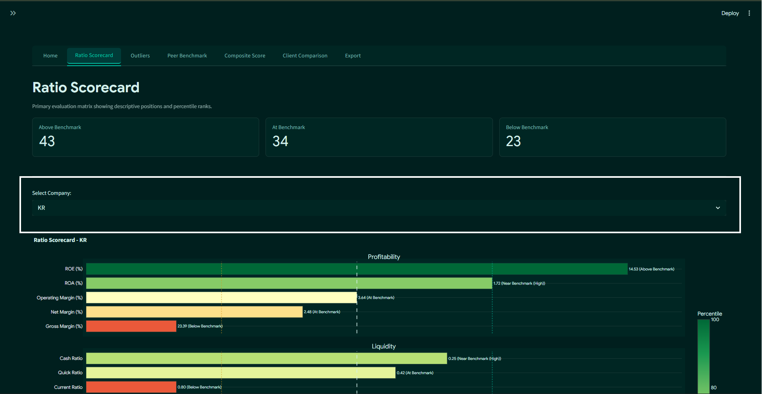
Figure: Ratio Scorecard Tab

📝 Visual Elements & Controls to Note:
- Scorecard Metric Cards: Three horizontal metric cards highlighting the count of ratios classified as Above Benchmark, At Benchmark, and Below Benchmark.
- Company Selection Dropdown: Dynamically switches the target peer analysis view (switched to KR).
- Scorecard Heatmap Viz: Plotly comparative visual highlighting the selected company's percentile rank across liquidity, solvency, profitability, efficiency, and growth vectors.
- Raw Scorecard Dataframe: Standardized, clean interactive table with built-in search, filtering, and cell-sorting capabilities.

📊 High-Resolution Interactive Plotly View:
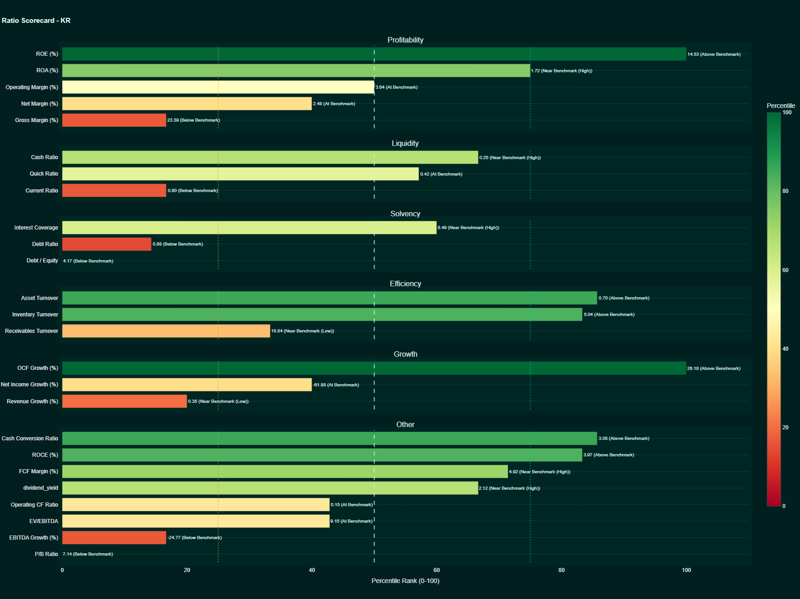
Figure: High-Resolution Ratio Scorecard - KR
TIP: KR Case Study Insights: Kroger exhibits excellent performance in Growth (OCF Growth at 26.18%, ranking at 85th percentile) and Efficiency (Asset Turnover at 0.70, ranking at 85th percentile), but shows liquidity tightness (Current Ratio at 0.80, Below Benchmark).

Outliers Tab
Highlights extreme, abnormal, and potentially risky financial values across the peer group.

📸 Interface Capture:
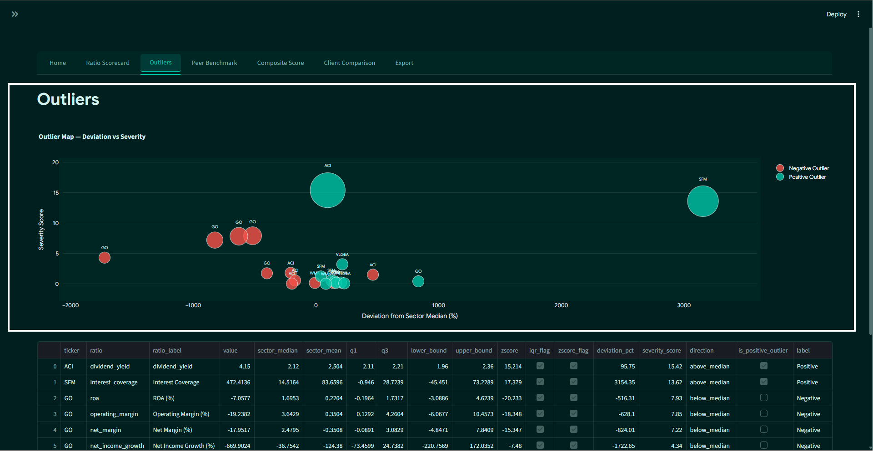
Figure: Outliers Tab

📝 Visual Elements & Controls to Note:
- Outlier Scatter Plot: Multi-color Plotly scatter chart graphing ratio values against median thresholds, color-coded by severity (Moderate in yellow, High/Extreme in red).
- Univariate Outlier List: Complete dataframe listing identified outliers, showing the company ticker, ratio category, deviation percent from the sector median, and severity rating.
- Multivariate Isolation Forest Anomaly Chart: Scatter plot highlighting companies exhibiting abnormal multivariate signatures across all ratios analyzed concurrently.

Peer Benchmark Tab
Presents sector-wide descriptive statistics to establish the baseline parameters of the peer group.

📸 Interface Capture:
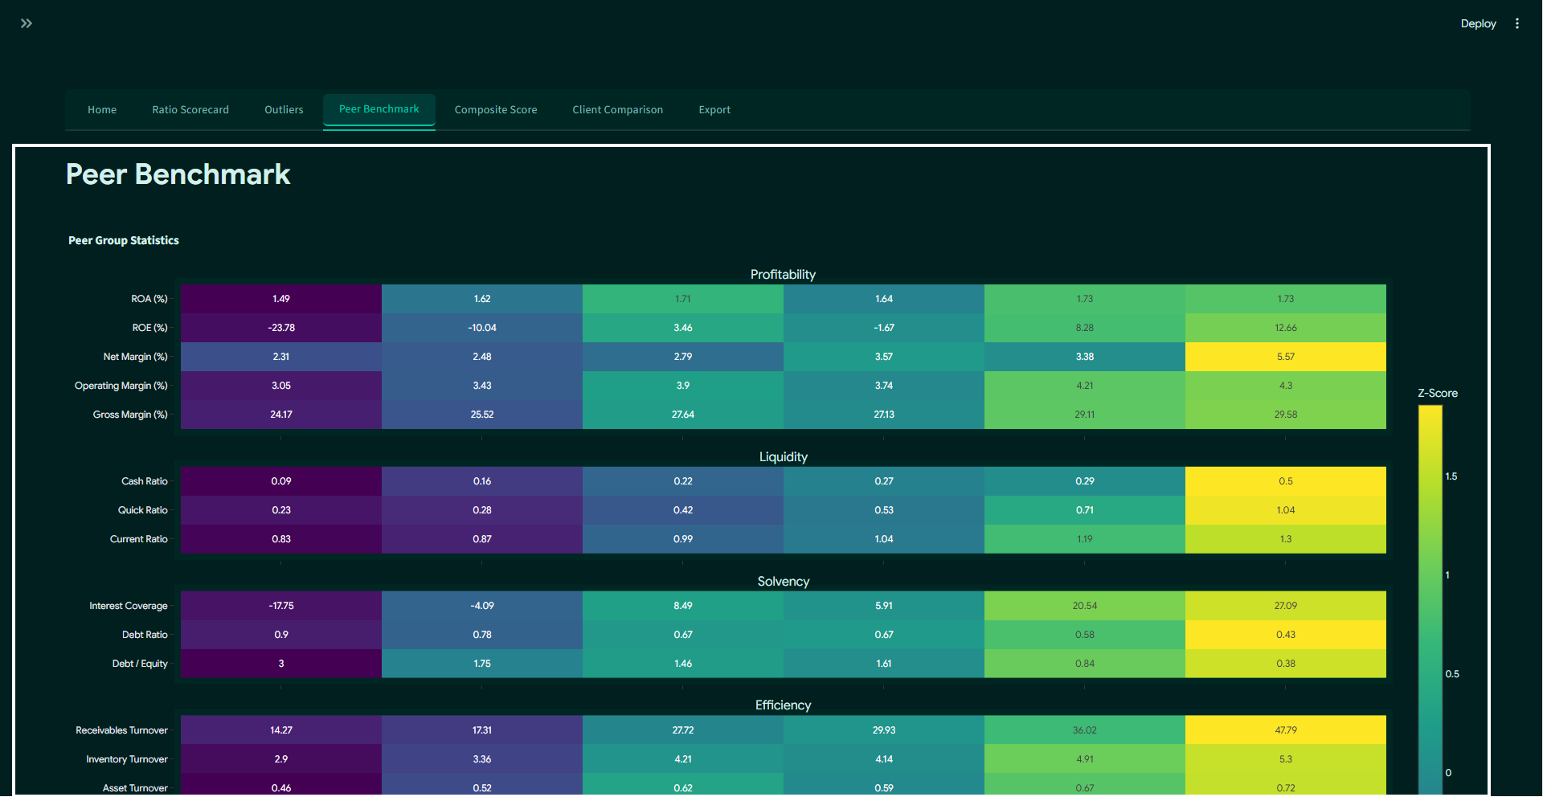
Figure: Peer Benchmark Tab

📝 Visual Elements & Controls to Note:
- Peer Stats Heatmap: Visual grid showcasing the median, mean, 25th percentile, and 75th percentile values for every calculated ratio across the selected sector.
- Descriptive Statistics Dataframe: Clean, sorted table displaying underlying statistics (count, min, max, standard deviation) for deeper quantitative review.

📊 High-Resolution Peer Statistics Heatmap Plot:
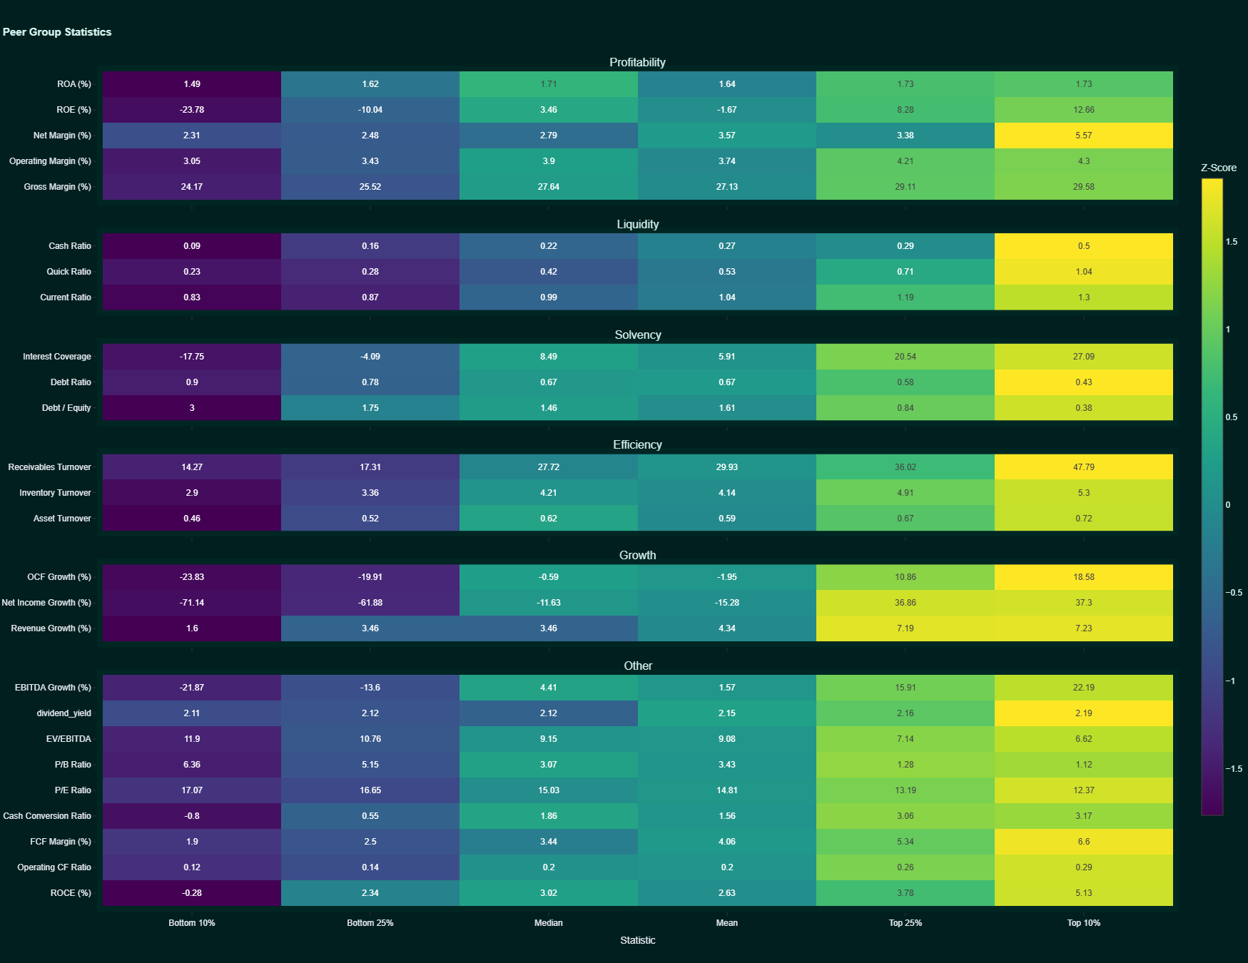
Figure: High-Resolution Peer Group Heatmap

Composite Score Tab
Displays the aggregated, weighted financial health scores for all companies in the peer group.

📸 Interface Capture:
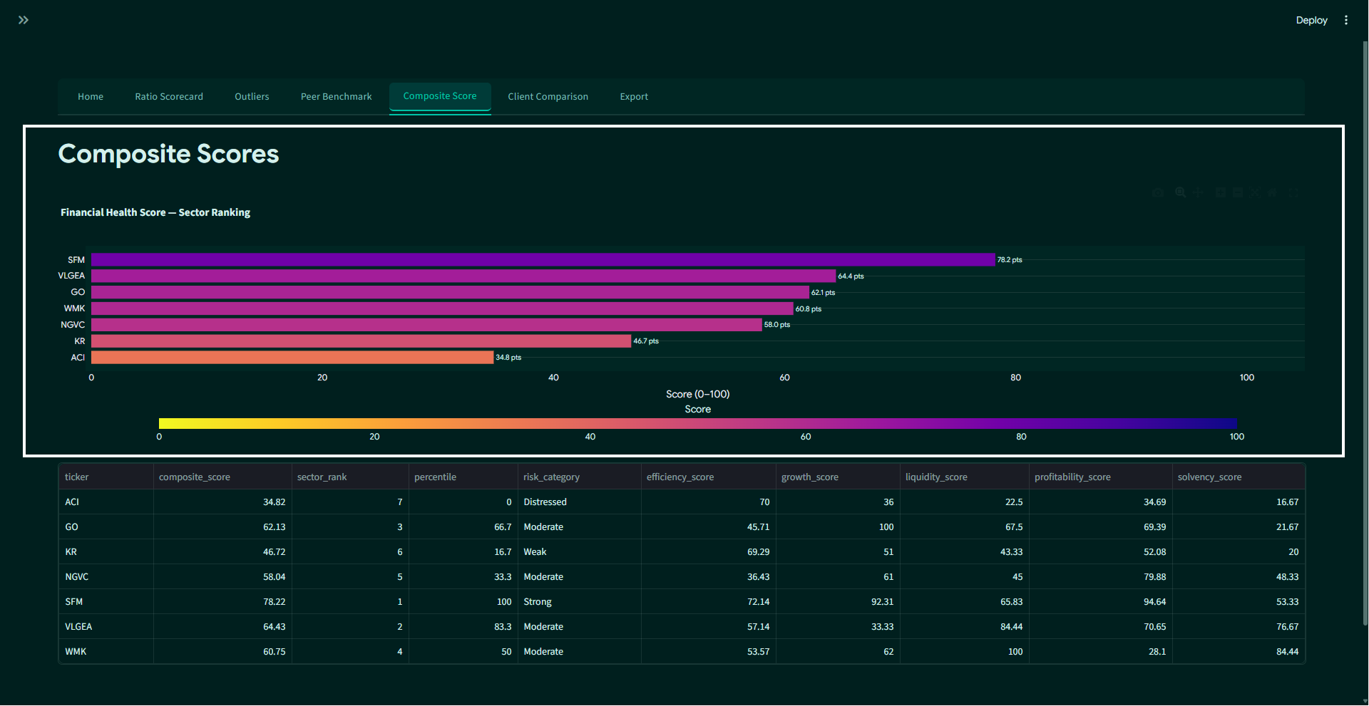
Figure: Composite Score Tab

📝 Visual Elements & Controls to Note:
- Health Score Bar Chart: Plotly horizontal bar chart ranking companies by their overall financial health score (0 to 100), color-coded by risk category.
- Weighted Pillar Summary Dataframe: Data table mapping individual company performance across the five core financial pillars (Profitability 30%, Solvency 20%, Growth 20%, Liquidity 15%, Efficiency 15%).

📊 High-Resolution Financial Health Score Sector Ranking Plot:
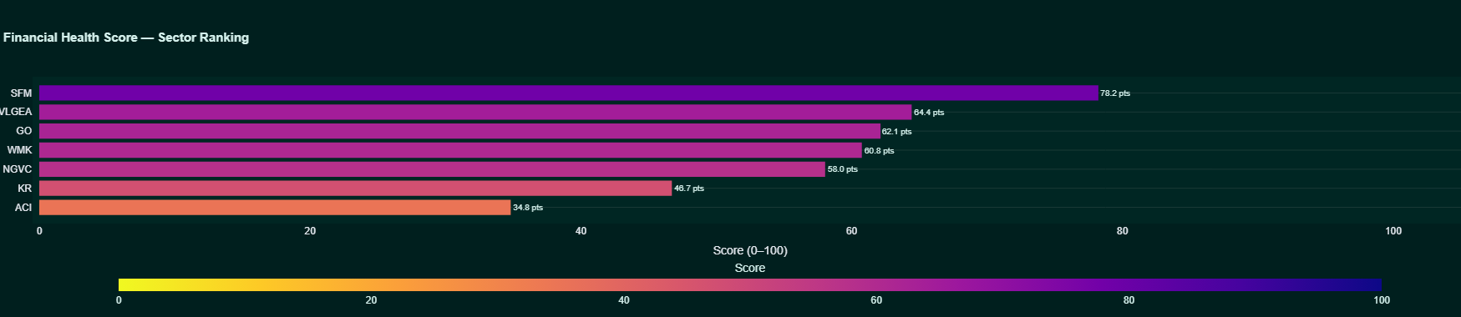
Figure: High-Resolution Financial Health Score
NOTE: Supermarket Peer Rankings: SFM leads the sector with an outstanding score of 78.2, followed by VLGEA (64.4), GO (62.1), WMK (60.8), NGVC (58.0), and KR (46.7), while ACI ranks last with a distressed score of 34.8.

Client Comparison ➔ Trial Balance Tab
First sub-tab of Client Comparison. Renders the calculated ledger trial balance from TallySync logs. In our live trace, this displays entries for the FMCG Client.

📸 Interface Capture:
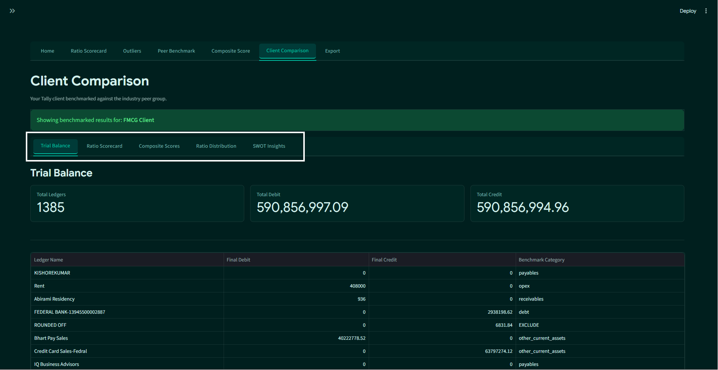
Figure: Client Trial Balance Tab

📝 Visual Elements & Controls to Note:
- Trial Balance Metrics: Core summary boxes displaying Total Ledgers processed (1,385), Total Debit balance (590,856,997.09), and Total Credit balance (590,856,994.96).
- Trial Balance Dataframe: Multi-column table sorting ledger accounts with absolute debit/credit amounts, indicating the internal mapping categories (e.g. KISHOREKUMAR mapped to payables, Rent mapped to opex, Abirami Residency mapped to receivables).
- Download Button: Single-click action button to download the finalized Trial Balance as a CSV sheet.

Client Comparison ➔ Ratio Scorecard Tab
Second sub-tab of Client Comparison. Benchmarks the private client's financial ratios against the sector standard.

📸 Interface Capture:
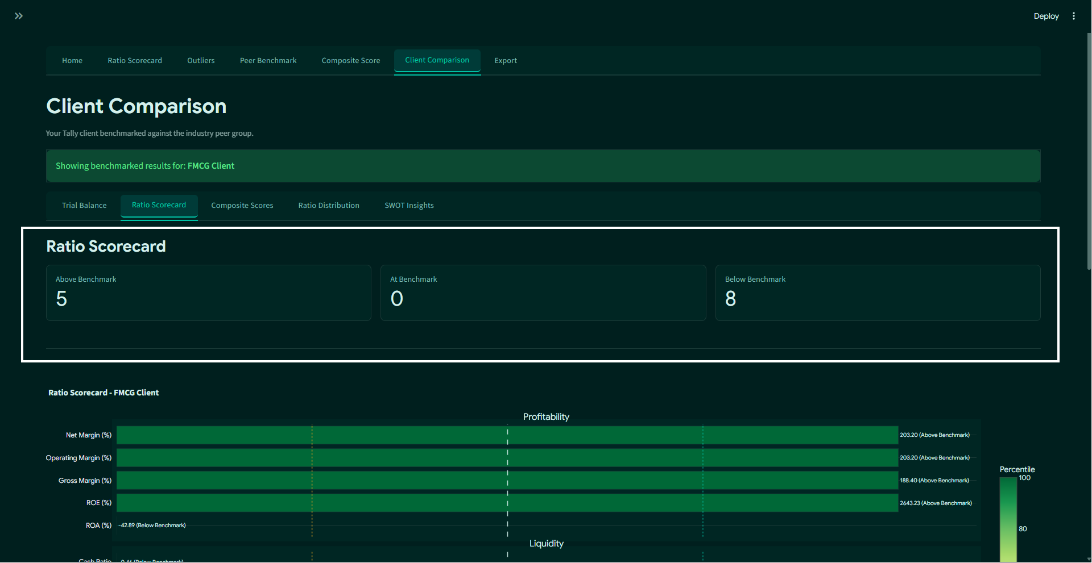
Figure: Client Scorecard Tab

📝 Visual Elements & Controls to Note:
- Client Metric Counters: Displays above, at, and below benchmark counts specific to the client's performance (showing 5 Above Benchmark, and 8 Below Benchmark).
- Interactive Scorecard Heatmap: Detailed Plotly chart visualizing the client's specific ratio percentile ranges relative to the sector peer groups.
- Client Scorecard Dataframe: Complete list showing raw values, sector medians, percentiles, and position labels.

📊 High-Resolution Client Ratio Scorecard Plot:
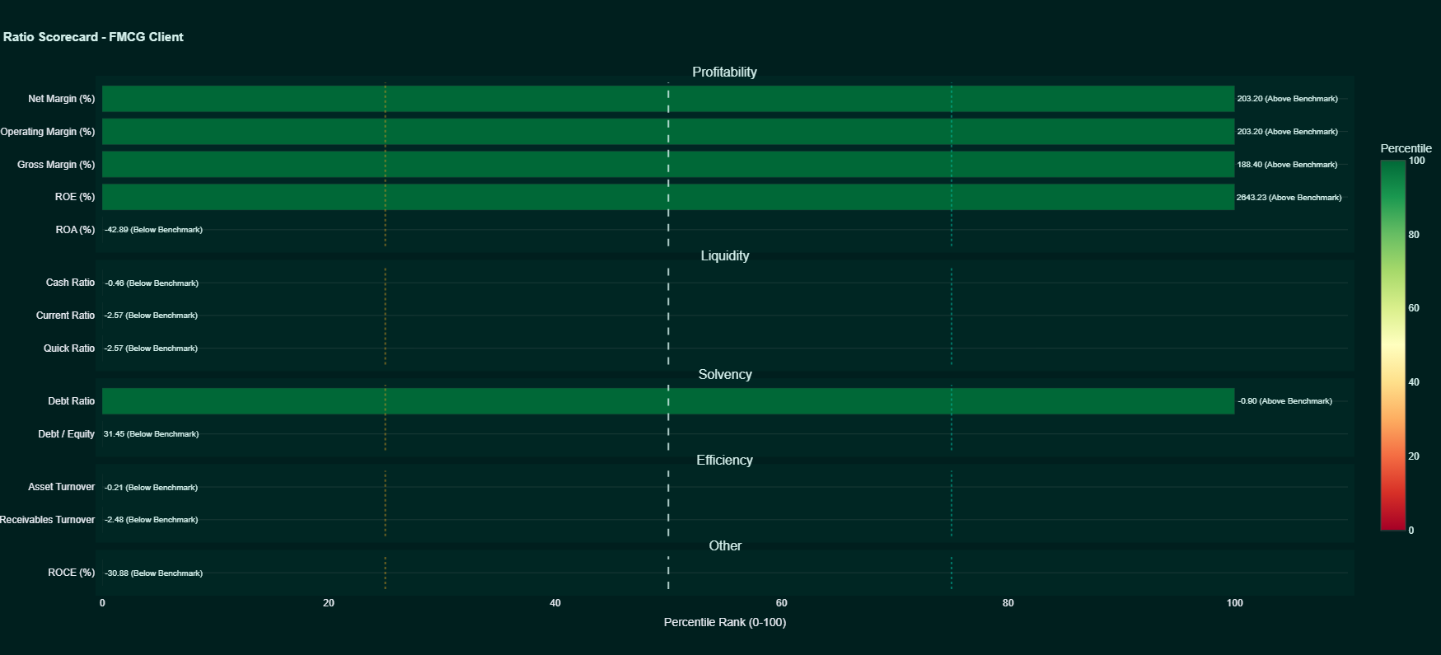
Figure: High-Resolution Client Scorecard

Client Comparison ➔ Composite Scores Tab
Third sub-tab of Client Comparison. Ranks the client's health score directly within the public sector peer ranking.

📸 Interface Capture:
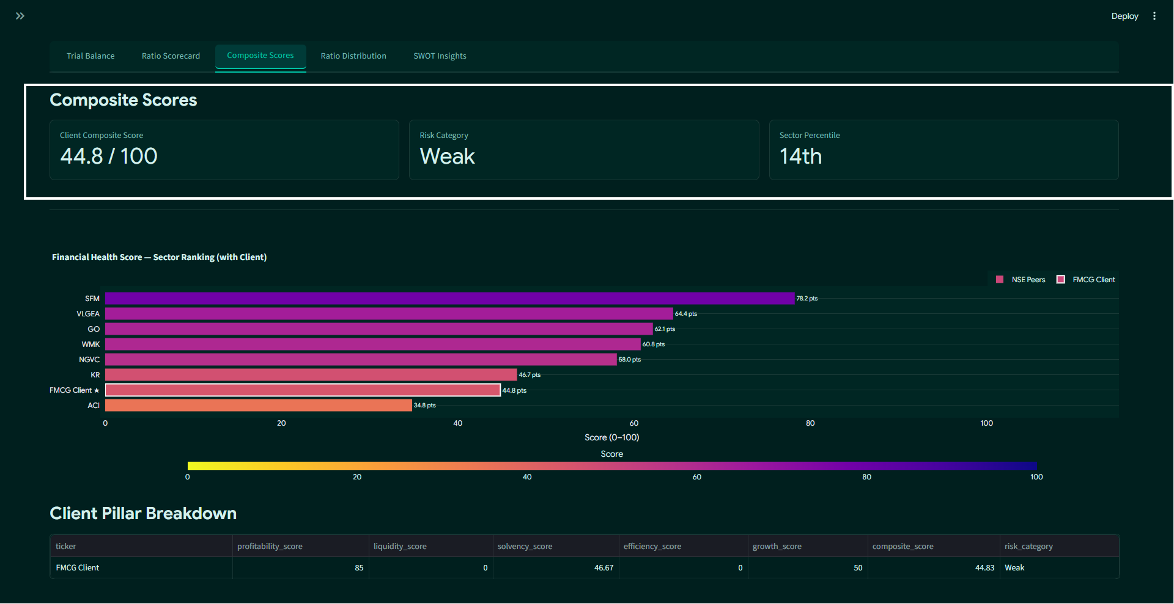
Figure: Client Composite Scores Tab

📝 Visual Elements & Controls to Note:
- Client Health Metrics: Displays the Client's Composite Score (0-100) (44.8 / 100), Assigned Risk Category (Weak), and Sector Percentile rank (14th).
- Comparative Score Bar Chart: Renders the sector health score chart, with the private FMCG Client prominently highlighted in a distinct color and white border to show exactly where they stand among public peers (ranking 7th, right above ACI's 34.8).
- Client Pillar Breakdown Dataframe: Individual table displaying the client's score across the five financial pillars.

📊 High-Resolution Health Score Ranking (with Client) Plot:
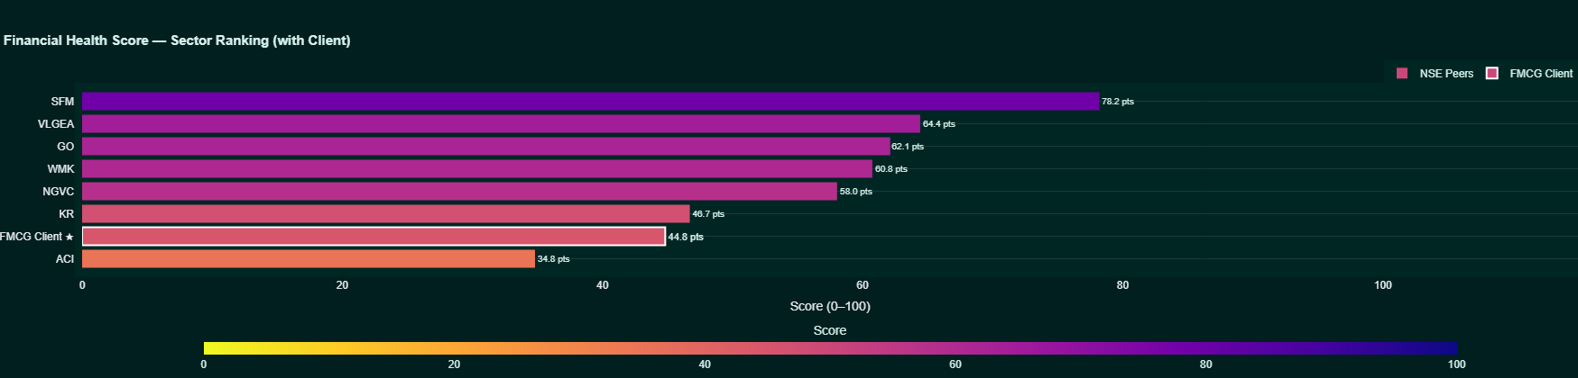
Figure: High-Resolution Health Score with Client

Client Comparison ➔ Ratio Distribution Tab
Fourth sub-tab of Client Comparison. Maps the client against all peer companies across customizable ratio axis.

📸 Interface Capture:
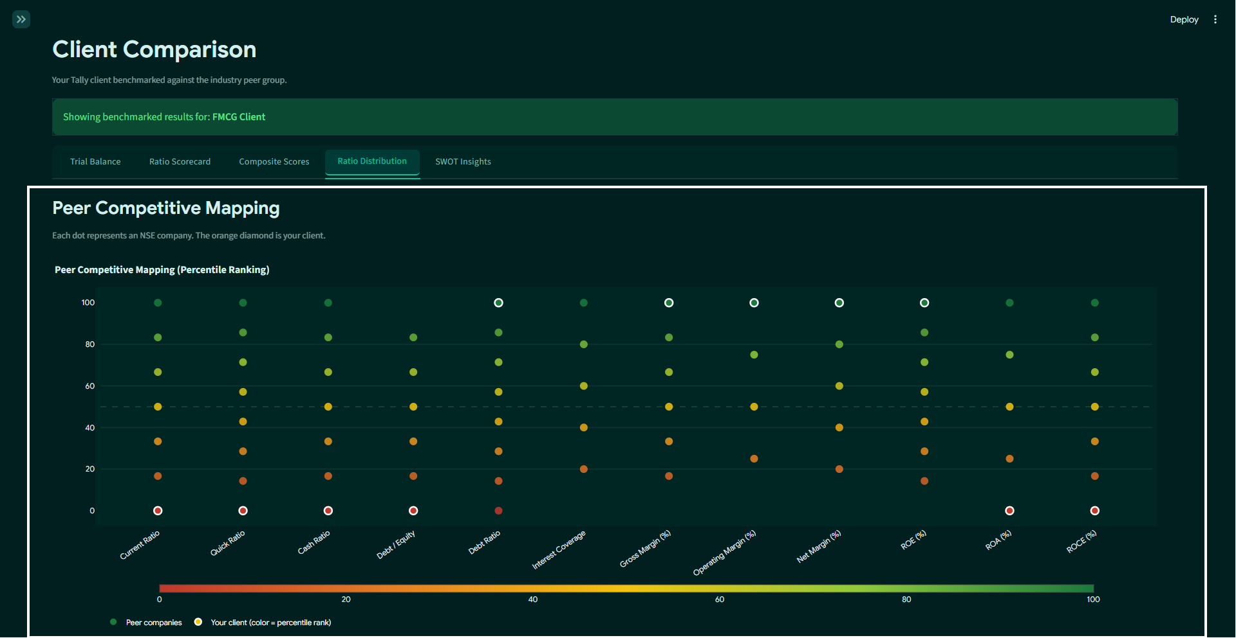
Figure: Client Peer Competitive Mapping

📝 Visual Elements & Controls to Note:
- Axis Selectors: Dropdown controls to dynamically change the X-axis and Y-axis ratios (e.g., mapping operating margin against current ratio).
- Competitive Mapping Scatter Plot: Scatter chart where every public peer is mapped as a node, and the client is plotted as a prominent, glowing node with a distinct white ring.

📊 High-Resolution Peer Competitive Percentile Distribution Plot:
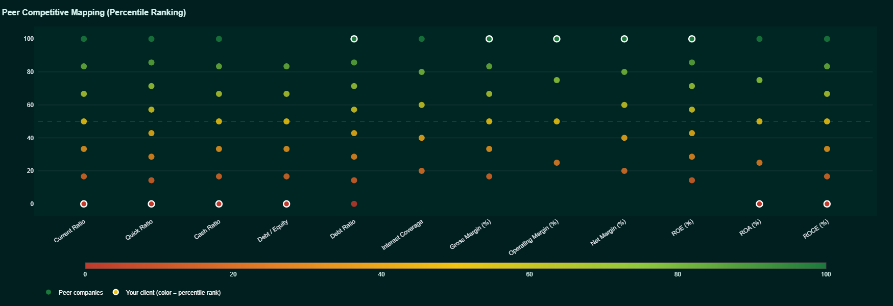
Figure: High-Resolution Peer Competitive Mapping

Client Comparison ➔ SWOT Insights Tab
Fifth sub-tab of Client Comparison. Translates comparative numerical metrics into a strategic 2×2 SWOT matrix.

📸 Interface Capture:
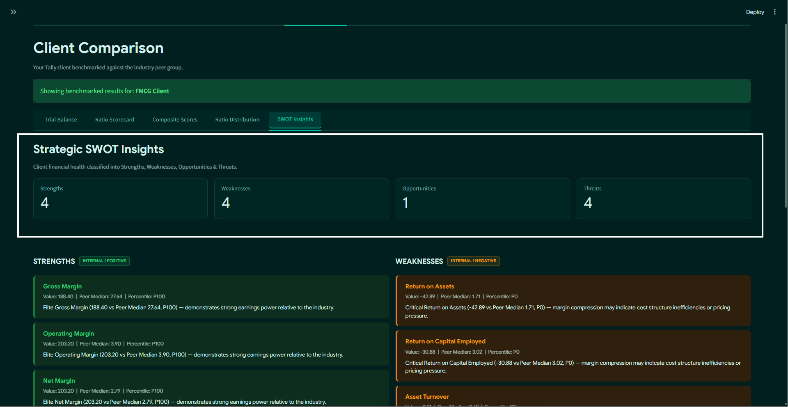
Figure: Client SWOT Insights

📝 Visual Elements & Controls to Note:
- SWOT Metric Indicators: Metric cards showing the number of items classified in Strengths (4), Weaknesses (4), Opportunities (1), and Threats (4).
- 2×2 SWOT Grid Cards:
- 🟢 STRENGTHS (Internal / Positive): High-percentile ratios (percentile P100) such as Gross Margin (188.40%), Operating Margin (203.20%), Net Margin (203.20%), and Return on Equity (2643.23%) with positive, plain-English business descriptions.
- 🟠 WEAKNESSES (Internal / Negative): Low-percentile performance metrics (percentile P0) such as Return on Assets (-42.89%), Return on Capital Employed (-30.88%), Asset Turnover (-0.21), and Receivables Turnover (-2.48).
- 🔵 OPPORTUNITIES (External / Strategic): Key efficiency indicators demonstrating room for market scaling, e.g. Debt Ratio (-0.90 vs peer median 0.67, P100) — conservative leverage provides untapped borrowing capacity.
- 🔴 THREATS (External / Risk): Severe outliers or leverage indicators signaling financial risk, e.g. Current Ratio (-2.57, P0) and Quick Ratio (-2.57, P0) indicating working capital gaps and liquidity distress.
- SWOT Export Button: Primary download button to export the SWOT report as a CSV.

Export Tab
Handles reporting pipelines, allowing you to export the entire multi-tab analysis into an Excel workbook.

📸 Interface Capture:
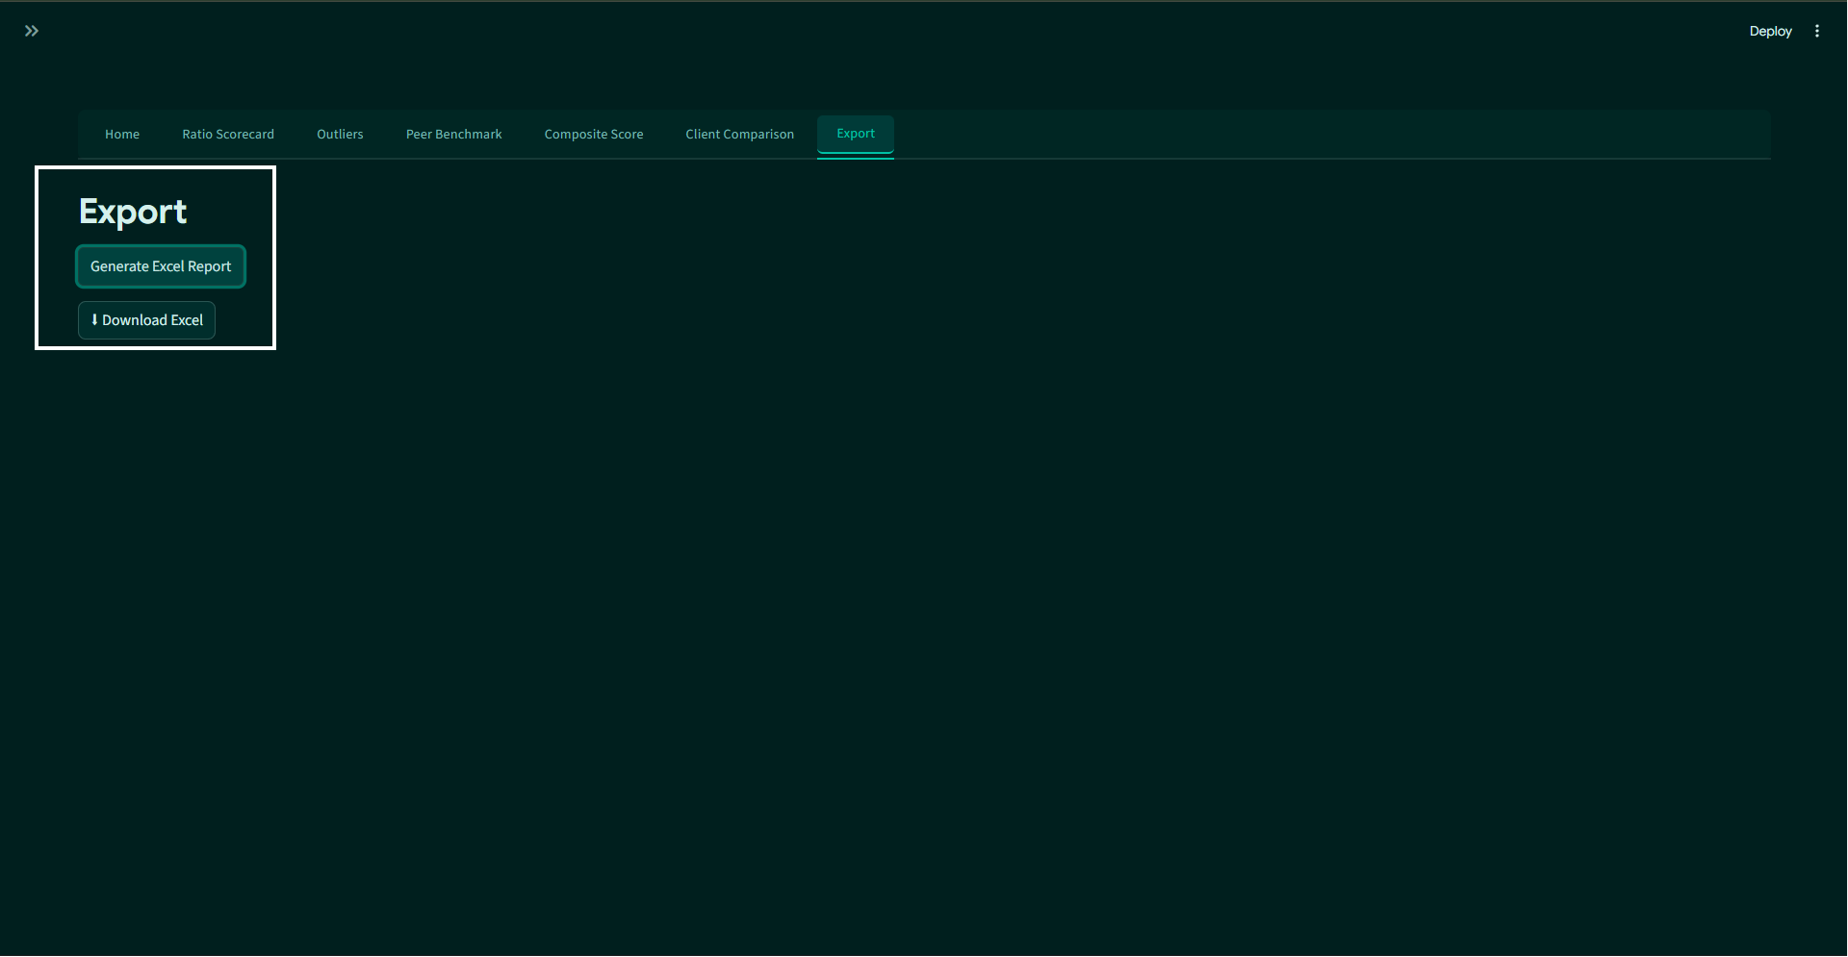
Figure: Export Tab

📝 Visual Elements & Controls to Note:
- Generate Excel Report Button: Clicking this triggers the ReportGenerator background engine.
- Download Excel Button: Large download action button that appears once the multi-sheet Excel file (containing Ratios, Outliers, Scores, SWOT, and peer statistics) has been built.

📸 5. Visual Asset Directory
All visual assets included in this manual are stored inside your local `docs/images/` directory.

📋 Visual Asset Verification Checklist:
- ✅ docs/images/01_sidebar_and_home.png — Sidebar & Home configuration interface.
- ✅ docs/images/02_tally_upload.png — Calibration & TallySync Upload file inputs interface.
- ✅ docs/images/03_ratio_scorecard.png — Standard Peer Ratio Scorecard interface.
- ✅ docs/images/04_outliers.png — Outlier scatter & univariate dataframe interface.
- ✅ docs/images/05_peer_benchmark.png — Peer stats heatmap and descriptive statistics table interface.
- ✅ docs/images/06_composite_score.png — Health Score bar chart and sector ranking table interface.
- ✅ docs/images/07_client_trial_balance.png — Mapped TallySync Trial Balance interface.
- ✅ docs/images/08_client_scorecard.png — Client Comparison Ratio Scorecard interface.
- ✅ docs/images/09_client_composite.png — Client Composite Health Ranking interface.
- ✅ docs/images/10_client_peer_scatter.png — Client Peer competitive percentile mapping interface.
- ✅ docs/images/11_client_swot.png — Client SWOT matrix grid interface.
- ✅ docs/images/12_export_tab.png — Report generation and Excel downloader interface.
- ✅ docs/images/chart_scorecard_kr.png — Standalone Plotly High-Resolution Scorecard (Kroger "KR" peer).
- ✅ docs/images/chart_peer_group_statistics.png — Standalone Plotly High-Resolution Peer Statistics Heatmap.
- ✅ docs/images/chart_health_score_sector_ranking.png — Standalone Plotly High-Resolution Health Score Sector Ranking.
- ✅ docs/images/chart_ratio_scorecard_client.png — Standalone Plotly High-Resolution Ratio Scorecard (FMCG Client).
- ✅ docs/images/chart_health_score_with_client.png — Standalone Plotly High-Resolution Health Score Ranking (with Client).
- ✅ docs/images/chart_peer_competitive_mapping.png — Standalone Plotly High-Resolution Peer competitive mapping scatter plot.
TIP: Standard Markdown readers (such as VS Code, GitHub, Obsidian, or Typora) will automatically render these images in real-time when viewing this file.

