EIND 468 –558 Homework #3 – Due 18 October at 11:59.

Adapted From Chapter 4 of *Time Series Analysis and Forecasting* (Each question is 15 points).

* 1. Consider the time series data shown in Table E4.1.

1. Make a time series plot of the data.

1. Use simple exponential smoothing with *𝜆* = 0.2 to smooth the first 40 time periods of this data. How well does this smoothing procedure work?
   1. I think the smoothing was all right. It seems like there is a slight positive trend which isn’t the greatest
2. Make one-step-ahead forecasts of the last 10 observations. Determine the forecast errors.
   1. Forecast shown in green
   2. MSE = 5.766825750542676
   3. Reconsider the time series data shown in Table E4.1.
3. Use simple exponential smoothing with the optimum value of *𝜆* to smooth the first 40 time periods of this data (you can find the optimum value from Minitab). How well does this smoothing procedure work? Compare the results with those obtained in Exercise 4.1.
4. Make one-step-ahead forecasts of the last 10 observations. Determine the forecast errors. Compare these forecast errors with those from Exercise 4.1. How much has using the optimum value of the smoothing constant improved the forecasts?

I had to redo this forecast with a different package that’s why it looks off. I think that the optimized alpha is better looking from a removal of noise standpoint. But it does have a higher SSE

MSE for alpha = 0.2 : 5.766825750542676

MSE for alpha = Optimized : 6.4607126708802305

* 1. Find the sample ACF for the time series in Table E4.1. Does this give you any insight about the optimum value of the smoothing constant that you found in Exercise 4.2?

1. Sample ACF: 0.10640581284369184
   1. Table B.1 in Appendix B contains data on the market yield on US Treasury Securities at 10-year constant maturity
2. Make a time series plot of the data.
3. Use simple exponential smoothing with *𝜆* = 0.2 to smooth the data, excluding the last 20 observations. How well does this smoothing procedure work?
4. Make one-step-ahead forecasts of the last 20 observations. Determine the forecast errors.

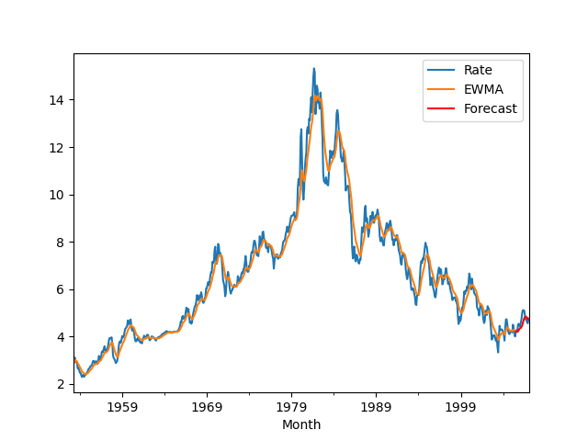

**4.20** Reconsider the global mean surface air temperature anomaly data shown in Table B.6 and used in Exercise 4.19.

1. Use simple exponential smoothing with the optimum value of 𝜆 to smooth the data (you can find the optimum value from either Minitab or JMP). How well does this smoothing procedure work? Compare the results with those obtained in Exercise 4.19.

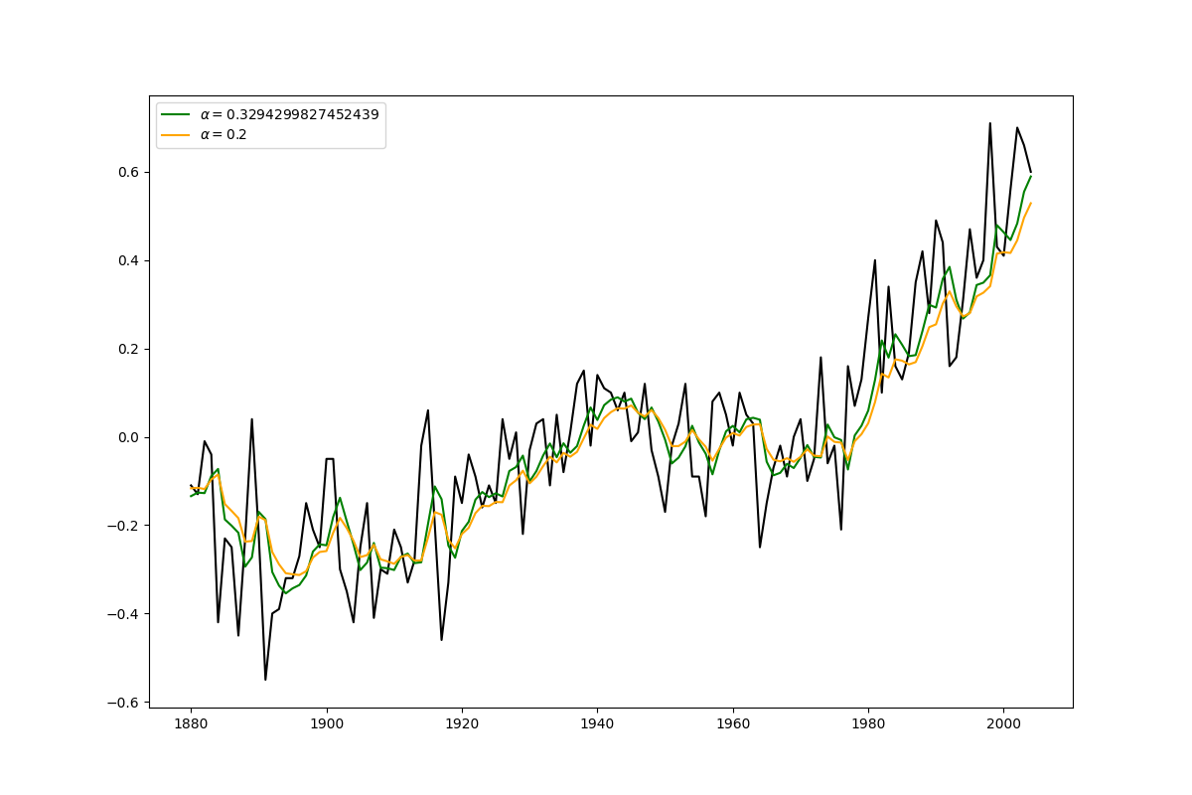

1. Do you think using the optimum value of the smoothing constant would result in improved forecasts from exponential smoothing?
   1. It might but honestly the upward trend might throw it off a little bit.
   2. The difference between 0.2 and 0.3294
2. Take the first difference of this data and plot the time series of first differences. Use exponential smoothing on the first differences. Instead of forecasting the original data, develop a procedure for forecasting the first differences and explain how you would use these forecasts of the first differences to obtain forecasts for the original global mean surface air temperature anomaly.’
   1. Below shows the forecast line for the difference. I think the best way to do the global mean forecast would be to shift the differences up and use those for the next forecast moving forward.

**4.48** (ignore the part about missing values, begin the data set in 2003. Use the 2003-2010 to develop a multiplicative Winters-type exponential smoothing model for the data. Use this model to simulate one-week-ahead forecasts for the remaining year. Calculate the forecast errors. Discuss the reasonableness of the forecasts:

1. Table B.23 shows weekly data on positive laboratory test results for influenza. Notice that these data have a number of missing values. In exercise you were asked to develop and implement a scheme to estimate the missing values. This data have a strong seasonal component. Use the data from 1997–2010 to develop a multiplicative Winters-type exponential smoothing model for this data. Use this model to simulate one-week-ahead forecasts for the remaining years. Calculate the forecast errors. Discuss the reasonableness of the forecasts.

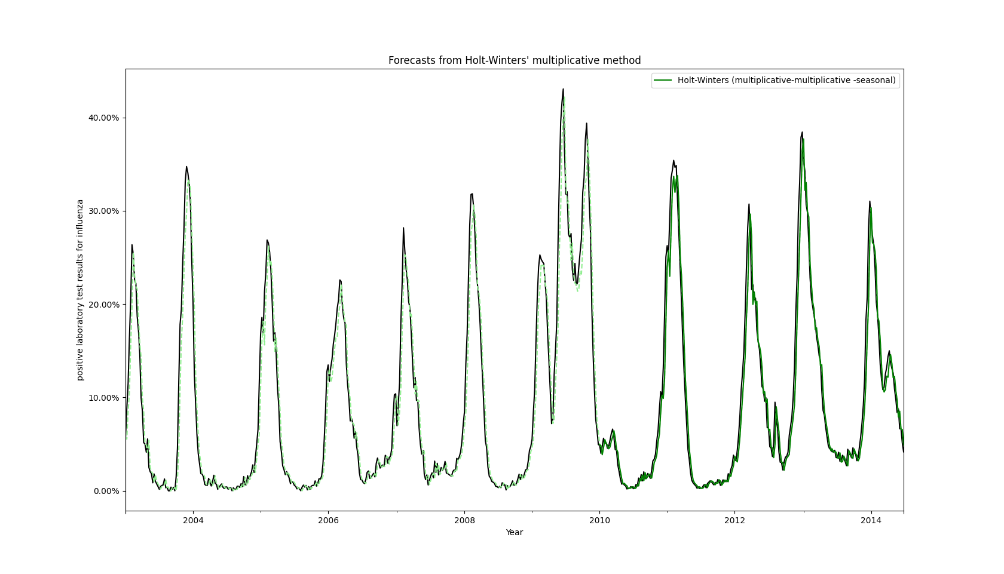

|  |  |
| --- | --- |
|  | Multiplicative |
| Alpha | 9.46E-01 |
| SSE | 3.18E+03 |

I think this model is pretty great! The error is low, and the one – week ahead forecast seems like reasonable way to forecast the future percentage of positive laboratory tests.

1. Repeat Exercise 4.48 using an additive Winters-type model. Compare the performance of the additive and the multiplicative model from Exercise 4.48.

|  |  |  |
| --- | --- | --- |
|  | Multiplicative | Additive |
| Alpha | 9.46E-01 | 0.937795 |
| SSE | 3.18E+03 | 3054.126264 |

Looking at the error for both models. The Additive model’s forecast has a little less error than the purely multiplicative model. Because of this I think choosing the additive model would be a better decision.

**4.52** Table B.25 contains data from the National Highway Traffic Safety Administration on motor vehicle fatalities from 1966 to 2012. This data are used by a variety of governmental and industry groups, as well as research organizations.

1. Plot the fatalities data and comment on any features of the data that you see.

1. Develop a forecasting procedure using first-order exponential smoothing. Use the data from 1966–2006 to develop the model, and then simulate one-year-ahead forecasts for the remaining years. Compute the forecasts errors. How well does this method seem to work?

1. Develop a forecasting procedure using based on double exponential smoothing. Use the data from 1966–2006 to develop the model, and then simulate one-year-ahead forecasts for the remaining years. Compute the forecasts errors. How well does this method seem to work in comparison to the method based on first-order exponential smoothing?

|  |  |  |
| --- | --- | --- |
|  | First-Order | Second-Order |
| alpha | 0.995 | 0.995 |
| beta |  | 0.0001 |
| SSE | 2.09E+08 | 1.98E+08 |

Both of these model have pretty high error but the Second order one has a little less error so I would choose that one.