UNIVERSITATEA „BABEŞ-BOLYAI” CLUJ-NAPOCA

FACULTATEA DE SOCIOLOGIE ŞI ASISTENŢĂ SOCIALĂ

DEPARTAMENTUL DE SOCIOLOGIE

SPECTRUL ATITUDINILOR POLITICE ÎN PERSPECTIVĂ COMPARATIVĂ

DISERTAȚIE MASTER

**Coordonator ştiinţific:**

Prof. Univ. Dr. Mircea Comșa

**Absolvent:**

Ioan Hălmagi

Cluj-Napoca

2023

**Abstract**

The spectrum of orientations about politicized issues varies significantly from one society to another. Past research has sought to identify the universal psychological processes and particular social circumstances that shape the spectrum of political orientation in various societies. Data from the World Values Survey and the European Values Survey was used to measure seven different components of attitudes toward topics that are politically contested in many countries: (1) individual freedom, (2) socialism and the welfare state, (3) gender equality, (4) ethnic relations and immigration, (5) family, sexuality, and reproduction, (6) nationalism, and (7) religiosity. Correlation matrices were calculated among the seven indices of social and political attitudes within more than 100 distinct countries and autonomous territories. The 21 correlations aggregated by country were then introduced as dependent variables into regression models in order to predict in what kind of countries are each pair of indices likely to correlate. Four predictors were used, based on findings from previous research: the presence of authoritarian socialist regimes in a country’s history, the zone of cultural heritage to which each country belongs, the level of economic development, and the level of liberal democracy. Socially progressive attitudes related to gender equality, ethnicity, respectively family, sexuality and reproduction are more likely to correlate strongly among each other and form a common dimension in economically developed countries. The correlation between socialist attitudes with cultural progressivism is insignificant or even negative in many countries, contrary to the expectations derived from the conventional left-right political spectrum. Many countries will likely never develop conventional left-right politicial spectrums as the correlation between social progressivism and economic equalitarianism does not increase with economic development. The findings of the current project add to the growing literuature that highlights the inadequacy of the traditional left-right spectrum for explaining political orientations.

**Content**

1. Introduction
   1. The origin of political orientations
   2. Theoretical models for the spectrum of political orientation
   3. Historical perspective
   4. Comparative research
   5. Questions and plan for the current study
2. Data
   1. Sources of data
   2. Selection of variables and calculated indices
3. Methods
   1. Individual level data analysis
   2. Country level data analysis
4. Results
   1. Individual level results
      1. Correlations in China
      2. Correlations in India
      3. Correlations in the United States
      4. Correlations in Indonesia
      5. Correlations in Pakistan
   2. Country level results
      1. First model: predicting the correlation between family values and gender equality
      2. Second model: predicting the correlation between family values and religiosity
      3. Third model: predicting the correlation between family values and ethnic attitudes
      4. Fourth model: predicting the correlation between individual freedom and family values
      5. Fifth model: predicting the correlation between gender equality and individual freedom
5. Conclusion

**List of tables and graphs**

**Tables**

Table 2. Average correlations across countries

Table 3. Correlation matrix for China

Table 4. Correlation matrix for India

Table 5. Correlation matrix for the United States

Table 6. Correlation matrix for Indonesia

Table 7. Correlation matrix for Pakistan

Table 8. Regression models at the country level of analysis

**Graphs**

Graph 1. The correlation between modern family values and gender equality according to the level of human development in each country

Graph 2. The human development index and the correlation between modern family values and religiosity

Graph 3. The correlation between modern family values and open attitudes toward immigrants and ethnic minorities according to the level of human development in each country

Graph 4. Human development index and the correlation between attitudes toward individual freedom and modern family values

Graph 5. Human development index and the correlation between support for individual freedom and support for gender equality

**1. Introduction**

In contemporary societies there are many topics that are subject to political contestation, including civil liberties, immigration and the rights of ethnic minorities, state intervention in the economy, redistribution of economic resources from the rich to the poor, gender equality, family relationships and the role of religion in society. In many countries, groups of attitudes toward politicized topics are packaged together into wider ideologies. For example, in the United States, one of the countries with the most strongly polarized political spectra (Fiorina & Abrams, 2008), individuals who support free-market market economics, an increased role for religion in society and traditional gender roles form the voter base of the Republican Party, while people who prefer a welfare state, a secular society and gender equality form the voter base of the Democratic Party. The American political spectrum, which is the most widely studied case in the research literature, represents a classic example of a left-right political spectrum. The right-left model has long dominated the study of political ideologies, both at the level of parties and politicians, and at the level of political orientation among common citizens.

Recent research has challenged the traditional left-right model of the political spectrum from two different perspectives. Psychologists and neuroscientists have started to investigate the factors that predispose individuals toward certain political orientations. They discovered that there are at least two separate dimensions of political orientation that originate in distinct cognitive and personality profiles. Comparative researchers from both political science and psychology have started to compare the spectrum of political attitudes in multiple countries and observed that the left-right spectrum is far from universal. In many countries around the world, especially in former communist countries, socially progressive attitudes are actually correlated with free market economic attitudes (conventionally associated with right – wing politics), contrary to the expectations derived from the traditional left-right model.

The purpose of the current project is to investigate differences among countries related to the type and pattern of the spectrum of political orientations. Seven varieties of politicized attitudes are included in the present study, relating to (1) individual freedom, (2) socialism and the welfare state, (3) immigration and ethnic minorities, (4) gender equality, (5) family, sexuality, and reproduction, (6) nationalism, as well as (7) religion. The present study extends previous research by investigating the relationships among seven components of political orientation instead of just social and economic orientation as well as by including a larger set of countries and territories from every inhabited continent, numbering more than 100 countries and autonomous territories in total.

**1.1. The origin of political orientations**

To what degree individuals’ political orientations and the structure of the political attitude spectrum itself are historically contingent or rooted in core psychological processes is still a hotly debated issue. The traditional model from political science is that ordinary citizens form broad clusters of political attitudes that can be associated with ideologies like liberalism, socialism, and conservatism by being exposed to the discourses of politicians and public intellectuals. For example, under this model, the fact that in the United States today attitudes toward gender equality correlate positively with attitudes that support more government intervention in the economy does not mean that there is any in inherent connection between the two groups of political attitudes. Gender equality may be positively correlated with free market orientations in other countries. Feminist attitudes correlate positively with social democratic attitudes in the United States since political advocates for feminism respectively social democracy sought to join forces in the past in order to attract a broader coalition of voters.

In psychology, a very different research tradition has taken hold. Political orientation is increasingly viewed as rooted in basic cognitive processes and even as influenced by one’s genes. In the last decade, novel fields of research like political neuroscience (Jost et al., 2014; Zmigrod & Tsakiris, 2021) and genopolitics (Fowler & Dawes, 2013; Hatemi et al, 2014; Dawes & Weinschenk, 2020) have emerged, linking the psychological study of political orientation with the biological sciences.

A large number of studies have investigated the relationship between political orientation and personality models like the Big Five. The most consistent finding is that openness to novelty is related to progressive political orientation while consciousness is related to political conservatism (Furnham & Fenton-O'Creevy, 2018; Xu et al. 2021). The correlations between political orientation and personality are most often considered marks of a causal relationship with the causal arrow pointing from personality to politics. Individuals’ personalities form earlier in life than political orientations and are more wide-ranging, affecting every aspect of one’s life. Many researchers consider that, if personality traits predict political orientation even after controlling for potential third variables that may affect both like gender, social class, or ethnic group, one can assume that personality factors cause political orientations rather than the other way around. The link between openness to novelty and political progressivism is explained by the fact that progressive political ideas like gender equality or gay marriage are novel in the context of contemporary Western societies where most research about the personality – politics connection has been done. Conscientiousness is thought to promote conservatism since it involves an emphasis on order and discipline, values usually associated with conservative ideology.

Cognitive abilities, measured by IQ tests, have been linked to political preferences in psychological research literature. Oskarsson et al. (2014) proposed that cognitive abilities are a key mediating variable linking the specific genetic alleles found to correlate with political orientation in previous research with the actual political beliefs and behavior that individuals develop. Social conservatism, often understood as a defense of traditional hierarchies built around race and gender, is associated with lower cognitive abilities (Hodson & Busseri, 2012; Saribay & Yilmaz, 2017; Dhont & Hodson, 2014; Onraet et al., 2015). By contrast, free market attitudes, traditionally viewed as part of a broader right-wing ideology together with social conservatism, are positively correlated with intelligence (Lewis & Bates, 2018). Individuals with better cognitive abilities are more likely to support freedom of expression even for groups and ideas that they dislike (de Keersmaecker et al., 2021; Drieghe et al., 2022).

Right-wing political orientation is considered as the product of a rigid cognitive style adopting by individuals when processing information (Costello et al., 2022). A rigid cognitive style has multiple aspects including dogmatism, structure, certainty, and closure. Dogmatism is the tendency to reject arguments and evidence that contradict one’s existing opinions. Some individuals have a stronger need to order everything they interact with in a pattern that is simple and easy to remember, a trait called “need for structure”. The need for certainty refers to the tendency of individuals to avoid information that is ambiguous or complex. People with a strong need for closure think that there is a single right answer to every question that they encounter (Brandt & Reyna, 2010).

The psychological study of authoritarianism was impacted by Theodor W. Adorno theory about the authoritarian personality. He argued that fascism is not just a political ideology, but an extension of the patterns of thought and behavior exhibited by individuals in their daily life. Adorno characterized authoritarians as persons obsessed with order, safety, and certainty, who reject any deviation from traditional models of conduct. Adorno’s theory linked authoritarianism with traditional right-wing attitudes and neglected the possibility of left-wing authoritarianism. More recent researchers have started to investigate authoritarianism as a phenomenon that can be found among both right – wing and left-wing individuals (Manson, 2020). The study of left-wing authoritarianism was motivated partly by findings from Eastern European countries with a history of communist dictatorship (de Regt et al., 2011), and partly by the more recent resurgence of authoritarian practices like censorship within the social justice movement from the United States (Conway et al., 2018). Whether authoritarianism is equally prevalent among both left-wing and right-wing individuals is still subject to debate (Conway et al., 2021).

**1.2. Theoretical models for the spectrum of political orientation**

The political spectrum was traditionally viewed as a contrast between the left, which values equality and progress, and the right, which values hierarchy, and tradition. Socialism, social democracy, the welfare state, secularism, cosmopolitanism, feminism, LGBT rights, and environmentalism are conventionally associated with the left. By contrast, support for capitalism, ethnic nationalism, the influence of religion on politics, and “traditional family values” are seen as typical right-wing attitudes.

The traditional left-right model was undermined by two types of empirical research. Firstly, political psychologists who sought to identify the personality and cognitive profiles of individuals who adopt different ideologies uncovered the fact that economic and social dimensions of political orientation have very different psychological underpinnings. While individuals who score high on tests of cognitive ability, measures of analytic thinking and personality questionnaires related with openness to novelty are more likely to adopt socially progressive attitudes toward gender roles, ethnic relations and LGBT rights, they are not more likely to support the redistribution of resources from the rich to the poor or the regulation of the economy by the government, once the shared variance between social progressivism and left-wing economic attitudes was controlled for using partial correlations or multiple regressions. Secondly, the increased availability of data from a large number of countries has made possible the study of political spectrums in a global comparative perspective. Such studies have often found that the traditional association between social progressivism (gender equality, secularism, tolerance for diversity) and economic leftism often found in Western societies, where most research in political sciences and political psychology has historically been done, is inadequate for explain the variation of political attitudes in many parts of the world, especially in former communist countries.

Feldman and Johnston (2013) argued that there are distinct social and economic dimensions of political orientation, and that the traditional left-right spectrum is inadequate for measuring the policy preferences of individuals. Costello and Lilienfeld (2021) found that only social conservatism is associated with the rigid psychological profile that was attributed in previous research to all right-wing individuals. Statistically controlling for social conservatism, the correlations between economic conservatism and psychological rigidity become insignificant or even change sign and become negative. Such results suggest that social and economic conservatism are caused by different cognitive processes and correlate among the general public only as a result of being exposed to political discourses that links social and economic attitudes into broader “right-wing” and “left-wing” packages.

Johnston et al. (2017) argue that a dimension of political contestation they call “open versus closed”, related to immigration, gender equality, family values and foreign policy is becoming more important than the traditional economic dimension contrasting the left (supporting redistribution and regulation) with the right (supporting free markets and free trade). They draw attention to the fact that even in the United States and in the Western European countries, where the left-right axis captured most of the variation on political orientations historically, new movements and ideologies emerged that challenge the old political spectrum. Nationalist and populist parties built around an anti-immigration platform often adopt a pro-welfare economic ideology due to their voter base, which is composed of people with low education and low income. Even in the rigid party system of the United States, where the same two parties have competed for power for more than a century, a populist ideology combining ethnic nationalism with protectionist attitudes has largely replaced neoconservatism and free – market libertarianism as the core ideology of the Republican Party. Meanwhile, social progressives campaigning for gender equality and minority rights often originate from the ranks of middle-class urban professionals who are skeptical toward the socialist ideals of the old left.

**1.3. Historical perspective**

The meaning of “left” and “right” have changed over time. These two designations originated during the French Revolution, when those who supported the absolute monarchy, the hereditary privileges of the nobles and the established Church positioned themselves in the right part of the National Assembly while those who desired a new social and political order based on the ideals of secularism, freedom and equality positioned themselves on the left side of the National Assembly. During the 19th century, the left was associated with liberal and radical groups while the right was associated with conservative and reactionary groups.

In the early 20th century, socialist parties in industrialized countries gained widespread support from the newly enfranchised working-class voters and entered national legislatures, sometimes replacing liberal parties in the process. The most extreme example is that of the Liberal Party of the United Kingdom. Despite being one of the two main British political parties of the late 19th century along with the Conservative Party, the Liberal Party faded into obscurity after the 1924 elections, while the Labor Party took its place as the main party of British progressives (McKibbin, 2010).

The rise of socialism within the political systems of rich countries coincided with the rise of anticolonial nationalist movements in the rest of the world (Friedman, 2022). Socialist intellectuals and activists supported the anticolonial movement, leading to a long-lasting alliance between socialists and nationalists within most non-Western countries, especially in Eastern Europe, the Middle East, Sub-Saharan Africa, India, and China. The fusion between socialism and nationalism led to the apparition of a wide variety of new political ideologies specific to certain countries or regions. Most had an authoritarian character and served as the justification for dictatorial power. Such ideologies include Soviet patriotism/ socialism in one country, Titoism (Yugoslav socialism), Ba’athism/ Arab socialism, Islamic socialism, African socialism, Nehruvian socialism (India), Burmnese Way to Socialism, socialism with Chinese Characteristics, Ho Chi Minh Thought (Vietnam), and Juche (North Korea).

**1.4. Comparative research**

Unlike in Western countries, in the former communist countries from Eastern Europe, openness to novelty is correlated with right-wing attitudes while the needs for security and certainty are correlated with leftism (Thorisdottir et al., 2007). A similar situation is encountered in China, a country which, despite remaining nominally communist, has undergone major economic reforms since 1978. Pan and Xu (2018) have studied the structure of the political attitude spectrum among a large sample of thousands of respondents from mainland China. They found that nationalism, social conservatism, and left-wing economic attitudes are correlated positively, unlike in Western countries.

Despite the fact that communist regimes have suppressed the religious and traditional worldviews of both Chinese and East Europeans, after the fall of communist states in Eastern Europe and the reform of China’s economy, a dramatic change occurred in how people perceive the relationship between the period of communist rule and traditional culture. Communism became seen as an extension of the national tradition, in contrast with Western-style modernity.

Malka et al. (2019) found that in most countries, right-wing economic attitudes (support for free markets and free trade) relate positively to socially progressive attitudes like gender equality or openness toward immigrants. By contrast, in developed Western democracies, adherents of economic right-wing ideology are more likely to support social conservatism and ethnic nationalism. Apart from economic development, the history of political regimes in a country influences the structure of its political spectrum. In former communist countries, economically right-wing attitudes are correlated with socially progressive attitudes, in stark contrast with Western democracies. In developing and/ or former communist countries, the social and political orientations of citizens form an open – closed or freedom – protection spectrum, as opposed to a right-left spectrum.

**1.5. Questions and plan for the current study**

Previous studies have uncovered the heterogeneity of political orientations and the inadequacy of the traditional left-right model. The present study aims to contribute to the still neglected research area of international comparisons involving spectra of political orientations and attitudes by extending previous research with a larger set of countries and a more detailed breakdown of the political spectrum into distinct subcomponents that were often simply assumed to be part of a larger left-right dimension, without testing the respective assumption.

The research questions that the present study aims to answer are:

* How do economic (the human development index), historical (the experience of authoritarian socialist regimes), and cultural (Western or non-Western cultural heritage) features of nations affect the structure of the political attitude spectrum among the citizens of each country?
* Do the two constructs of social conservatism and economic conservatism identified in recent empirical research about the spectrum of political orientation break down into multiple independent sub-components just like the traditional left-right dichotomy?

**2. Data**

**2.1. Sources of data**

Two types of data are used for the present research project. The first consists in individual – level data measuring social attitudes and political orientations. The second represents characteristics of countries like economic development, the level of democracy or the historical circumstances of each country.

**2.1.1. Individual level measures of social and political attitudes**

The World Values Survey (WVS) provides a wide range of indicators measuring political and social attitudes in samples from many countries (Haerpfer et al., 2022). The number of countries in which the World Values Survey was conducted increased from 11 countries in the first wave (1981-1984) to 100 countries in the seventh wave (2017 - 2022). The European Values Survey (EVS) is designed for compatibility with the World Values Survey. It was conducted at intervals of roughly 10 years, spanning the first (1981), second (1990), third (1999), fourth (2008) and fifth (2017) waves (EVS, 2022). The Integrated Values Survey (IVS) represents the merged datasets from the World Values Survey and the European Values Survey according to a common codebook.

**2.1.1. Country level predictors**

Country-level predictors for the correlations between the indices of political orientation can be divided into two categories. Two variables, related to the cultural and political history of each country, were coded manually. Other two variables, related to the economic and political development of various countries, are the Human Development Index and the Liberal Democracy Index that is part of the Varieties of Democracy Project.

One of these variables is about whether a country was governed by Marxist-Leninist or other type of authoritarian socialist regime in the past. Countries with a history of communist rule receive a score of 1, countries governed in the past by other varieties of authoritarian socialism (such as Baʽathism, Nasserism, African socialism, or the “Burmese way to socialism”) were coded with 0.5, while countries that were never ruled by authoritarian socialist regimes were coded with 0. Variables related to social class equality and political freedom from the V-Dem dataset (Coppedge et al., 2023; Pemstein et al., 2023) as well as about historical governing parties and their ideologies from the V-Party datasets (Lindberg et al., 2022) were consulted when coding each country. The other manually coded variable concerns the cultural heritage of each country, and its path to modernization. The United States, the United Kingdom, Ireland, Canada, Australia, and the New Zealand were coded with 1. The United Kingdom is the country where the modern industrial revolution originated. The other Anglophone countries mentioned were former settler colonies of the British Empire. They imported British-style industrialism and classical liberal economics relatively early compared with other countries. Western European countries were coded with 0.66. Latin American countries were coded with 0.33. They have strong ties with Western European culture since they were settler colonies of Spain or Portugal. Non-Western countries were coded with 0.

The HDI is published by the Human Development Programme supported by the United Nations, while the Liberal Democracy Index is component of the Varieties of Democracy (V-Dem) project organized by a global team of political science researchers who are members of the V-Dem Institute, with headquarters at the University of Gothenburg (Sweden).

**2.2. Selection of variables and calculated indices**

Seven categories of variables were extracted from the Integrated Value Survey (IVS). They measure social and political attitudes related to individual freedom, the welfare state, gender equality, ethnicity & immigration, family values, nationalism, and religiosity. In order to maximize the number of countries with available data, only variables that were present in all WVS waves from the third to the seventh wave (the waves with unique countries not found in other waves) as well as in at least one EVS wave were selected.

**2.2.1. Individual freedom**

The index measuring socio-political attitudes in favor of individual freedom is built from four subindices. The first subindex measures attitudes toward child education. Respondents are asked to select up to five qualities they think children should learn at home from a list of possible child qualities. Three qualities are relevant for the concept of individual freedom: independence, imagination, and obedience. Independence and imagination were coded to 1 as they are favorable to the free development of a child’s personality, while obedience was coded with 0 as it is incompatible with personal freedom. The three variables were averaged to calculate the subindex about child qualities. The second subindex is formed from one item asking respondents if an increased level of respect for authority in society would be a good thing, a neutral thing, or a bad thing. Saying that an increased level of respect for authority would be a bad thing is most compatible with a value system centered on individual freedom. Therefore the “bad thing” answer option was coded with one. The neutral option was coded with 0.5, while the “good thing” option was coded with 0. The next subindex is composed of two questions about what goals or priorities the respondent thinks are most important for their country and for themselves as individual citizens.

**2.2.2. Socialism and welfare**

Support for socialism and public welfare was measured with four variables, all of which took the response format of a scale with ten steps. The questions asked to the respondents are whether they think incomes should be made more equal or there should be inequalities to stimulate hard work, whether private or public ownership of business should be increased, whether the government has the responsibility to take care of citizens when they are in need, and whether they think competition is harmful. All variables were recoded so that higher values indicate a pro-socialist or pro-welfare orientation while lower values indicate support for free markets.

**2.2.3. Family values**

The family values index measures whether respondents adopt modern attitudes supportive of individual autonomy and free choice in matters related to family relationships, sexuality, and reproduction. There are four variables measured on a scale from 1 to 10, asking respondents whether they think homosexuality, abortion, and divorce are morally justifiable or not. Approval of homosexuality signifies the rejection of the traditional family ideal consisting of man and a woman who marry to have children and continue the family line of their ancestors in favor of a model of family oriented around personal satisfaction and the free expression of an individual sexual orientation. Abortion is related to women’s autonomy over their own bodies, while divorce is often a way for individuals to protect their freedom by abandoning an unwanted or abusive relationship. Considering each of the four issues as morally acceptable indicates a modern orientation regarding family, sexuality, and reproduction.

**2.2.4. Ethnicity and immigration**

Tolerance for ethnic minorities and support for open immigration policies were measured using three items from the WVS and EVS datasets. The first two items are about acceptance for those who are from a different ethnic group than that of the respondent. Participants were asked to select several types of neighbors they would not like to have from a list of often stigmatized social groups. Among that list, neighbors of another race and neighbors that are immigrants were included. The third item measures discriminatory attitudes toward immigrants when searching for jobs. The respondents were asked if they believed that the natives of a given country should be given preference over immigrants when selecting new employees.

**2.2.5. Gender equality**

Three questions about gender stereotypes and discriminatory attitudes toward women were included in the index of support for gender equality. The first question asked respondents to state whether they think men are better than women as political leaders. The second and third questions are about whether men respectively boys should be given preference when allocating jobs respectively educational opportunities. Opposition to discriminatory attitudes and disbelief in gender stereotypes were taken as evidence of support for the principle of gender equality.

**2.2.6. Nationalism**

Only two questions measuring nationalism were found within a sufficiently large number of WVS and EVS waves. One question is about the degree of pride survey respondents feel when they think about their national identity, while the other question measured patriotic loyalty by asking participants to state if they would be willing to fight for their country should a war break out.

**2.2.7. Religiosity**

Five different questions were used to measure religiosity. Two questions are related to the importance that respondents give to religion, respectively God, in their lives. One item is derived from a larger question where respondents were asked to select several qualities that they would like to teach to their children from a list of potentially desirable qualities for a child. Among them is religious faith. The last two items measure religious practice, operationalized as church/ mosque/ temple attendance, respectively religious identity, measured by asking survey participants to choose if they see themselves as “a religious person”, “not a religious person”, or “an atheist”.

**3. Methods**

All data processing and analysis was performed in Python using libraries including NumPy, Pandas, and statsmodels. The code was organized into six Jupyter notebooks, involving data transformation at the individual level, building indices of political orientation, data analysis at the individual level (calculating correlations among the indices), data transformation at the country level, data analysis at the country level and data visualization. The code within each Jupyter notebook was organized using the principles of object-oriented programming. In each notebook, there is a section dedicated to the definition of the class, a section for the creation of the object by instantiating the class, a section for calling each method defined for the class and a section for inspecting the results of applying each method to the data. All files with code for the transformation and analysis of data for the present project are publicly available on GitHub, in the repository “political spectrum_comparative_perspective” for the user “hi99-john” (https://github.com/hi99-john/political_spectrum_comparative_perspective).

**3.1. Individual – level data analysis**

Correlations were calculated for each pair of political orientation indices. There were seven indices of political orientation in total, measuring attitudes toward individual freedom, socialism, ethnic minorities, gender equality, family values, nationalism as well as the level of personal religiosity. Correlations were calculated within each country with available data for the two indices necessary for calculating a correlation.

Since the data analysis at the individual level involved calculating over 2000 correlation coefficients, only a small fraction of the correlations can be verbally described in the results section. The 21 correlation coefficients among the 7 indices, averaged across all countries with available data was well as the correlation matrices for the five countries with the largest population in the world (China, India, the United States, Indonesia, and Pakistan) were described in the results section.

|  |  |  |  |  |  |  |  |
| --- | --- | --- | --- | --- | --- | --- | --- |
| Indices | freedom | socialism | family | ethnicity | gender | nationalism | religiosity |
| freedom |  | 108 | 106 | 105 | 108 | 107 | 108 |
| socialism |  |  | 113 | 113 | 110 | 113 | 113 |
| family |  |  |  | 113 | 109 | 112 | 113 |
| ethnicity |  |  |  |  | 109 | 111 | 111 |
| gender |  |  |  |  |  | 109 | 109 |
| nationalism |  |  |  |  |  |  | 112 |
| religiosity |  |  |  |  |  |  |  |

Table 1. Number of countries with available data for each correlation

**3.2. Country-level data analysis**

Data analysis at the country level consisted in regression models predicting the correlation coefficients of each country for the 21 correlations calculated among the 7 indices. Four predictors were used in each of the multiple linear regression models. The first predictor is the variable measuring whether a country had an authoritarian socialist regime in the past. The second predictor contains information about each country whether it has a Western cultural heritage or not. The third predictor is the Human Development Index. The fourth and last predictor is the Liberal Democracy Index calculated by the V-Dem Institute.

The intercept, the regression coefficients for the four predictors, the R2 score and the R2 score adjusted for the number of predictors were reported in the results section for each of the 21 regression models. The regression models are displayed according to the R2 score, in decreasing order. Since verbally describing all 21 regression models would have occupied too much space, only the five best performing models are described using words while the other models are shown only in the table.

Five scatterplots, showing how the correlation coefficients among the indices of political attitudes vary according to the human development index of each country are included in the results section. The five scatterplots are related to the five best – performing regression models. The human development index was chosen from the four predictors for inclusion in the scatterplots since it is the strongest predictor in each of the five regression models.

**4. Results**

**4.1. Individual level results**

The strongest correlation averaged across countries (Pearson's r = -0.21) is between modern attitudes about family, sexuality, and reproduction on the one side and religiosity on the other side. In many countries, highly religious people hold socially conservative orientations, opposing homosexual relationships, divorce, and abortion. The next strongest correlations (r = 0.16) are between attitudes supportive of: individual freedom and modern family values, individual freedom and gender equality, modern family values and gender equality, respectively gender equality and openness toward immigrants. Across many countries, politically liberal individuals are more likely to support gender equality and to express tolerance for LGBT lifestyles. Moreover, people who support gender equality are likely to also oppose discrimination against ethnic minorities, immigrants, and LGBT individuals.

|  |  |  |  |  |  |  |  |
| --- | --- | --- | --- | --- | --- | --- | --- |
| r | freedom | socialism | family | ethnicity | gender | nationalism | religiosity |
| freedom | 1 | -0.02 | 0.16 | 0.08 | 0.16 | -0.09 | -0.13 |
| socialism |  | 1 | -0.01 | -0.02 | -0.02 | -0.05 | 0.01 |
| family |  |  | 1 | 0.08 | 0.16 | -0.08 | -0.21 |
| ethnicity |  |  |  | 1 | 0.16 | -0.03 | -0.03 |
| gender |  |  |  |  | 1 | -0.04 | -0.07 |
| nationalism |  |  |  |  |  | 1 | 0.07 |
| religiosity |  |  |  |  |  |  | 1 |

Table 2. Average correlations across countries

**4.1.1. Correlations in China**

People who consider that men and women should have equal rights are more likely to support more permissive immigration policies and to oppose discrimination against ethnic minorities (r = 0.2, p < .001). Individuals who hold liberal democratic values are more likely to have a modern stance toward family, sexuality, and reproduction (r = 0.12, p < .001), to support gender equality (r = 0.1, p <.001) and to favour a more open approach to immigration (r = 0.09, p < .001).

As has been observed in previous research involving countries with a communist past, in China, people with socialist economic attitudes are more likely to have an authoritarian political orientation (r between individual freedom and socialism is - 0.07, with p < .001). Such a correlation indicates that the correlation between socialist and liberal attitudes is a product of a country’s particular history. In countries ruled by authoritarian socialist governments, people who adopt the economic ideology embraced by the government are also more likely to approve of its authoritarian policies. In contrast, people who reject the authoritarian regime may be also more likely to question the socialist ideology that the regimes uses to justify its rule.

|  |  |  |  |  |  |  |  |
| --- | --- | --- | --- | --- | --- | --- | --- |
| r | freedom | socialism | family | ethnicity | gender | nationalism | religiosity |
| freedom | 1 | -0.07*** (N = 7436) | 0.12***  (N = 7234) | 0.09*** (N = 7425) | 0.10*** (N = 7466) | -0.07*** (N = 7217) | -0.05** (N = 2640) |
| socialism |  | 1 | -0.04 *** (N = 10047) | -0.04*** (N = 10285) | -0.04*** (N = 9343) | 0.01 (N = 10021) | 0.02 (N = 2742) |
| family |  |  | 1 | 0.08*** (N = 10127) | 0.05*** (N = 9162) | -0.07*** (N = 10079) | -0.04** (N = 2704) |
| ethnicity |  |  |  | 1 | 0.20*** (N = 9437) | 0.01 (N = 10079) | -0.02 (N = 2735) |
| gender |  |  |  |  | 1 | 0.04*** (N = 9134) | -0.07*** (N = 2667) |
| nationalism |  |  |  |  |  | 1 | -0.02 (N = 2678) |
| religiosity |  |  |  |  |  |  | 1 |

Table 3. Correlation matrix for China

**4.1.2. Correlations in India**

The strongest correlation observed in India is the negative correlation between modern family values and religiosity (r = 0.2, p < .001, N = 11537). People who hold stronger religious beliefs or engage in more frequent religious practices are more likely to disapprove of homosexuality, divorce, and abortion. The next highest correlation is between support for gender equality and openness toward immigrants (r = 0.12, p < .001, N = 10117). In stark contrast with China, socialist attitudes are positively correlated with attitudes in favour of individual freedom in India (r = 0.08, p < .001). This may be explained by the history of Indian democracy. In most non-Western countries that obtained independence from colonial rule, individuals and movements inclined toward socialism sought to imitate the Soviet political system of one-party rule. However, in India, socialist politicians affiliated with the Indian National Congress accepted the principle of multi-party democracy as necessary for a highly diverse country like India.

|  |  |  |  |  |  |  |  |
| --- | --- | --- | --- | --- | --- | --- | --- |
| r | freedom | socialism | family | ethnicity | gender | nationalism | religiosity |
| freedom | 1 | 0.08*** (N = 10083) | 0.06***  (N = 9609) | 0.04***  (N = 10084) | 0.09***  (N = 10082) | -0.04*** (N = 10066) | -0.03** (N = 9536) |
| socialism |  | 1 | 0.00 (N = 12133) | -0.02** (N = 12618) | 0.01 (N = 10116) | -0.04*** (N = 12599) | -0.01 (N = 11990) |
| family |  |  | 1 | -0.01 (N = 12134) | 0 (N = 9632) | -0.08*** (N = 12119) | -0.20*** (N = 11537) |
| ethnicity |  |  |  | 1 | 0.12*** (N = 10117) | -0.05*** (N = 12600) | -0.04*** (N = 11991) |
| gender |  |  |  |  | 1 | 0.04*** (N = 10098) | -0.05*** (N = 9561) |
| nationalism |  |  |  |  |  | 1 | 0.05 (N = 11974) |
| religiosity |  |  |  |  |  |  | 1 |

Table 4. Correlation matrix for India

**4.1.2. Correlations in United States**

In the United States, strongly religious people are more likely to adopt a socially conservative stance toward issues related to family, sexuality, and reproduction (r = -0.45, p < .001, N = 9148). It is the strongest correlation in the matrix for the United States as well as among all correlations observed in the five countries with the largest population (China, India, United States, Indonesia, and Pakistan). Correlations in the United States are also stronger than those found in most other countries, highlighting the highly polarized character of contemporary American politics.

|  |  |  |  |  |  |  |  |
| --- | --- | --- | --- | --- | --- | --- | --- |
| r | freedom | socialism | family | ethnicity | gender | nationalism | religiosity |
| freedom | 1 | -0.02  (N = 8358) | 0.38*** (N = 8364) | 0.17*** (N = 8423) | 0.28*** (N = 8449) | -0.19*** (N = 8277) | -0.23*** (N = 6162) |
| socialism |  | 1 | 0.01 (N = 11951) | 0.00 (N = 12070) | -0.01 (N = 8554) | -0.12*** (N = 11835) | -0.03*** (N = 9075) |
| family |  |  | 1 | 0.11*** (N = 12133) | 0.36*** (N = 8546) | -0.22*** (N = 15885) | -0.45*** (N = 9148) |
| ethnicity |  |  |  | 1 | 0.27*** (N = 8667) | -0.05*** (N = 12018) | -0.01 (N = 9261) |
| gender |  |  |  |  | 1 | -0.16*** (N = 8464) | -0.12*** (N = 6318) |
| nationalism |  |  |  |  |  | 1 | 0.13*** (N = 9073) |
| religiosity |  |  |  |  |  |  | 1 |

Table 5. Correlation matrix for the United States

**4.1.4. Correlations in Indonesia**

In Indonesia, individuals who are more nationalistic are also more likely to be highly religious (r = 0.14, p < .001, N = 4882). Support for individual freedom is correlated with equalitarian gender attitudes (r = 0.15, p < .001, N = 6012). Nationalists are more likely to disapprove of homosexuality, divorce, or abortion (r = -0.1, p < .001, N = 5069). Highly religious Indonesians are more likely to reject homosexuality, divorce, and abortion (r = -0.11, p < .001), similarly with respondents from Western countries. Such finding indicates that the strong association between religion and social conservatism observed in Western countries, especially the United States, is not culturally particular and is likely to reflect common features of most religions or universal human cognitive processes. Indonesia is a multireligious nation, composed from Muslims, Christians, and practitioners of animism, shamanism, and other types of folk spirituality. Religions may promote conservatism by transmitting the values and norms of traditional societies that existed centuries ago and enshrining them as sacred commands of God. Since religious morality is presented as unchanging divine truth, individuals who live in strongly religious communities are more likely to reject lifestyles that threaten traditional norms.

|  |  |  |  |  |  |  |  |
| --- | --- | --- | --- | --- | --- | --- | --- |
| r | freedom | socialism | family | ethnicity | gender | nationalism | religiosity |
| freedom | 1 | -0.03* (N = 4915) | -0.05 *** (N = 6018) | 0.00 (N = 6017) | 0.15*** (N = 6012) | 0.03* (N = 4949) | -0.03* (N = 5834) |
| socialism |  | 1 | 0.05*** (N = 5017) | 0.03* (N = 5016) | -0.04 ** (N = 5002) | 0.04** (N = 4952) | -0.01 (N = 4849) |
| family |  |  | 1 | 0.01 (N = 6142) | -0.04** (N = 6126) | -0.10*** (N = 5069) | -0.11*** (N = 5939) |
| ethnicity |  |  |  | 1 | -0.01 (N = 6133) | 0.08*** (N = 5077) | 0.01 (N = 5939) |
| gender |  |  |  |  | 1 | -0.02 (N = 5056) | 0.06*** (N = 5932) |
| nationalism |  |  |  |  |  | 1 | 0.14*** (N = 4882) |
| religiosity |  |  |  |  |  |  | 1 |

Table 6. Correlation matrix for Indonesia

**4.1.5. Correlations in Pakistan**

The negative correlation between socialist and nationalist attitudes in the strongest correlation in the matrix for Pakistan (r = -0.21, p < .001, N = 3129). Similar with the United States, modern family values (r = -0.18, p < .001) and gender equality (r = -0.20, p < .001) are negatively correlated with nationalism in Pakistan. Nationalism and religiosity are positively correlated among Pakistani individuals (r = 0.16, p < .001). Such a correlation may be caused at least in part by Pakistan’s history as a state created specifically for South Asian Muslims during the partition of India (1947), when the former British colony was divided into one Hindu – majority state (India) and one Muslim – majority state (Pakistan).

|  |  |  |  |  |  |  |  |
| --- | --- | --- | --- | --- | --- | --- | --- |
| r | freedom | socialism | family | ethnicity | gender | nationalism | religiosity |
| freedom | 1 | 0.05** (N = 3116) | 0.01 (N = 5051) | -0.05*** (N = 5126) | 0.05*** (N = 5115) | -0.05** (N = 3085) | -0.13*** (N = 4870) |
| socialism |  | 1 | 0.08*** (N = 3103) | 0.04* (N = 3181) | 0.14*** (N = 3164) | -0.21*** (N = 3129) | -0.03 (N = 2919) |
| family |  |  | 1 | 0.02 (N = 5115) | 0.03* (N = 5100) | -0.18*** (N = 3068) | -0.06*** (N = 4860) |
| ethnicity |  |  |  | 1 | 0.14*** (N = 5176) | -0.03 (N = 3141) | 0.02 (N = 4930) |
| gender |  |  |  |  | 1 | -0.20*** (N = 3125) | 0.06*** (N = 4914) |
| nationalism |  |  |  |  |  | 1 | 0.16*** (N = 2886) |
| religiosity |  |  |  |  |  |  | 1 |

Table 7. Correlation matrix for Pakistan

**4.2. Country – level results**

Four of the five most successful regression models, as indicated by the explained share of the dependent variable (R2), involve as the dependent variables correlations between modern attitudes toward family, sexuality, and reproduction respectively attitudes toward gender equality, religiosity, ethnic attitudes, and views about individual freedom. The fifth most successful regression model predicts the correlation between attitudes supportive of individual freedom and attitudes supportive of gender equality.

|  |  |  |  |  |  |  |  |
| --- | --- | --- | --- | --- | --- | --- | --- |
| Dependent variable | Intercept | Authoritarian socialism | Cult. zone | HDI 2010 | LDI | R2 | R2 adj. |
| Family * gender | -0.22*** | 0.03 | 0.15*** | 0.42*** | 0.11** | 0.74 | 0.73 |
| Family * religiosity | 0.13*** | -0.03 | -0.10** | -0.33*** | -0.18*** | 0.73 | 0.72 |
| Family * ethnicity | -0.25*** | 0.01 | 0.02 | 0.46*** | 0.03 | 0.61 | 0.59 |
| Freedom * family | -0.13 | 0.01 | 0.11** | 0.31*** | 0.12 | 0.63 | 0.62 |
| Freedom * gender | -0.05 | 0.01 | 0.07* | 0.24*** | 0.06 | 0.5 | 0.48 |
| Freedom * ethnicity | -0.11** | 0.01 | 0.11 | 0.2** | 0.07 | 0.5 | 0.48 |
| Freedom * socialism | 0.03 | -0.02 | 0.11*** | -0.15* | 0.09* | 0.34 | 0.31 |
| Ethnicity * gender | 0.05 | -0.01 | 0.09* | 0.14* | 0.02 | 0.3 | 0.27 |
| Gender * religiosity | 0.14** | -0.02 | -0.04 | -0.31*** | 0.04 | 0.27 | 0.24 |
| Socialism * nationalism | 0.01 | -0.02 | -0.01 | 0.01 | -0.11*** | 0.24 | 0.20 |
| Nationalism * religiosity | 0.06 | -0.08*** | -0.08* | 0.13* | -0.08* | 0.24 | 0.21 |
| Socialism * family | 0.09** | -0.04** | 0.06* | -0.13* | -0.03 | 0.2 | 0.16 |
| Socialism * religiosity | -0.08** | 0.03* | -0.03 | 0.08 | 0.05 | 0.19 | 0.15 |
| Freedom * nationalism | -0.02 | 0.01 | -0.07* | -0.09 | 0.01 | 0.18 | 0.15 |
| Socialism * ethnicity | -0.05 | -0.04** | 0.03 | 0.09* | -0.05 | 0.18 | 0.15 |
| Freedom * religiosity | -0.08* | 0.03*** | 0.02 | -0.05 | -0.06 | 0.14 | 0.10 |
| Ethnicity * nationalism | 0.00 | 0.02 | -0.04 | -0.03 | -0.02 | 0.12 | 0.08 |
| Family * nationalism | 0.02 | -0.02 | -0.02 | -0.15* | 0.00 | 0.1 | 0.06 |
| Gender * nationalism | -0.01 | 0.02 | -0.03 | -0.08 | 0.02 | 0.08 | 0.04 |
| Socialism * gender | -0.02 | -0.01 | 0.04 | -0.00 | -0.02 | 0.05 | 0.01 |
| Ethnicity * religiosity | -0.04 | 0.01 | 0.05 | 0.00 | -0.02 | 0.05 | 0.01 |

Table 8. Regression models at the country level of analysis

**4.2.1. First model: predicting the correlation between family values and gender equality**

The four predictors collectively explain 74% of the variation in the strength across countries of the correlation between modern attitudes toward family, sexuality, and reproduction respectively attitudes in favour of gender equality. The intercept is -0.22 (p < .001), which indicates that the correlation between would be negative in a country where all predictors equal 0. In a hypothetical non – Western country with a HDI of 0 (practically impossible since a life expectancy of 0 means that nobody is alive) and a totalitarian form of government (0 on the Liberal Democracy Index), the correlation between modern attitudes toward family, sexuality, and reproduction respectively attitudes in favour of gender equality would be -0.22.

A history of authoritarian socialism does not impact the level of the correlation within a country as the regression coefficient for the authoritarian socialism predictor is both very small and statistically insignificant. The correlation is stronger in Western countries (b = 0.15, p < .001), in countries with a higher human development index (b = 0.42, p < .001) and in countries with a higher level of liberal democracy (b = 0.11, p < .01). The human development index is the strongest predictor of the correlation between modern family values and gender equality.

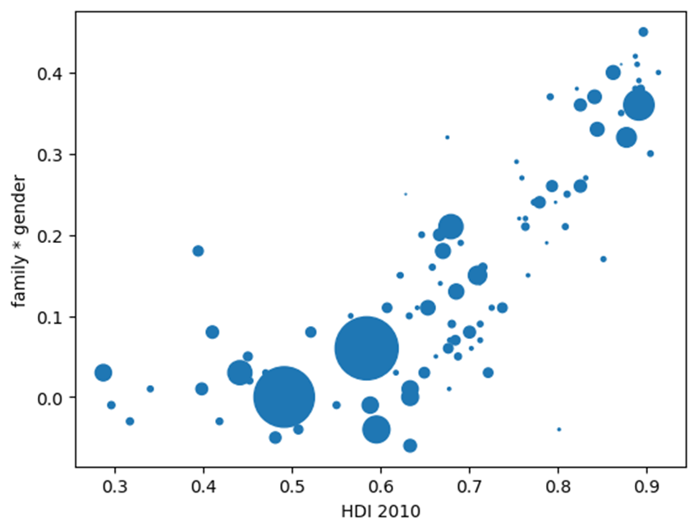

Graph 1. The correlation between modern family values and gender equality according to the level of human development in each country

**4.2.2. Second model: predicting the correlation between family values and religiosity**

The model explains 73% of the variation in the correlation between modern family values and religiosity among countries. The fact that the intercept is positive and statistically significant (b0 = 0.13, p < .001) indicates that in countries that are non-Western, economically poor and governed by undemocratic regimes, the correlation between modern family values and religiosity tends to be weak and positive.

The regression coefficients for the predictors are statistically significant and negative, except the variable about authoritarian socialist regimes, which is not a significant predictor. In Western countries (b2 = -0.1, p < .01), economically developed countries (b = -0.33, p < 001), and liberal democratic countries (b = -0.18, p < .001) non-religious individuals are more likely to consider homosexuality, divorce, and abortion morally acceptable.

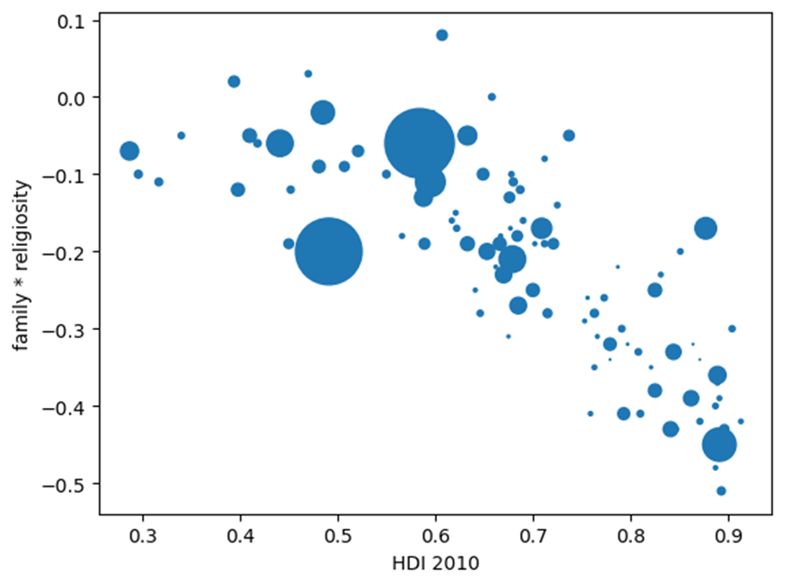

Graph 2. The human development index and the correlation between modern family values and religiosity

**4.2.3. Third model: predicting the correlation between family values and ethnic attitudes**

59% of the variation in the correlation between modern family values and open attitudes toward immigration and ethnic minorities is explained by the predictors. The intercept is negative and significant, suggesting that in a hypothetical country where all predictors would take the value 0, individuals who are more accepting of homosexuality, divorce and abortion would have more closed and xenophobic attitudes toward immigrants and ethnic minorities. Among the predictors, only the human development index is statistically significant (b3 = 0.46, p < .001). In developed countries, people who adopt modern family values are also more likely to have a tolerant stance toward immigrants and ethnic minorities.

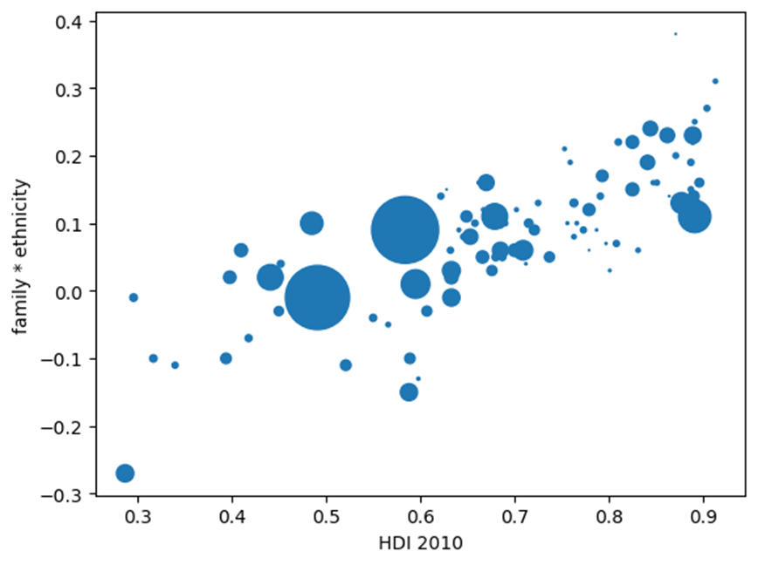

Graph 3. The correlation between modern family values and open attitudes toward immigrants and ethnic minorities according to the level of human development in each country

**4.2.4. Fourth model: predicting the correlation between individual freedom and family values**

The model explains 63% of the correlation between attitudes supportive of individual freedom and modern family values. The intercept is not statistically significant, which indicates that in a hypothetical country where all predictors would take the value 0, the value of the dependent variable would not be significantly different from 0 either. Among the predictors, the culture zone and the level of human development are statistically significant while authoritarian socialism and the liberal democracy index are not. The correlation between attitudes supportive of individual freedom and modern family values is strong and positive in countries that are Western (b2 = 0.11, p < .01) and or highly developed economically (b3 = 0.31, p < .001). The human development index is the strongest predictor.

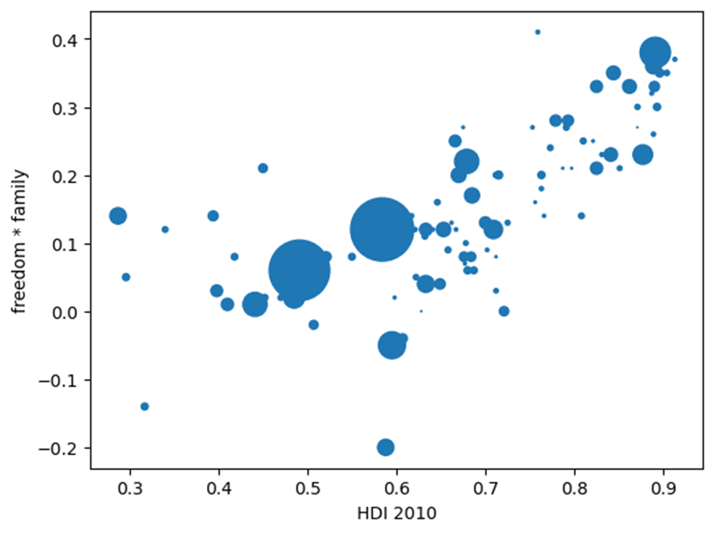

Graph 4. Human development index and the correlation between attitudes toward individual freedom and modern family values

**4.2.5. Fifth model: predicting the correlation between gender equality and individual freedom**

Half of the variation in the correlation between attitudes toward gender equality respectively individual freedom is explained by the four predictors of the model, among which two are statistically significant. The intercept does not reach statical significance, meaning that in a country that is non-Western (culture zone = 0) and extremely poor (HDI = 0), the correlation between equalitarian attitudes regarding gender roles and support for liberal democracy would be close to 0. The culture zone (b2 = 0.11, p < .01) and the level of economic development (b3 = 0.31, p < .001) are statistically significant predictors. The correlation between attitudes supportive of gender equality respectively attitudes supportive of individual freedom is stronger in countries that are economically developed and culturally Western.

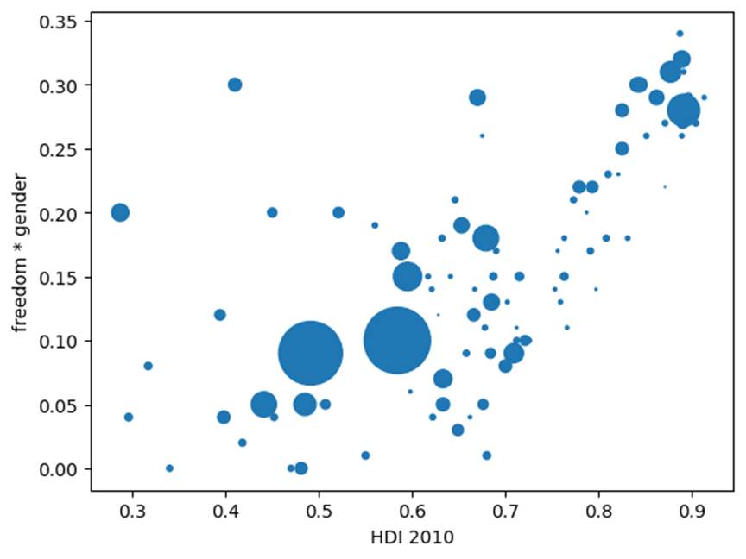

Graph 5. Human development index and the correlation between support for individual freedom and support for gender equality

**5. Conclusion**

The results of the current study highlight both common features of political spectrums found in many countries and characteristics that distinguish some groups of countries from another. While in most countries, individual freedom, gender equality, modern family values and tolerant attitudes toward immigrants correlate together, such correlations are stronger in more economically developed countries. Such findings indicate that common psychological processes interact with the societal environment in the formation of political attitudes. Developed countries provide a better environment for the formation of stable and coherent political orientations due to the greater availability of both formal education and access to political information. The results provide evidence in support of the perspective that economic and social attitudes are distinct dimensions of political orientation. In many countries, socialist attitudes are uncorrelated with progressive social attitudes (gender equality, ethnic minority rights, LGBT rights), while in others (especially in former communist countries) they are even negatively correlated. Moreover, the country-level regressions indicate that the relationship between economically left-wing orientations and culturally progressive orientations is unlikely to increase as a consequence of economic development.

Future research can follow several lines in order to extend and improve the current study. Other politicized issues that were not included in the current study can be added, including environmental issues, attitudes related to science and technology, as well as foreign policy views. Psychological constructs like personality traits and cognitive styles, proposed as causes of political orientation can be added to statistical models predicting the diverse array of political orientations studies as part of the current project instead of just the “left-right” dimension or social conservatism and economic conservatism as has been the custom in previous studies. More precise indices of past government policies toward economic redistribution, state intervention in the economy, and civil liberties can be used to replace the variable about authoritarian socialist regimes employed in the current study.

**References**

Brandt, M. J., & Reyna, C. (2010). The role of prejudice and the need for closure in religious fundamentalism. *Personality and Social Psychology Bulletin*, *36*(5), 715-725.

Coppedge, Michael, John Gerring, Carl Henrik Knutsen, Staffan I. Lindberg, Jan Teorell, David Altman, Michael Bernhard, Agnes Cornell, M. Steven Fish, Lisa Gastaldi, Haakon Gjerløw, Adam Glynn, Ana Good God, Sandra Grahn, Allen Hicken, Katrin Kinzelbach, Joshua Krusell, Kyle L. Marquardt, Kelly McMann, Valeriya Mechkova, Juraj Medzihorsky, Natalia Natsika, Anja Neundorf, Pamela Paxton, Daniel Pemstein, Josefine Pernes, Oskar Rydén, Johannes von Römer, Brigitte Seim, Rachel Sigman, Svend-Erik Skaaning, Jeffrey Staton, Aksel Sundström, Eitan Tzelgov, Yi-ting Wang, Tore Wig, Steven Wilson and Daniel Ziblatt. 2023. "V-Dem [Country-Year/Country-Date] Dataset v13" Varieties of Democracy (V-Dem) Project. <https://doi.org/10.23696/vdemds23>.

Costello, T. H., Bowes, S. M., Baldwin, M. W., Malka, A., & Tasimi, A. (2022). Revisiting the rigidity-of-the-right hypothesis: A meta-analytic review. Journal of Personality and Social Psychology.

Costello, T. H., & Lilienfeld, S. O. (2021). Social and economic political ideology consistently operate as mutual suppressors: Implications for personality, social, and political psychology. *Social Psychological and Personality Science*, *12*(8), 1425-1436.

Conway III, L. G., Houck, S. C., Gornick, L. J., & Repke, M. A. (2018). Finding the Loch Ness monster: Left‐wing authoritarianism in the United States. *Political Psychology*, *39*(5), 1049-1067.

Conway III, L. G., McFarland, J. D., Costello, T. H., & Lilienfeld, S. O. (2021). The curious case of left‐wing authoritarianism: When authoritarian persons meet anti‐authoritarian norms. *Journal of theoretical social psychology*, *5*(4), 423-442.

Crawford, J. T., & Pilanski, J. M. (2014). Political intolerance, right and left. *Political Psychology*, *35*(6), 841-851.

Dawes, C. T., & Weinschenk, A. C. (2020). On the genetic basis of political orientation. *Current opinion in behavioral sciences*, *34*, 173-178.

De Keersmaecker, J., Bostyn, D. H., Van Hiel, A., & Roets, A. (2021). Disliked but free to speak: Cognitive ability is related to supporting freedom of speech for groups across the ideological spectrum. *Social Psychological and Personality Science*, *12*(1), 34-41.

De Regt, S., Mortelmans, D., & Smits, T. (2011). Left-wing authoritarianism is not a myth, but a worrisome reality. Evidence from 13 Eastern European countries. *Communist and Post-Communist Studies*, *44*(4), 299-308.

Dhont, K., & Hodson, G. (2014). Does lower cognitive ability predict greater prejudice?. *Current Directions in Psychological Science*, *23*(6), 454-459.

Drieghe, L., Roets, A., Van Hiel, A., & Bostyn, D. (2022). Support for freedom of speech and concern for political correctness: The effects of trait emotional intelligence and cognitive ability. *Journal of Individual Differences*.

EVS (2022): EVS Trend File 1981-2017. GESIS Data Archive, Cologne. ZA7503 Data file Version 3.0.0, doi:10.4232/1.14021

Feldman, S., & Johnston, C. (2014). Understanding the determinants of political ideology: Implications of structural complexity. *Political Psychology*, *35*(3), 337-358.

Fiorina, M. P., & Abrams, S. J. (2008). Political polarization in the American public. *Annu. Rev. Polit. Sci.*, *11*, 563-588.

Fowler, J. H., & Dawes, C. T. (2013). In defense of genopolitics. *American Political Science Review*, *107*(2), 362-374.

Friedman, J. (2022). *Ripe for Revolution: Building Socialism in the Third World.* Harvard University Press.

Furnham, A., & Fenton-O'Creevy, M. (2018). Personality and political orientation. *Personality and Individual Differences*, *129*, 88-91.

Hatemi, P. K., Medland, S. E., Klemmensen, R., Oskarsson, S., Littvay, L., Dawes, C. T., ... & Martin, N. G. (2014). Genetic influences on political ideologies: Twin analyses of 19 measures of political ideologies from five democracies and genome-wide findings from three populations. *Behavior genetics*, *44*, 282-294.

Haerpfer, C., Inglehart, R., Moreno, A., Welzel, C., Kizilova, K., Diez-Medrano J., M. Lagos, P. Norris, E. Ponarin & B. Puranen et al. (eds.). 2022. World Values Survey Trend File (1981-2022) Cross-National Data-Set. Madrid, Spain  &  Vienna,  Austria:  JD  Systems  Institute  &  WVSA Secretariat. Data File Version 3.0.0, [doi:10.14281/18241.23](https://doi.org/10.14281/18241.23).

Hodson, G., & Busseri, M. A. (2012). Bright minds and dark attitudes: Lower cognitive ability predicts greater prejudice through right-wing ideology and low intergroup contact. *Psychological science*, *23*(2), 187-195.

Hill, J. L. (2001). An extension and test of Converse’s “black-and-white” model of response stability. *American Political Science Review*, *95*(2), 397-413.

Johnston, C. D., Lavine, H. G., & Federico, C. M. (2017). *Open versus closed: Personality, identity, and the politics of redistribution*. Cambridge University Press.

Jost, J. T., Nam, H. H., Amodio, D. M., & Van Bavel, J. J. (2014). Political neuroscience: The beginning of a beautiful friendship. *Political Psychology*, *35*, 3-42.

Jost, J. T. (2017). Ideological asymmetries and the essence of political psychology. *Political psychology*, *38*(2), 167-208.

Onraet, E., Van Hiel, A., Dhont, K., Hodson, G., Schittekatte, M., & De Pauw, S. (2015). The association of cognitive ability with right–wing ideological attitudes and prejudice: A meta–analytic review. European Journal of Personality, 29(6), 599-621.

Saribay, S. A., & Yilmaz, O. (2017). Analytic cognitive style and cognitive ability differentially predict religiosity and social conservatism. *Personality and Individual Differences*, *114*, 24-29.

Staffan I. Lindberg, Nils Düpont, Masaaki Higashijima, Yaman Berker Kavasoglu, Kyle L. Marquardt, Michael Bernhard, Holger Döring, Allen Hicken, Melis Laebens, Juraj Medzihorsky, Anja Neundorf, Ora John Reuter, Saskia Ruth–Lovell, Keith R. Weghorst, Nina Wiesehomeier, Joseph Wright, Nazifa Alizada, Paul Bederke, Lisa Gastaldi, Sandra Grahn, Garry Hindle, Nina Ilchenko, Johannes von Römer, Steven Wilson, Daniel Pemstein, and Brigitte Seim. 2022. “Codebook Varieties of Party Identity and Organization (V–Party) V2”. Varieties of Democracy (V–Dem) Project. <https://doi.org/10.23696/vpartydsv2>

Thorisdottir, H., Jost, J. T., Liviatan, I., & Shrout, P. E. (2007). Psychological needs and values underlying left-right political orientation: Cross-national evidence from Eastern and Western Europe. *Public Opinion Quarterly*, *71*(2), 175-203.

Lewis, G. J., & Bates, T. C. (2018). Higher levels of childhood intelligence predict increased support for economic conservatism in adulthood. *Intelligence*, *70*, 36-41.

Malka, A., Lelkes, Y., & Soto, C. J. (2019). Are cultural and economic conservatism positively correlated? A large-scale cross-national test. *British Journal of Political Science*, *49*(3), 1045-1069.

Manson, J. H. (2020). Right-wing authoritarianism, left-wing authoritarianism, and pandemic-mitigation authoritarianism. *Personality and individual differences*, *167*, 110251.

Martin, J. L. (2001). The authoritarian personality, 50 years later: What questions are there for political psychology?. *Political Psychology*, *22*(1), 1-26.

McKibbin, R. (2010). *Parties and People: England 1914-1951*. OUP Oxford.

Oesterreich, D. (2005). Flight into security: A new approach and measure of the authoritarian personality. *Political Psychology*, *26*(2), 275-298.

Pan, J., & Xu, Y. (2018). China’s ideological spectrum. *The Journal of Politics*, *80*(1), 254-273.

Pemstein, Daniel, Kyle L. Marquardt, Eitan Tzelgov, Yi-ting Wang, Juraj Medzihorsky, Joshua Krusell, Farhad Miri, and Johannes von Römer. 2023. “The V-Dem Measurement Model: Latent Variable Analysis for Cross-National and Cross-Temporal Expert-Coded Data”. V-Dem Working Paper No. 21. 8th edition. University of Gothenburg: Varieties of Democracy Institute.

Sturgis, P., & Smith, P. (2010). Fictitious issues revisited: Political interest, knowledge and the generation of nonattitudes. *Political Studies*, *58*(1), 66-84.

Xu, X., Soto, C. J., & Plaks, J. E. (2021). Beyond openness to experience and conscientiousness: Testing links between lower‐level personality traits and american political orientation. *Journal of personality*, *89*(4), 754-773.

Zmigrod, L., & Tsakiris, M. (2021). Computational and neurocognitive approaches to the political brain: Key insights and future avenues for political neuroscience. *Philosophical Transactions of the Royal Society B*, *376*(1822), 20200130.