Exercise 4

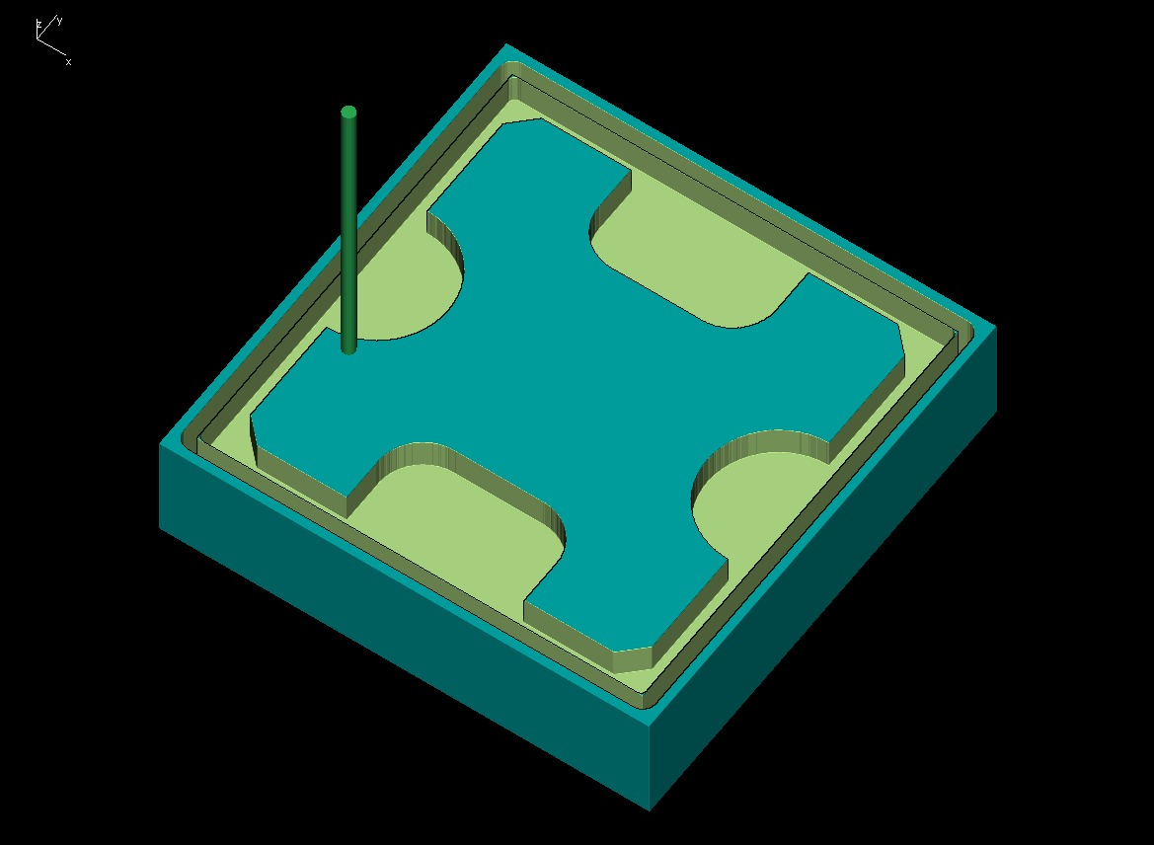

NAME: TANABAI RAJPUT USN:2GI20ME076
SIGN:

EXERCISE 5
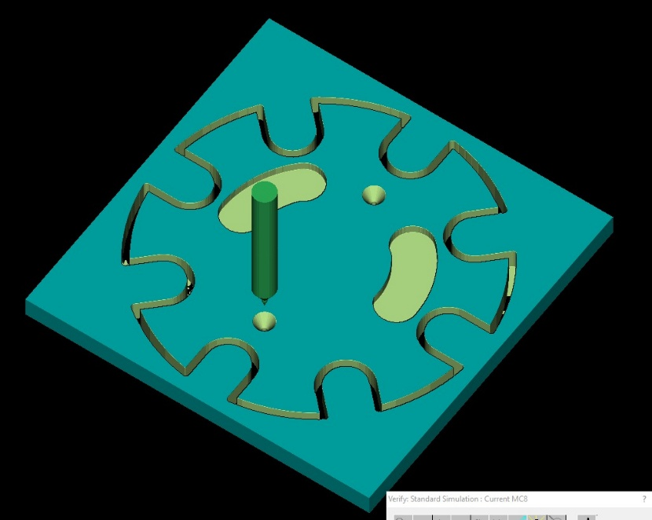

NAME: TANABAI RAJPUT USN:2GI20ME076
SIGN:

Exersise 6
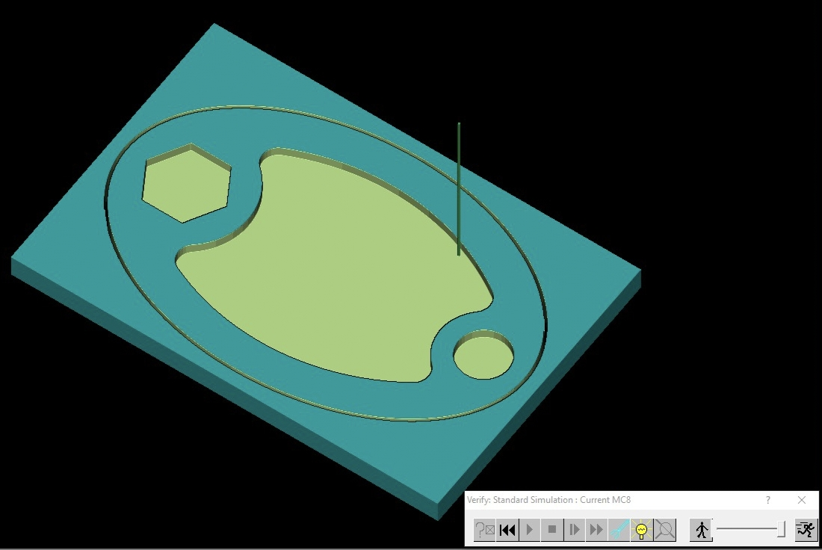

NAME: TANABAI RAJPUT USN:2GI20ME076
SIGN:

OPEN ENDED EXPERIMENT
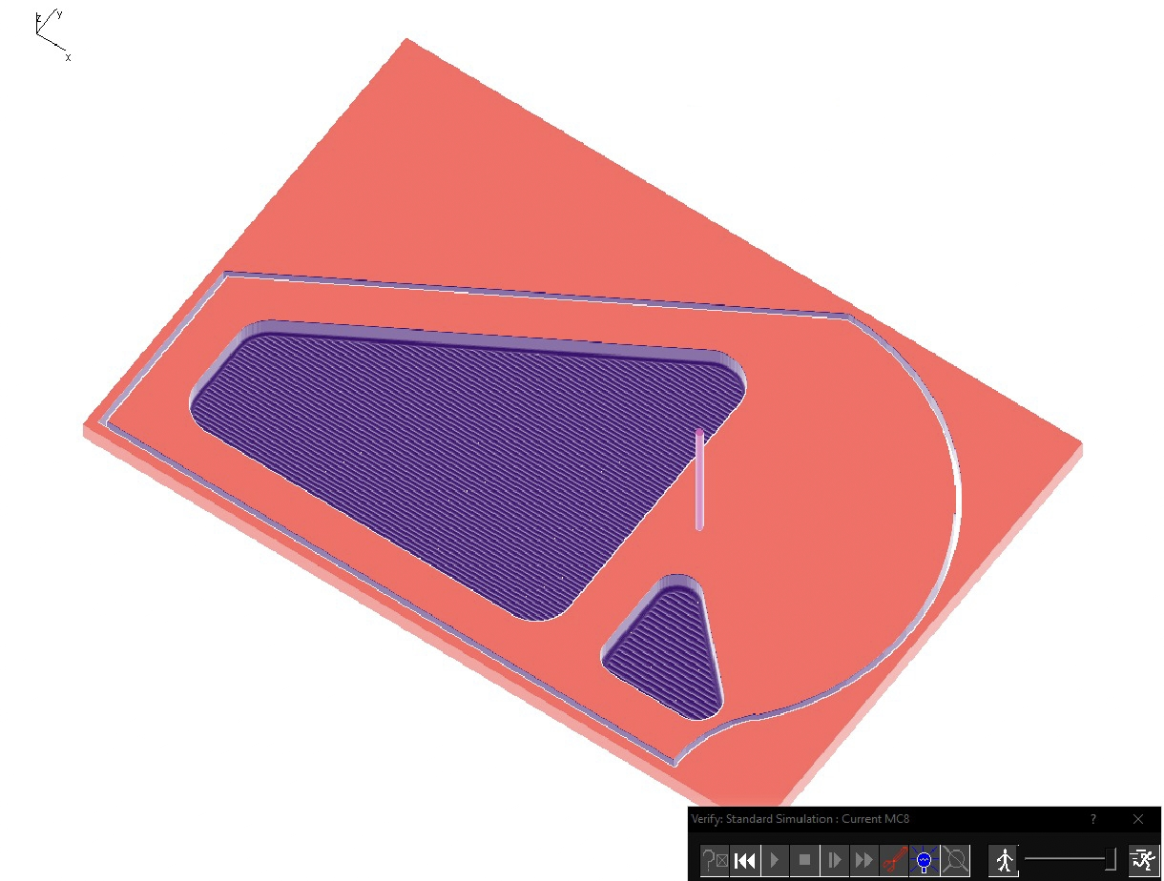

NAME: TANABAI RAJPUT USN:2GI20ME0
SIGN:

