**Appendix D**

**Software Requirement Specifications**

\

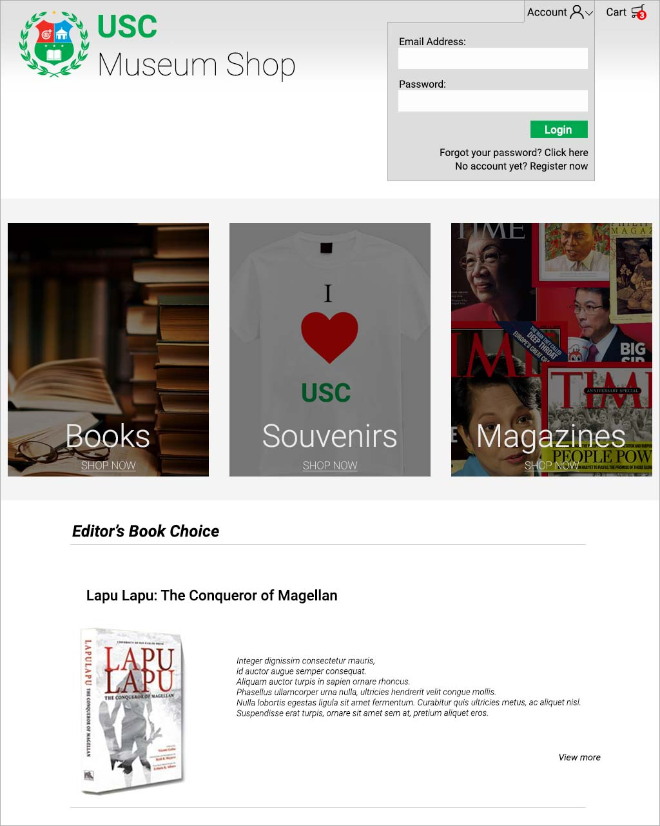

1

2

3

4

5

6

7

8

9

10

11

**Landing Page(Guest)**

1. **Cart Redirect –** It redirects the user to the cart page
2. **Email Address Textfield –** It lets the user input their email address
3. **Password Textfield –** It lets the user input their password
4. **Login Button –** Confirms the login details inputted by the user
5. **Forgot Password –** It redirects the user to forgot password page
6. **Register –** It redirects the user to register page
7. **Magazines Redirect –** It redirects the user to magazines category page
8. **Souvenirs Redirect –** It redirects the user to souvenirs category page
9. **Books Redirect –** It redirects the user to book page
10. **Editor’s Choice –** It shows the recommended book
11. **Editor’s Choice Read More –** It redirects the user to the book’s page

12

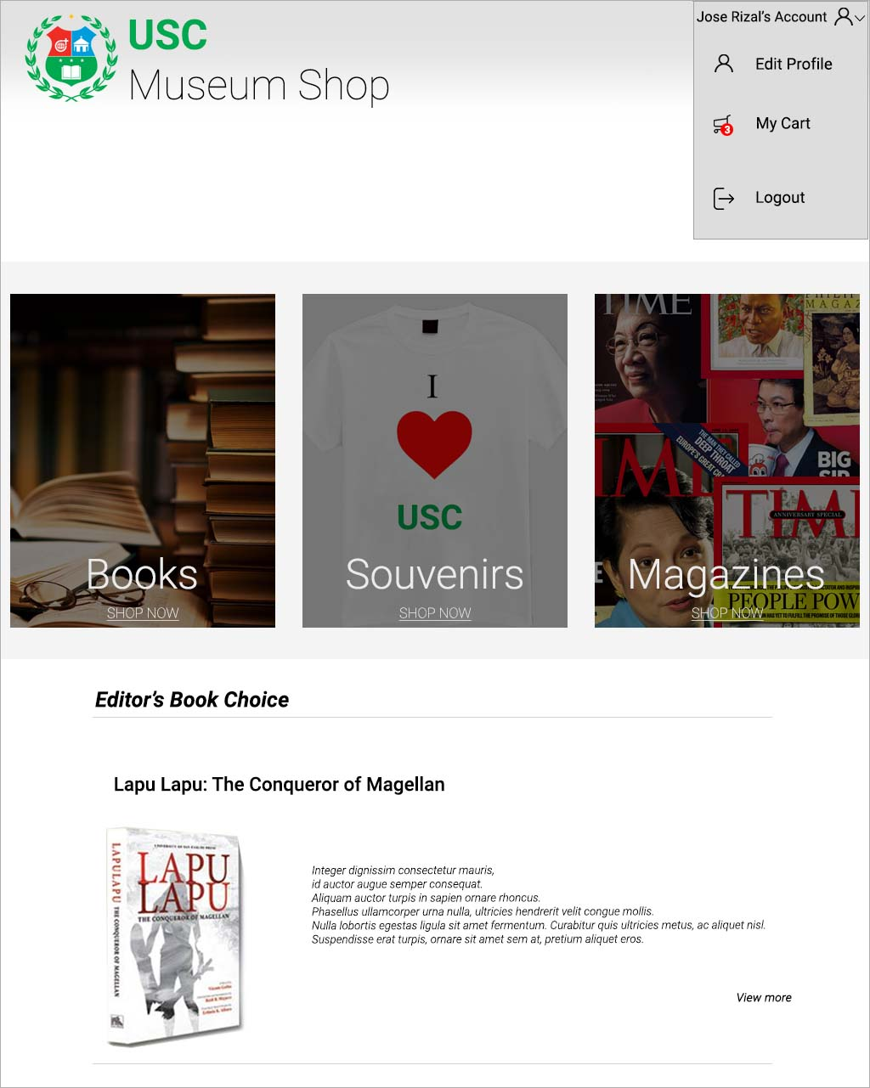

13

14

**Landing Page(User)**

1. **Edit Profile –** It redirects the user to the edit profile page
2. **My Cart –** It redirects the user to the cart page
3. **Logout –** It logs the user out of their account

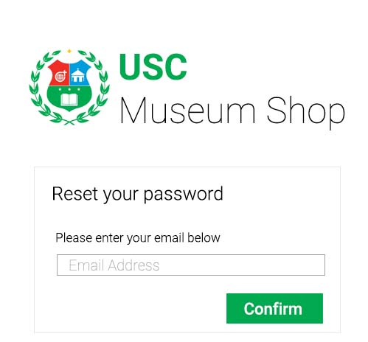

5.1

5.2

**Forgot Password**

**5.1. Email Address Textfield –** It lets the user input their email

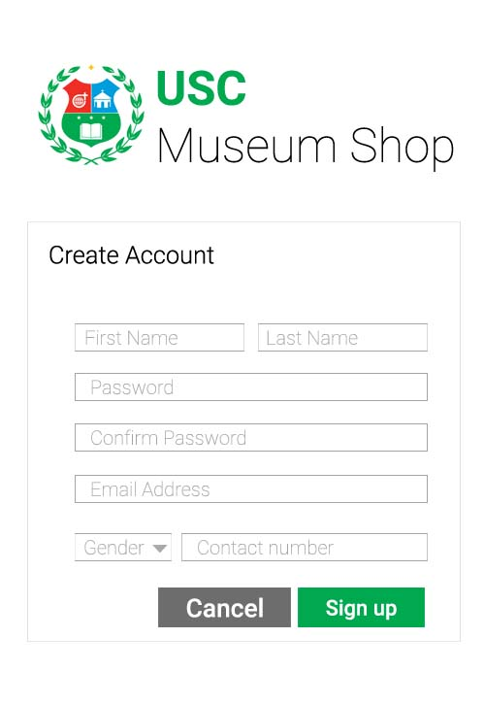**5.2. Confirm Button –** A button for the user to confirm their action on password reset.

6.1

6.2

6.3

6.4

6.5

6.6

6.7

6.9

6.8

**Create Account**

**6.1. First Name Textfield –** It lets the user input their first name

**6.2. Last Name Textfield –** It lets the user input their last name

**6.3. Password Textfield –** It lets the user input their password

**6.4. Confirm Password Textfield –** It lets the user reinput their password

**6.5. Email Address Textfield –** It lets the user input their email address

**6.6. Gender Dropdown –** It lets the user choose between Male/Female

**6.7. Contact Number Textfield –** It lets the user input their contact number

**6.8. Sign up button Textfield –** It submits the user’s inputted information.

**6.9. Cancel button Textfield –** It redirects the user to the landing page.

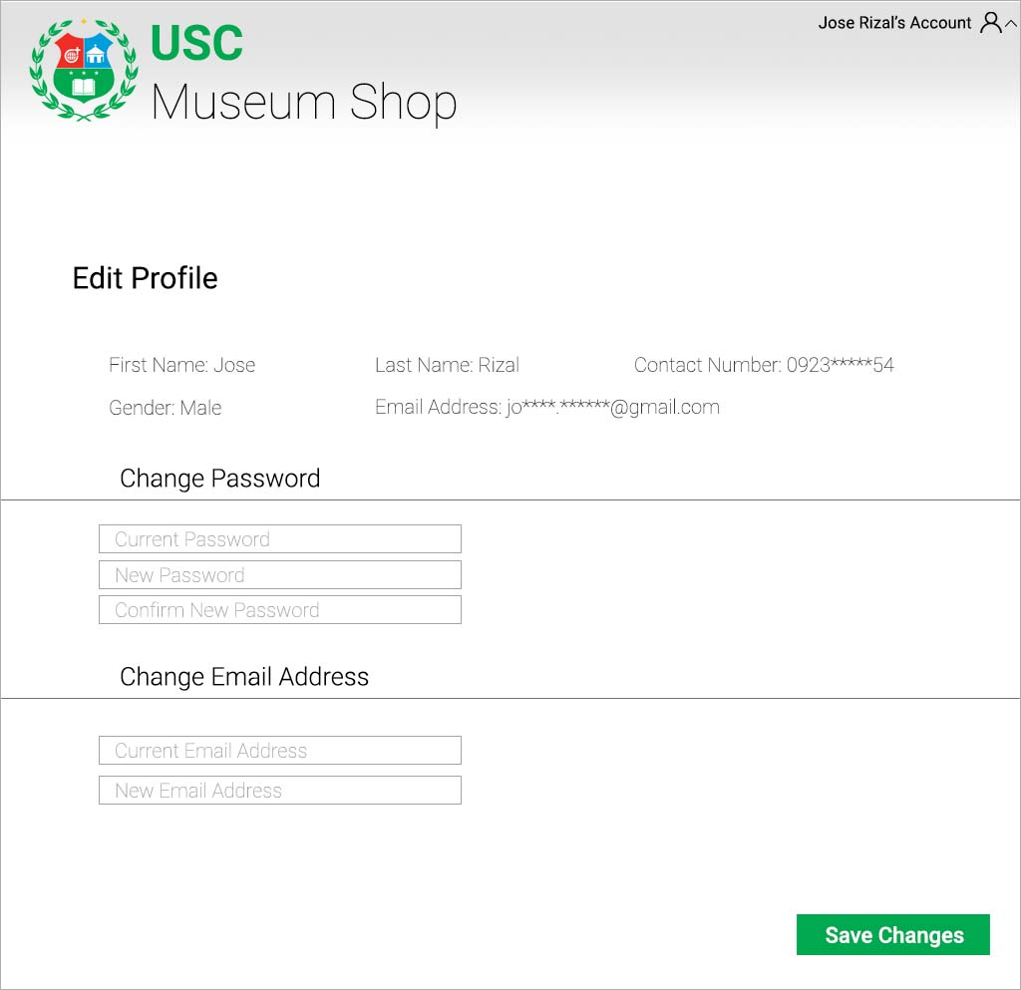

12.1

12.2

12.3

12.4

12.5

12.6

12.7

**Edit Profile**

**12.1. Current User’s Information –** It shows the user their information

**12.2. Current Password Textfield –** It lets the user input their current password

**12.3. New Password Textfield –** It lets the user input their desired password

**12.4. Confirm New Password Textfield –** It lets the user reinput their desired password

**12.5. Current Email Address Textfield –** It lets the user input their email address

**12.6. New Email Address Textfield –** It lets the user input their new email address

**12.7. Save Changes Button –** It lets the user confirm their changes.

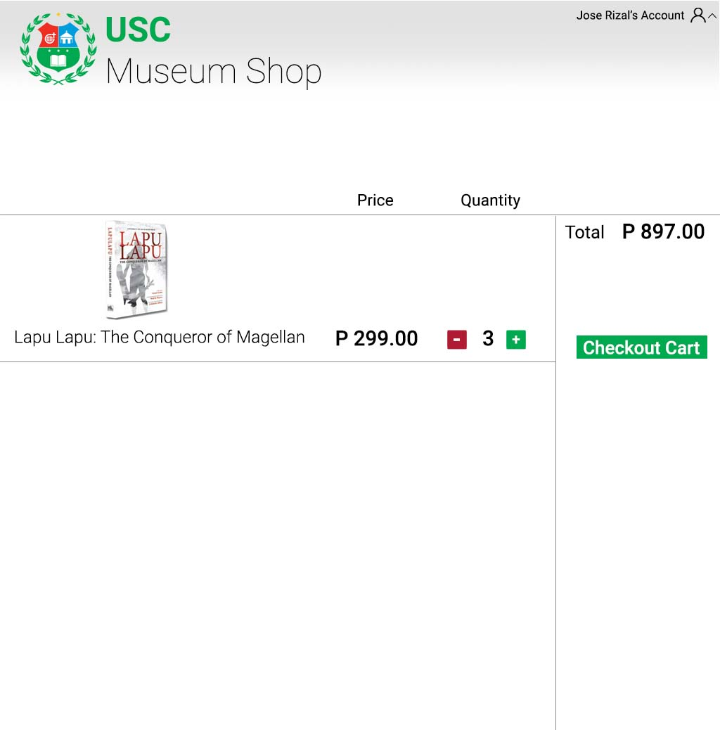

1.1

1.2

1.3

1.4

1.5

**Cart**

* 1. **Show Product –** It shows the name and picture of the product
  2. **Product Price –** It shows the current price of the product
  3. **Quantity in cart –** It shows the quantity of the product in the cart
  4. **Total Price –** It shows the total price inside the cart
  5. **Checkout Cart –** It lets the user confirm their order

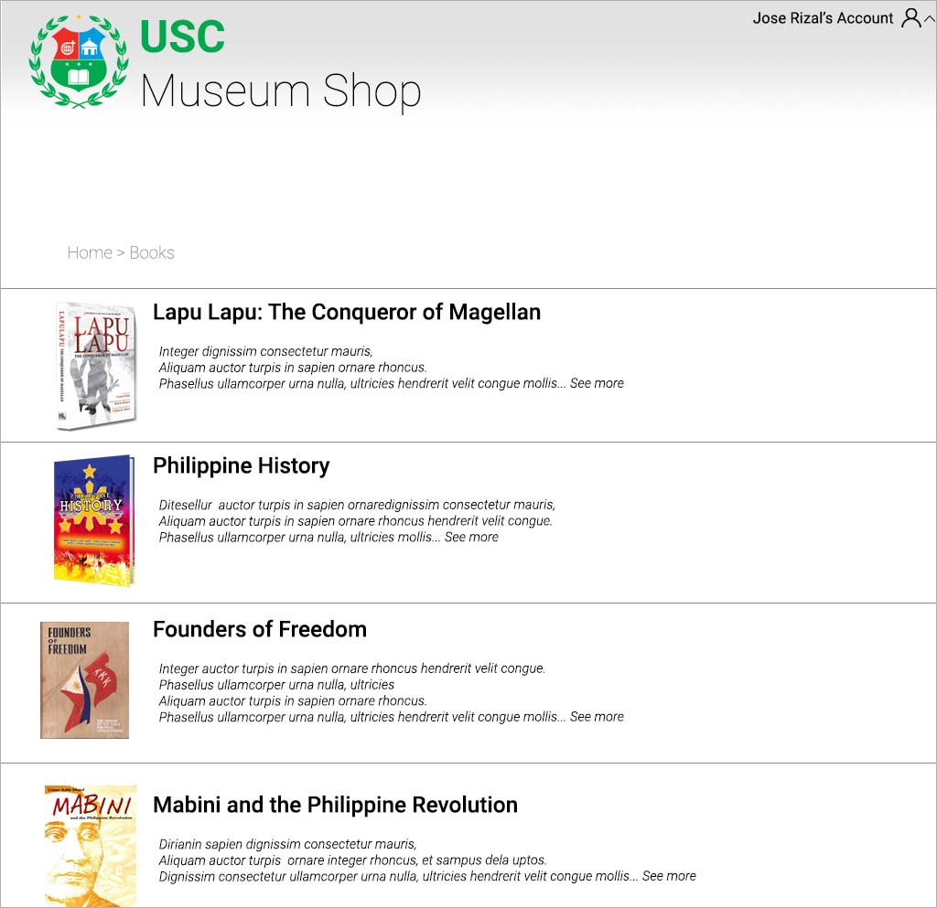**Book Category**

9.2

9.1

**9.1. Directory –** It shows the user their current directory

**9.2. Book Information –** It displays a brief information of the book. It also redirects the user to the book’s full information when clicked.

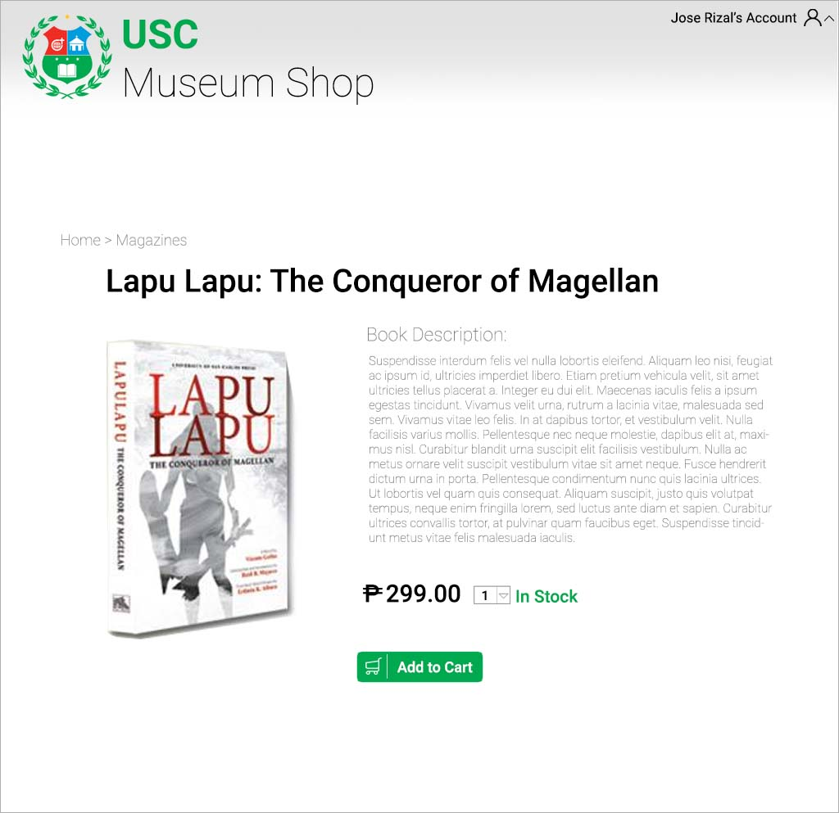

11.1.1

11.1.2

11.1.3

11.1.4

11.1.5

**Books Page(User/Guest)**

**11.1.1. Book Description –** It displays the full description of the book

**11.1.2. Product Price –** It displays the product’s current price

**11.1.3. Order Quantity –** It lets the user decide the quantity they will purchase

**11.1.4. Stock Indicator –** It displays if the product is still in stock

**11.1.5. Add to Cart –** It adds the product to the cart along with the quantity

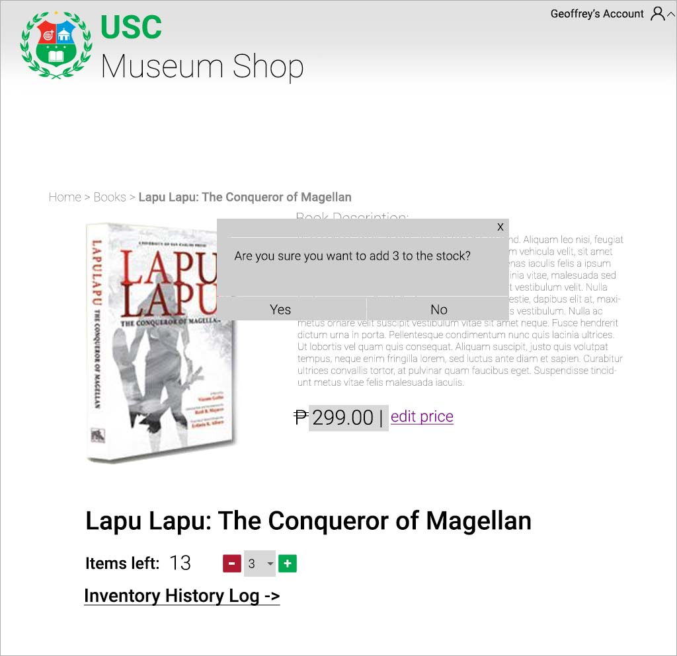**Books Page(Admin)**

11.2.5

11.2.4

11.2.3

11.2.2

11.2.1

**11.2.1. Confirmation Box –** It lets the admin confirm their action.

**11.2.2. Product Price Edit –** It lets the admin edit the price of the product

**11.2.3. Stocks Left –** It displays the exact number of items left in the inventory

**11.2.4. Inventory Edit –** It lets the admin add or deduct the stock manually

**11.2.5. Inventory History Log –** It redirects the admin to the product’s inventory log

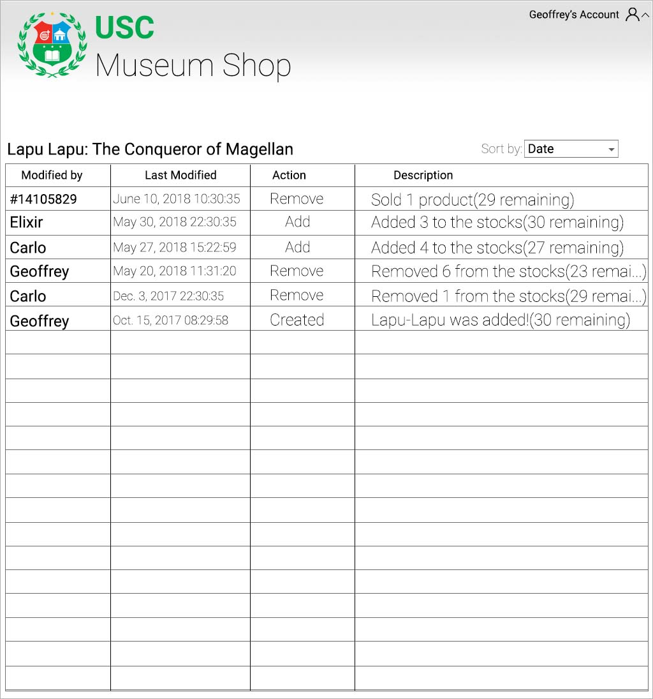

17

19

18

16

15

**Inventory History Logger(Book)**

**15. Sorter –** Sorts the inventory by user, date modified or action, quantity.

**16. Description box –** It displays details of the action done to the product.

**17. Action box –** It displays what was done to the product.

**18. Date Modified box –** It displays the date and timestamp of when the action was done.

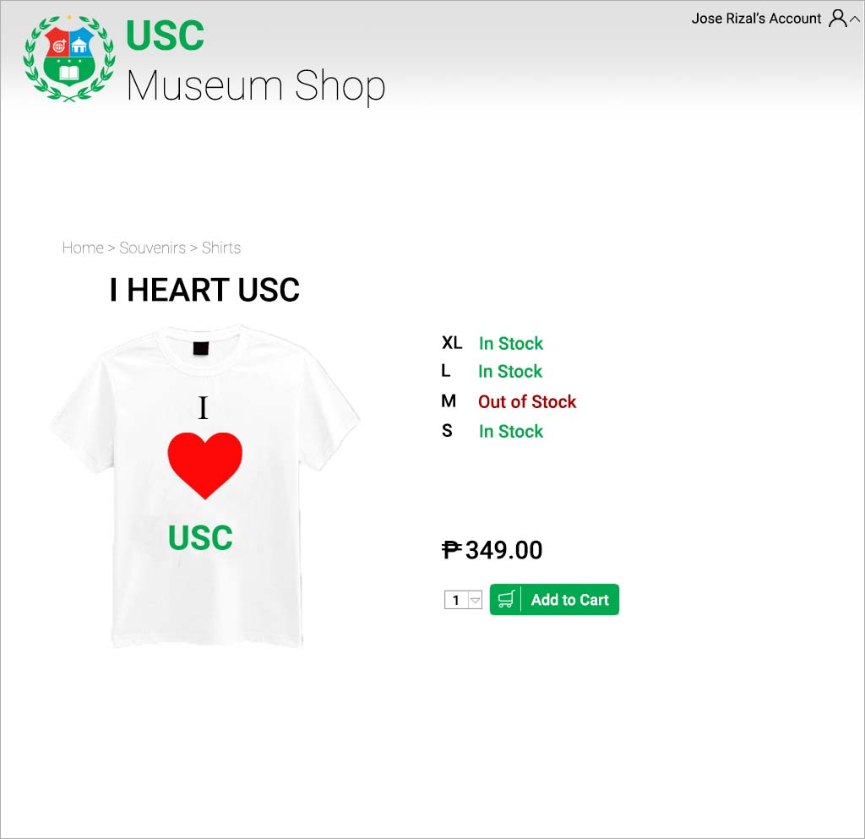**19. Modified by box –** It displays ID number or the name of the user who modified the product.

23

22

21

20

**Shirts Page(User/Guest)**

**20. Stock Indicator –** It displays if the product is still in stock

**21. Product Price –** It displays the product’s current price

**22. Order Quantity –** It lets the user decide the quantity they will purchase

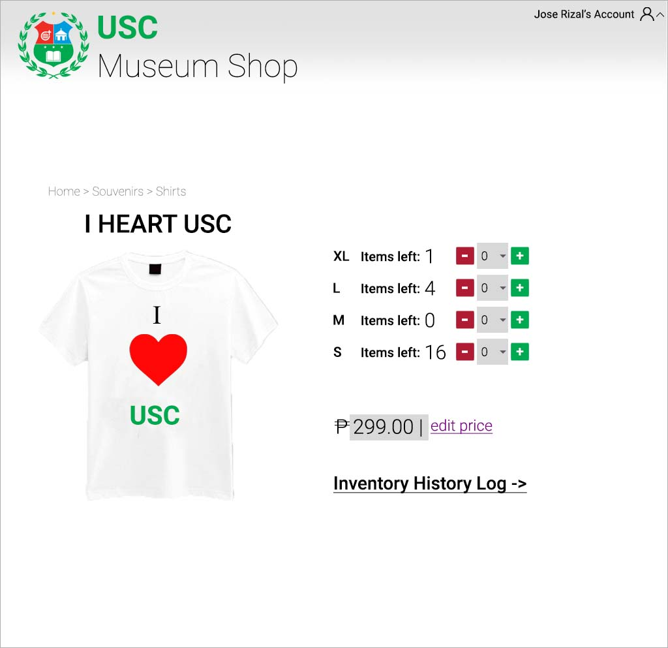**23. Add to Cart –** It adds the product to the cart along with the quantity

27

267

25

24

**Shirts Page(Admin)**

**24. Stocks Left –** It displays the exact number of items left in the inventory

**25. Inventory Edit –** It lets the admin add or deduct the stock manually

**26. Product Price Edit –** It lets the admin edit the price of the product

**27. Inventory History Log –** It redirects the admin to the product’s inventory log

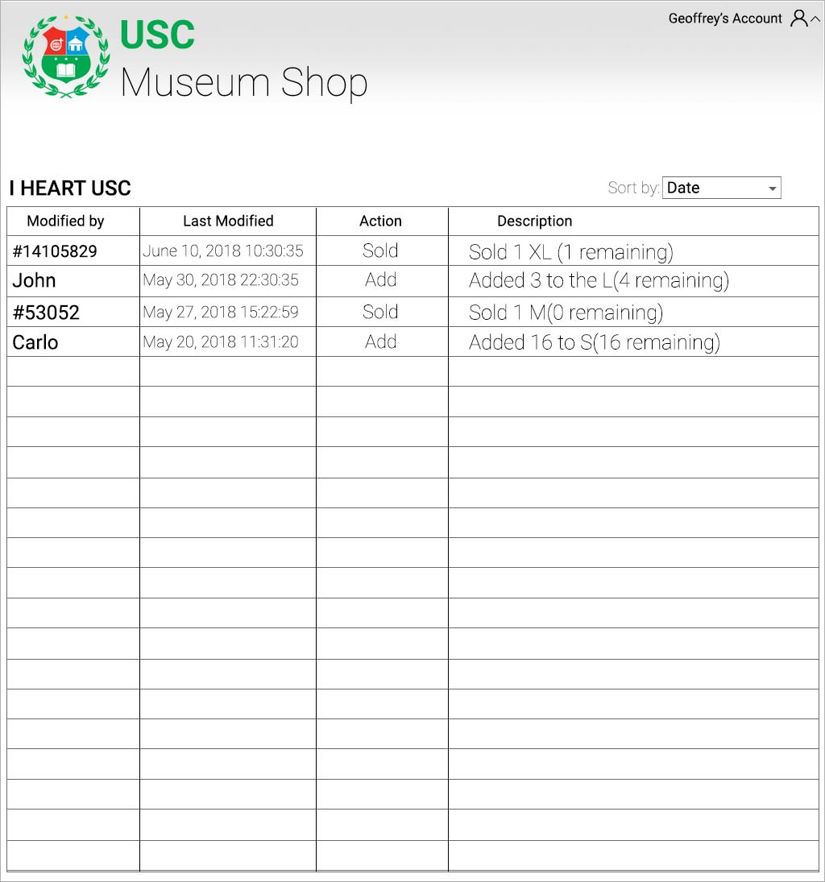

30

32

31

29

28

**Inventory History Logger(Book)**

**28. Sorter –** Sorts the inventory by user, date modified or action, quantity.

**29. Description box –** It displays details of the action done to the product.

**30. Action box –** It displays what was done to the product.

**31. Date Modified box –** It displays the date and timestamp of when the action was done.

**32. Modified by box –** It displays ID number or the name of the user who modified the product.