Varun Koundal
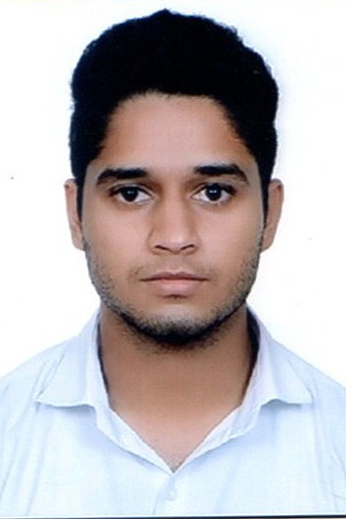
A T-53, Shukar Bazar, Uttam Nagar, New Delhi – 110059, India | +91-8800166903 | varunkoundal24@yahoo.com
_____________________________________________________________________________________________ Career Objective I aspire for a challenging position in a professional Organization where I can enhance my skills and strengthen them in conjunction with Organization’s goals. A self motivated achiever with an ability to plan and execute.
Educational Credentials
B.-Tech Computer Science Engineering 2017 Manav Rachna University, Faridabad 70.5%
Class 12, 2013 Kendriya Vidhyalaya Gole Market, New Delhi CBSE Board 76%
Class 10, 2011 Kendriya Vidhyalaya Gole Market, New Delhi CBSE Board 8.0
Technical Skills
- Languages known: Java, C++, C, HTML5, CSS3, JavaScript
- Operating system : Windows , Ubuntu
- Technologies and Tools Known: NetBeans, Turbo C++, Cisco Packet Tracer, Eclipse IDE, Adobe Photoshop.
- Databases: Oracle SQL.
- Adequate knowledge of software development cycle models, well versed with various MS office tools

Professional Experience
- Freelancer
Android Application Developer, Web Designer

Projects
- Apollo Connect
Description: An android application also available on Google Play Store for Customer Support which allow the residents of Apollo Builder Society to fill complaint against any issue in their apartment. An admin app was also developed to handle these issues. Link: https://play.google.com/store/apps/details?id=app.apollobuilders.com.apollobuilders&hl=en

- Quikstreamer
Description: An android application to do group video calling and broadcasting their video. Users can see other Public Broadcasts also and can join them to be the part of the interaction.

- Last Mile
Description: An ultimate security Android application which keeps track of the passenger and automatically alerts emergency contacts in case of danger. This project received 2nd prize in project carnival held at Manav Rachna Campus.

- Exam Android Application
Description: An Android Application developed for trainees of Enecosystems pvt Ltd who can take online test on their Android devices and also there is hidden Admin panel through which the admin can view result of every candidate with their details, Add or modify questions and products Languages Used: PHP and Android..
Link: http://www.enecosystems.com/ExamConduct/Exam.apk

- Uddaan
Description: Developing a website to help NGO’s to get donations. From this website the user can donate and can also inform NGO’s that where he had seen the poor people, So that the NGO can help them.
Link: www.uddaan.in

- Eneco Systems (Sukam)
Description: Developing a website for “Center For Smart Solar Energy” Lab in MRU. This lab is formed by the joint initiative of MRU and Sukam to make solar appliances more efficient and Smart. Link: www.enecosystems.com

- My Pc Fixers
Description: A website for USA based company for assistance on computer consultancy.
Link: www.mypcfixers.com

- Candidate Management Website
Description: Weblinks through which the Candidates of Enecosystems Pvt Ltd can register themselves online with their details including their photograph, admin can view candidate details and can download them in Excel format or print them in a particular layout. Languages used : PHP and HTML, CSS, JavaScript.

Technical Training
- Summer Training on working with C language at MRU (formerly MRCE) from 11th June 2014 to 21st June 2014.
- Summer Training on working with C++ language at MRU (formerly MRCE) from 8th June 2015 to 1st July 2015.
- Summer Training on Android App development for Solar Appliance at Sukam (Center for Smart Solar Energy) at MRU (formerly MRCE) from 24th June 2016 to 19th July 2016.

Achievements and Commendations
- Won 2nd prize in project carnival held at Manav Rachna International University.
- Secured 1402 Rank in TCS CodeVita V.
- Second runners up in Football Tournament in National Level competition held in IMS Ghaziabad.
- Secured First Position in inter college Football Tournament.

Extra-Curricular Activities
- An active member of Center for Smart Solar Energy.
- Participated in various Cultural Events.

Personal Dossier
Date of birth: 13-10-1995
Areas of interest: Football, Drawing
Linguistic Competencies: Fluency in English & Hindi.

