

**Comsats university Islamabad, Lahore Campus**

**Semester project**

**Theory Assignmnet#4**

**Group members :3**

**Member 1: Hiba Akram**

**Roll number:sp24-bse-043**

**Member2: Mehrunisa Rafique**

**Roll number:SP24-BSE-135**

**Member3:Saba Ahmad**

**Roll number:SP-24-BSE-136**

**Assign date: 06-12-2024**

**Due date:20-12-2024**

**Submitted to: Sir Shahad Bhatti**

**Landing page:** 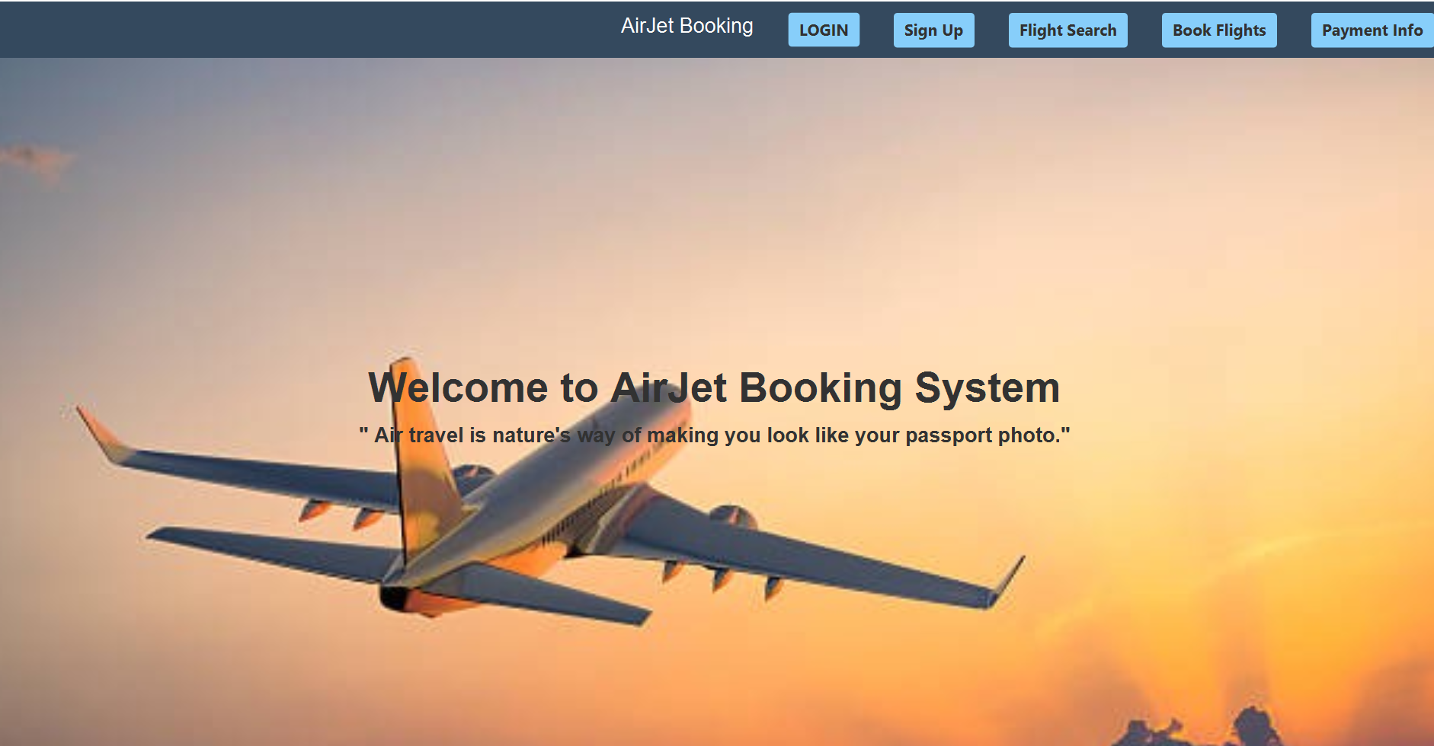

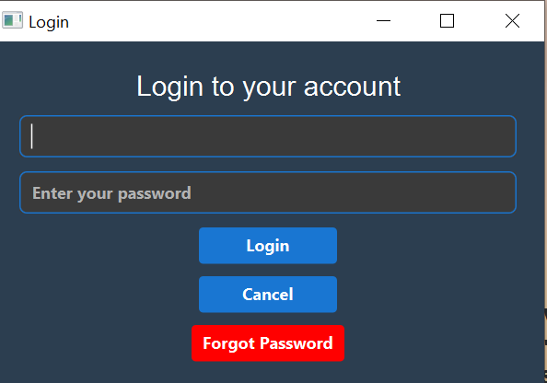**Login page form:**

**After successful login:**

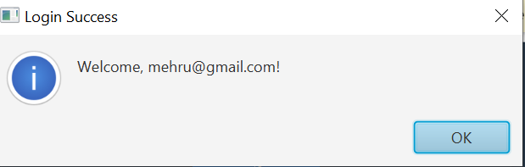

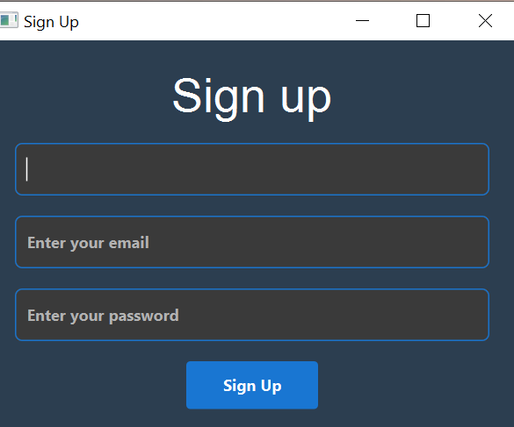**Sign up form:**

**After successful sign up:**

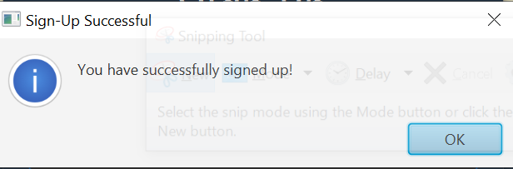

**Flight search:**

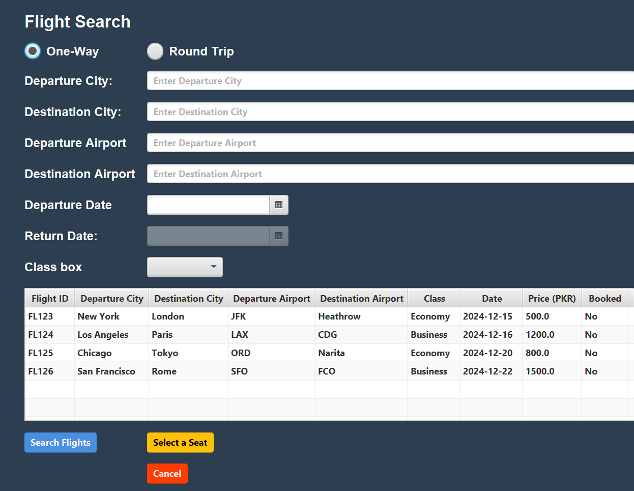

**After entering entries and clicking the select flight button:**

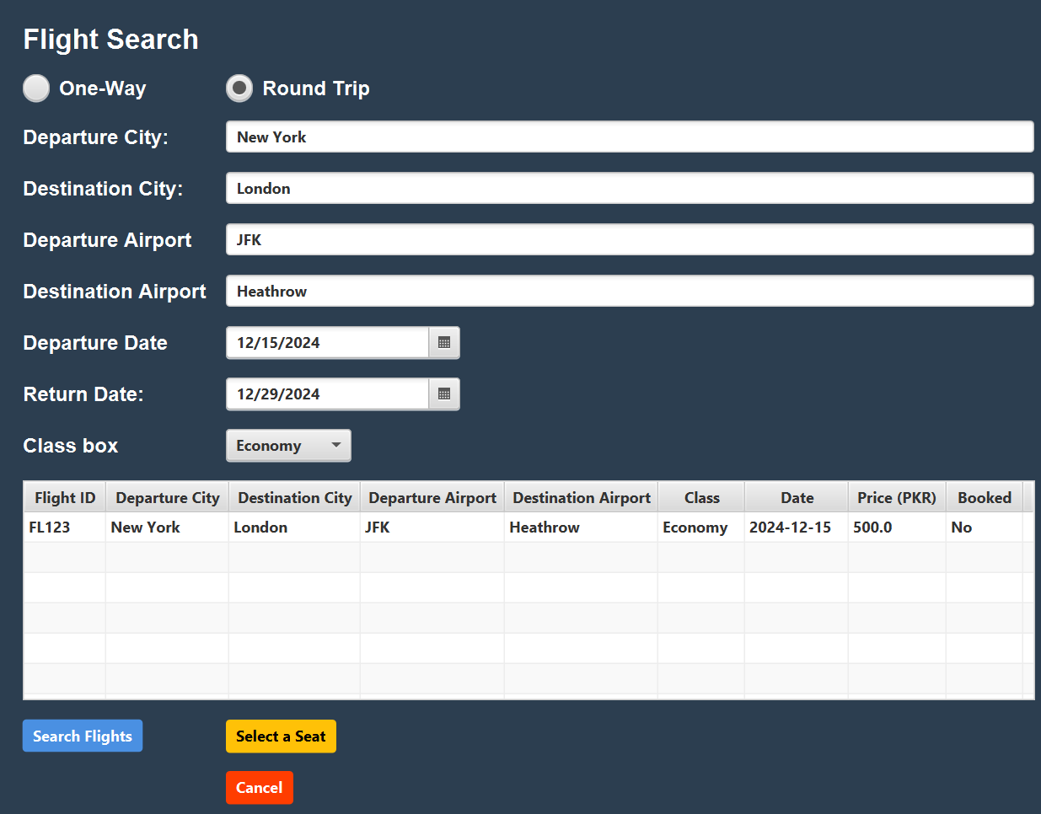

**Select seat:**

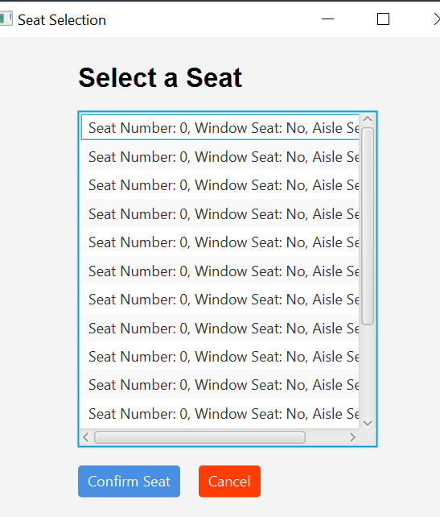

**Confirm seat:**

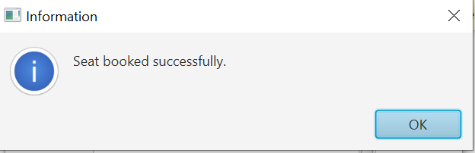

**Book Flight:**

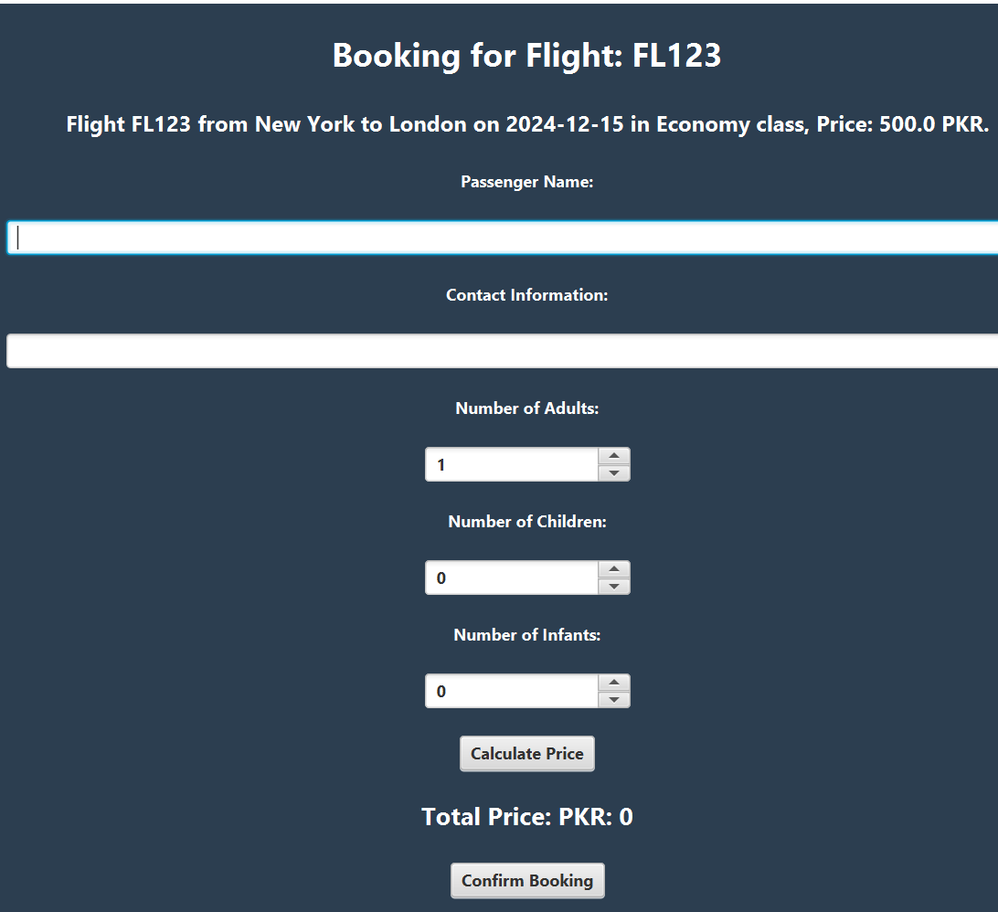

**After Putting entries:**

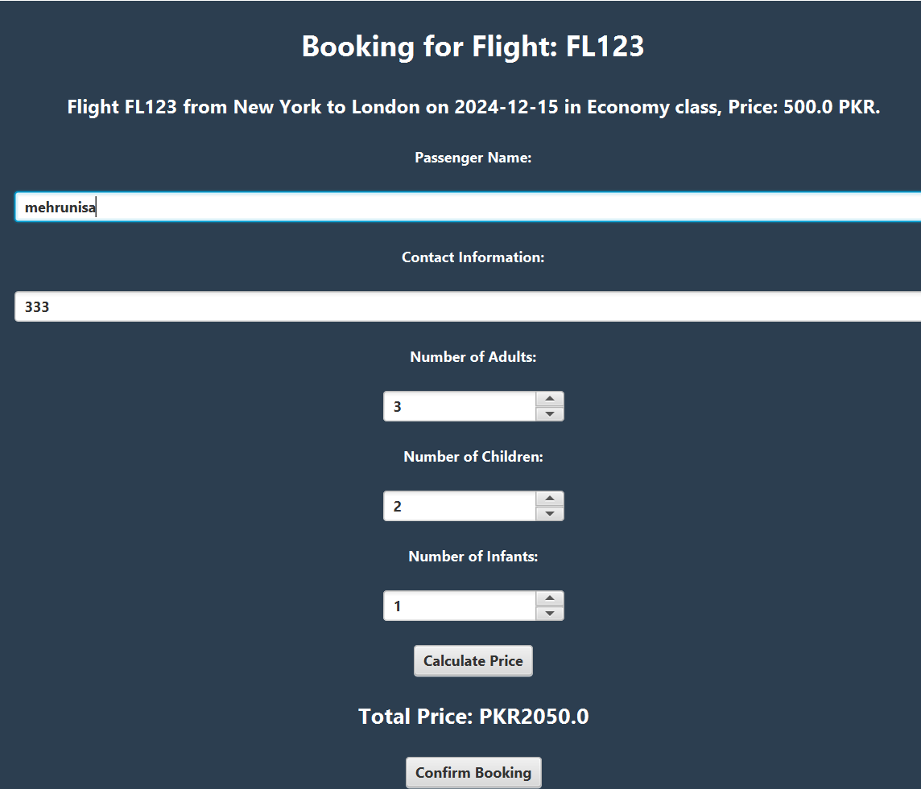

**Confirm booking:**

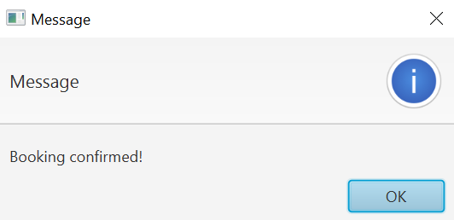

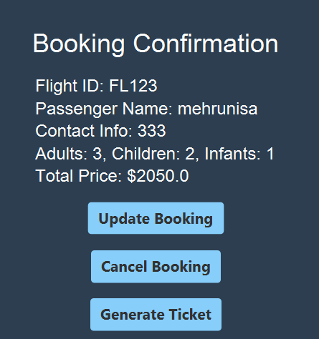

**Cancel Booking:**

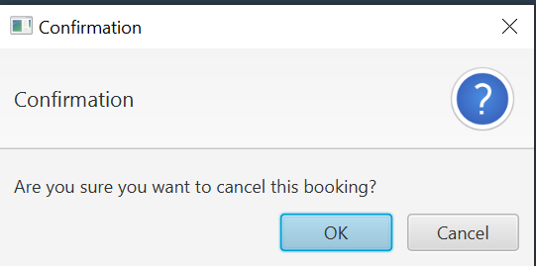

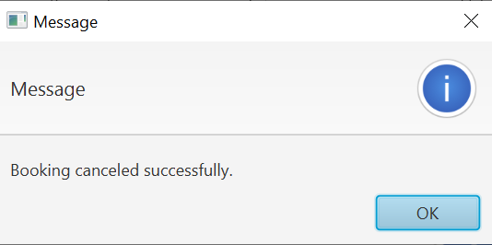

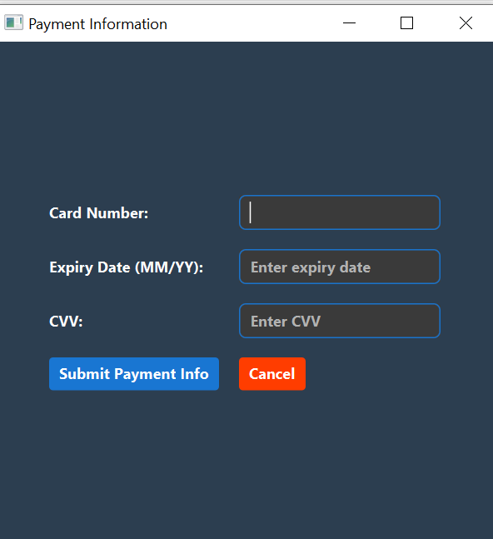**Payment form:**

