illust486_thumb.gifillust477_thumb.gifillust486_thumb.gifillust477_thumb.gif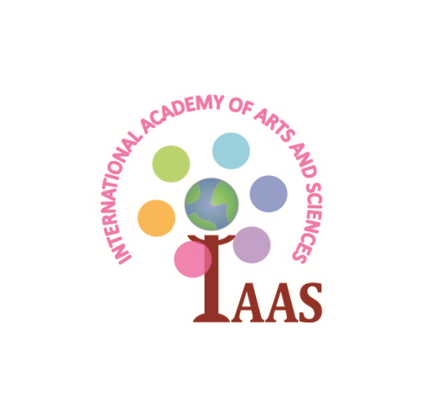illust486_thumb.gifillust486_thumb.gif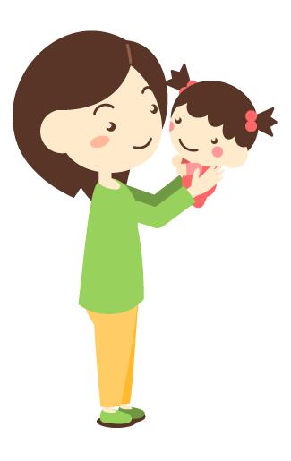

**Mommy and Me**

**We will let you know in our blog   
if the class has to be cancelled.   
Please check in the morning.**

**asunarokokusai.blogspot.com**

**Fridays 9:30AM10:30AM**

**Jan. 12 & 19 & 26**

**Feb. 2 & 9 & 16**

**Mar. 2 & 16**

**Apr. 6 & 13 & 20 & 27**

**May 4 & 18**

**June 1 & 8**

**At IAAS, we offer Mommy and Me class on Fridays. We incorporate music, games, and art to offer a real introduction to the world of preschool.   
The classes are conducted in English and Japanese. Please call to register!**

**International Academy of Arts and Sciences**300 High St., Closter, NJ 07624  
TEL: (201)767-1144

JPHP: asunarokokusai.org

ENG HP: iaasnj.org

Blog: asunarokokusai.blogspot.com

E-mail: info@asunarokokusai.org

**Eurythmic Class**

**With Ms. Manami**

**\*Please call or email to**

**reserve your seat.**

**Place: IAAS   
 300 High St., Closter, NJ**

**Fee: $15 per class  
$130 for 10 classes**

**Ages: 1 – 2.5 years old**