**International Academy of Arts & Sciences**

**Spanish Summer Program**

Enjoy our NEW SPANISH - ENGLISH BILINGUAL SUMMER PROGRAM with Ms. Mai and Mr. Alex! Learn Spanish while playing!! We also provide swimming classes with professional coaches at a local swimming pool.

Dates：8/04/2014 (Mon) -8/29/2014 (Fri)　(4 weeks in total)

You can register daily.

　　　　 Please write down the days you want to enroll for.

Time：9:00am〜2:30 pm

Place：International Academy of Arts and Sciences

　 300 High Street, Closter, NJ 07624

Ages：2.5 -7 years old

Course：**☆ English - Spanish Bilingual course**

* **School gardening.**
* **Art.**
* **Drama.**
* **Sport activities every day.**
* **Spanish music.**
* **Spanish culture.**
* **One excursion per week (to a farm, to a botanical garden, to visit the town, the zoo…).**

**☆Swimming lessons (1st-2nd week)**

***Swimming lessons at Pascack Valley Swim Club!***

(http://swimpascack.com/)

Capacity：20 children

Registration Fee：$50

*No Registration fee for the students already enrolled

to IAAS for 2013-14 school year

Tuition : Registration by week

1st & 2nd Week: $365/ week (Swimming on Tue & Thu)

3rd & 4th Week: $325/week (No swimming class these week)

Registration by day

No Swimming class day $70 per day

(1st & 2nd week 's Mon, Wed , Fri and 3rd & 4th week)

Swimming class day $90 per day

(Tue & Thu for 1st & 2nd week)

*You need to register and pay in advance for daily registration too.

*We cannot make up days or give a refund if your child is absent.

　　 *We also have some discount options.

　　　　　　（Please check with your application form)

We will have a van service for some areas. ($9/ ride)

How To Enroll：

Please return the registration form and a check to us.

Make sure that the form is all filled out, properly.

We will send you all the additional documents.

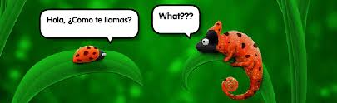

**International Academy of Arts and Sciences**

300 High St, Closter, NJ 07624

(201)76701144

Email:iaasnj.spanish@gmail.com

Contact : Ms. Mai or Mr. Alex

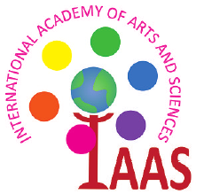 **2014 Spanish**

**Summer School**

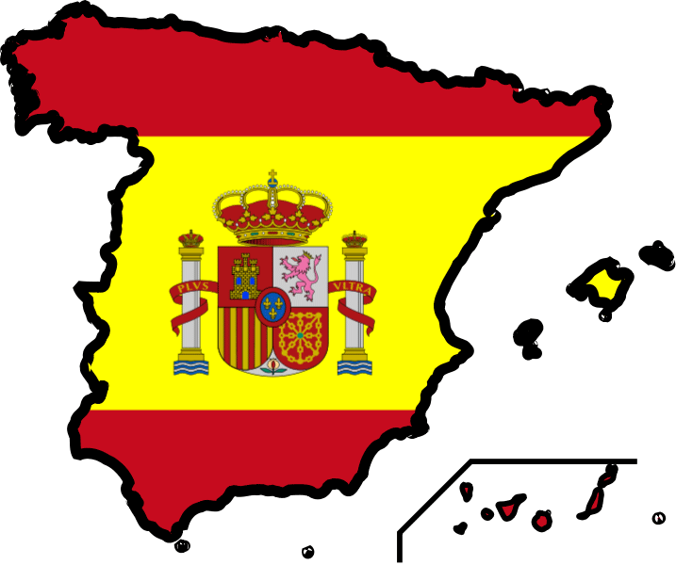

**Register Now!!**

**International Academy of Arts and Sciences**