**Case Study 1: Streamlining Library Operations: A Database Management System for Efficient Book Lending and Member Management**

**Problem Statement:**

“This project aims to develop a database system for college libraries that will store and manage information about books, members, and transactions, to automate lending activities, eliminate manual record-keeping, and generate reports on issued books and due dates.”

**Entities and their attributes**

1. Book
2. **book_id** (INT): Unique identifier for each book.
3. **title** (VARCHAR(30)): Title of the book.
4. **publisher** (VARCHAR(30)): Publisher of the book.
5. **isbn** (INT, NOT NULL): International Standard Book Number, a unique identifier for books.
6. **category** (VARCHAR(20)): Category or genre of the book.
7. **copies_available** (INT): Number of copies available for lending.

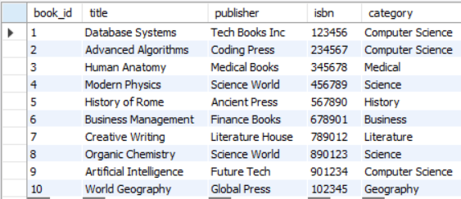

1. Members
2. **member_id** (INT): Unique identifier for each library member.
3. **mname** (VARCHAR(40)): Name of the member.
4. **department** (VARCHAR(20)): Department or field of study of the member.
5. **membership_date** (DATETIME): Date when the member registered.
6. **contact** (INT): Contact number of the member.

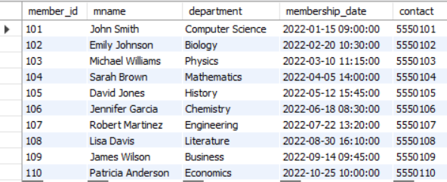

1. Transactions
2. **transaction_id** (INT): Unique identifier for each transaction.
3. **book_id** (INT): Identifier for the book being issued (foreign key referencing **book**).
4. **member_id** (INT): Identifier for the member who borrowed the book (foreign key referencing **members**).
5. **issue_date** (DATETIME): Date and time when the book was issued.
6. **return_date** (DATETIME): Date and time when the book was returned (NULL if not yet returned).
7. **fine** (INT): Fine amount for late returns (if applicable).

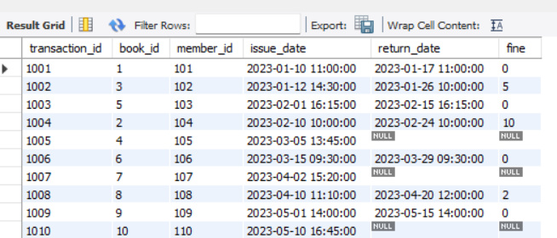

**Case Study 2 : Optimizing Patient Management: A Comprehensive Database System for Hospital Operations**

**Problem Statement**

“This project aims to develop a database system for hospitals, that will store and manage patient records, doctor availability, and appointment scheduling, in order to ensure faster access to medical histories and optimized staff usage.”

**Entities and Attributes**

1. Patient
   1. **patient_id** (INT): Unique identifier for each patient
   2. **name** (VARCHAR(30)): Full name of the patient
   3. **dob** (DATE): Date of birth of the patient
   4. **gender** (VARCHAR(6)): Gender (Male/Female/Other)
   5. **contact** (INT): Contact number of the patient
   6. **address** (VARCHAR(30)): Residential address of the patient

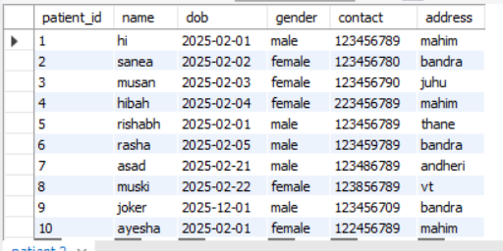

1. Doctor
2. **doctor_id** (INT) PRIMARY KEY: Unique identifier for each doctor
3. **uname** (VARCHAR(20)): Username or name of the doctor
4. **specialization** (VARCHAR(30)): Medical specialization of the doctor
5. **contact** (INT): Contact number of the doctor

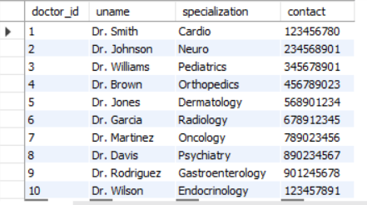

1. Appointment
2. **appointment_id** (INT) PRIMARY KEY: Unique identifier for each appointment
3. **patient_id** (INT): Foreign key referencing patient table
4. **doctor_id** (INT): Foreign key referencing doctor table
5. **dat** (DATE): Date of the appointment
6. **times** (TIME): Time of the appointment
7. **statuss** (VARCHAR(3)): Status of appointment (e.g., "C" for confirmed, "P" for pending)

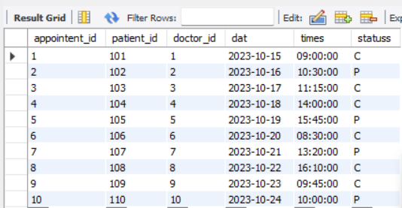

Case Study 3: **Streamlining Car Rental Operations: A Comprehensive Database System for Efficient Vehicle Management**

**Problem Statement**

**“**This project aims to develop a database system for managing car rental operations. The system will facilitate the management of customers, vehicles, rentals, and staff, ensuring efficient tracking of vehicle availability and rental transactions. By optimizing the rental process, the system will enhance customer satisfaction and improve operational efficiency within the car rental business.**”**

**Entities and Attributes**

* + 1. Customer
  1. **customer_id** (INT) PRIMARY KEY: Unique identifier for each customer.
  2. **uname** (VARCHAR(30)): Full name of the customer.
  3. **license_number** (INT) UNIQUE: Unique driver's license number of the customer.
  4. **contact** (INT): Contact number of the customer.

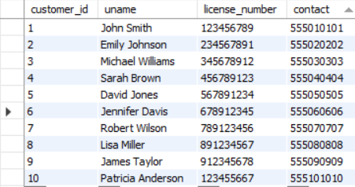

* + 1. Car
  1. **car_id** (INT) PRIMARY KEY: Unique identifier for each car.
  2. **model** (VARCHAR(30)): Model of the car.
  3. **category** (VARCHAR(20)): Category of the car (e.g., Sedan, SUV, Truck).
  4. **manufacturer** (VARCHAR(100)): Manufacturer of the car.
  5. **availability** (VARCHAR(1)): Availability status of the car (Y for Yes, N for No).

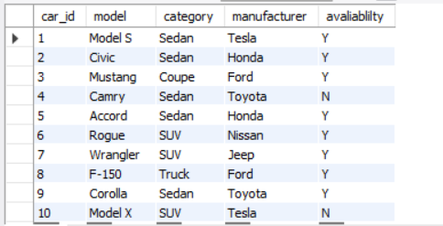

* + 1. Rental
  1. **rental_id** (INT) PRIMARY KEY: Unique identifier for each rental transaction.
  2. **customer_id** (INT): Foreign key referencing the **customer** table.
  3. **car_id** (INT): Foreign key referencing the **car** table.
  4. **rental_date** (DATE): Date when the car was rented.
  5. **return_date** (DATE): Date when the car is scheduled to be returned.
  6. **total_amount** (INT): Total rental amount charged.

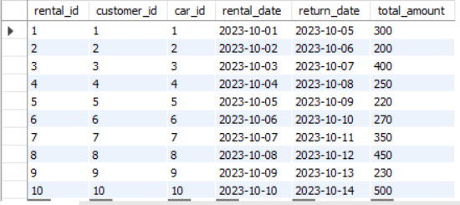

* + 1. Staff
  1. **staff_id** (INT) PRIMARY KEY: Unique identifier for each staff member.
  2. **sname** (VARCHAR(30)): Full name of the staff member.
  3. **role** (VARCHAR(30)): Role of the staff member (e.g., Manager, Sales, Mechanic, Customer Service).
  4. **contact** (INT): Contact number of the staff member.

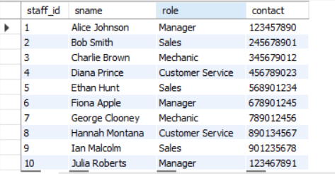

**Case Study 4: Efficient Student Accommodation Management: A Database System for Room Allocation in Educational Institutions**

**Problem Statement**

“This project aims to develop a database system for managing student accommodation in educational institutions. The system will facilitate the allocation of rooms to students, track occupancy status, and ensure efficient utilization of available resources. By streamlining the room allocation process, the system will enhance the overall living experience for students and optimize the management of accommodation facilities.”

Entities and Attributes

* + 1. Student
    2. **student_id** (INT) PRIMARY KEY: Unique identifier for each student.
    3. **sname** (VARCHAR(30)): Full name of the student.
    4. **gender** (VARCHAR(1)): Gender of the student (M/F).
    5. **course** (VARCHAR(40)): Course of study the student is enrolled in.
    6. **years** (YEAR): Year of study (e.g., 2023, 2024).

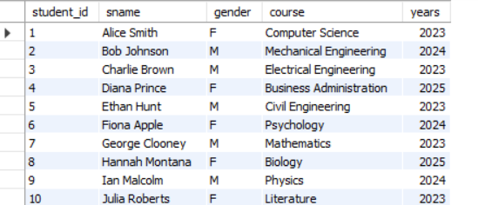

1. Room
   1. **room_id** (INT) PRIMARY KEY: Unique identifier for each room.
   2. **room_type** (VARCHAR(30)): Type of room (e.g., Single, Double, Triple, Quad, Suite).
   3. **capacity** (INT): Maximum capacity of the room.
   4. **occupancy** (VARCHAR(10)): Current occupancy status (e.g., Vacant, Occupied)

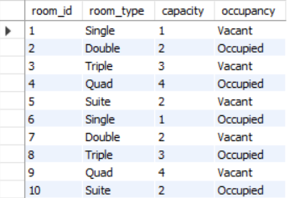

1. Allocation
   1. **allocation_id** (INT) PRIMARY KEY: Unique identifier for each room allocation.
   2. **student_id** (INT): Foreign key referencing the **student** table.
   3. **room_id** (INT): Foreign key referencing the **room** table.
   4. **checkin** (DATE): Date when the student checked in to the room.
   5. **checkout** (DATE): Date when the student is scheduled to check out of the room.

