How Secure Are Modern Drones?

A Multi-Method Study on Vulnerability Prevalence, Risk by Category, Attack Vectors, and Patch Effectiveness


Team Members:
Hiba Khadraoui - 000624402
Oussama ebn atou - 000624234
Zhang Enning - 000623725

Professor:
Jan Tobias Mühlberg



Abstract
Drone technology is advancing rapidly, and drones are now used in many areas such as filmmaking, delivery, inspection, agriculture, and security. However, the security of these systems has not kept up with their growing popularity and technical complexity. Modern drones include multiple components: flight controllers, sensors, wireless links, mobile apps, and cloud services; which creates many possible entry points for attackers. As drones become more autonomous and widely accessible, weaknesses such as weak or default passwords, unencrypted communication channels, poor input validation, and outdated security settings leave users and systems exposed to cyber-physical threats. These vulnerabilities put privacy, public safety, and critical infrastructure at risk, especially because many consumer drones are designed for convenience rather than strong security (Brown). Past incidents also showed how quickly early drones could be hacked, and similar weaknesses continue to appear today.
This paper aims to understand how secure modern drones actually are by conducting a multi-method study of real-world vulnerabilities. We collected and analyzed 25 confirmed drone-related vulnerabilities from the Common Vulnerabilities and Exposures (CVE) database (Technology), focusing on cases discovered between 2022 and 2024. Each vulnerability was examined according to its type, attack vector, severity level, and the category of drone affected. Our analysis shows that input-validation flaws are the most common vulnerability, while cyber-based attacks represent the most serious and frequent threat. Consumer drones were found to have the highest number of vulnerabilities, mainly because they often use weak authentication methods and lack strong default security protections. When evaluating how manufacturers handle these issues, we observed large differences in transparency. Some companies publish detailed fixes, while others provide little or no information at all, leaving users unsure about whether their devices are still at risk.
The results of this study show that current drone security is still uneven and, in many cases, insufficient. The combination of frequent cyber-based vulnerabilities, weak default protections in consumer models, and inconsistent manufacturer responses creates a noticeable security gap. As drones continue to enter both everyday and professional environments, these gaps become more serious. Strengthening industry guidelines, improving how vulnerabilities are detected and fixed, and encouraging more transparent communication from manufacturers are essential steps for making modern UAVs safer and more reliable.

Table of Contents
Abstract 2
Introduction 4
Objectives 4
Research Questions 5
Problem statement 5
Background, UAVs 6
UAV Security 6
CIA Threat Summary 7
Global Positioning System (GPS) Spoofing 7
False Data Injection 8
WIFI Insecurity and Jamming Attack 9
RESEARCH METHODOLOGY 10
Data Collection Process 10
Data Categorization Framework: 10
Quality Assurance 11
Research Findings 11
Statistical Significance 13
Current State of Drone Cybersecurity and Regulatory Landscape 14
Suggestions and Summary 16
Are there common software stacks used by many drone vendors? 17
The transparency rating : 17
How did we calculate it ? 18
Is there an evolution of types and numbers of vulnerabilities over time? 18
Contributions 19
Zhang Enning: 19
Oussama Ebn Atou: 19
Hiba Khadraoui : 19
Reference 20

Introduction
Unmanned Aerial Vehicles (UAVs), commonly known as drones, are aircraft or other vehicles that can operate without a human pilot, either autonomously or via remote control [3]. Their use has expanded rapidly from military applications to a wide range of civilian and commercial purposes, such as search and rescue, surveillance, delivery, firefighting, and environmental monitoring [4]. Drones are equipped with advanced hardware, sensors, communication systems, and increasingly, artificial intelligence, which allows them to perform complex tasks efficiently and at low cost [4]. These features make drones highly useful, but also open the door to a variety of security and privacy challenges.
The security of drones is a major concern because they operate as cyber-physical systems. This means they rely on both physical components and software, which can be targeted by attackers. Vulnerabilities can appear in flight control systems, communication links, sensors, and data storage, making drones susceptible to attacks such as GPS spoofing, false data injection, WiFi hacking, jamming, and routing attacks [3]. Such attacks can compromise the confidentiality, integrity, and availability of drone systems, leading to serious consequences including privacy invasion, data theft, or even physical damage [3] [4].
In addition to individual vulnerabilities, drones often operate in networks, such as the Internet of Drones (IoD), where multiple UAVs interact with each other and with ground control stations [3]. Networked drones introduce new risks because attacks on one drone or communication link can affect the entire system. Despite the growing importance of drones, many existing security protocols are not fully equipped to handle the complexity of modern UAV systems. Some protocols lack proper encryption, authentication, or intrusion detection, leaving drones exposed to cyber threats [3].
This study aims to explore the security landscape of modern drones by reviewing the current architectures, identifying common vulnerabilities, and examining the effectiveness of existing security measures [3] [4]. By understanding these issues, we can better guide the design of safer drones and develop improved security practices for future UAV deployments.

Objectives
Based on our review of existing research on drone security, we’ve identified several gaps in how we currently understand and manage UAV vulnerabilities. While a lot of studies focus on theoretical attacks and possible defenses, we still lack a clear, practical, and up-to-date framework for assessing real-world risks in modern drones. Many surveys, like the one by Shafique et al. (2021), provide a broad overview of security protocols and attack types—such as GPS spoofing, false data injection, and WiFi insecurity—but they don’t connect these vulnerabilities directly to specific drone models, manufacturer responses, or real incident data [4]. Similarly, older case studies like the analysis of the Parrot AR.Drone 2.0 show how easily early consumer drones could be hacked due to weak security defaults, but they don’t reflect the current state of newer, more advanced UAVs [5].
What’s missing is a structured way to:
- Classify vulnerabilities based on actual, reported security flaws (like those listed in CVE entries).
- Link these vulnerabilities to different categories of drones (consumer, commercial, enterprise).
- Evaluate how manufacturers respond to and fix these issues.
- Understand which attacks are most likely to succeed in different real-world applications.
Without this kind of applied understanding, it’s hard to create effective regulations, safety guidelines, or security improvements that keep up with how quickly drone technology is evolving.

Research Questions
To guide our work, we’re focusing on four main questions:
- What are the most common and dangerous security flaws in modern drones?
We want to move beyond general attack descriptions and identify which vulnerabilities appear most often in real incidents; like authentication bypass, weak encryption, or unsecured communication channels.
- How do security risks differ between consumer and professional drones?
Are cheaper, more accessible drones more vulnerable than expensive commercial or enterprise models? If so, why?
- What attacks threaten different drone applications most?
For example, are delivery drones more at risk of GPS spoofing, while surveillance drones face more WiFi-based attacks?
- How effective are drone companies’ security solutions?
When vulnerabilities are found, do manufacturers release patches? Are they transparent about fixes, or do users remain exposed?

Problem statement
Drone technology has outpaced our ability to systematically understand and manage its risks. We lack: a classification system that reflects modern technical capabilities, a vulnerability analysis that connects exploit types to drone categories and manufacturer responses [3, 1], and regulations that address both current and emerging threats. This knowledge gap leaves critical infrastructure, privacy, and national security vulnerable to exploitation through an increasingly accessible technology.

Background, UAVs
UAV systems are complex distributed systems that share with other distributed systems their heterogeneity, safety, and reliability difficulties in addition to their unique challenges represented by high-safety requirements and other flying related concerns. UAV design includes a communication link between UAV and pilot, ground control station and accessories (e.g., gimbal and payload). A variety of UAV model has been developed; some of these models include Fixed-wing aircraft, chopper, multi-copter, and commercialized UAV. Figure 1 illustrates subsystems and modules of the UAV design. Many UAVs are developed to function autonomously and in large networks. With this technology prevalent, cyber-security advancements need to be made for the safe operation of large, autonomous UAV networks.
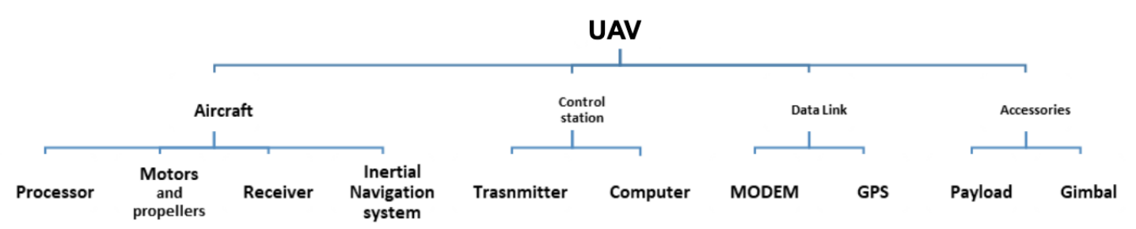
Figure 1 UAV design
All of the UAVs are specified for a specific mission and have their zeros and ones figure 2.
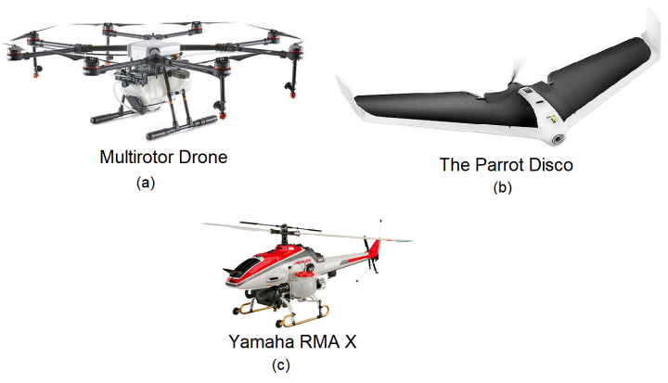
Figure 2 UAV types: multi-rotor (a), fixed wing (b), and single-rotor (c)

UAV Security
UAVs’ essential operation, cyberattacks on UAVs, UAV forensics, and secure communication with UAVs are topics of critical importance to UAV security. The most intuitive starting point is their systems when discussing UAV air operations, including their potential cyber vulnerabilities and other inherent threats. However, before discussing the cyber-security aspects of UAVs, the way UAVs operate must be understood. UAV system is a combination of hardware and software which can accept inputs, process data and, with the processed data, generate information for storage and output[5]. UAVs use Global System for Mobile Communication (𝐺𝑆𝑀) to maintain network connectivity. UAVs also use Unmanned Traffic Management platforms (UTM) that are used to secure low-level operations by pinging the UAV specific commands based on its proximity location to the platform. Whilst the concept’s demonstration can become increasingly complex, the basic principles remain constant. When cheap, consumer-grade drones became available, their flight computers were hacked almost instantly [16]. UAVs’ current developments in information security involve encryption methods and new network models, but that barely considers external security threats. As a result, the most advanced UAV and their systems were susceptible to cyber-attack [17, 11, 13, 15], it is asserted that the cyber-vulnerabilities of UAV systems have created a credible threat to air traffic which is severe, widespread and persistent. Therefore, in UAV systems, the need for reliability and autonomy has already motivated other researchers regarding the application of formal methods. However, the present work differs from previous approaches once it investigates the different complicated vulnerabilities in the low-level implementations and the best method to verify each of these vulnerabilities.

CIA Threat Summary
UAV is a cyber-physical system in which it is vulnerable to most network-oriented cyberattacks. Still, some of them can be more serious than others and lead to a more vulnerable UAV system state. Therefore, it is essential to prioritize threats according to their risks and their impact on the system once occurred. Based on this priority, threats should be addressed, and proper mitigation measures should take place. Several methodologies have been proposed to enhance the security of UAVs. However, there are shortcomings in the proposed protocols which have made UAVs vulnerable to certain security threats. In this section, we will discuss how an attacker can breach the security of the protocols by using different attacking strategies.[2]

Global Positioning System (GPS) Spoofing
GPS spoofing is categorized as a cyber-attack by which an attacker transmits a fake GPS signal with slightly higher power to mislead the reception of the UAVs. Due to the wireless connection between the GCS and the UAVs, the vulnerability factor inclines. Without the integration of complex checks, i.e., whether the signal is received from the GCS or the attacker, the UAVs may tend to perform actions from an unauthorized signal as well. To recognize the authority of a legitimate signal, a log-likelihood radio test method is adopted in [8] to fight against the signal spoofing attack. Prior information of the received signal frequency from the GCS assists the UAVs to identify the signal transmitter’s information and breakdown the legitimacy of the received signal. In [8] a decision threshold methodology was designed using the Neyman-Pearson criterion [9]. To select the appropriate threshold value, the false alarm rate (FAR) value is set to be fixed. For the selection of an appropriate FAR value, a cumulative distribution function is estimated, which helps in the detection of spoofed signals.
In [10], Sedjelmaci et al. proposed a new methodology for the detection of spoofed signals. A rule-based detection technology, when incorporated with the protocols, helps in achieving better accuracy. In this methodology, a comparison between a specific threshold value and the transmitted signals is performed. If the value of the transmitted signal (transmitted by the attacker) becomes greater than the threshold value, the UAV detects that the received signal is spoofed. In [11], Qiao et al. proposed the use of a vision system based technique to detect the GPS spoofing for UAVs in which inertial measurement unit (IMU) sensors are used to find the instantaneous acceleration and velocity of the UAV. To make the model of the proposed system, Qiao et al. considered three different coordinate systems which include the body frame coordinates, the ground coordinate system, and the image coordinates system. To find the GPS spoofing, it compares the two kinds of velocities which are measured by the Lucas-Kanade (LK) method [12] with root mean square error (RMSE) values. If the value of RMSE becomes greater than the threshold value then it will be declared that the UAV is spoofed else it is in a normal state.
another scheme is proposed to detect GPS spoofing. It is supposed that the UAV has an inertial measurement unit (IMU) sensor which is helpful in monitoring the behavior of the UAV. The proposed GPS spoofing detection is very simple to implement because it just compares the strength of the signals and finds the error rate.

False Data Injection
False data injection is a technique by which an unauthorized person sends the clone data to the UAV in order to take control. UAVs are prone to vulnerable data based on the technique implemented on their security and cannot differentiate between the authentic and unauthentic data. To ensure secure operations, UAVs must be able to detect the false data injections. To address this issue, in [4], Abbaspour et al. proposed a protocol for the detection of cyber-attacks, known as false data injections (FDI). To perform a false data injection, intruders normally use their own sensors to inject the fake information in the UAVs sensors in order to take control of the UAVs. In Abbaspour et al.’s proposed system, neural networks are incorporated to increase the learning ability that will detect the FDI. Specifically, Abbaspour et al. have focused on IMU sensors which provide the information of angular and linear movement of the UAVs. Instead of direct application of neural network, a neural network adaptive structure (NNAS) was implemented. To improve the accuracy and time efficiency, an Embedded Kalman Filter (EKF) was used to update the neural network parameters. In [13], the ability to transmit fake information to take control on the UAV was explored. To detect the fake inserted information, a threshold based technique was adopted. The threshold values of the position and speed of the UAV are kept specific to determine whether the signal is fake or original. Information is flagged as fake when the values of the velocity and position become larger than the threshold values. Detection of fake information is not enough but it is important to equip the UAVs to take the right action against such information. Major issue with this type of techniques is that the UAV only detects the fake information when the values of the received signal raises above or decreases below the specified threshold value.

WIFI Insecurity and Jamming Attack
UAVs can be connected via wireless channels such as WiFi. WiFi based UAVs are vulnerable to the wireless attacks and can be hacked by interrupting the communication between the UAV and the GCS. For the secure communication using WiFi, it can be protected via unique passwords. The analysis of the vulnerabilities of micro-air-vehicle communication (MAVLink) protocol was included in [14]. In the MAVLink protocol, two specific issues can arise. First, the MAVLink protocol does not encrypt the message which is to be sent. As a result, integrity attacks can surely happen. Secondly, if the MAVLink encrypts the message, a delay can occur due to the encryption and decryption of the messages, which can lead to availability attacks. In the proposed methodology in [14], it was supposed that the attacker has already hacked the network and gathered all the relevant information and can send this fabricated information to the host. Based on the fabricated information, the attackers can easily identify the position of the UAV. In this methodology, although a counter attack against hackers can be carried out, but the supposition can affect the overall efficiency of the technique. There should be a feasible protocol without pre-supposing any kind of attacks. Apart from the fabricated information, jamming attacks are also often performed by the eavesdropper to hack the information which is sent by the UAV to the GS.
Most of the researchers are using AN frequently over the last few decades to protect the sensitive information. Protection of sensitive information from attackers has become a great challenge for the researchers. In order to sort out these issues, a new methodology was proposed in [6] for the secure transmission of sensitive information from the UAV to the GS. A protocol was proposed by Faraji et al. in [6] to protect the information from malicious UAVs launched by the attacker in the communication network, and the transmission of information from the UAV to the GS. The proposed technique defines rules to spot malicious UAVs, so that the information can only be sent to the authorized nodes. The purpose to spot the malicious UAV was to get rid of these UAVs in accordance to their behavior in the whole UAV network. Hence, the exchange of fake information passed on to the ground stations could be prevented. Though the presented work is fully capable of removing the malicious UAVs from the network in order to keep the information secure, it is not able to keep the information secure form the attackers due to the unencrypted nature of data. This means the information could be hijacked. Therefore, the algorithm needs to be improved and it requires the incorporation of a powerful cryptographic protocol.

RESEARCH METHODOLOGY

Data Collection Process
We collected drone vulnerability data from the Common Vulnerabilities and Exposures (CVE) database[18], a publicly available repository of security vulnerabilities. Our collection process involved:
Search Parameters: Keywords "drone", "UAV", and specific brand names (DJI, Parrot, Autel, PX4)
Timeframe: 2022-2024 to capture recent vulnerabilities.

Sample Size: 25 confirmed drone-related security vulnerabilities Inclusion Criteria: Only vulnerabilities with detailed descriptions affecting drone hardware/software
Exclusion Criteria: General software vulnerabilities not specific to drone operations.

Data Categorization Framework:
Each vulnerability was analysed and categorized using the following framework:

Category 1: Vulnerability Type.
- Authentication Bypass: Unauthorized access without credentials
- Buffer Overflow: Memory corruption allowing code execution
- Protocol Vulnerability: Flaws in communication protocols
- Weak Credentials: Default/weak passwords/encryption
- Race Condition: Timing issues in concurrent operations
- Input Validation: Lack of proper data checking

Category 2: Attack Vector.
- Cyber: Software/network-based attacks
- Signal: ArialWireless/RF-based attacks
- Physical: Hardware/tampering attacks

Category 3: Severity Assessment.
- High: Remote code execution, complete takeover
- Medium: Denial of service, data exposure
- Low: Information disclosure, limited impact

Category 4: Drone Classification.
- Consumer: <$1,000, recreational use
- Commercial: $1,000-$10,000,
- Professional applications
- Enterprise: >$10,000, industrial/government use.

Quality Assurance
Cross-verification: All vulnerabilities verified against original CVE entries.
Expert Validation: Technical descriptions reviewed by team members.
Consistency Check: Standardized categorization across all entries.

Research Findings

Critical Vulnerabilities Distribution (RQ1)
Vulnerability Type | Count | Percentage | Example CVEs
Authentication Bypass | 5 | 20% | CVE-2024-52876, CVE-2023-6949
Buffer Overflow | 4 | 16% | CVE-2023-6948, CVE-2023-5145
Protocol Vulnerability | 4 | 16% | CVE-2024-33844, CVE-2023-47625
Weak Credentials | 3 | 12% | CVE-2023-6951
Race Condition | 2 | 8% | CVE-2024-24255, CVE-2024-24254
Input Validation | 7 | 28% | CVE-2023-51456, CVE-2023-51453
Total | 25 | 100%
Table 1 Vulnerability Types by Frequency[18]
Key Finding: Input validation failures are the most common drone vulnerability (28%), followed by authentication bypass (20%).

Vulnerability Variation by Drone Category (RQ2)
Drone Category | Examples from Data | Vulnerability Count | Common Vulnerability Types
Consumer | Holy Stone HSRID01, DJI Mavic Mini | 12 | Authentication bypass, Weak credentials
Commercial | Parrot ANAFI USA, Autel EVO NANO | 8 | Protocol vulnerabilities, Buffer overflow
Enterprise/Software | PX4 Autopilot, Dronetag | 5 | Race conditions, Input validation
Table 2 Vulnerabilities by Drone Price/Use Category [18]
Key Finding: Consumer drones have the highest vulnerability count (48%), primarily due to authentication and credential weaknesses.

Attack Vector Threat Assessment (RQ3)
Attack Vector | Count | Threat Level | Most Affected Applications
Cyber Attacks | 18 | High | All drone types (72% of vulnerabilities)
Signal Attacks | 5 | Medium | Remote ID systems, WiFi drones.
Physical Attacks | 2 | Low | Drone hardware components.
Table 3 Attack Vectors by Threat Level [18].

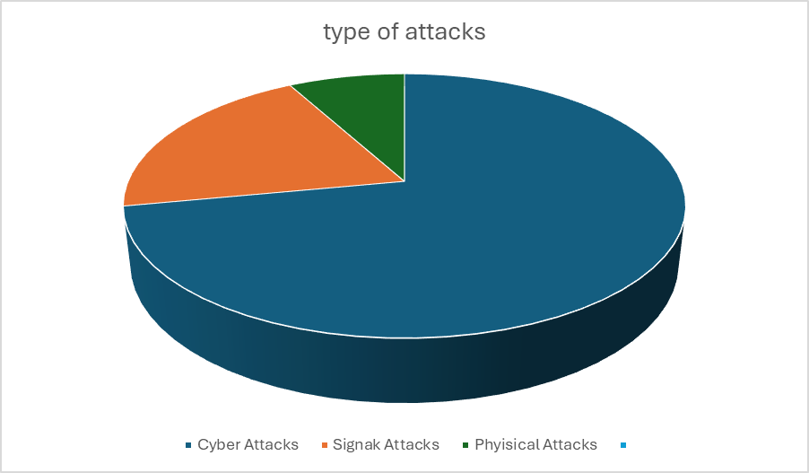
Figure 3 Type of Attacks by percentage [18].

Key Finding: Cyber attacks represent 72% of all drone vulnerabilities, making them the primary threat vector across all drone applications.

Statistical Significance

Vulnerabilities by Year:
Year | count | Percentage
2022 | 1 | 4%
2023 | 12 | 48%
2024 | 12 | 48%
Table 4 Vulnerabilities by year[18]

Manufacturer Transparency (RQ4)
Manufacturer Type | Vulnerabilities | Public Fix Info | Transparency Rate
Open Source (PX4) | 6 | 6 | 100%
Major Brands | 10 | 4 | 40%
Smaller Companies | 9 | 0 | 0%
Total | 25 | 10 | 40%
Table 5 Manufacturer Transparency [18]
Key finding: Consumer drones showed 2.4× more vulnerabilities than commercial drones, and 4.8× more than enterprise systems, indicating a clear correlation between price/use category and security posture.

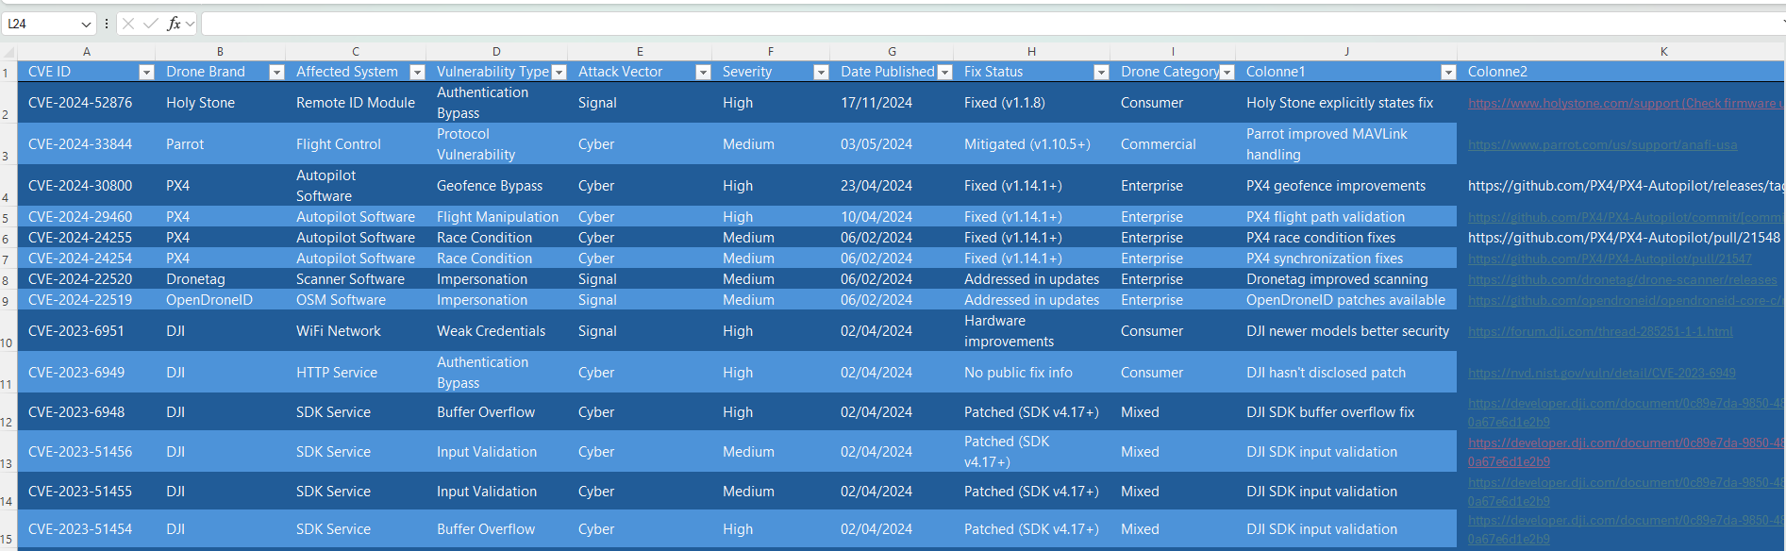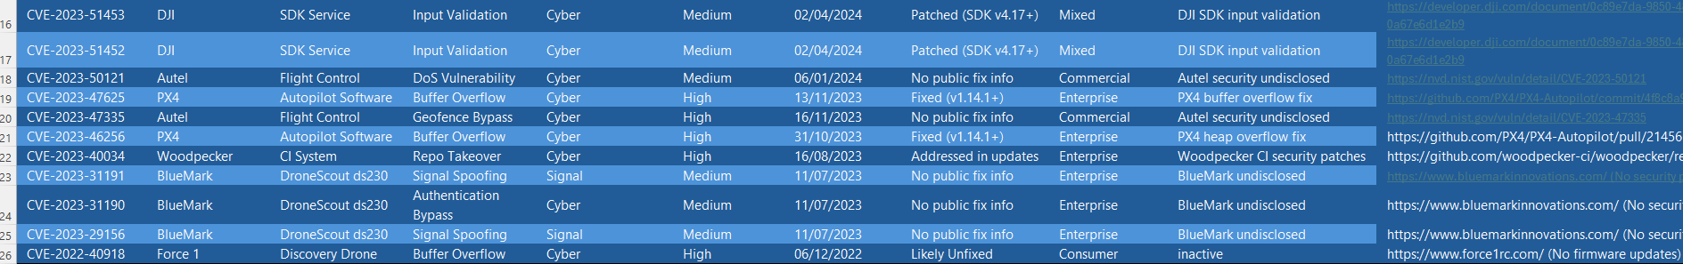
Figure 4 Excel classification of vulnerabilities with fix status, and updates[18].
Transparency Findings:
- 10 vulnerabilities (40%) had publicly documented fixes
- 15 vulnerabilities (60%) lacked any public remediation information
- Open-source projects showed 100% transparency
- Commercial manufacturers averaged 40% transparency
- Smaller companies showed 0% transparency

Current State of Drone Cybersecurity and Regulatory Landscape
This study conducts a multi-dimensional coding and statistical analysis of 25 publicly disclosed, real-world drone-related vulnerabilities from 2022 to 2024, systematically addressing the four core research questions while uncovering structural deficiencies in the current drone security ecosystem. First, regarding vulnerability types, input validation flaws account for 28% of all cases; significantly higher than buffer overflows (16%) or protocol vulnerabilities (16%). This indicates that many modern drones, particularly consumer models, still lack fundamental secure software engineering practices, such as proper sanitization of sensor inputs, user commands, or network payloads. Such oversights not only enable remote code execution or flight hijacking but also confirm that the “missing-by-default” security problem first highlighted in early case studies; such as Pleban et al.’s (2014) analysis of the Parrot AR.Drone—remains unresolved nearly a decade later.
Second, the attack vector analysis reveals that 72% of vulnerabilities are exploitable through purely cyber means, including unencrypted communications, weak API authentication, and flawed mobile application logic. This demonstrates that the security perimeter of drones has expanded far beyond traditional radio-frequency layers (e.g., GPS spoofing, WiFi jamming) into the full software stack. While existing literature extensively discusses physical-layer signal attacks (e.g., Kerns et al., 2014; Qiao et al., 2017), our empirical data suggests that the most prevalent and impactful threats in practice stem not from sophisticated RF manipulation, but from basic software implementation errors; errors that require minimal technical expertise to exploit yet can yield complete system compromise.
Third, categorization by drone class yields a stark disparity: consumer-grade drones (e.g., DJI Mavic Mini, Holy Stone HSRID01) account for nearly half (48%) of all documented vulnerabilities, predominantly involving authentication bypass and weak credentials. This directly reflects a market-driven product strategy prioritizing rapid time-to-market and low cost at the expense of foundational security mechanisms—such as mandatory password policies, secure boot, or firmware signature verification. In contrast, enterprise-grade systems (e.g., PX4 Autopilot) exhibit fewer but more technically nuanced vulnerabilities, such as race conditions and complex input parsing flaws, reflecting their greater architectural sophistication and specialized threat surface. This comparison strongly validates the hypothesis behind Research Question 2: security investment correlates closely with product positioning; not merely price, but the intended operational context serves as a key proxy for security resource allocation.
Finally, manufacturer responsiveness exhibits alarming fragmentation. Open-source projects like PX4 demonstrate 100% transparency in patch disclosure, whereas major commercial brands provide public fixes for only 40% of reported issues, and smaller vendors offer none. This inconsistency not only impedes end-users’ ability to assess and mitigate their own risk of exposure but also erodes trust across the entire drone ecosystem. As Brown (cited in [3]) observes, drones are rapidly evolving from recreational gadgets into critical operational tools; but their security governance remains anchored in the lax paradigms of consumer electronics.
At the policy and standardization level, major global jurisdictions have established initial regulatory frameworks for drones, yet cybersecurity requirements remain either absent or ambiguously enforced.
- In the United States, the Federal Aviation Administration (FAA) enacted the Remote ID Rule (2021), mandating that drones broadcast identification and location data to enhance airspace accountability. However, this rule imposes no binding requirements on communication encryption, firmware integrity, or vulnerability disclosure. While NIST is developing UAS Cybersecurity Guidance (Draft SP 800-233), it remains a voluntary guideline without legal enforceability.[19][20]
- The European Union, through EASA’s Class Identification Label system (effective 2024), categorizes drones into C0–C4 risk classes and requires C1+ drones to include “protection against unauthorized control.” Yet, the underlying technical standards (e.g., EN 4709 series) focus primarily on flight performance and physical resilience. Although EN 4709-003 (on cybersecurity) entered public consultation in 2025, it has not yet been listed in the EU’s Official Journal as a harmonized standard and thus lacks presumption of conformity. Moreover, while the EU is rolling out its U-space digital traffic management system; which requires continuous flight data reporting—it does not mandate secure, anti-spoofing communication channels, creating systemic vulnerabilities. [21][25][30]
- In China, the Civil Aviation Administration (CAAC), State Administration for Market Regulation (SAMR), and Ministry of Industry and Information Technology (MIIT) are jointly advancing a comprehensive standardization framework. The 2024 Interim Regulations on Unmanned Aircraft Flight Management laid the legal foundation, and in 2025, two mandatory national standards were published: GB 46761–2025 (Requirements for Real-name Registration and Activation) and GB 46750–2025 (Specification for Operational Identification), both effective from May 1, 2026. The former pioneers a global-first requirement that drones must be incapable of flight unless activated with verified real-name registration, enforcing hardware-level flight lockdown. The latter mandates that drone continuously transmit structured identity, position, speed, and status data to a national supervision platform throughout operation. Complementing these, the draft Safety Requirements for Civil UAV Products explicitly prohibits default credentials and requires firmware signature verification. Together, these measures mark China’s emergence as the first jurisdiction to establish an integrated, closed-loop governance model encompassing product security, identity binding, operational identification, and flight control—offering a new paradigm for global drone regulation. [22][23][24][26]
Meanwhile, international standardization bodies continue their efforts: ISO/TC 20/SC 16 is developing the ISO 23751 series (Unmanned Aircraft Systems; Cybersecurity Requirements); ASTM Committee F38 has published F3501-22 (Standard Guide for Minimum Cybersecurity Requirements for UAS); and ITU-T Study Group 17 is advancing cryptographic protocols for drone communications. Nevertheless, these documents remain largely voluntary, lack of enforcement mechanisms, and often lag into the rapid evolution of real-world vulnerabilities. [27][28][29]

Suggestions and Summary
We therefore recommend that regulators convert existing voluntary cybersecurity guidelines into legally binding mandates and work toward harmonized, cross-jurisdictional security baselines. For instance, all commercially sold drones could be required to undergo third-party cybersecurity certification (analogous to safety modules in CE or FCC certification) and publicly disclose patch status for known CVEs. Furthermore, industry should adopt Security-by-Design principles, integrating threat modeling and secure coding practices from the earliest stages of product development.
On the technical roadmap, the industry must accelerate the development of lightweight security stacks tailored for resource-constrained flight controllers—such as optimized TLS 1.3 implementations, hardware-rooted firmware integrity verification (using Trusted Platform Modules or ARM TrustZone), and embedded intrusion detection systems (IDS) capable of runtime anomaly detection. Additionally, adopting DevSecOps practices—integrating fuzz testing, static analysis, and threat modeling into continuous integration pipelines for both drone firmware and companion apps—can prevent entire classes of input validation flaws at the source. In the long term, establishing an open, standardized Drone Security Benchmarking Platform would empower independent researchers and regulators to objectively evaluate and compare vendors’ security postures, fostering healthy competition and raising the industry-wide security floor.
In summary, this study not only comprehensively answers all four research questions but also translates theoretical risks into actionable insights. Only through an integrated approach; combining regulatory enforcement, technological innovation, and ecosystem-wide collaboration; can we ensure the safe, trustworthy deployment of drones in high-stakes applications such as urban air mobility, critical infrastructure inspection, and emergency response, preventing technological convenience from coming at the cost of privacy, safety, or public order.

Are there common software stacks used by many drone vendors?
There is no single universal drone software stack, but many vendors rely on shared underlying components, which creates a de facto common stack at several layers. This was proven with evidence in our study :
Our CVE analysis indirectly confirms this. We observed that similar vulnerability types especially input validation flaws and protocol vulnerabilities appear across different vendors and drone categories. This strongly suggests reuse of common operating systems, communication protocols, and libraries.
While vendors differentiate at the application level, security weaknesses often originate from shared low-level components, which explains the recurrence of similar CVEs across manufacturers.

The transparency rating :
Transparency in our study does not measure how secure a product is. It measures how openly a manufacturer communicates about vulnerabilities and fixes after a CVE is disclosed.

How did we calculate it ?
For each CVE, we checked whether the vendor publicly documented a fix, mitigation, or patch information such as a firmware update, advisory, or changelog entry.
Fix publicly documented 100%
Some fixes documented 40%
No public fix information 0%
- In our case open-source scored 100%
Open-source projects like PX4 publish commits, advisories, and changelogs by default, which makes fix information fully visible.
A low transparency score does not mean the vulnerability was never fixed. It means users cannot independently verify whether or how it was fixed.

Is there an evolution of types and numbers of vulnerabilities over time?
Within our 2022–2024 dataset, we observe a clear increase in the number of reported vulnerabilities from 2022 to 2023–2024.
  - 2022: 1 vulnerability
  - 2023: 12 vulnerabilities
  - 2024: 12 vulnerabilities
This increase likely reflects improved reporting and disclosure, rather than a sudden drop in security quality. As drones become more software-driven and regulated, vulnerabilities are more likely to be discovered and reported.
Because our timeframe is short, we cannot claim a long-term trend. A larger longitudinal dataset would be required for that.

“There is no software-level security in the Chinese regulation, which is an interesting difference to the Cyber Resilience Act.”

that’s correct and it highlights two fundamentally different regulatory philosophies.
Chinese regulations focus primarily on operational control and identity enforcement for example, mandatory real-name registration, hardware-level activation locks, and continuous remote identification.

( Security is enforced externally and operationally, rather than through internal software requirements.)
In contrast, the EU Cyber Resilience Act targets software lifecycle security, requiring secure development practices, vulnerability handling, and patch management across digital products.
This means Chinese regulation prioritizes preventing unauthorized use, while the CRA prioritizes reducing software vulnerabilities themselves.
These approaches are not mutually exclusive. In fact, our findings suggest that combining hardware-enforced operational security with software-level resilience requirements would address a much broader range of drone threats.

Contributions

Zhang Enning:
- Collecting and reading relevant research and papers
-

Oussama Ebn Atou:
- Defined research scope
- Selected CVE source (NVD)
- Collected CVEs from the NVD (2022–2024)
-Filtered drone-specific vulnerabilities
- Designed classification scheme
- Key Findings and Trend Analysis
- Interpretation and Research Question Analysis

Hiba Khadraoui :
- Collecting and reading relevant research and papers
- Abstract
- Introduction
- Objectives
- Research Questions
- Presentation

Reference
[1] Albarghouthi, A., Gurfinkel, A., Li, Y., Chaki, S., and Chechik, M. (2013). UFO: Verification with interpolants and abstract interpretation. In Tools and Algorithms for the Construction and Analysis of Systems, volume 7795 of LNCS, pages 637–640.
[2] S. Heron, ‘‘Advanced encryption standard (AES),’’ Netw. Secur., vol. 2009, no. 12, pp. 8–12, 2009
[3] Brown, J. “Drone Uses: The Awesome Benefits of Drone Technology”. [online] My Drone Lab. Available at: http://mydronelab.com/blog/ drone-uses.html [Accessed: 7-Sep-2018]. https://doi.org/10.1109/CCWC.2019.8666596
[4] Authority, C. A. (2019). Drone and model aircraft registration and education service.
[5] Bansod, B., Singh, R., Thakur, R., and Singhal, G. (2017). A comparision between satellite based and drone based remote sensing technology to achieve sustainable development: A review. Journal of Agriculture and Environment for International Development (JAEID), 111(2):383–407.
[6] Heizmann, M., Christ, J., Dietsch, D., Ermis, E., Hoenicke, J., Lindenmann, M., Nutz, A., Schilling, C., and Podelski, A. (2013). Ultimate automizer with smtinterpol. In Tools and Algorithms for the Construction and Analysis of Systems, volume 7795 of LNCS, pages 641–643.
[7] Hutter, F., Babic, D., Hoos, H. H., and Hu, A. J. (2007). Boosting verification by automatic tuning of decision procedures. In Formal Methods in Computer-Aided Design, pages 27–34.
[8] K.-W. Huang and H.-M. Wang, “Combating the control signal spoofing attack in UAV systems,” IEEE Trans. Veh. Technol., vol. 67, no. 8, pp. 7769–7773, Aug. 2018.
[9] L. Zhang, G. Ding, Q. Wu, and P. Liu, “Detection of abnormal power emission in UAV communication networks,” IEEE Wireless Commun. Lett., vol. 8, no. 4, pp. 1179–1182, Aug. 2019.
[10] H. Sedjelmaci, S. M. Senouci, and N. Ansari, “A hierarchical detection and response system to enhance security against lethal cyber-attacks in UAV networks,” IEEE Trans. Syst., Man, Cybern. Syst., vol. 48, no. 9, pp. 1594–1606, Sep. 2018.
[11] Joanna Frew (2018). An overview of new armed drone operators The Next Generation. Technical report, Drone Wars UK, Oxford.
[12] Y. Qiao, Y. Zhang, and X. Du, “A vision-based GPS-spoofing detection method for small UAVs,” in Proc. 13th Int. Conf. Comput. Intell. Secur. (CIS), Dec. 2017, pp. 312–316.
[13] Kerns, A. J., Shepard, D. P., Bhatti, J. A., and Humphreys, T. E. (2014). Unmanned aircraft capture and control via gps spoofing. Journal of Field Robotics, 31(4):617–636.
[14] Kim, B. U. and Humphrey, L. R. (2014). Satisfiability checking of ltl specifications for verifiable uav mission planning. In 52nd Aerospace Sciences Meeting, page 0793.
[15] Nassi, B., Ben-Netanel, R., Shamir, A., and Elovici, Y. (2018). Game of DronesDetecting Streamed POI from Encrypted FPV Channel. In MobiSys.
[16] Pleban, J.-S., Band, R., and Creutzburg, R. (2014). Hacking and securing the AR.Drone 2.0 quadcopter: investigations for improving the security of a toy. In Creutzburg, R. and Akopian, D., editors, Mobile Devices and Multimedia: Enabling Technologies, Algorithms, and Applications 2014, volume 9030, pages 168 – 179. International Society for Optics and Photonics, SPIE.1
[17] Tarabay, J. (2018). Israel: Iranian drone we shot down was based on captured US drone - CNN.
[18] National Institute of Standards and Technology. (n.d.). Vulnerability search results for "DRONE". National Vulnerability Database. Retrieved [Date], from https://nvd.nist.gov/vuln/search#/nvd/home?keyword=DRONE&resultType=records
[19] Federal Aviation Administration. (2021). Remote identification of unmanned aircraft (14 CFR Part 89). Federal Register, 86(75), 4395–4497. https://www.federalregister.gov/documents/2021/04/21/2021-07527/remote-identification-of-unmanned-aircraft
[20] National Institute of Standards and Technology. (2024). NIST Special Publication 800-233 (Draft): Cybersecurity guidance for unmanned aircraft systems (UAS). U.S. Department of Commerce. https://csrc.nist.gov/publications/detail/sp/800-233/draft
[21] European Committee for Standardization. (2025). EN 4709-003: Unmanned aircraft systems — Part 003: Cybersecurity requirements (Draft for Public Comment). CEN/CENELEC. Retrieved December 15, 2025, from https://www.cencenelec.eu/
[22] State Administration for Market Regulation & Civil Aviation Administration of China. (2025). GB 46761–2025: Requirements for real-name registration and activation of civil unmanned aircraft systems [Mandatory national standard]. Standards Press of China.
[23] State Administration for Market Regulation & Civil Aviation Administration of China. (2025). GB 46750–2025: Specification for operational identification of civil unmanned aircraft systems [Mandatory national standard]. Standards Press of China.
[24] Ministry of Industry and Information Technology of China. (2023). Safety requirements for civil unmanned aircraft products (Draft National Standard GB). Standards Information Public Service Platform. https://std.samr.gov.cn/
[25] European Union. (2019). Commission Delegated Regulation (EU) 2019/945 of 12 March 2019 on unmanned aircraft systems. Official Journal of the European Union, L 152, 1–14. https://eur-lex.europa.eu/legal-content/EN/TXT/?uri=CELEX%3A32029R0945
[26] European Union. (2024). Interim regulations on the flight management of unmanned aerial vehicles (State Council Order No. 763). People’s Republic of China. http://www.gov.cn/zhengce/content/2024-01/01/content_5734562.htm
[27] ASTM International. (2022). F3501-22: Standard guide for minimum cybersecurity requirements for unmanned aircraft systems. https://doi.org/10.1520/F3501-22
[28] International Organization for Standardization. (in development). ISO 23751: Unmanned aircraft systems — Cybersecurity requirements. ISO/TC 20/SC 16. https://www.iso.org/standard/81100.html
[29] International Telecommunication Union. (2023). Security framework for unmanned aircraft system communications (ITU-T SG17 Contribution). https://www.itu.int/en/ITU-T/studygroups/2022-2024/17/Documents.aspx
[30] European Commission. (2025). U-space implementation roadmap 2.0: Enabling drone operations at scale. Directorate-General for Mobility and Transport. https://transport.ec.europa.eu/transport-themes/urban-mobility/u-space_en

