Opdracht – Razan & Quency

Solve this.

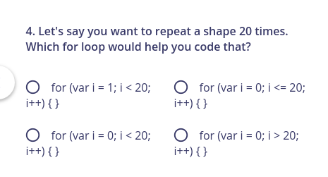
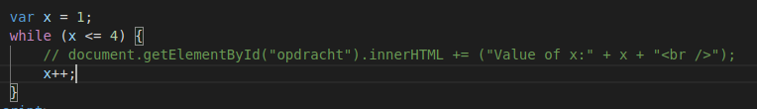

What comes here out?

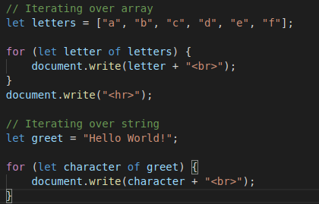
Opdracht 3

Solve this

