TP3
Pair work :
hiba mhirit
Salma mana

Ex1
1-for firefox :10000 days ,27.39years
For google :20000days , 54.79 years
2-team work + splitting tasks
3-the one that writes the solution in 50 lines is more efficient in terms of time and effort
4- we can mesure productivity by time and memory efficiency and also how many problems have been solved
Ex2
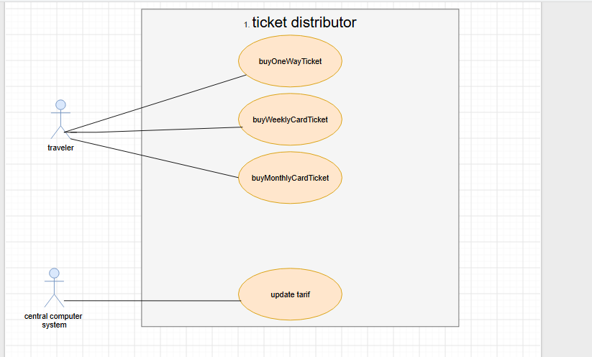
Ex3
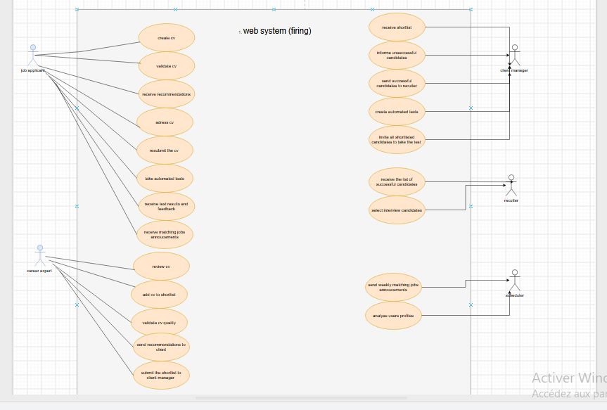
5 functional requirements :
FA1 The system shall allow applicants to create CVs through the CV Builder module. High priority (5 days effort)
FA2 The system shall allow the career expert to review CVs and provide recommendation. High priority (6 days effort)
FA3 The system shall allow the client manager to create automated tests and invite shortlisted candidates to take them. High priority (7 days effort)
FA4 The system shall evaluate completed tests and send the successful candidates' list to the recruiter. High priority( 6 days effort)
FA5 The system shall analyze users' profiles and job postings and automatically send weekly job announcements matching users' preferences. Medium priority (8 days effort)
Ex4
1. Actors of the system :
Hotel Client
Receptionist
Cashier
Cleaning Staff
Floor Manager
Maintenance Staff
Client’s Bank Server

2. Actions that occur outside the system :
Client calls the hotel by phone to make a reservation.
Client provides payment information for an online payment.
Client's bank server validates the CIB payment.
Bank server communicates with the hotel system through SSL.
Client arrives at the hotel.
Cleaning staff cleans the room.
Floor manager checks the room.
Maintenance staff physically repairs damaged equipment.
Client consumes breakfast/lunch/dinner.
Client hands over payment at checkout.

3. System boundaries :
Boundary 1 :Reservation Management
Boundary 2 — Room / Reception Management
Boundary 3 — Billing Management
Boundary 4 — Cleaning Management
