NAME : HIBA SAJID
ROLL NO : SU92-BSAIM-F25-199
SUBJECT : AI (LAB )
SUBMITTED TO : SIR RASIKH ALI

Problem Statement and Assumption:
A university needs an AI help desk and scholarships screening prototype. We have used two different systems of comparison: transparent rule-based verification against probabilistic threshold.
Timeline of Major Events (Task 1):
- 1950 – Proposal of Turing Test: Turing put forward the “Imitation Game” as a test for machine conversation (Source: Turing, A.M., 1950).
- 1956 – Dartmouth Conference: Founding of the academic discipline of Artificial Intelligence.
- 1974-1980-AI Winter 1: Reduction in funding and lowered expectations as a result of initial overhyping.
- 1997 – IBM Deep Blue: Beat Garry Kasparov through brute force searches and evaluation
- 2012 – AlexNet: Indicated the beginning of deep learning era due to large amounts of data and GPUs
Task 2
Rule-Based Implementation & Disagreement Table :
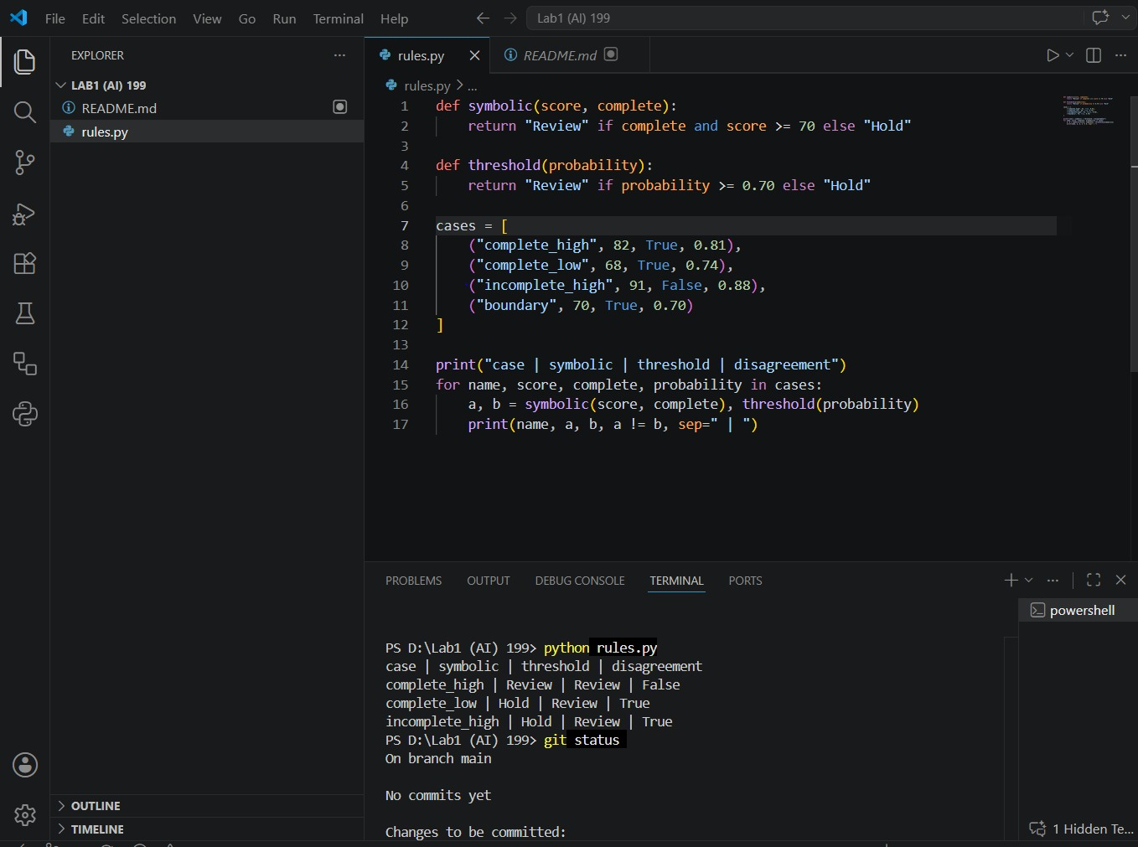
Task 3
Conversational Test vs. General Intelligence
. What the Conversational Test Observes:
It only checks surface-level fluency, sentence coherence, and how naturally a system can hold a text conversation.

. What it Fails to Establish:
Sounding convincing or fluent does not mean the system possesses actual logical reasoning, general intelligence, or a true understanding of hard rules.

. Example of Fluent but Incorrect Reasoning:
In our scholarship scenario, an AI assistant might write a very fluent and encouraging message saying: "The student is fully eligible due to an amazing score!" while completely overlooking the fact that their mandatory document verification is still incomplete.

. Additional Test for Reliable Performance:
To truly trust the system, we need deterministic rule-based checks and automated unit testing alongside the chat output to make sure rules are actually being followed.

