Project Documentation

1. Introduction

Project Title: Product Inventory Management System

Team ID: SWTID-2026-9368

Team Leader: HIBA FATHIMA S — 24bsccs46@cttewc.edu.in

Team Members:

• DIVYA SREE V — 24bsccs48@cttewc.edu.in

• KALAI SELVI C — 24bsccs42@cttewc.edu.in

• PRITHIKA S V — 24bsccs50@cttewc.edu.in

The Product Inventory Management System is a backend application developed using Node.js,
Express.js, and MongoDB. It provides secure REST APIs to manage product inventory using JWT
authentication.

2. Project Overview

• Register a new user
• Login with credentials
• Create products
• View products
• Update product details
• Delete products

3. Architecture

• Backend: Node.js with Express.js
• Database: MongoDB with Mongoose
• Authentication: JSON Web Token (JWT)
• API Testing Tool: Thunder Client (VS Code Extension)

4. Setup Instructions

• Install Node.js and npm
• Open the project in Visual Studio Code
• Run npm install
• Run npm run dev
• Server runs at http://localhost:5000
Installation Commands:
# install dependencies
npm install
# run development server
npm run dev

5. Folder Structure

server/
■■ src/
■ ■■ controllers/
■ ■■ routes/
■ ■■ models/
■ ■■ middleware/
■■ config/
■■ server.js
■■ package.json
■■ .env

6. Running the Application

npm run dev
Server is running on port 5000
MongoDB connected !!

7. API Documentation

Register User API:
POST http://localhost:5000/api/v1/auth/register
{
"name": "TestUser",
"email": "test123@gmail.com",
"password": "123456"
}
Login User API:
POST http://localhost:5000/api/v1/auth/login
{
"email": "test123@gmail.com",
"password": "123456"
}
Product APIs:
POST http://localhost:5000/api/v1/products
{
"name": "Laptop",
"price": 50000,
"quantity": 5
}
GET /api/v1/products
PUT /api/v1/products/:id
DELETE /api/v1/products/:id

8. Authentication

JWT authentication is used. After login the server returns a token which must be included in API
requests.
Authorization: Bearer <JWT Token>

9. User Interface

This project mainly focuses on backend development. APIs were tested using Thunder Client inside
Visual Studio Code.

10. Testing

• Register new user
• Login user
• Generate JWT token
• Create product
• Retrieve products
• Update product
• Delete product

11. Screenshots or Demo

• Server running and MongoDB connected

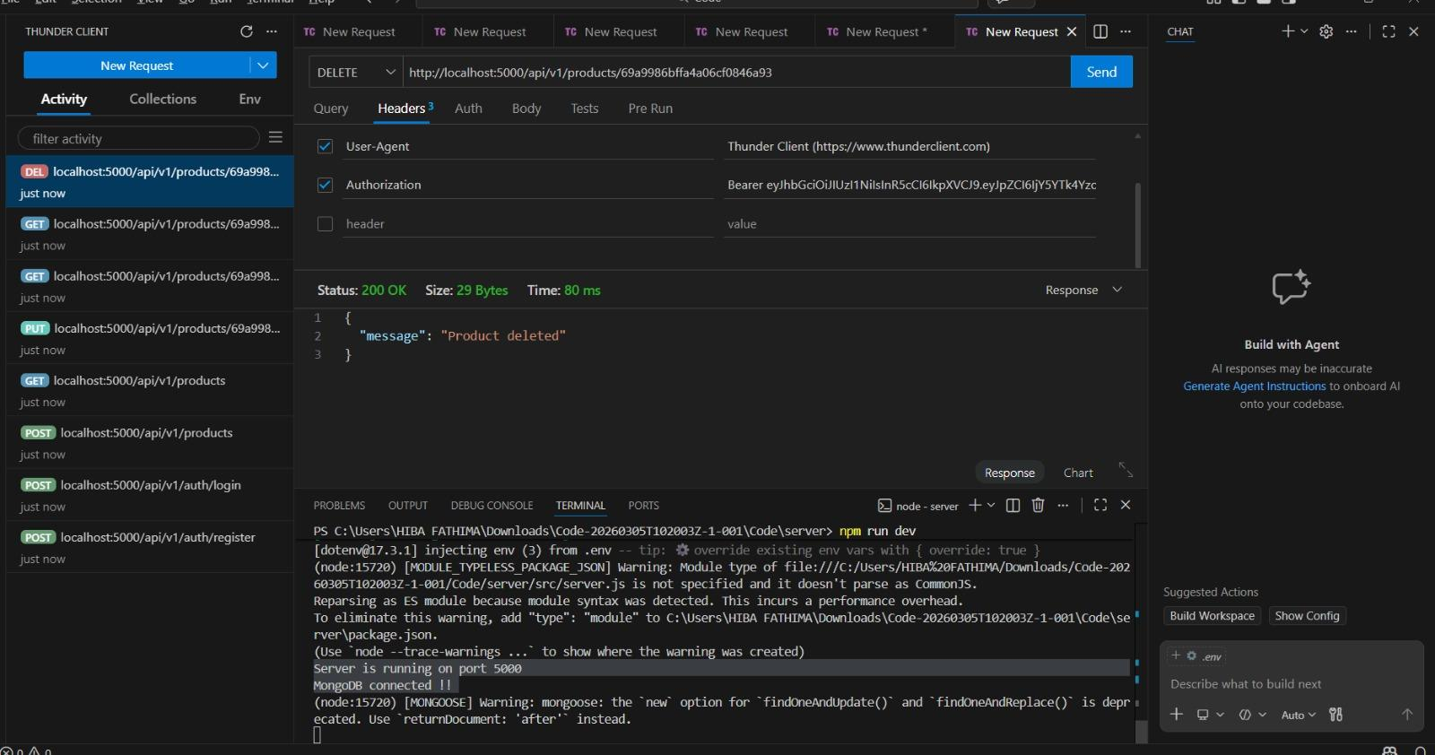

• Register API response

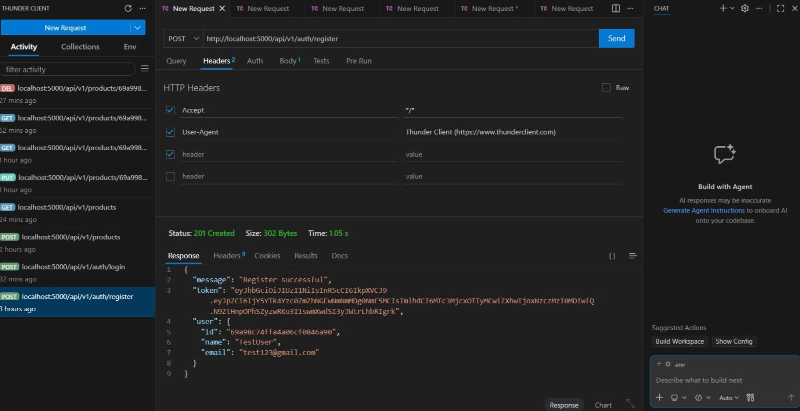

• Login API response

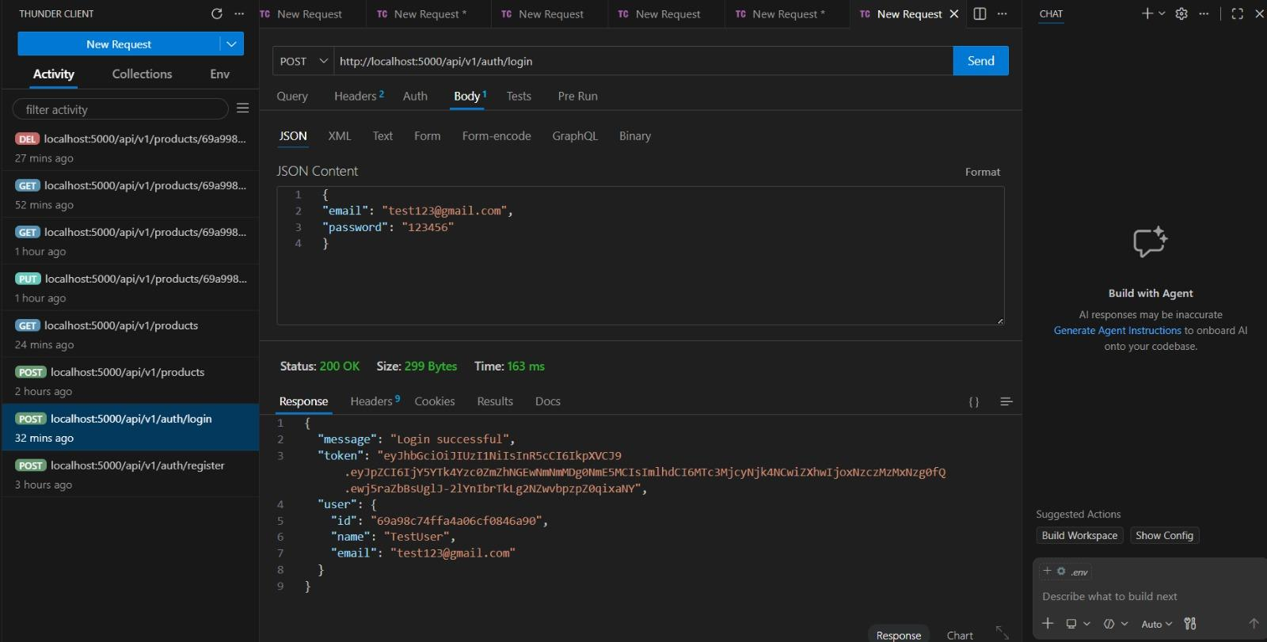

• Create product API

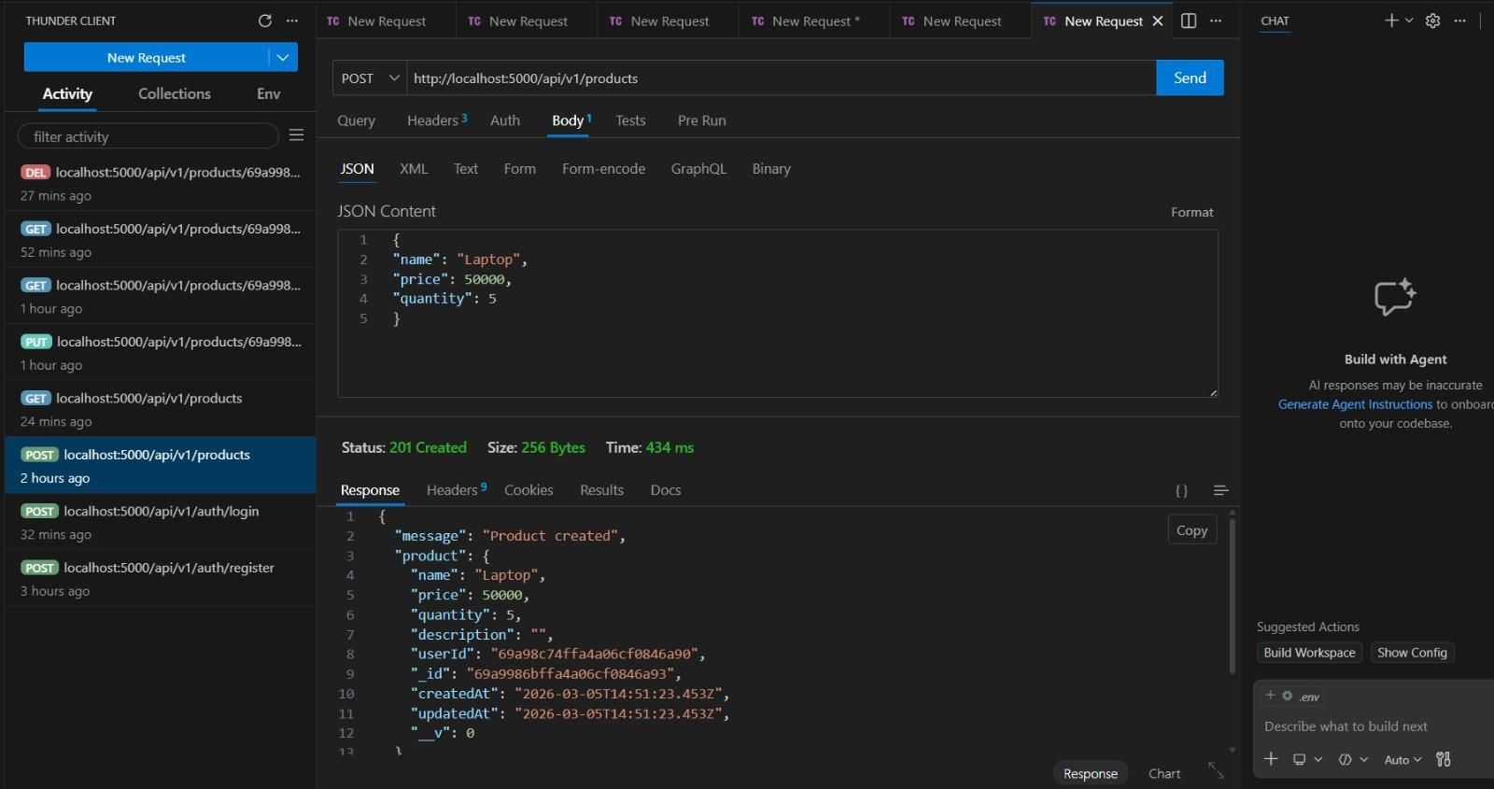

• Get products API

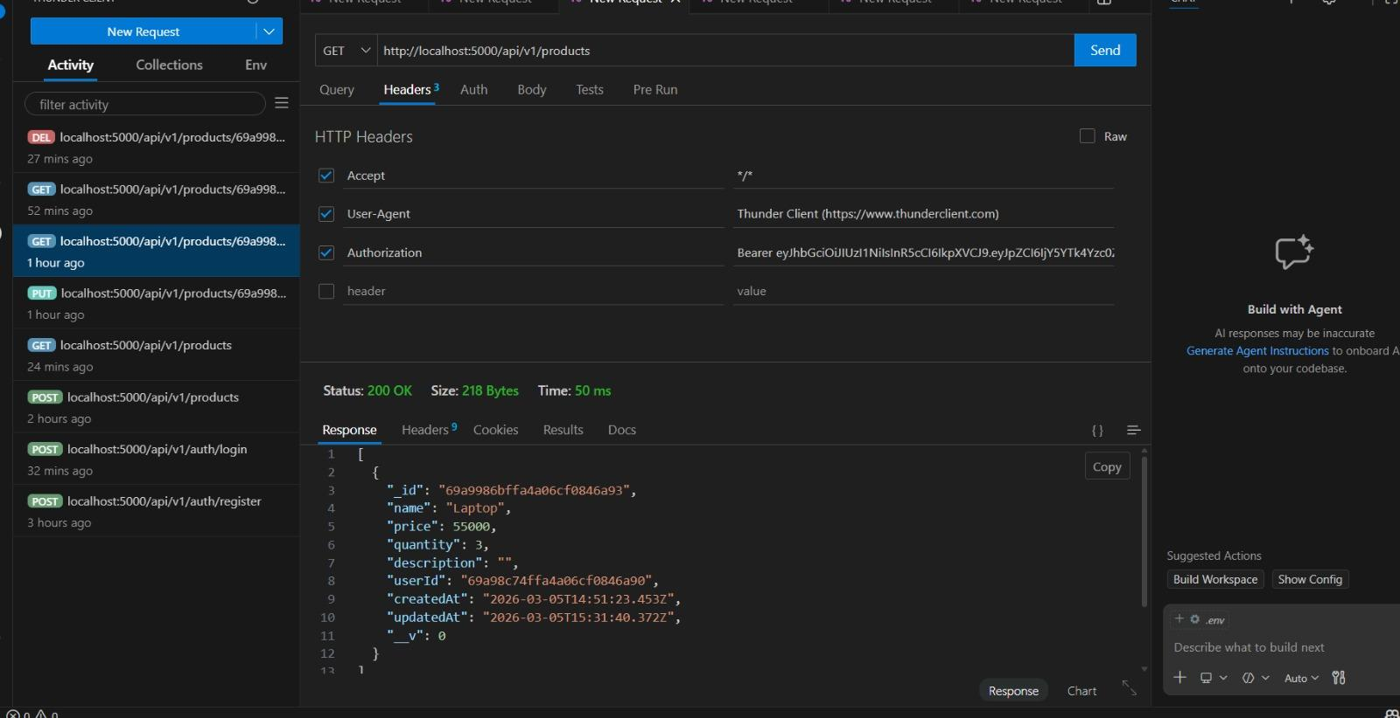

• Update product API

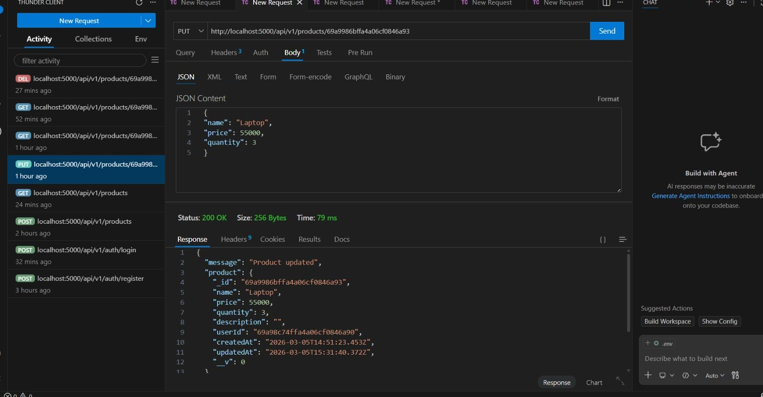

• Delete product API



• Final empty product list response

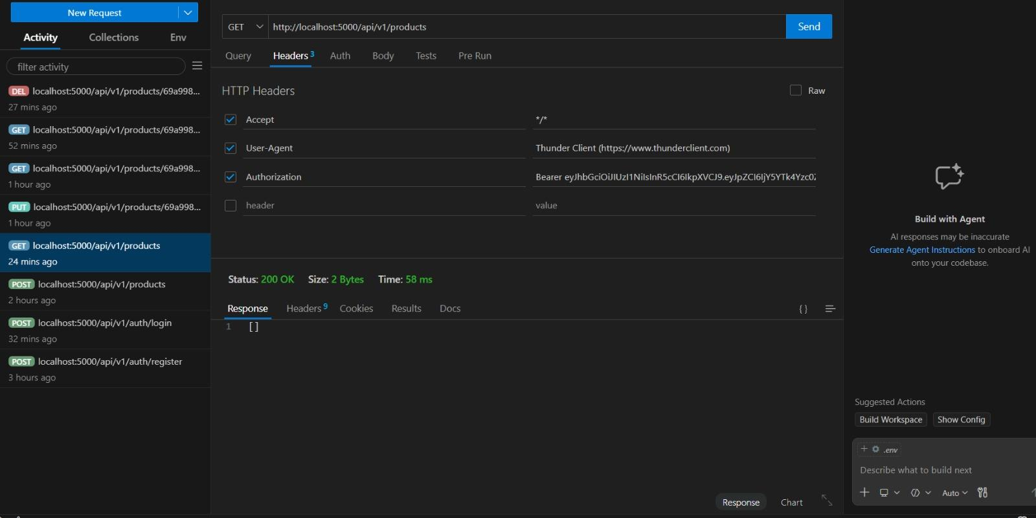

12. Known Issues

Currently backend APIs are implemented. A frontend interface is not yet included.

13. Future Enhancements

• Add frontend interface
• Product search feature
• Role-based authentication
• Product image uploads
• Product category management

